COURSE NO. : CE 363 | DATE OF TESTING : 15.10.2010
NO. AND TITLE OF THE TEST : SML 7(a)

Determination of particle size distribution of fine-grained soils by the hydrometer
YEAR AND SECTION : 4th year--sec. 4 | LAB. GROUP : 03
SURNAME, OTHER NAMES OF STUDENT : Nizami ÖZÇELİK

SML 7(a)
Determination of particle size distribution of fine-grained soils by the hydrometer

OBJECT OF THE EXPERIMENT
The object of this experiment is to determine quantitatively the particle size distribution in a soil from the coarse sand size down. The test is not applicable if less than 10% of the material passes the 63 micron (ASTM No.200) sieve as measured by wet or dry sieving.

APPARATUS
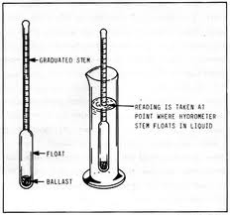

- A hydrometer calibrated to read density at 20C.
- Two 1000 ml graduated glass measuring cylinders about 7 cm in diameter and 33 cm high, marked at 1000 ml volume.
- A thermometer to cover the range 0-50C.
- An electrically driven stirrer.
- Test sieve sizes 2.5 mm, 630 µm, 200 µm, and 63 µm, and a receiver.
- A balance readable and accurate to 0.01 g.
- A thermostatically controlled drying oven, capable of maintaining a temperature of 105-110C.
- A stop watch.
- A desiccator containing anhydrous silica gel.
THEORY
The particle size distribution of a coarse soil can be determined by the method of sieving. However, the particle size distribution of a fine soil can be determined by the method of sedimentation. Sedimentation is based on Stoke’s Law which governs the velocity at which spherical particles setle in a suspension: the larger the particles the greater is the settling velocity. The particle size distribution of the soil is presented as a curve on a semilogarithmic plot, the ordinates being the percentage by mass of particles smaller than the size given by the abscissa.

PROCEDURE
- Of the air-dried soil, obtain by riffling two subsamples weighing 50-100 g approximately. Determine the moisture content of one sample. Weigh the other accurately to the nearest 0.01 g, and place in an evaporating dish.
- Mix with 100 ml sodyum-hexametaphospat.
- Transfer the mixture to the dispersing cup of the mixer then stirr the soil suspension.
- Transfer the suspension immediately to the 63-micron test sieve placed on the receiver. Transfer suspension that has passed through the sieve to the 1000 ml measuring cylinder.
- Transfer the material retained on 63-micron test sieve to weigh materials that retained on 2.5 mm.
- Shake the cyclinder, then immerse hydrometer to a depth, take hydrometer readings after periods ½,1, 2, 4, 8 min and 24 hour and record temperature.
- Re-insert the hydrometer in the suspension and take the readings after periods of 8, 15 and 30 minutes, 1, 2 and 4 hours after the shaking.
- Read and record the temperature of the suspension once during the first 15 minutes and then after every subsequent reading, with an accuracy of at least +/- 0.5C.
- Place exactly 50 ml of the dispersing agent solution on a weighted beaker. Hence, calculate the mass (md) of the dispersing agent. Calculate the dispersing agent correction (x) from the formula:
X=2(md)
*This correction should be approximately 4.
RESULTS
The results of the experiment are tabulated in the data sheet which is added to the end of the report.

CALCULATIONS

The corrected hydrometer reading was calculated by adding hydrometer reading to an meniscus correction coefficient (Cm = 0.5). In addition, the temperature correction was calculated by the help of nomographic chart was tabulated in the data sheet as well.(Mt = +0.58)

The relation between Rh and HR is given in the laboratory by these datas.
Rh | 40 | 30 | 20 | 10
HR (cm) | 8.951 | 11.401 | 13.881 | 16.361

By using these given datas we have plotted a curve which relates Rh and HR:
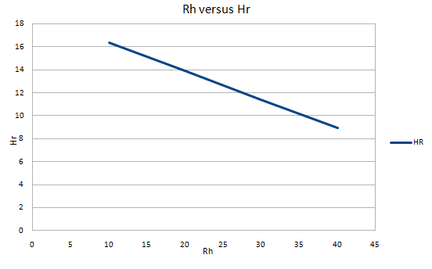

By using the Rh-HR graph and putting Rh readings into this graph, we found our HR values.

Time | ½ min | 1 min | 2min | 4 min | 8 min | 15 min | 24 hr
R’h | 21 | 20 | 18.8 | 18 | 17 | 16 | 8
Rh | 21.5 | 20.5 | 19.3 | 18.5 | 17.5 | 16.5 | 8.5
Hr(mm) | 135 | 137 | 140 | 141 | 142 | 145 | 173

Using these HR values on the nomographic chart, firstly we found velocities at each time.
Time | ½ min | 1 min | 2min | 4 min | 8 min | 15 min | 24 hr
v | 0.50 | 0.25 | 0.13 | 0.0620 | 0.031 | 0.015

Then, we drew a line from Gs to temperature on the nomographic chart to find B value. Next, joined B and V rulers on the nomographic chart to find diameter(D) in mm. In addition, we know that Mb = 50 g and x = 4; so we found these values to be able to find percentage finer than D (K%).
Time | ½ min | 1 min | 2min | 4 min | 8 min | 15 min | 24 hr
D | 0.075 | 0.055 | 0.036 | 0.0260 | 0.018 | 0.013 | 0.0014
Rh+Mt-x | 18.080 | 17.080 | 15.880 | 15.080 | 14.080 | 13.080 | 5.08
Mb | 50.000 | 50.000 | 50.000 | 50.000 | 50.000 | 50.000 | 50

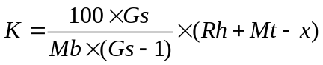 ; (100*Gs)/(Mb*(Gs-1)) = 3.176;

Time | ½ min | 1 min | 2min | 4 min | 8 min | 15 min | 24 hr
K(%) | 57.420 | 54.246 | 50.434 | 47.8940 | 44.718 | 41.542 | 26.996
** Weight of materials retained on each sieve:
# of sieve weight (g)
- 16.12
- 4.02
- 2.11
- 1.36
- 8.63

To be able to plot the cumulative percentages of the particles passing each sieve obtained form the results of the fine sieving, we need to find the percentages of materials retained on each sieve,
Percentage of material retained on the “i” sieve = [(the weight of the material retained on the “i” sieve) / ( total material weight used in the sieve analysis) ]*100
# of sieve percentage (%)
- 24.93
- 13.09
- 8.43
- 53.53

GRAPHS
The asked graphics on a semi-logarithmic chart are added to the end of the report.

DISCUSSION OF RESULTS

