Object

The object of this test is to determine the unconfined compressive strength and hence, the undrained shear strength of saturated clay. (Non-fissured)

Apparatus

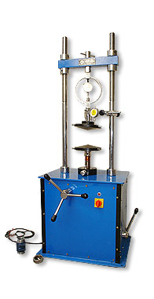

http://www.accrotechscientific.com/pcat-gifs/products-small/soil.jpg

Theory

Strain: A change in the form or shape of a body or material which is subjected to an external force.

In this test proving ring dial is obtained according to value of strain dial. After that axial load and corrected area are calculated then compressive stress of the specimen is calculated. (P/A)

Procedure

- Prepare a specimen by jacking a thin-walled, lubricated core cutter into the soil sample. Then push the specimen out of the core cutter by means of loose-fitting wooden dolly, and trim it to the required height by placing it inside a trimming tube which is of the right height and has a diameter slightly larger than that of the specimen
- Take water content and specific gravity samples.
- Weigh the sample and determine its mean diameter and height
- Place the sample between the loading platens of the testing machine, Adjust the vertical deflection and proving ring dial gauges to zero
- Apply an axial load at a constant rate of strain, sufficiently slow to permit recording of the strain and the proving ring dial readings at 10-division intervals of the strain dial. Continue until failure occurs.
- Prepare a sketch showing the mode of failure of the specimen, measuring the angle of inclination of the failure plane, if any to the axis of the specimen
- Repeat the test for two more specimens.

Discussion of Results

In this test, personal factor of the operator can affect the results because some steps in the procedure should be done properly. For instance, specimen should be put into the machine very carefully. No force should be applied to the specimen before starting the test. Some personal errors may affect the results like reading or recording errors. To avoid these errors digital devices should be used because digital devices give more accurate results when it is compared with analog devices.

Conclusion

In this experiment, strain dial and proving ring dial values are obtained and strain corrected area axial load and compressive stress values are calculated. This specimen failed at 1.362244-kPa. When it failed, its strain values was 0,030986

References

Lecture Notes
www.answers.com
Mirata, T. (2001) Laboratory Instructions for Soil Mechanics Students, Department of Civil Engineering, METU

Course No: 5620363 Date of Testing: 03.12.2008

No and Title of Test: 19, Unconfined Compression Test

Year and Section: 3, 02 Lab. Group: 4

SURNAME, Other names of Student:

Calculations and Graph

Strain ε = δ₁/h₀

Corrected Area A = A₀ / 1-ε

Axial Load P = C_{p} . δ₂

Compressive Stress P/A

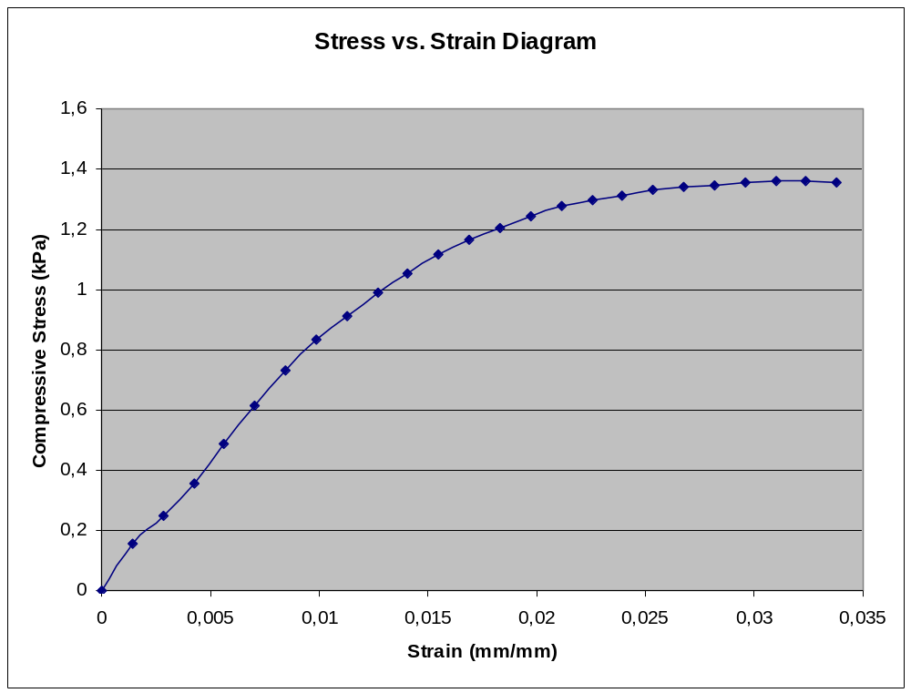
Failure

