Course No. : 5620363 | Date of Testing : 12.11.2008
No. and Title of Test : SML(20) - Direct Shear Box Test on Sands
Year and Section : 20081, Sec.1 | Lab. Group : 4
SURNAME, Other names of student :

Direct Shear Box Test on Sands
1. Object of The Experiment:
The object of this experiment is to determine the drained shear strength and the stress-strain characteristics of a sample of remoulded sand, having particles not larger than 2mm by means of the direct shear box test.
In this test, we recorded both the readings and the deflections of spring deflection and vane rotation. Then we obtained the stress-strain curve of a sample of a soft clay by using calibration graph obtained and the derived expression for the shear strength.

2. Apparatus:
• A Shear test box.
• A Loading machine.
• 3, 16kg weights.
• A dial gauge.
• A shear motor.

3. Theory:
Shear strength of a specific soil can be found by means of laboratory test on representative specimens. The shear strength was originally introduced by Coulomb as a linear function of normal stress on a plane at the same point.
τ_{f} = c + σ_{f} tanϕ
where c and ϕ are the shear strength parameters referred to as the cohesion intercept and the angle of shearing resistance respectively. Also by Terzaghi shear strength extension, τ_{f} can be expressed in terms of effective stress as follows:
τ_{f} = c’+ σ_{f}’ tanϕ’
where c’ and ϕ’ are parameters of effective stress. So, failure occurs at points where there is a critical combination of shear and effective stress. The soil is assumed to fail when the Mohr’s Circle of Stress becomes tangential to the Coulomb failure envelope.
The plane in which failure occurs is determined by drawing a common tangent on circles drawn according to Mohr's-Coulomb principles.
The strength of a clay in terms of effective stress can be determined by means of either the consolidated-undrained triaxial test with pore pressure measurement during the undrained part of the test, or the drained triaxial test. The undrained part of the consolidated-undrained test must be run at a rate of strain slow enough to allow equalization of pore water pressure throughout the specimen, this rate being a function of the permeability of the clay. If the pore water pressure at failure is known, the effective principal stresses can be calculated and the corresponding Mohr circle drawn. A number of tests, each performed at a different value of all-round pressure, enable the failure envelope to be drawn and the shear strength parameters c' and φ' determined.
For a normally consolidated clay the value of c' is zero, whereas for a overconsolidated clay c' has a value not usually exceeding 30 kPa. The value of ϕ' generally lies between 200 and 350, lower values being associated with high plasticity index and vice versa.

4. Method of Test:
• Measure the internal diameter of the shear box.
• Place the upper half of the shear box on a flat glass plate and tighten the upper screws until they just contact this plate. Adjust the lateral screws until they are just clear of the inner face of the shear box.
• With the lower porous stone in place, and the two halves of the shear box keyed together by the two locating pins, measure the depth to the top of the porous stone using a vernier gauge. Taking care not to let any sand escape into the holes of the vertical screws, place sufficient sand in the shear box such that, when the gauging disc is placed in position, its base rests on the top of the sand, and its rim just touches the top of the box. Measure the depth of the circular part of the gauging disc in order to determine the initial thickness of the sand sample.
• Replace the gauging disc by the pressure plate, mount the shear box on the loading machine, and set the yoke, carrying the hanger, on top of the pressure plate. Fix the vertical deflection gauge in position, and set it to zero.
• Place on the hanger the weight (16kgf, say) necessry to give the desired normal stress. Record the change in the thickness of the sample. Then fill the brass container with water to just below the level of the top of the shear box, in order to soak the sample, and note the additional deflection, if any.
• By tightening the vertical screws on the upper half of the shear box by half a turn more, raise the upper half slightly relative to the lower half. Then tighten the lateral screws securing the upper half of the box on to the pressure plate, and slacken the vertical screws by at least one turn.
• Remove the two locating pins.
• Mount another dial gauge to measure the shear displacement. Adjust all three dial gauges to zero, and the strain rate setting to 1,2 divisions.
• Start the shear motor, recording all three dial readings at suitable intervals until the sample fails. Stop the motor.
• Repeat the above procedure for three more samples using different normal loads.

5. Results:
Normal load, P = 16 kgf = 0,157 kN zzzzzzzzzzzzzzzzzzzzzzzzzzzzzzzzzzzzzzzzzzzzzzzzzzz aaaaaaaaaaaaP = 32 kgf = 0,314 kN zzzzzzzzzzzzzzzzzzzzzzzzzzzzzzzzzzzzzzzzzzzzzzzzzzz aaaaaaaaaaaaP = 48 kgf = 0,471 kN
Applied Torque (Ncm)
Internal diameter of shear box = 63,5 mm
Area of specimen, A = π*D²/4 = 0,003167 m²
Normal stress, σ = P /A = 49,546 kPa aaaaaaaaaaaaaaaaaaaaaaaaaaaaaaaaaaaaaaaaaaaaaaaaa aaaaaaaaaaaaaσ = P /A = 99,092 kPa aaaaaaaaaaaaaaaaaaaaaaaaaaaaaaaaaaaaaaaaaaaaaaaaaa aaaaaaaaaaaaaσ = P /A = 148,638kPa
Depth to the top of the lower porous stone, d = 39 mm Thickness of circular part of gauging disc, t = 19 mm Initial thickness of the specimen, T = d – t = 20 mm Proving ring constant, Cp = 1,579 * 10-3 kN/division
Change in thickness due to consolidation, δt = (504-500)*10⁻³*25,4 = 0,1016 mm a δt = (505,1-499,9)*10⁻³*25,4 = 0,13208 mm a δt = (506,1-502,2)*10⁻³*25,4 = 0,09906 mm
Thickness of specimen after consolidation, T₂ = 20 - 0,1016 = 19,8984 mm a T₂ = 20 - 0,13208 = 19,86792 mm a T₂ = 20 - 0,09906 = 19,90094 mm

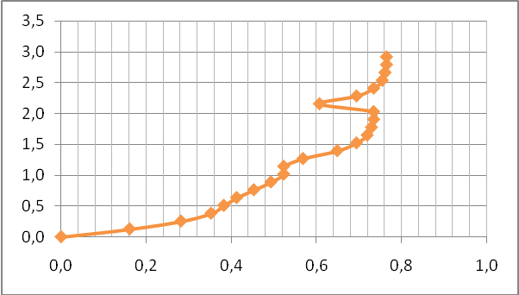

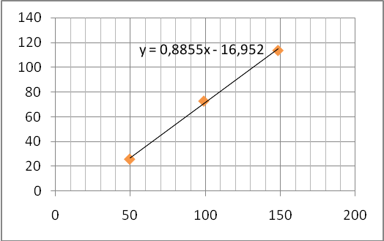

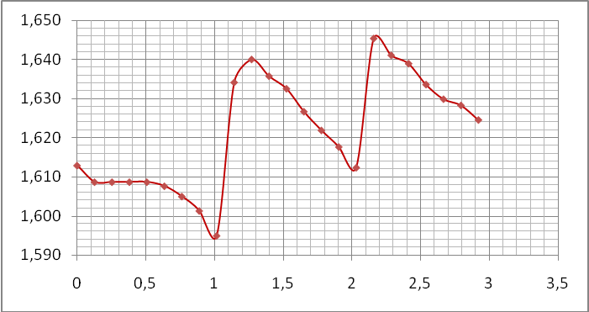

6. Calculations
τ / σ = Cp*δ / P = peak (shear stress/normal stress) for:
P=16kg (τ/σ) = 0,5233 τ=0,5233*49.546kPa τ=25,926 kPa
P=32kg (τ/σ)= 0,7346 τ=0,7346 *99.092kPa τ=72,793 kPa
P=48kg (τ/σ) = 0.7648 τ=0,7648*148.638kPa τ=113,676 kPa

Shear envelope equation is obtained from τ vs. σ graph:
τ = 0,8855σ - 19,952

By looking again the same graph:
Cohesion, c_{d} = 0,5551 kPa and
Internal friction angle, ϕd = tan-1(0,8855) ≈ 45,525º.

7. Discussion of Results:
As it can be seen we obtained the shear strength parameters in terms of effective stresses by undrained triaxial tests with pore water pressure measurement.
For a normally consolidated clay the value of c' is zero, whereas for a overconsolidated clay c' has a value not usually exceeding 30 kPa. The value of ϕ' generally lies between 200 and 350, lower values being associated with high plasticity index and vice versa.
The parameters c' and ϕ' can also be obtained by means of drained triaxial tests or direct shear tests.
Because the drainage conditions during all stages of the test markedly influence the shear
strength of soils, the direct shear test is only applicable for relatively clean sands which are free
draining during shear. For clay soils, some unknown amount of consolidation could occur during
shear, which would give a larger shear strength than actual. Therefore the test is not generally
recommended for cohesive soils.
The personal factor in this test is very important since it affects directly the results obtained from the test. A misreading of the values, a carelessness or improper application of the test may yield totally wrong results. Also the equipment limit the accuracy of the test since the values are read from dials and the human eye can not determine exactly the values but rather approximate values are obtained. Instead of these equipment electronic, data processors with high accuracy(if available) could be used.
After computations were done, shear envelope equation was obtained. However, the intercept of c (cohesion) was found to be -17 which is unacceptable. This was probably caused by the data recorded during the test being not reliable due to the factors mentioned above. It would also be due to the some disadvantagous of the direct shear test.
This test is disadvantageous when the facts mentioned below are considered:
1. Difficult or impossible to control drainage, especially for fine-grained soils.
2. Failure plane is forced--may not be the weakest or most critical plane in the field
3. Non-uniform stress conditions exist in the specimen.
4. The principal stresses rotate during shear, and the rotation cannot be controlled.
Principal stresses are not directly measured.

8. Conclusion:
After the test performed we obtained the necessary data for a given soil which can be used directly to the solution of engineering problems involving shear strength parameters. This test was also very useful for us since it provides us with knowledge of laboratory test.
The Direct Shear Test is advantageous as it is simple and fast method for obtaining shear strength parameters (cohesion and friction angle) of soils especially for sands. Shear strength parameters are important in all types of geotechnical designs and analyses. The results obtained from this test can be used when we are dealing with problems such as slope stability in sites where slope exists(such as highways).

9. References:
- Mirata, T. (2001). Laboratory Instructions for Soil Mechanics Students. Department of Civil Engineering. METU.
- Craig, R. F. (2004). Craig’s Soil Mechanics. University of Dundee UK, pp.6-17.

