Course No: 5620363 Date of Testing: 24.11.2008

No and Title of Test: 21, Constant Head Permeameter

Year and Section: 3, 02 Lab. Group: 4

SURNAME, Other names of Student:

Object

The object of this experiment is to verify Darcy’s Law and investigate the range over which it applies and to determine the coefficient of permeability and its variation with void ratio and to observe the occurrence of boiling and the conditions under which it takes place.

Theory
Porosity: A ratio, usually expressed as a percentage, of the volume of voids in a material to the total volume of the material, including the voids. The voids permit gases or liquids to pass through the material.

Permeability: The property of soil, rock, or mantle which permits water to flow through it.

Apparatus
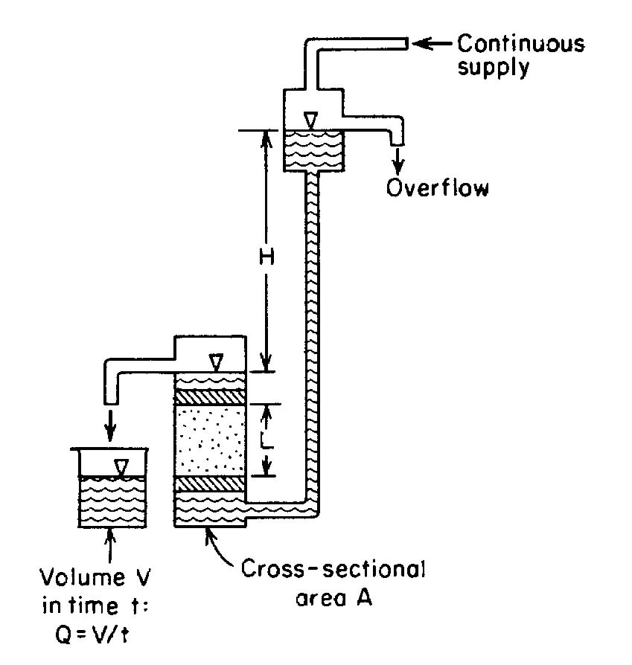

Procedure

- Determine the specific gravity and the initial water content of the sand.
- Weigh out enough sand to fill the permeameter up to a level of about 5 cm below the top of the permeameter. Stir this sand thoroughly in water in a tray to drive out all free air bubbles.
- Fill the permeameter with water with the porous base plate in position. Using a suitably sized plastic tube, siphon the sand-water mixture into the permeameter and allow the sand to settle uniformly in the cylinder. Add more water to the sand sample if necessary. Then compact this sand as far as possible using the steel rule
- Measure the height of the sample, and the internal diameter of the lucite cylinder.
- Allow air-free water to flow upwards through the sample at a slow rate so as not disturb the sand, and wait until uniform discharge is taking place through the outlet. Measure the rate of discharge and record the temperature of the water at intervals of about 2 cm of difference, h, in head between the stand-pipe tapping point and the top of the sample. Carry on up to a hydraulic gradient of about 0.8, and thereafter, take readings at smaller intervals of difference in head up to critical gradient, i_{c}.
- After boiling has been observed, measure the height of the sample, then reduce the head until the sand settles back and re-measure the height. Reduce the head until the sand settles back and re-measure the height. Reduce the head at wider intervals, measuring the rate of flow and the temperature as before. At the end of the test, take a final measurement of the height of the sample.
- Measure the distance, d, between the stand-pipe tapping point and the top of the porous stone, for determining the effective length, L, of the sample at various stages of the test from a knowledge of the total height, H, of the sample.

Discussion of Results

In this experiment, personal factor of the operator can affect the results because some steps in the procedure should be done properly. For instance, when one is determining the discharge, one may not be able to do correctly; one may collect water in wrong time. This kind of errors affects the results. Some laboratory conditions may also be effective in this test. For instance, the sample, which is used in this experiment, should be oven dried. Temperature also affects the results because it changes the viscosity

Conclusion

In conclusion, this test is done to determine coefficient of permeability and porosity which were at initial, during boiling and after boiling time.

References

Lecture Notes
www.answers.com
Mirata, T. (2001) Laboratory Instructions for Soil Mechanics Students, Department of Civil Engineering, METU

