Course No: 5620363 Date of Testing: 24.11.2008

No and Title of Test: 22, Consolidation Test of an Undisturbed Clay

Year and Section: 3, 02 Lab. Group: 3

SURNAME, Other names of Student:

1-OBJECT OF THE EXPIREMENT
To determine, for an undisturbed saturated, cohesive soil, the relationship between the effective pressure and void ratio and the time-settlement characteristics.

2-APPARATUS
1. Soil Test Inc. Consolidometer 5. A balance accurate to 0.5 g.
2. Filter paper discs 6. A dial gauge
3. Loading apparatus 7. A microwave oven
4. A chronometer

Ring Loading cap Porous stone

Standpipe

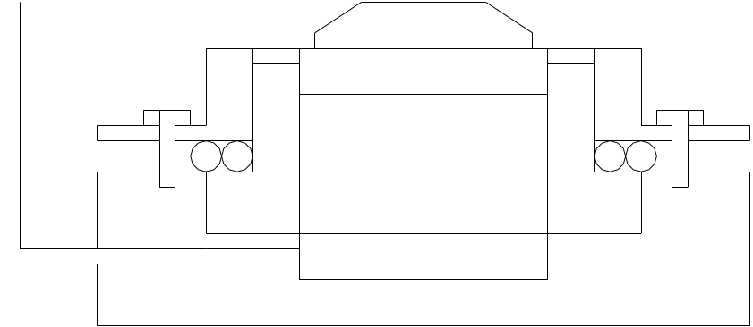
Specimen

SOILTEST INC. CONSOLIDOMETER

3-THEORY
Consolidation is the gradual reduction in volume of a fully saturated soil of low permeability due to drainage of some of the pore water, the process continuing until the excess pore water pressure set up by an increase in total stress has completely dissipated.

4-METHOD OF TEST
- Weigh the consolidometer ring and measure its depth and interval diameter, entering these values in data sheet I. Then extract a specimen by driving a special thin-walled ring ( with the over-drive price attached ) into the undisturbed soil sample, and trim the ends as follows.
  - For the Soiltest Inc. consolidometer, the thickness of the specimen should be slightly less than the depth of the ring in order to accommodate the porous stone. While the specimen is still in the thin walled ring, trim one end, then, using the extruder, push the specimen through the ring for a few millimeters and cut the other end flush with the edge of the ring for a few millimeters and cut the other end flush with the edge of the ring. Measure the height of the specimen and transfer it into the consolidometer ring.
- Take samples for the determination of the specific gravity of the soil.
- Place the specimen with its ring in an evaporating dish and weight.
- With filter paper disc placed on top and bottom of the specimen, assemble the ring in the consolidation cell and mount this on the loading device.
- Adjust the deflection dial to give sufficient trial under the proposed increment of load, and to record a small amount of swelling.
- Loading sequence: Selected pressures 25, 50, 100, 200, 400 kPa. Dial readings are taken at given times in data sheet II.

5- CALCULATIONS AND RESULTS
Calculations are done on the data sheet.

6-DISCUSSION OF RESULTS
This test is used for the observe of the relationship between the effective pressure and void ratio and time-settlement characteristics.
There are personal factors could affect the accuracy of the test and these personal factors may mislead and change the results. These factors in consolidation test can be listed as; incorrect measure the depth of consolidation ring and the weigh of consolidation ring, wrongly put the specimen in consolidation ring, and incorrect measurement of the height of the specimen.

7-CONCLUSION
To conclude, during one dimensional consolidation or swelling, the characteristics of undisturbed clay is determined and relationship between the effective pressure and void ratio is acquired.

8-REFERENCES
- Craig, R. F., Sixth Edition. Soil Mechanics
- Mirata T. (1987) , Laboratory Instructions for Soil Mechanics Students, METU, Ankara 2001

