Course No: 5620363 Date of Testing: 17.11.2008

No and Title of Test: 23, Laboratory Vane Test

Year and Section: 3, 02 Lab. Group: 3

SURNAME, Other names of Student:

1-OBJECT OF THE EXPIREMENT
The object of the experiment is to determine the peak and residual undrained strength of a soft, undisturbed or remoulded clay, assumed as saturated, using the laboratory vane apparatus.

2-APPARATUS
1- Vane apparatus
2- Remoulded clay
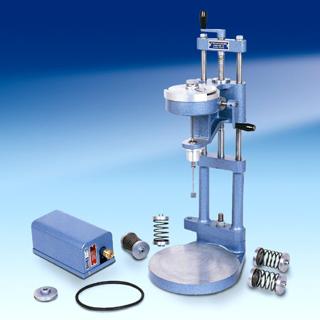
(Vane apparatus)
http://www.wfi.co.uk/immagini/product_zoom/23500-+-23542.jpg

3-THEORY

dF = c*dA and dM = c*dA*r, dA=r*dr*dθ;
From there we derive, T = π / 2 * D² * H * (1 + D/3H) * c.

Where;
c = mobilized shear stress in the clay sample when a torque is applied by pushing vane into the clay.
H = height of vanes
D = diameter of circle circumscribing vanes.

4-METHOD OF TEST
(a) Calibration
1. Apply a known torque to the vertical shaft carrying the vane and read off the angular deflection of the spring. The required torque can be applied by means of a thread wound round the 9.5 mm diameter section of the vane shaft, and pulled horizontally by passing it over a pulley supported independently on a horizontal axis, and placing weights on ah neger attached to its end.
2. Readings should be taken for loading and unloading stages and the mean spring deflection determined in order to eliminate the effect of friction at the pulley.
(b)Testing Procedure
1.If an undisturbed sample is available, transfer this into a Proctor or other suitable mould. Otherwise, remould about 1 kg of Ankara Clay with distilled water to a consistency corresponding to a water content of about 35%. Fill a C.B.R. mould with this clay, taking care not to trap any air in the sample. Place the sample so prepared on the base plate of the vane apparatus, centrally below the vane.
2. Rotation of the handle, having a horizontal axis, rotates a graduated disc wihch is coupled with the top of a helical spring. (Four springs of the varying stiffness are available, and the one giving as wide a range of readings as possible must be chosen according to the consistency of the sample tested, provided that the spring deflection does not exceed 180 degrees.) The lower end of tihs spring is coupled with the vane shaft and also with two pointiers. The shorter of these pointiers reads against the graduated disc and hence registers the relative angular motion between the top and bottom of the spring, that is, “spring defleciton”. The longer pointer reads against a stationary graduated dial and hence gives the angular rotation of the vane.
3. Set the two pointers in contact with each other, with longer pointer reading a value close to zero. Take the initial readings of both pointers.
4. By turning the handle at the top of the screw spindle anticlockwise, lower the vane until it is just in contact with the top of the sample. Then give it 12 more turns so that the vane penetrates the sample by about three times its own height, H, in order to avoid the surface irregularitiesof the sample. Take the pointier readings once more to check whether any twist of the vane has taken place as it entered the soil .
5. Then apply a torque to the vane by steady clockwise rotation of the appropriate handle at a speed of one-quarter of a revolution every 10 seconds. During this process, take readings of the spring deflection (iner dial) and of the angular rotation of the vane (outer dial) at intervals of 10 seconds. Continue until the sample fails, tihs being indicated by a reduction in the spring deflection. If the spring deflection reaches 100 degrees, stop the test and repeat with stiffer spring.
6. Rotate the vane rapidly through two complete revolutions; then reduce the speed of rotation of the handle to the value used in (5), and take a final reading of the spring deflection and the angular rotation.
7. Raise the vane out of the sample by rotating the vertical spindle clockwise. Wipe the blades clear of adhering soil. Shift the sample so that the vane can be lowered to a point at least 30 mm from the point of the previous test and repeat steps (4) to (6).

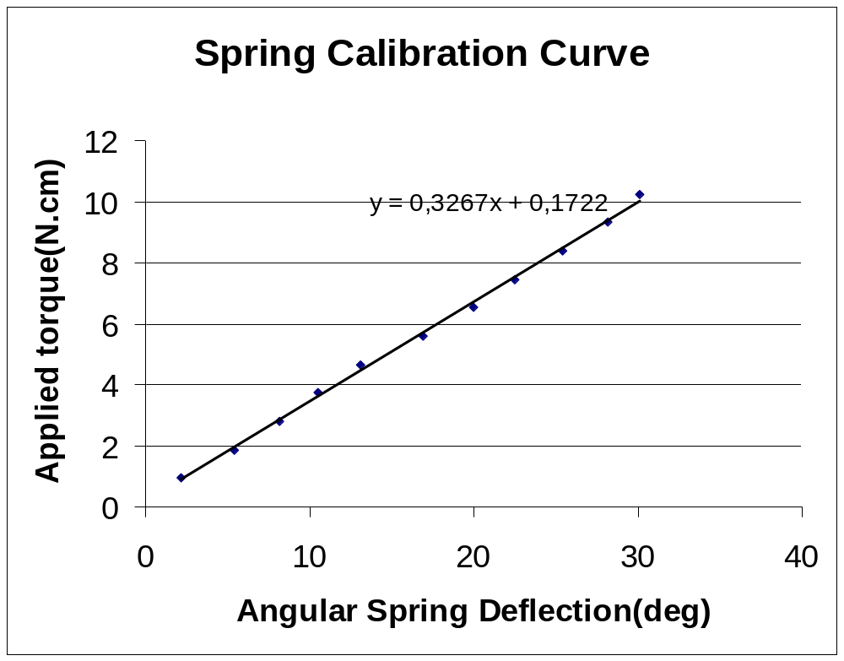

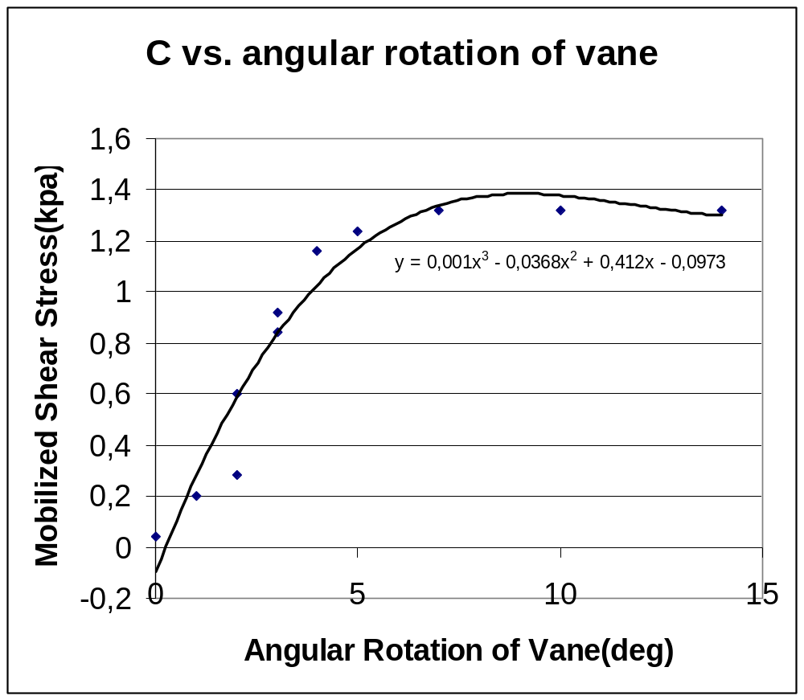

6-DISCUSSION OF RESULTS
This test is used for the determination of the undrained strength of intact, fully saturated clays; the test is not suitable for other types of soil. Generally, this test is only used in clays having undrained strengths less than 100 kN/m²
There are personal factors could affect the accuracy of the test and these personal factors may mislead and change the results. These factors in the laboratory vane test can be listed as; not using a clay sample with consistency corresponding to 35% water content, reading the pointers wrong, timing errors while reading the pointers, and error while turning the handle of vane apparatus. Furthermore there may be computation differences due to the fitting best line to the spring calibration curve and mobilized shear stress(c) vs. angular vane rotation graph. Most of these errors can be reduced by digital and automatic devices.
In engineering uses, shear strength can be calculated for determining the slope stability.

7-CONCLUSION
When vane apparatus used in open air and the handle begins the rotate, there is no spring deflection but only vane rotation. Although when the vane apparatus used in clays have more than 100 kN/m² undrained strengths, there is no vane rotation but only spring deflection. In the test in a clay sample which has less than 100 kN/m² undrained strength, vane rotation happens at the same time with spring deflection. To sum up, in this test we found the peak and residual undrained shear strength of a clay sample and we drawn spring calibration curve and mobilized shear stress(c) vs. angular vane rotation.

8-REFERENCES
- Craig, R. F., Sixth Edition. Soil Mechanics
- Mirata T. (1987) , Laboratory Instructions for Soil Mechanics Students, METU, Ankara 2001

