LIQUID LIMIT TEST

OBJECT:
The object of the liquid limit test is to determine the liquid limit of the air – dried soil, i.e. the moisture content at which a soil passes from the plastic to the liquid state.

APPARATUS:
- Liquid limit device
- Grooving tool
- A glass plate
- Two palette knives
- Moisture content test apparatus
- 400 micron sieve (ASTM No.40)

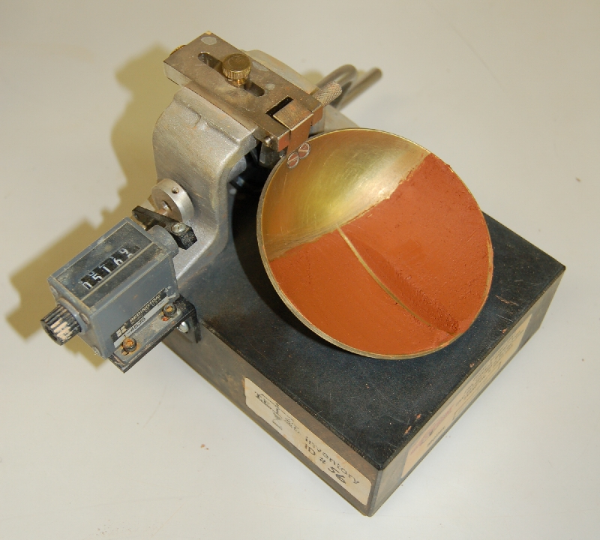
http://www.test-llc.com/liquid_limit_determination.jpg

THEORY:

Moisture content: The quantity of water in a mass of soil, sewage, sludge, or screenings; expressed in percentage by weight of water in the mass.
Liquid limit: The moisture content boundary that exists between the plastic and semi liquid states of sediment.
Plastic Limit: The water content of sediment, such as a soil, at the point of transition between the plastic and semisolid states.

PROCEDURE:

(1) Adjust the height to which the cup of the liquid 1imit device is lifted, so that, when the cup is raised to its maximum height, the 10 mm gauge will just pass between it and the base.
(2) Take at least 200 9 of the air-dried so11 passing the 400 micron sieve, and place it on the glass plate. Add distilled water very slowly, and using the palette knives mix up the soil thoroughly until it becomes a thick, homogeneous paste. Be careful not to add too much water.
(3) A110w the paste to stand in an airtight container for about 24 hours to let the water permeate through the soi1 mass. (NOTE: This step may be omitted for instruction purposes, and for soils of law clay content.)
(4) Place a portion of the soil-water mixture in the cup (the cup resting on the base), and by means of a palette knife, level the surface parallel to the base.
(5) Divide the soil in the cup by drawing the grooving tool along the diameter through the center of the hinge, at the same time holding it normal to the surface of the cup with the chamfered edge facing the direction of movement. (If the ASTM type of grooving tool is used, the excess material, which bulges above the original smoothed surface of the soil, must be scraped off from the upper edges of the groove.)
(6) Turn the crank at the rate of two revolutions per second until the parts of the soil come into contact at the bottom of the groove along a distance of 13 mm. If the number of drops is between 40 and 60 this happens, take about 10 g of the soil from the portions of the sample that have just flowed together, using a palette knife, and place this in a suitable container for subsequent determination of the moisture content (see SML 2(a)).
(7) Repeat operations (2) to (6) at least four times using the same sample to which further increments of distilled water have been added. The amount of water added must be such that when the moisture contents are plotted, they will be evenly distributed over a range between 50 and 10 blows. The test must always proceed from the drier to the wetter condition of the soil (i.e. in no ease must the soil – water mixture be allowed to dry in order to obtain a higher blow count than the one obtained last). Each time the soil is removed from the cup for the addition of more water, the cup and the grooving tool must be cleaned and dried. During testing of the soil in the cup, keep the remainder of the sample covered with a damp cloth to prevent rapid drying.

CALCULATIONS

Mass of moisture= (mass of container + wet soil) – (mass of container + dry soil)

For 50 drops: 22,2-13,78 = 8,42 g
For 31 drops: 23,36-14,21 = 9,15 g
For 20 drops: 23,43-14,11 = 9,32 g

Mass of dry soil = (mass of container + dry soil) – (mass of container)

For 50 drops: 13,78-4,04 = 9,74 g
For 31 drops: 14,21-4,07 = 10,14 g
For 20 drops: 14,11-4,24 = 9,87 g

Moisture Content= 100 * (Mass of moisture/mass of dry soil)

For 50 drops: 100 * (8,42/9,74) = 86,44%
For 31 drops: 100 * (9,15/10,14) = 90,23%
For 20 drops: 100 * (9,32/9,87) = 94,43%

According to the flow curve table, moisture content in 25 drops is 92%

W_{L} = 92%

B. PLASTIC LIMIT TEST
OBJECT:
The object is to determine the plastic limit of the soil, i.e., the minimum moisture content at which the soil can be rolled into a thread 3 mm in diameter without breaking.

APPARATUS:
- A glass plate.
- A palette knife.
- Moisture content apparatus.
- 400-micron sieve.
- A non – corrodible airtight container.

PROCEDURE:
(1) Take about 20 g of the air-dried soil passing the 400 micron sieve, and mix it with distilled water until it can be formed into two balls. Place one of the balls and about three-quarters of the second ball in the airtight container. Apply the following operations to the remaining quarter.
(2) By using the first finger and thumb of each hand, form the quarter of the ball into a thread, about 6 mm in diameter. Then place this thread on the glass plate, and roll it with the tips of the fingers of one hand until its diameter is reduced to 3mm, keeping the rolling pressure constant throughout the test.
(3) Remould the thread between the fingers, and repeat Step (2), until the thread shears both longitudinally and transversely when it has been rolled to a diameter of 3 mm. Place the crumbled soil thread into a suitable container for moisture content determination.
(4) Repeat steps (2) and (3) for each quarter of the same ball, placing the crumbled soil into the same container, and determine the moisture content as a whole.
(5) Repeat steps (2) to (4) for the second ball.
CALCULATIONS:
Mass of moisture= (mass of container + wet soil) – (mass of container + dry soil)

For 1 specimen: 12,7-10,96 = 1,74 g
For 2. specimen: 11,84-9,7 = 2,14 g

Mass of dry soil = (mass of container + dry soil) – (mass of container)

For 1 specimen: 10,36-3,85 = 6,51 g
For 2. specimen: 9,7-3,78 = 5,92 g

Moisture Content= 100 * (Mass of moisture/mass of dry soil)

For 1 specimen: 100 * (1,74/6,51) = 26,73%
For 2. specimen: 100 * (2,14/5,92) = 36,15%

W_{p} = (26,73+36,15) / 2 =31,44%

I _{p} = W_{L} - W_{p} = 60,56%

DISCUSSION OF RESULTS and CONCLUSION:

In liquid limit test we found the liquid limit was 92% When we look at the results of plastic limit test, difference between moisture content of the specimens is 36,15-24,47=11,68% Therefore, the experiment should be repeated because of 11.68%>1%
In this experiment, personal factor of the operator can affect the results because some steps in the procedure should be done properly. For instance, specimen should be placed to Atterberg apparatus carefully. There should be no spaces Upper surface of the specimen should be parallel to the table. Moreover, drops should be done from 1-cm height. If these steps are not done properly, the results may be changed.

REFERENCE:

Lecture Notes
www.answers.com
Mirata, T. (2001) Laboratory Instructions for Soil Mechanics Students, Department of Civil Engineering, METU

Course No: 5620363 Date of Testing: 27.10.2008

No and Title of Test: 3 (a) Atterberg Limit Test

Year and Section: 3, 02 Lab. Group: 4

SURNAME, Other names of Student:

