OBJECT OF EXPERIMENT:
To determine quantitatively the particle size distribution in a soil from the coarse sand size down. The test is not applicable if less than 10% of the material passes the 63 micron (ASTM No.200) sieve as measured by wet or dry sieving ( SML 6 (a) or (b) ).

APPARATUS:
- A hydrometer calibrated to read density (g / ml) at 20˚C, (e.g. ASTM 151 H).
- Two 1000ml graduated glass measuring cylinders about 7cm in diameter and 33cm high, marked at 1000ml volume.
- A thermometer to cover the range 0-50˚C.
- An electrically driven stirrer.
- Test sieve sizes 2.5mm, 630µm, 200µm, 63µm (ASTM No. 8, 30, 70, and 200 respectively), and a receiver.
- A balance readable and accurate to 0.01g.
- A thermostatically controlled drying oven, capable of maintaining a temperature of 105-110˚C.
- A stop watch.
- A desiccator containing anhydrous silica gel.

THEORY:
The particle size distribution is determined by Stoke’s law. According to Stoke’s law, larger particles have bigger velocity.

Stokes Equation:
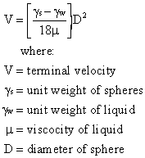

TEST PROCEDURE:
- Of the air-dried soil, obtain by riffling two sub samples weighing 50-100g approximately. The actual amount of soil required will vary according to the type of soil, e.g. 50g with a clay soil and 100g with a sandy soil. Determine the moisture content (ma) of one sample. Weigh the other accurately to the nearest 0.01g (ma), and place in an evaporating dish.
- To the soil in the evaporating dish add 100ml of sodium hexametaphodphate solution, and warm the mixture gently for about 10 minutes.
- Transfer the mixture to the dispersing cup of the mixer, by means of a jet of distilled water from a wash-bottle. Do not use more than 150ml of water for this operation. Then stir the soil suspension for 15 minutes by means of the mechanical mixer.
- Transfer the suspension immediately to the 63 micron test sieve placed on the receiver, and washes the soil on the sieve using a jet of distilled water from the wash-bottle. Take particular care to wash of all traces of suspension adhering to the dispersion cup and buffle wires. Do not use more than 500ml of water for this operation. Transfer the suspension that has passed through the sieve to the 1000ml measuring cylinder and make up to exactly 1000ml with distilled water.
- Transfer the material retained on the 63 micron sieve to an evaporating dish, and dry in the oven at 105-110˚C. After drying, sieve this material on the 2.5mm, 630µm, 200µm, 63µm test sieves. Weigh the material retained on each sieve and recorded the masses (Mg, Mc, Mm, Mf respectively).
- Insert a rubber bung in the mouth of the measuring cylinder, shake this vigorously until a uniform suspension is formed, and finally invert it end over end. Immediately the shaking has ceased, allow the measuring cylinder to stand, and start the stop watch. Immerse the hydrometer to a depth slightly below its floating position, and then allow it to float freely. Take the hydrometer readings after periods of ½, 1, 2 and 4 minutes. Then remove the hydrometer slowly, rinse it in distilled water, and keep it in a cylinder of distilled water at the same temperature as the soil suspension.
- Re-insert the hydrometer in the suspension and take readings after periods of 8, 15 and 30 minutes, 1, 2 and 4 hours after shaking. Remove the hydrometer. Rinse it and place it in distilled water after each reading. In taking all readings, insert and withdraw the hydrometer carefully to avoid disturbing the suspension unnecessarily, allowing about 10 seconds for each operation. After 4 hours’ sedimentation, take readings once or twice daily, noting the exact period of sedimentation.
- Read and record the temperature of the suspension once during the first 15 minutes and then after every subsequent reading, with an accuracy of at least ± 0.5˚C.
- Place exactly 50ml of the dispersing agent solution in a weighed beaker, and place this in the oven at 105-110˚C until the water evaporates. Hence calculate the mass (Md) of dispersing agent. Calculate the dispersing agent correction (x) from the formula:
X = 2M_{d}
This correction should be approximately 4, if the recommended concentration of sodium hexametaphosphate has been used.

CALCULATIONS:
- Mb (given)=50g

- Rh=Rh’+Cm
Rh=17+0.5=17.5( t=1/2 min)
Rh= 16.5+0.5= 17( t=1 min)
Rh=16+0.5=16.5(t=2 min)
Rh=15+0.5=16(t=4 min)
Rh=14.8+0.5=15.5(t= 8min)
Rh=10.8+0.5=11.3(t= 24 hours)

Rh-Hr graph
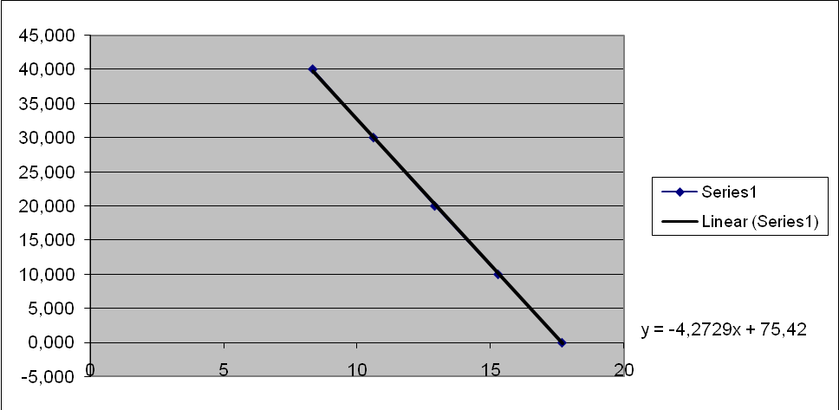

R_{H} H₁ H_{R}
1.040 3.36 83.34
1.030 5.88 10.614
1.020 7.88 12.914
1.010 10.26 15.294
1.000 12.66 17.694

New H_{R}
135.55
136.72
137.89
140.23
140.70

- We found new H_{R} values from the graph(Rh-Hr). Then, we obtained equivalent particle diameter(D) with these H_{R} values by using nomographic chart. Also, we found temperature correction from the nomographic chart (Mt= 0.4)

- K= [100Gs/Mb (Gs-1)]*(Rh+Mt-x)→ percentage finer than D (%)
Elapsed time Rh + Mt - x percentage finer than D = K (%)
½min 17.5+0.40-4=13.9 44.20
1min 17+0.40-4=13.4 42.61
2min 16.5+0.40-4=12.4 39.43
4min 15.5+0.40-4=11.9 37.84
8min 15.3+0.40-4=11.2 35.62
24hours 11.3+0.40-4=7.7 24.49

DISCUSSION OF RESULTS:

In the hydrometer analysis the soil smaller than #200 sieve is placed in suspension and by use of Stokes' equation for the velocity of a free falling sphere the equivalent particle size and percent of soil in suspension are computed.
This test was carried out to determine the particle size distribution of a fine-grained soil. Some factors may change the test results. Thus, we cannot obtain accurate results. People must be careful as the hydrometer is read. Also, time arrangement is very important to read correct values.

CONCLUSION:
This test is used to determine the particles size distribution of the soil particles for fine-grained soils. The hydrometer test uses Stokes equation (for the velocity of a free falling sphere in suspension) to determine grain size distribution smaller than #200 sieve.
REFERENCES:
- Craig R.F.(1997) , Soil Mechanics ,London

- Mirata T. (1997) , Laboratory Instructions for Soil Mechanics Students, METU, Ankara 2001

- Lecture Notes

