Course Name : CE 363 | Date of Testing: 11.12.2009
No. and Title of Test : SML 19 UNCONFINED COMPRESSION TEST
Year and Section: 3rd Year, Section 4 | Lab. Group : 5
SURNAME, Other names of student:

OBJECT
To determine the unconfined compressive strength and hence the undrained shear strength of a saturated clay.

TEST PROCEDURE
- Prepare a specimen by jacking a thin-walled, lubricated core cutter into the soil sample. Then push the specimen out of the core cutter by means of a loose-fitting wooden dolly, and trim it to the required height by placing it inside a trimming tube which is of the right height and has a diameter slightly larger than that of the specimen.
- Take water content and specific gravity samples.
- Weigh the sample and determine its mean diameter and height.
- Place the sample between the loading platens of the testing machine. Adjust the vertical deflection and proving ring dial gauges to zero.
- Apply an axial load at a constant rate of strain, sufficiently slow to permit recording of the strain and the proving ring dial readings at 10-division intervals of the strain dial. Continue until failure occurs.
- Prepare a sketch showing the mode of failure of the specimen, measuring the angle of inclination of the failure plane, if any, to the axis of the specimen.

CALCULATIONS
Values are tabulated in the data sheet.

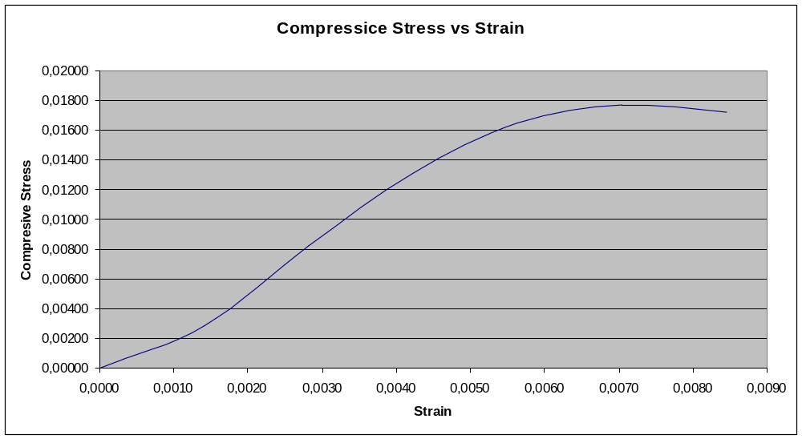

DISCUSSION
Since the experiment was conducted only once. The shear strength parameters could not be calculated.

