Object of the experiment:
- To verify Darcy’s Law and investigate the range over which it applies.
- To determine the coefficient of permeability and its variation with void ratio.
- To observe the occurrence of ′boiling′ and the conditions under which it takes place.

Apparatus:
- Permeameter
- Plastic tubing
- Stop watch
- Water tank

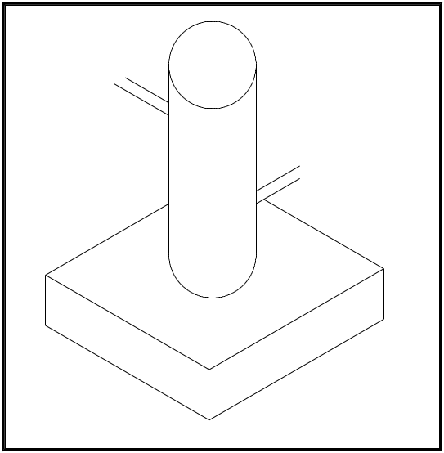

Permeameter

Theory:
In one dimension, water flows through a fully saturated soil in accordance with Darcy’s empirical law:
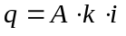 or 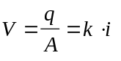
where q = volume of water flowing per unit time, A = cross-section area of soil corresponding to the flow q, k = coefficient of permeability, i = hydraulic gradient, and V = discharge velocity.

The coefficient of permeability primarily depends on the average size of the pores, which in turn is related to the distribution of particle shape and soil structure. In general, the smaller the particles the smaller is the average size of the pores and the lower is the coefficient of permeability.

The coefficient of permeability also varies with temperature, upon which the viscosity of the water depends. If the value of k measured at 20 °C is taken as 100 % then the values at 10 °C and 0 °C are 77 % and 56 % respectively. The coefficient of permeability can also be represented by the equation:
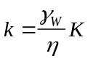
where γ_{w} is the unit weight of water, η is the viscosity of water and K (units m²) is an absolute coefficient depending only on the characteristics of the soil skeleton.

The coefficient of permeability for coarse-grained soils can be determined by means of the constant head permeability test. The soil specimen, at the appropriate density, is contained a perspex cylinder of cross-sectional area A: the specimen rests on a coarse filter or a wire mesh. A steady vertical flow of water, under a constant total head, is maintained through the soil and the volume of water flowing per unit time (q) is measured. Tappings from the side of the cylinder enable the hydraulic gradient (h/l) to be measured. Then from Darcy’s law:
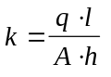

Procedure:
- Determine the specific gravity and the initial water content of the sand.
- Weigh out enough sand to fill the permeameter up to a level of about 5 cm below the top of the permeameter. Stir this sand thoroughly in water in a tray to drive out all free air bubbles.
- Fill the permeameter with water with the porous base plate in position. Using a suitably sized plastic tube, siphon the sand-water mixture into the permeameter and allow the sand to settle uniformly in the cylinder. Add more water to the sand sample if necessary. Then compact this sand as far as possible using the steel rule
- Measure the height of the sample, and the internal diameter of the lucite cylinder.
- Allow air-free water to flow upwards through the sample at a slow rate so as not disturb the sand, and wait until uniform discharge is taking place through the outlet. Measure the rate of discharge and record the temperature of the water at intervals of about 2 cm of difference, h, in head between the stand-pipe tapping point and the top of the sample. Carry on up to a hydraulic gradient of about 0.8, and thereafter, take readings at smaller intervals of difference in head up to critical gradient, i_{c}.
- After boiling has been observed, measure the height of the sample, then reduce the head until the sand settles back and re-measure the height. Reduce the head until the sand settles back and re-measure the height. Reduce the head at wider intervals, measuring the rate of flow and the temperature as before. At the end of the test, take a final measurement of the height of the sample.
- Measure the distance, d, between the stand-pipe tapping point and the top of the porous stone, for determining the effective length, L, of the sample at various stages of the test from a knowledge of the total height, H, of the sample.

Results & Calculations:

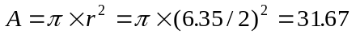cm²
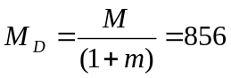 g
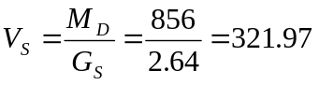ml
The data obtained during the experiment and results obtained by calculations are presented in data sheet SML-21.

Discussion of Results:
As discussed in theory part, there is a positive correlation between velocity and head, and porosity and permeability. But when we examine the graphs obtained, it can be seen that we get increasing and decreasing curves in both. The reason for this result is the boiling process.

Conclusion:
Boiling point is determined. The boiling is done when total stress is equyal to pore water pressure and head pressure. It s when the effective stress is equal to zero.There is no need to do the experiment again

.

References:
- MİRATA, Türker (2001). Laboratory Instructions For Soil Mechanics Students. METU, pp. 60-62

