Object of the experiment: To determine, for an undisturbed saturated, cohesive soil, the relationship between the effective pressure and void ratio and the time-settlement characteristics.

Apparatus:

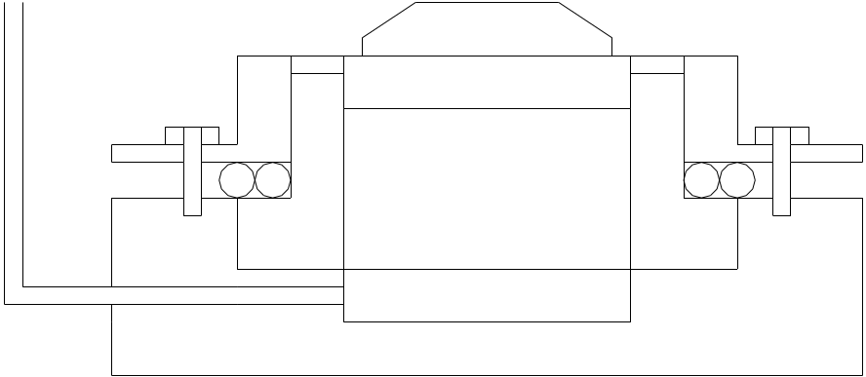

SOILTEST INC. CONSOLIDOMETER

Theory:
Consolidation is the gradual reduction in volume of a fully saturated soil of low permeability due to drainage of some of the pore water, the process continuing until the excess pore water pressure set up by an increase in total stress has completely dissipated.

Method of Test:
- Weigh the consolidometer ring and measure its depth and interval diameter, entering these values in data sheet I. Then extract a specimen by driving a special thin-walled ring ( with the over-drive price attached ) into the undisturbed soil sample, and trim the ends as follows.
  - For the Soiltest Inc. consolidometer, the thickness of the specimen should be slightly less than the depth of the ring in order to accommodate the porous stone. While the specimen is still in the thin walled ring, trim one end, then, using the extruder, push the specimen through the ring for a few millimeters and cut the other end flush with the edge of the ring for a few millimeters and cut the other end flush with the edge of the ring. Measure the height of the specimen and transfer it into the consolidometer ring.
- Take samples for the determination of the specific gravity of the soil.
- Place the specimen with its ring in an evaporating dish and weight.
- With filter paper disc placed on top and bottom of the specimen, assemble the ring in the consolidation cell and mount this on the loading device.
- Adjust the deflection dial to give sufficient trial under the proposed increment of load, and to record a small amount of swelling.
- Loading sequence: Selected pressures 25, 50, 100, 200, 400 kPa. Dial readings are taken at given times in data sheet II.

Results & Calculations:
Data obtained during experiment is presented in data sheet SML 22.

2H₀=M_{S}/(A*G_{S})=83,99/(31,67*2,7)=0,98 cm

ρ_{d}=100*ρ/(100+m₁)=100*1,82/(100+30)=1,40 g/ml

m_{v}=Δe/(100*(1+e₀))=(1,572-1,38)/(100*(1+1,38))=8,06*10⁻⁴

Discussion of Results:
The consolidation test is carried out on undisturbed clay. It is seen in the test that as the applied pressure increases, the void ratio decreases. M_{v} is calculated for a stress increment of 100 kPa in excess of the effective overburden pressure at the depth from which the soil is taken.

Conclusion:
In this test, the characteristics of a soil during one dimensional consolidation or swelling can be determined by means of oedometer test.

References:
- CRAIG, R.F. (1993). Soil Mechanics. 5th edition Chapman & Hall , Britain, pp. 43-47
- MİRATA, Türker (1997). Laboratory Instructions For Soil Mechanics Students. METU, pp. 63-69.

