COURSE: CE 363 | DATE OF TESTING: 19/10/09
NO. AND TITLE OF THE TEST: SML 7(a)

Determination of Particle Size Distribution of Fine-graded Soils by the Hydrometer

YEAR-SECTION: 3/01 | LAB GROUP: 05
SURNAME, NAME:

OBJECT
To determine quantitatively the particle size distribution in a soil from coarse sand size down. The test is not applicable if less than 10% of the material passes the 63micron (ASTM No.200) sieve as measured or dry sieving.

APPARATUS
- A hydrometer calibrated to read density (g/ml) at.
- Two 1000ml graduated glass measuring cylinders about 7 cm in diameter and 33 cm high, marked at 1000 ml volume.
- A thermometer to cover the range.
- An electrically driven stirrer.
- Test sieve sizes 2.5 mm, 630µm, 200µm, 63µm (ASTM No.8, 30, 70, and 200 respectively), and a receiver.
- A balance readable and accurate to 0.01g.
- A thermostatically controlled drying oven, capable of maintaining a temperature of.
- A stop watch.
- A desiccators containing anhydrous silica gel.

THEORY:

Sieving analysis tests are for medium and coarse grained soils so they can not be used for determining the particle size distribution of fine grained soils. Hydrometer test that works by the principle of density rate i.e. change of density with time is an altrnative method. The percentages can be found by the amount of change in density in Δt since the coarser particles settle down faster than the finer particles.

PROCEDURE:

1. Two sub samples of 50-100 g of the air dried soil is obtained by riffling; the actual amount is decided according to the soil type (50 g for clayey, 100 g for sandy). The moisture content of one sample is determined (m_{a}) and the other is weighed to the nearest 0.01 g (M_{a}) and placed in the evaporating dish.
2. 100 ml of sodium hexametaphosphate solution is added to the sample.
3. The mixture is passed to the mixer cup and distilled water is added. After that the suspension is stirred for 15 minutes in mechanical mixer.
4. The suspension is transferred to the 63 μm test sieve, taking care of washing all traces of suspension. The retaining amount is passed to a dish to be dried and sieved weighing retaining amounts on each sieve (M_{G}, M_{C}, M_{M}, M_{F}).
5. The suspension’s passed part is put into a 1000ml graduated cylinder and distilled water is added up to 1000 ml level. The cylinder is shaken till uniform suspension is obtained. After that the stop watch is started immediately and hydrometer is inserted in cylinder to take readings at 30 sec., 1 min, 2 min, 4 min, 8 min, 15 min, 30 min, 1 hrs, 2 hrs, 24 hrs.
6. The temperature is read once for first 15 min., then every subsequent. The hydrometer is rinsed after each reading.
7. The dispersing agent (sodium hexametaphosphate) is involved in calculations so to correct it;
x = 2 M_{d}
is used. The x value is 4 if the reagent is properly prepared.

CALCULATIONS:

M_{b} = M_{a} / (1+ M_{a})
material retained percentage = M_{G} /M_{B} * 100
Calculations necessary for sedimentation stage is done according to the nomographic chart:
R’_{h}: the hydrometer reading at the upper rim of the meniscus.
C_{m}: meniscus correction.
M_{t}: temperature correction given in Fig 2.
x : dispersing agent correction
Corresponding D values are obtained using Stoke’s law chart. Details are explained in labaratory manual in page 35.
K = 100 Gs / (M_{b}*(Gs - 1)) * (Rh + M_{t} - x)

Hr vs. Rh Graph:

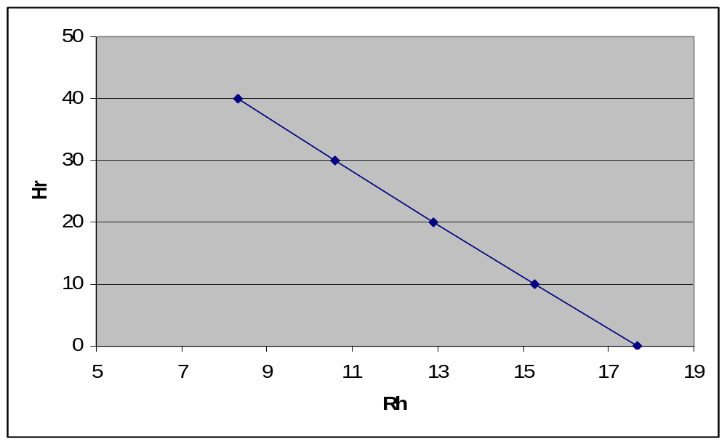

DISCUSSION OF RESULTS:

Although test precedure is carried out properly, the results may not be accurate.
For example temperture is assumed to be constant through out the test.
This test is important because it is only way to derive a distribution graph for soils which classified as clay or silt.

