Course Name : CE 363 | Date of Testing: 24.05.2010
No. and Title of Test :
SML 18(a) UNDRAINED TRIAXIAL TEST WITH OR WITHOUT PORE PRESSURE MEASUREMENT
Year and Section: 3,1 | Lab. Group : 4
SURNAME, Other names of student:

OBJECT
To determine, for unsaturated cohesive soil,shear strength parameters in terms of effective stresses by undrained triaxial tests with pore pressure measurement.

APPARATUS
These instructions are for the use of the ELE triaxial equipment; the general procedure applies for the use of other equipment. A line diagram, similar to that in the figure shown in the laboratory manual page 45.

TEST PROCEDURE
- Slip two rubber O-rings over each end of a suction membrane stretcher. Place a rubber membrane, previously tested for punctures by inflating under water, inside the stretcher, and turn the ends back over the stretcher.
- Prepare a specimen by jacking a thin-walled, lubricated core cutter into the undisturbed sample of the soil to be tested. Then push the specimen out of the core cutter by means of a loose-fitting wooden dolly, trimming it to the required height by placing it inside a trimming tube of the right height and having a diameter slightly larger than that of the specimen. Place two discs, lightly smeared with Vaseline, one at each end off the trimming tube, to prevent drying of the specimen. Collect some of the soil trimmings for determining the specific gravity and the initial moisture content.
- Flush the pore pressure ducts with de-aired, distilled water. Place a porous disc, which has previously been de-aired by boiling under distilled water and kept under water until used, on the cell pedestal, removing the excess water around the pedestal and the porous disc by means of moist filter value. Smear the periphery of the pedestal lightly with castor oil to form a better seal between it and the rubber membrane to be placed around it.
- Measure the height of the specimen, and determine its mass and mean diameter. Mount the specimen on the porous stone on the cell pedestal, and place a top cap, without a top drainage connection smeared lightly with castor oil, on top of the specimen. Applying suction to the membrane stretcher, slip the membrane over the specimen. Then, holding the top cap in position, releases the suction, and slips the ends of the rubber membrane off the stretcher. Finally, roll off the rubber O-rings to grip the ends of the membrane on to the pedestal and the top cap.
- Assemble the triaxial cell and fill this with de-aired, distilled water, keeping the air vent at the top of the cell open during this operation. Enter the ring constant, C_{p} on your data sheet.
- Keeping the valve between the triaxial cell and the constant pressure unit closed, bring up the pressure in this unit to the desired cell pressure, before transferring this pressure to the triaxial cell.
- When the cell pressure is applied, the pore pressure in the specimen will increase, and the mercury level in the fine-bone section of the null indicator will be depressed. Restore the Hg level to its null position, by means of the screw piston of the pore pressure measurement unit. Pore pressure up to about 100 kPa can be measured by means of the mercury manometer. For higher pore pressures, shut off the manometer, and measure the pore pressure by means of the pressure gauge. The level of Hg must be continuously adjusted to its null position during the test.
- Press run key, and set the proving ring dial gauge to zero, thus eliminating the effect of the frictional drag on and the uplift at the end of the cell arm. Then raise the cell until the proving ring just deflects, and set the compression dial to zero. Enter the start time, the initial readings of the compression and proving ring dials, and the initial pore pressure in appropriate columns of the attached data sheet, and start loading. Record the time, proving ring deflection, and the pore pressure.
- Shut off the cell pressure and pore pressure valves; open the air vent at the top of the cell, disconnect the cell pressure lines from the cell, and empty the water from the cell. Dismantle the cell, wiping off the water around the specimen. Then roll the membrane off the specimen, remove and re-weigh the specimen, and prepare a sketch showing the mode of failure.

CALCULATIONS and GRAPH
Mass of specimen : 144 g | Initial area: 1017,87602 mm²
Initial height : 72 mm | Proving ring constant : 0.0748 kg/div.
Initial diameter : 36mm | Cell pressure : 50kPa

Strain dial reading | Strain | Corrected Area | Proving Ring  Deflection | Deviator Load | Deviator Stress
0 | 0 | 1017.876 | 0 | 0 | 0
10 | 0.004 | 1021.480 | 20.000 | 14.676 | 14.367
20 | 0.007 | 1025.109 | 110.000 | 80.717 | 78.740
30 | 0.011 | 1028.764 | 190.000 | 139.420 | 135.522
40 | 0.014 | 1032.445 | 245.000 | 179.778 | 174.128
50 | 0.018 | 1036.153 | 290.000 | 212.799 | 205.374
60 | 0.021 | 1039.887 | 323.000 | 237.014 | 227.922
70 | 0.025 | 1043.648 | 350.000 | 256.826 | 246.085
80 | 0.028 | 1047.437 | 373.000 | 273.703 | 261.307
90 | 0.032 | 1051.253 | 390.000 | 286.177 | 272.225
100 | 0.035 | 1055.098 | 405.000 | 297.184 | 281.665
110 | 0.039 | 1058.970 | 415.000 | 304.522 | 287.564
120 | 0.042 | 1062.871 | 423.000 | 310.392 | 292.032
130 | 0.046 | 1066.801 | 431.000 | 316.263 | 296.459
140 | 0.049 | 1070.760 | 439.000 | 322.133 | 300.845
150 | 0.053 | 1074.748 | 448.000 | 328.737 | 305.874
160 | 0.056 | 1078.766 | 456.000 | 334.607 | 310.176
170 | 0.060 | 1082.815 | 463.000 | 339.744 | 313.760
180 | 0.064 | 1086.894 | 469.000 | 344.147 | 316.633
190 | 0.067 | 1091.004 | 475.000 | 348.549 | 319.476
200 | 0.071 | 1095.145 | 480.000 | 352.218 | 321.618
220 | 0.078 | 1103.522 | 490.000 | 359.556 | 325.826
240 | 0.085 | 1112.028 | 496.000 | 363.959 | 327.293
260 | 0.092 | 1120.666 | 501.000 | 367.628 | 328.044
280 | 0.099 | 1129.440 | 506.000 | 371.297 | 328.744
300 | 0.106 | 1138.352 | 510.000 | 374.232 | 328.749
320 | 0.113 | 1147.405 | 513.000 | 376.433 | 328.073
340 | 0.120 | 1156.604 | 515.000 | 377.901 | 326.733
360 | 0.127 | 1165.952 | 516.000 | 378.635 | 324.743
380 | 0.134 | 1175.452 | 518.000 | 380.102 | 323.367
400 | 0.141 | 1185.108 | 519.000 | 380.836 | 321.351
420 | 0.148 | 1194.924 | 519.000 | 380.836 | 318.711
440 | 0.155 | 1204.904 | 518.000 | 380.102 | 315.463
460 | 0.162 | 1215.052 | 510.000 | 374.232 | 307.997

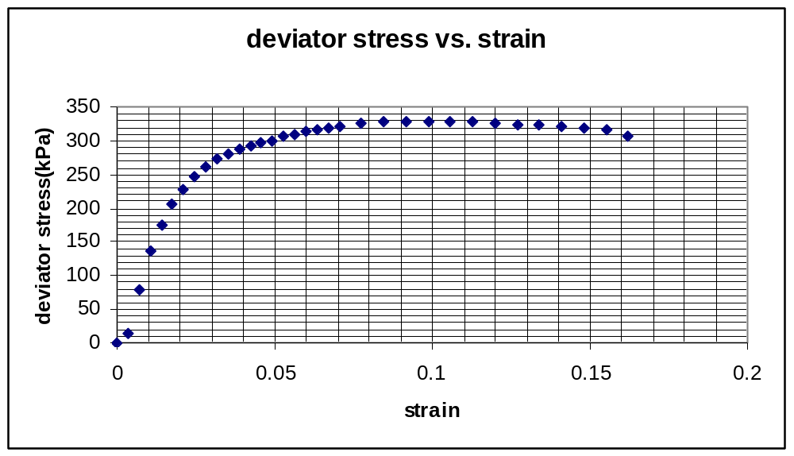

DISCUSSION
It was undrained-unconsolidated experiment. The proving ring deflections were recorded according to the specific strain dial readings and strain, corrected area, deviator load and deviator stress values were calculated by using them. Pore pressure gauge value readings and pore pressure changes were not measured and calculated since it was undrained experiment. Moreover, since just one measurement was carried out, it is not possible to calculate the shear strength parameters.

REFERENCES
Mirata, Türker (2001). Laboratory Instructions for Soil Mechanics Students. Middle East Technical University.

