Course Name : CE 363 | Date of Testing: 10.05.2010
No. and Title of Test : SML 21 Constant Head Permeameter
Year and Section: 3rd Year, Section 1 | Lab. Group : 4
SURNAME, Other names of student:

OBJECT
- To verify Darcy’s Law and investigate the range over which it applies.
- To determine the coefficient of permeability and its variation with void ratio.
- To observe the occurrence of “boiling” and the conditions under which it takes place.

APPARATUS
Sand specimen
Porous disk
Measuring cylindering
Outlet pipe
Water tank
Stand pipe

THEORY
Coefficient of permeability is constant which is being used for seepage calculations, calculating the amount of water seeping through a section per unit time. The coefficient of permeability for coarse grained soils can be obtained by constant head permeability test. In this test a steady vertical flow of water is obtained, q is detected, hydraulic gradient (h/l) is measured from the cylinder containing soil sample and head difference. As a result, coefficient of permeability, k, is computed via following formula:

TEST PROCEDURE
- Determine the specific gravity and the initial water content of the sand.
- Weigh out enough sand to fill the permeameter up to a level of about 5 cm below the top of the permeameter. Stir this sand thoroughly in water in a tray to drive out all free bubbles.
- Make sure that no air bubbles are trapped in the plastic tubing. Then fill the permeameter with water the porous base plate in position. Using a suitable sized plastic tube, siphon the sand-water mixture into the permeameter, allowing the sand to settle uniformly in the cylinder while the excess water flows into a large tray placed under the permeameter. Pour more water into the tray containing the sand sample if necessary. The sand so deposited is in a very loose state. Compact this sand as far as possible using the steel rule. Measure the height of the sample, and the internal diameter of the lucite cylinder.
- Allow air-free water to flow upwards through the sample at a slow rate so as to disturb the sand, and wait until uniform discharge is taking place through the outlet. Measure the rate of discharge and record the temperature of the water at intervals of about 2 cm of difference, h, in head between the stand-pipe tapping point and the top of the sample. Carry on up to a hydraulic gradient of about 0.8, and thereafter, take readings at smaller intervals of difference in head up to the critical gradient, i_{c}.
- After boiling has been observed, measure the height of the sample, then reduce the head until the sand settles back and re-measure the height. Reduce the head at wider intervals, measuring the rate of flow and the temperature as before. At the end of the test, take a final measurement of the height of the sample.
- Measure the distance, d, between the stand-pipe tapping point and the top of the porous stone, for determining the effective lengths, L, of the sample at various stages of the test from a knowledge of the total height, H, of the sample.

CALCULATIONS and GRAPHS
M | m | Md | Gs | Vs | A | d
850 | 0 | 850 | 2.65 | 320.7547 | 30.68 | 2
Condition | Ht. Of Sample  H | Total Volume  V | Volume of voids  Vv | Porosity (n) | Permeability
Initial | 21.18 | 649.8024 | 329.0477 | 0.5064 | 0.2501
During boiling | 23 | 705.64 | 384.8853 | 0.5454 | 0.4671
After boiling | 22 | 674.96 | 354.2053 | 0.5248 | 0.3333
At the end of test | 22 | 674.96 | 354.2053 | 0.5248 | 0.3333
Discharge  Q(ml/s) | Velocity  V(cm/s) | Head  h (cm) | H(cm) | L (cm) | i=h/L
2 2/5 | 0.0782 | 6 | 21.18 | 19.18 | 0.3128
11 3/5 | 0.3781 | 17 | 23 | 21 | 0.8095
4 11/20 | 0.1483 | 8.9 | 22 | 20 | 0.4450
4 11/20 | 0.1483 | 8.9 | 22 | 20 | 0.4450
kt=V/i | Temp. | k20
0.2501 | 20 | 0.2501
0.4671 | 20 | 0.4671
0.3333 | 20 | 0.3333
0.3333 | 20 | 0.3333

For 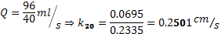
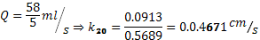
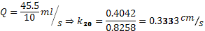
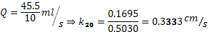

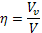

Initial n=259.65/573.72=0.4526, k20=0.2978
Then, we calculate for other conditions.

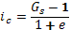
All calculations are on the table.

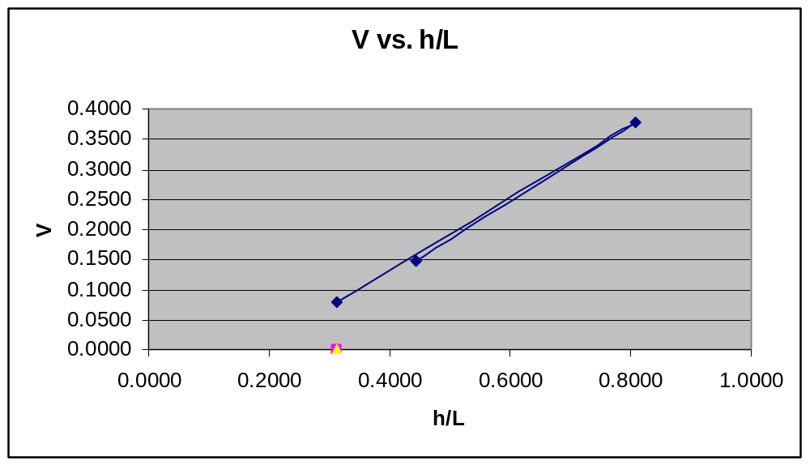

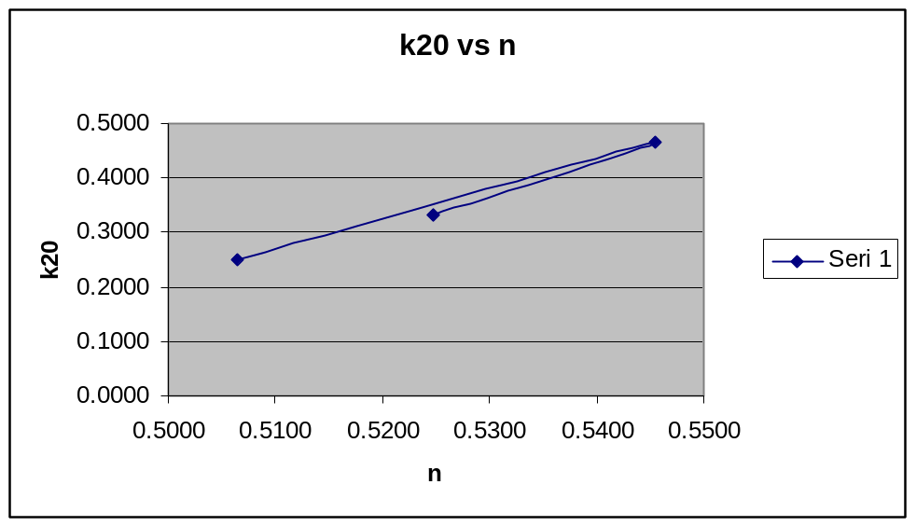

DISCUSSION
The k_{t} values are equal to the k₂₀ values due to the fact that the relative viscosity is 1.0 at 20ºC and the temperature is constant during the experiment. Also, two graphs are plotted according to data obtained. For increasing head, the hydraulic gradient increases, as permeability coefficient decreases and for decreasing head, hydraulic gradient decreases as permeability coefficient increases. Moreover, the measured value of the hydraulic gradient at the start of boiling is almost same with the theoretical value.

REFERENCES
Mirata, Türker (2001). Laboratory Instructions for Soil Mechanics Students. Middle East Technical University.

