Course Name : CE 363 | Date of Testing: 10.05.2010
No. and Title of Test : SML 22 Consolidation Test on An Undisturbed Clay
Year and Section: 3rd Year, Section 1 | Lab. Group : 4
SURNAME, Other names of student:

OBJECT
The object of this experiment is to determine, for an undisturbed saturated, cohesive soil, the relationship between the effective pressure and void ratio and the time-settlement characteristics.

APPARATUS
Specimen
Loading Cap
Porous stone
Porous stone
Standpipe
Force

THEORY
Consolidation is the reduction of a fully saturated soil of low permeability due to the drainage of pore water, until the excess pore pressure set up by an increase in total stress has dissipated. The void ratio vs. pressure graph gives us the coefficients and characteristics of the consolidation. To find C_{V} the following expression is used:

TEST PROCEDURE
- Weigh the consolidometer ring and measure its depth and internal diameter. Then extract a specimen by driving a special, thin-walled ring into the undisturbed soil sample, and trim the ends.
- Take samples for the determination of the specific gravity of the soil.
- Place the specimen with its ring in an evaporating dish and weigh.
- With filter paper discs placed on top and bottom.
- Adjust the deflection dial to give sufficient travel under the proposed increment of load, and to record a small amount of swelling.
- The sequence of loading was selected as 25, 50, 100 kPa. After recording the initial dial reading, the pressure was applied and the stopwatch was started. And, compression readings were taken.

CALCULATIONS and GRAPHS
Data obtained during experiment and results of the calculations are presented in attached data sheet.

Mass of water: Initial : 651.69-636.13=15.56g
Final : 654.64-639.08=15.56
2H₀=M_{S}/(A*G_{S})cm
ρ_{d}=100*ρ/(100+m₁) g/ml

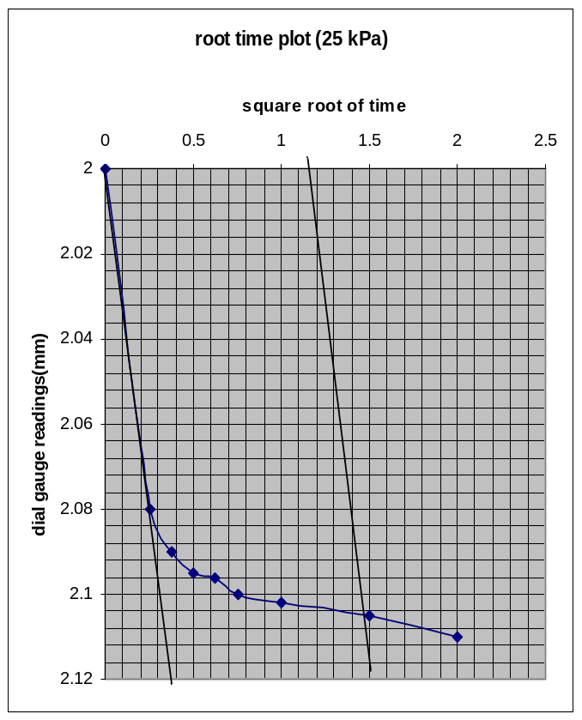

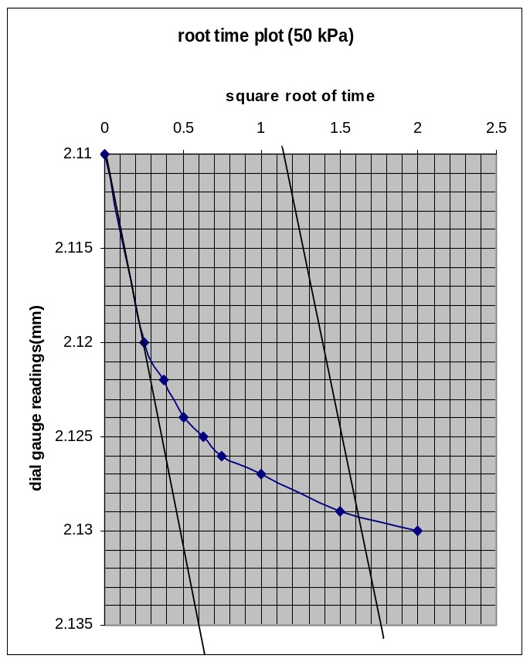
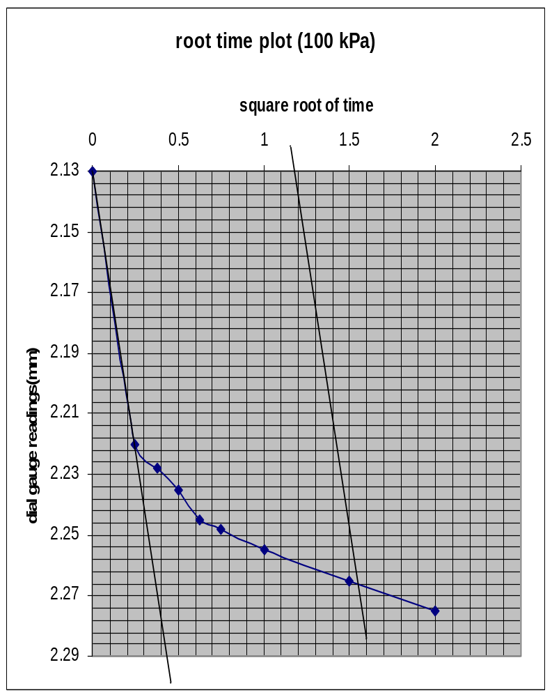

Cv=0.848*(H^2)/t90
m_{v}=-de/(100*(1+e₀))=0.012/(100*(1+0.541)=7.79*(10^(-5))
Calculations of Cv are on data sheet III.

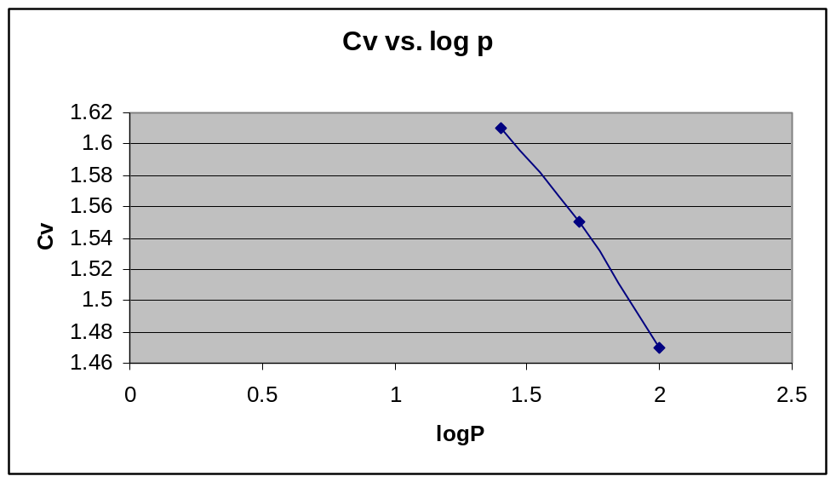

DISCUSSION
At the end, the degree of saturation and void ratio decreased. Also, while the applied pressure was getting bigger, the t₉₀ increased and C_{v} decreased. However, there may be some errors during calculating data.

REFERENCES
Mirata, Türker (2001). Laboratory Instructions for Soil Mechanics Students. Middle East Technical University.

