Course No: 5620363 Date of Testing: 13.10.2010

No and Title of Test: 8 (a) Determination of Dry Density/Moisture Content Relation by the 2.5 kg Rammer (Standard Proctor Compaction Test)

Section: 03 Lab. Group: 1

SURNAME, Other names of Student:

OBJECT OF EXPERIMENT:

The object is to determine the dry densities of soil when compacted in a specified manner over a range of moisture contents including that giving the maximum dry density

APPARATUS:

1. Proctor compaction mould, with removable base plate and collar.
2. A 2.5 kg rammer, with a suitable arrangement for controlling the drop to 300 mm
3. A balance readable and accurate to 1.0 g.
4. A palette knife.
5. A metal straightedge
6. A 20 mm test sieve and a receiver
7. A large metal tray.
8. Apparatus for moisture content determination.
9. Apparatus for extracting specimens from the mould.

THEORY:

- Soil compaction is defined as the method of mechanically increasing the density of soil.

- The degree of compaction is measured by dry unit weight and depends on the water content and comp active effort (weight of hammer, number of impacts, weight of roller, and number of passes). For a given compactive effort, the maximum dry unit weight occurs at optimum water content.

Dry density; p_{d}= (100*p) / (100+m) g/ml

PROCEDURE and METHOD OF TEST

- For soils not susceptible to crushing during compaction

- Take a 5 kg sample of air-dried soil passing the 20 mm test sieve and mix thoroughly with a suitable amount of water depending on the type of soil.

- Smear the inside of the compaction mould lightly with Vaseline .Then weigh the mould with base-plate attached. Place the mould on a solid base and compact the moist soil into the mould in three layers of approximately equal mass giving each layer 25 blows of the rammer dropped from a height of 300 mm above the soil. See that the blows are distributed uniformly over the surface of each layer and that the tube of the rammer is kept clear of soil so that the rammer always falls freely. The amount of soil used must be sufficient to fill the mould leaving not more than 6 mm to be struck off when the collar is removed. Remove the collar and carefully level off the compacted soil to top of the mould by means of the straightedge. Then weigh the mould and soil.

- Remove the compacted soil specimen from the mould and place on the large metal tray. Take a representative sample of the specimen and determine its moisture content.

- Break up the remainder of the soil specimen rub through the 20 mm sieve and mix the remainder of the original sample. Add suitable increments of water and mix into the sample. Then repeat the above procedure from operations (2) to (4) for each increment of water added. The total number of determinations made must be at least five and the range of moisture contents should be such that the optimum moisture content at which the maximum dry density occurs is within that range.

- For soils susceptible to crushing during compaction

- Take five or more 2.5 kg samples of air-dried soil passing the 20 mm test sieve. Mix the samples thoroughly each with a different amount of water to give a suitable range moisture contents. The range of moisture contents should be such that the optimum moisture content at which the maximum dry density occurs is within that range.

- Treat each sample as in (a) (2) above

- Treat the compacted specimen as in (a) (3) above

- Discard the remainder of each soil specimen

CALCULATIONS:

DENSITY

- Mass of compacted specimen(M₂-M₁);

- 4950-3673=1277g
- 5165-3673=1492g
- 5325-3673=1652g
- 5500-3673=1827g
- 5430-3673=1757g

- Bulk density (p=(M₂₋M₁)/V) ;

- 1277/943= 1.35 g/ml
- 1492/943= 1.58 g/ml
- 1652/943= 1.75 g/ml
- 1827/943= 1.94 g/ml
- 1757/943= 1.86 g/ml

- Dry density [p_{d}=100*p/(100+m)]

- 100*1.35/(100+5.78)=1.276 g/ml
- 100*1.58/(100+12,12)=1.409 g/ml
- 100*1.75/(100+18.07)=1.482 g/ml
- 100*1.94/100+25.16) = 1.550g/ml
- 100*1.86/(100+31.45)=1.415g/ml

MOISTURE CONTENT

- Mass of moisture=(Container+wet sample)-(container+dry sample)

1. 37.99-36.66=1.33 g
2. 27.75-26.30=1.45 g
3. 32.13-29.41=2.72 g
4. 38.69-33.69=5.00 g
5. 35.77-30.77=5.00 g

- Dry mass= (container+dry sample)-container

36.66-13.66=23.00g
26.30-14.34=11.96g
29.41-14.36=15.05g
33.69-13.82=19.87g
30.77-14.87=15.90g

- Moisture content= 100*(mass of moisture/dry mass)

100*(1.33 /23.00) = 5.78%
100*(1.45 /11.96) = 12, 12%
100*(2.72 /15.05) = 18.07%
100*(5.00/19.87) = 25, 16%
100*(5.00/15.90) = 31.45%

AIR VOID CURVES

P_{d}=G_{s}*P_{w}*(1-V_{a}/V_{t})/ (1+mG_{s})

m: 5.78 12,12 18.07 25.16 31.45
Air voids

V_{a}/V_{t}=0% 2.298 2.006 1.792 1.590 1.445
V_{a}/V_{t}=5% 2.183 1.905 1.702 1.511 1.373
V_{a}/V_{t}=10% 2.068 1.805 1.613 1.431 1.301

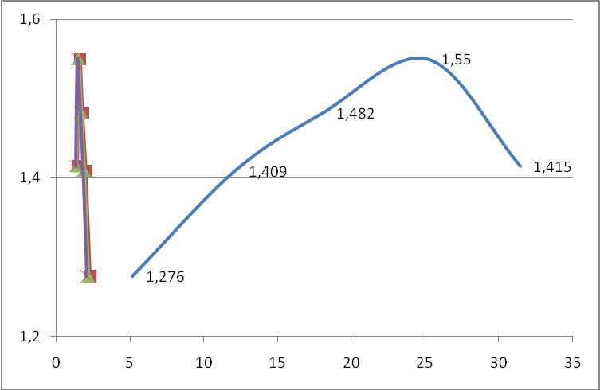

DISCUSSION OF RESULTS:

Soil compaction occurs when soil particles are pressed together, reducing pore space between them. Soil compaction changes pore space size, distribution, and soil strength. One way to quantify the change is by measuring the bulk density which is obtained in this test. As the pore space is decreased within a soil, the bulk density is increased.
In this test, the personal factor may change the test results when hammering the specimen. Changing the results has some effects on the soil particles such as pore space size and distribution.
After compaction, the dry density of soil particles depends on the moisture content. We obtain maximum dry density at the level of high moisture content because most of the air is removed from the soil.

CONCLUSION:

We find the dry density and moisture content of the sample. We draw the dry density-moisture content graph. Lastly, we find the maximum dry density and optimum moisture content.
Maximum dry density= 1.550 g/ml
Optimum moisture content=25.16%

REFERENCES:

Mirata T. (1980) , Laboratory Instructions for Soil Mechanics Students, METU Press, Ankara (reprinted in 2009)
www.eoearth.org/article/Soil_Compaction
www.royalmachinery.in
www.environment.uwe.ac.uk

