Course No: 5620363 Date of Testing: 16.12.2011

No and Title of Test: 18 (a), Undrained Triaxial Test with or without Pore Pressure Measurement

Year and Section: 3, 05 Lab. Group: 3

SURNAME, Other names of Student:

Object

The object of this experiment is to determine, for an unsaturated cohesive soil, the shear strength parameters in terms of effective stresses by undrained triaxial tests with pore pressure measurement.

Theory

Strain: A change in the form or shape of a body or material, which is subjected to an external force.

In this test-proving ring deflections are recorded according to strain dial reading. After that strain, corrected area, deviator load and deviator stress are calculated.

Procedure

1. Four spherical flasks are filled up to just under half with water, and a vacuum is applied in order the water be de-aired.
2. A specimen is prepared by jacking a thin walled, lubricated core cutter into the undisturbed soil sample. After that, the specimen is pushed out of the cutter via a loose-fitting wooden dolly, and trimmed to the required height by placing into a trimming tube with the right dimensions. Then, two lightly greased discs (one at each end of the trimming tube) is placed to prevent the specimen from drying. Finally, some of the soil is collected for moisture content and specific gravity determinations.
3. The Perspex pedestal with its inlaid porous stone (a coarse one) into a bowl of de-aired water. The stone and the connected tubes are saturated by applying a 30-kPa vacuum to the system. Having this done, the vacuum is removed followed by the pedestal being taken out of the water and the vacuum lines being disconnected.
4. After having the pore pressure adjusted, the soil specimen’s height is measured, and its mean diameter and mass are found out. Two rubbers 0–rings are slipped over each end of a suction membrane stretcher. A rubber membrane is placed inside the stretcher and the ends are turned back over the stretcher. The specimen is mounted on the cell pedestal, and cellophane is placed on top of the specimen in order to isolate it from the porous stone placed on the top of cap. The membrane is slipped as suction is applied to the membrane stretcher. Then, the suction is released; keeping the top cap in position and the ends of the membrane is slipped off the stretcher. Finally, the rubber 0–rings is rolled off to grip the ends of the membrane onto the caps at two ends.
5. Next, the triaxial cell is assembled and water is filled by applying a small pressure to the storage chamber’s top, while the valve is kept in the top cover of the cell open along this process. Then the pressure is removed and the valve is closed.
6. The pressure in the storage chamber is adjusted to the required cell pressure by keeping the valve closed and then this pressure is transferred to the triaxial cell by opening the valve. In this way by restoring the mercury to its original level (i.e. preventing any drainage from the specimen) this adjustment is kept on till the pore pressure gets a steady pressure.
7. The speed regulator is adjusted with a suitable output shaft of the reducer gear coupled with the triaxial machine drive, in order to give the required strain rate. After that, the motor drive is switched on, and the dial gauge on the proving ring is set to zero. This action automatically compensates for the upward thrust on the ram due to the cell pressure as well as for any frictional drag. Contact between the ram and the top of the sample is indicated by the dial gauge to zero, and the test is ended by re–starting the motor. The time, the proving ring deflection are recorded at intervals of 20 divisions thereafter, till the sample fails. The readings are recorded in the suitable columns of the attached data sheet.
8. At the end of the test; the axial load is simply removed by reverse process. Then, by hand-pump the pore pressure is set to zero, followed by the cell pressure is reduced.
9. The cell water is transferred back into storage chamber by applying a small pressure to the top of the cell. The apparatus is dismantled, the specimen is re-weighed, and two samples are taken so as to determine the final water content and a sketch showing the failure mode is drawn.

Calculations

Strain dial reading | Strain | Corrected Area | Proving Ring  Deflection | Deviator Load | Deviator Stress
0 | 0 | 1017.876 | 0 | 0 | 0
5 | 0.002 | 1019.675 | 75.000 | 71.368 | 69.991
10 | 0.004 | 1021.480 | 126.000 | 119.898 | 117.377
15 | 0.005 | 1023.291 | 173.000 | 164.622 | 160.875
20 | 0.007 | 1025.109 | 215.000 | 204.588 | 199.576
25 | 0.009 | 1026.933 | 257.000 | 244.553 | 238.140
30 | 0.011 | 1028.764 | 293.000 | 278.810 | 271.015
35 | 0.012 | 1030.601 | 334.000 | 317.824 | 308.387
40 | 0.014 | 1032.445 | 374.000 | 355.887 | 344.703
45 | 0.016 | 1034.295 | 408.000 | 388.241 | 375.367
50 | 0.018 | 1036.153 | 441.000 | 419.642 | 405.001
55 | 0.019 | 1038.016 | 473.000 | 450.093 | 433.608
60 | 0.021 | 1039.887 | 497.000 | 472.930 | 454.790
65 | 0.023 | 1041.764 | 523.000 | 497.671 | 477.720
70 | 0.025 | 1043.648 | 544.000 | 517.654 | 496.004
75 | 0.026 | 1045.539 | 559.000 | 531.928 | 508.759
80 | 0.028 | 1047.437 | 574.000 | 546.201 | 521.464
85 | 0.030 | 1049.342 | 586.000 | 557.620 | 531.400
90 | 0.032 | 1051.253 | 594.000 | 565.233 | 537.675
95 | 0.034 | 1053.172 | 603.000 | 573.797 | 544.827
100 | 0.035 | 1055.098 | 608.000 | 578.555 | 548.342
105 | 0.037 | 1057.030 | 613.000 | 583.312 | 551.841
110 | 0.039 | 1058.970 | 617.000 | 587.119 | 554.424
115 | 0.041 | 1060.917 | 621.500 | 591.401 | 557.443
120 | 0.042 | 1062.871 | 625.000 | 594.731 | 559.552
125 | 0.044 | 1064.832 | 626.000 | 595.683 | 559.415
130 | 0.046 | 1066.801 | 627.000 | 596.634 | 559.274
135 | 0.048 | 1068.777 | 627.000 | 596.634 | 558.241
140 | 0.049 | 1070.760 | 627.000 | 596.634 | 557.207

Calculations for the first row
Strain=0.002= 0.0254*5/72
Corrected Area = (18^2*PI())/(1-0.002) = 1019.675
Deviator Load = 0.097*75*9.81 = 71.368
Deviator Stress = (71.368*0.001)/(1019.675*0.000001) = 69.991
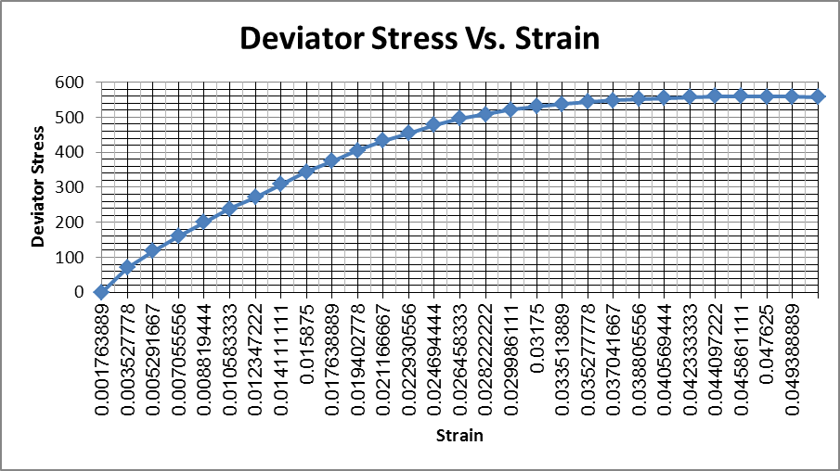

Discussion of Results

In this experiment we were supposed to use a new machine which gave all the results in a digital way so the errors due to personal factors were neglected. But due to some problems with the machines we did the experiment in the old one. So some of the stuff should be done properly to obtain more accurate values for example water should not be contacted with the specimen because if it does moisture content of the specimen will increase, the measurements should be read from directly across it (reading it from an angle changes it a lot). The values of strain and deflection were read through the experiment. It took about 15 minutes and the results obtained were logical, so we can say that during the experiment no big errors appeared. From the values obtained strain, corrected area, deviator load & deviator stress was calculated. From those values Deviator stress vs strain diagram was plotted.

Conclusion

In conclusion the results we obtained were all reasonable, through the plotted graph we can say that the stress has no trouble increasing at the beginning but after sometime it stops at some point and starts to decrease. We calculated this point around 559.5 Kpa.

References

Mirata, T. (2009) Laboratory Instructions for Soil Mechanics Students, Department of Civil Engineering, METU

