Course No: 5620363 Date of Testing: 02.12.2011

No and Title of Test: 19, Unconfined Compression Test

Year and Section: 2011/5 Lab. Group: 3

SURNAME, Other Names:

Object

The object of this test is to determine the unconfined compressive strength and hence, the undrained shear strength of saturated clay. (Non-fissured)

Apparatus

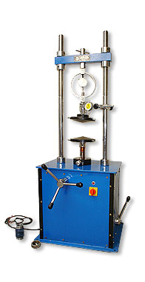

http://www.accrotechscientific.com/pcat-gifs/products-small/soil.jpg

Theory

Strain: A change in the form or shape of a body or material which is subjected to an external force.

In this test proving ring dial is obtained according to value of strain dial. After that axial load and corrected area are calculated then compressive stress of the specimen is calculated. (P/A)

Procedure

- Prepare a specimen by jacking a thin-walled, lubricated core cutter into the soil sample. Then push the specimen out of the core cutter by means of loose-fitting wooden dolly, and trim it to the required height by placing it inside a trimming tube which is of the right height and has a diameter slightly larger than that of the specimen
- Take water content and specific gravity samples.
- Weigh the sample and determine its mean diameter and height
- Place the sample between the loading platens of the testing machine, Adjust the vertical deflection and proving ring dial gauges to zero
- Apply an axial load at a constant rate of strain, sufficiently slow to permit recording of the strain and the proving ring dial readings at 10-division intervals of the strain dial. Continue until failure occurs.
- Prepare a sketch showing the mode of failure of the specimen, measuring the angle of inclination of the failure plane, if any to the axis of the specimen
- Repeat the test for two more specimens.

Calculations and Graph

Strain ε = δ₁/h₀

Corrected Area A = A₀ / 1-ε

Axial Load P = C_{p} . δ_{2 ббб}

Compressive Stress P/A б

g=125.5

h₀ = 72 mm

d₀ = 36 mm

A₀ = 1017.876 mm^2

W% = 15%

δ1 | ε | A | δ2 | P | P/A
0.00E+00 | 0.00E+00 | 1.02E+03 | 0.00E+00 | 0.00E+00 | 0.00E+00
1.00E+01 | 1.39E-03 | 1.02E+03 | 2.50E+00 | 1.68E-02 | 1.65E+01
2.00E+01 | 2.78E-03 | 1.02E+03 | 6.00E+00 | 4.03E-02 | 3.95E+01
3.00E+01 | 4.17E-03 | 1.02E+03 | 1.05E+01 | 7.06E-02 | 6.90E+01
4.00E+01 | 5.56E-03 | 1.02E+03 | 1.25E+01 | 8.40E-02 | 8.21E+01
5.00E+01 | 6.94E-03 | 1.02E+03 | 1.50E+01 | 1.01E-01 | 9.83E+01
6.00E+01 | 8.33E-03 | 1.03E+03 | 1.80E+01 | 1.21E-01 | 1.18E+02
7.00E+01 | 9.72E-03 | 1.03E+03 | 1.85E+01 | 1.24E-01 | 1.21E+02
8.00E+01 | 1.11E-02 | 1.03E+03 | 1.90E+01 | 1.28E-01 | 1.24E+02
9.00E+01 | 1.25E-02 | 1.03E+03 | 1.90E+01 | 1.28E-01 | 1.24E+02
1.00E+02 | 1.39E-02 | 1.03E+03 | 1.90E+01 | 1.28E-01 | 1.24E+02
1.10E+02 | 1.53E-02 | 1.03E+03 | 1.90E+01 | 1.28E-01 | 1.24E+02
1.20E+02 | 1.67E-02 | 1.04E+03 | 1.90E+01 | 1.28E-01 | 1.23E+02
1.30E+02 | 1.81E-02 | 1.04E+03 | 1.90E+01 | 1.28E-01 | 1.23E+02
1.40E+02 | 1.94E-02 | 1.04E+03 | 1.90E+01 | 1.28E-01 | 1.23E+02

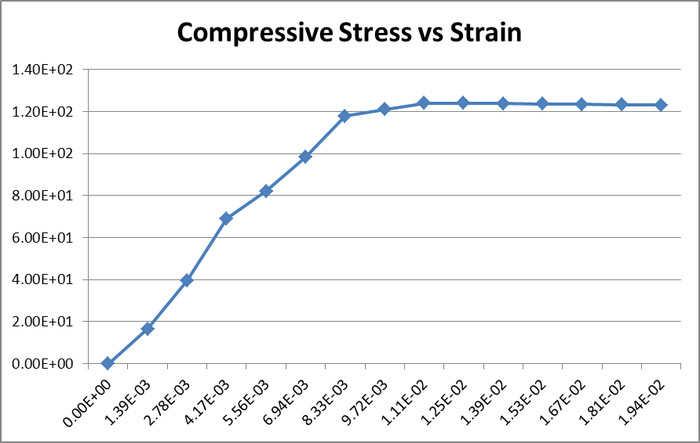

= 124,05

= = 62,03

Discussion of Results

Some factors of the person doing the test can affect the results significantly so the test should be done properly. For example while putting the specimen in the machine it should be done properly otherwise huge mistakes might happen in this test. Before the test starts no force should be applied to the specimen. Also the person reading the data might have read it wrong or while recording it could be said or heard wrong, to avoid these kinds of simple mistakes digital devices could be used, since they give more accurate results our experiment will also be more accurate.

Conclusion

Strain dial and proving ring dial values are obtained as shown above δ1 & δ2. Then strain, corrected area, axial load and compressive stress values are calculated (ε, A, P, б). At the end unconfined compressive strength & undrained shear strength were calculated. (,)

References

Mirata, T. (2009) Laboratory Instructions for Soil Mechanics Students, Department of Civil Engineering, METU

