Course No. : CE363 | Date of Testing : 9.12.2011
No. And Title of Test : (20) Direct Shear Box Test on Sand
Year and Section : 2011/5 | Lab Group : 3
SURNAME , Other names : YILMAZ, Demir Berkay

Direct Shear Box Test on Sand

Object of The Experiment:

The object of this experiment is to determine the drained shear strength and the stress-Strain characteristics of a sample of remoulded sand by means of the direct shear box test.

Apparatus:

- Shear test box(Fig.1)
- Loading machine
- 3, 16kg weights
- dial gauge
- shear motor

Verticle def. dial
Loading plate
Box
T
Shear displacement dial

Failure plane

Specimen

Proving
Ring Fig.1.Shear test box

Theory:

Shear strength of a specific soil can be found by means of laboratory test on representative specimens. The shear strength was originally introduced by Coulomb as a linear function of normal stress on a plane at the same point.
τ_{f}= c+ σ_{f}tanϕ
where c and ϕ are cohesion intercepts and angle of shearing resistance respectively. Also according to Terzaghi shear strength can be expressed as:
τ_{f}= c’+ σ_{f}’ tanϕ’
where c’ ϕ’ are parameters of effective stress. So, failure occurs at points where there is a critical combination of shear and effective stress.

The plane in which failure occurs is determined by drawing a common tangent on circles drawn according to Mohr's-Coulomb principles.

The strength of a clay in terms of effective stress can be determined by means of either the consolidated-undrained triaxial test with pore pressure measurement during the undrained part of the test, or the drained triaxial test. The undrained part of the consolidated-undrained test must be run at a rate of strain slow enough to allow equalization of pore water pressure throughout the specimen, this rate being a function of the permeability of the clay. If the pore water pressure at failure is known, the effective principal stresses can be calculated and the corresponding Mohr circle or stress point drawn. A number of tests, each performed at a different value of all-round pressure, enable the failure envelope to be drawn and the shear strength parameters c' and φ' determined.

For a normally consolidated clay the value of c' is zero, whereas for a overconsolidated clay c' has a value not usually exceeding 30 kPa. The value of ϕ' generally lies between 20⁰ and 35⁰, lower values being associated with high plasticity index and vice versa.

The parameters c' and ϕ' can also be obtained by means of drained triaxial tests(or direct shear tests). The rate of strain must be slow enough to ensure full dissipation of excess pore water pressure at any time during the application of the principal stress difference: total and effective stresses will thus be equal at any time. The rate of strain must again be related to the permeability of the soil. the volume change taking place during the application of the principal stress difference must be measured in the drained test so that the corrected cross-sectional area of the specimen can be calculated.(Craig,1993)

Method of Test:

See:
Mirata, T. (1997).''Laboratory Instructions for Soil Mechanics Students.’’ Department of Civil Engineering, METU, Ankara.pp57-58 paragraph (1)-(2)-(3)-(4)-(5)-(6)-(7)-(8)-(9)-(10).

Calculations:

First Test |  |  | Second Test
Sigma'(kpa) | ζ(kpa) | u(mm) | Sigma'(kpa) | ζ(kpa) | u(mm)
160 | 0 | 0 | 320 | 0 | 0
160 | 66.4 | 0.127 | 320 | 242.24 | 0.127
160 | 93.76 | 0.254 | 320 | 265.6 | 0.254
160 | 109.28 | 0.381 | 320 | 271.36 | 0.381
160 | 121.12 | 0.508 | 320 | 275.2 | 0.508
160 | 132.8 | 0.635 | 320 | 273.28 | 0.635
160 | 136.64 | 0.762 | 320 | 269.44 | 0.762
160 | 138.56 | 0.889 | 320 | 267.52 | 0.889
160 | 136.64 | 1.016 | 320 | 261.76 | 1.016
160 | 132.8 | 1.143
160 | 130.88 | 1.27

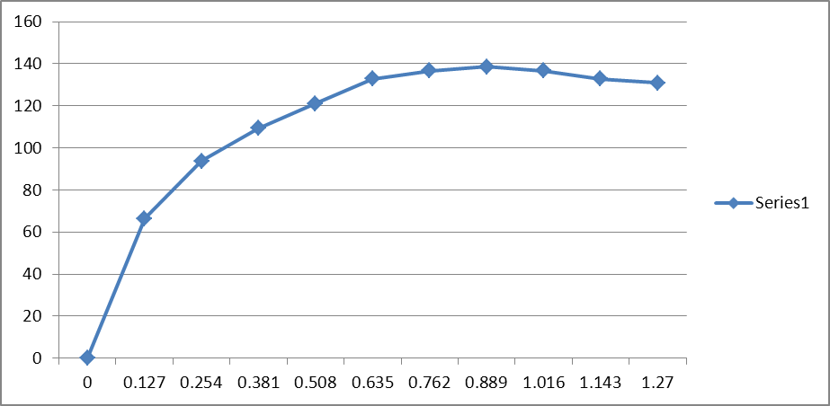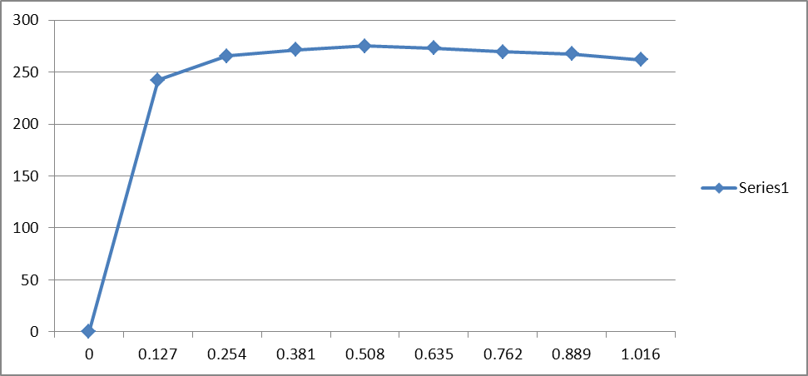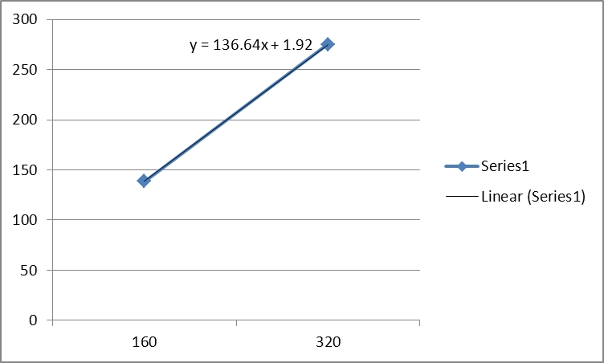

Y= 136.64x +1.92
When x=0, c= 1.92
Φ = arctan((275.28-138.56)/(320-160)) = 40.4973

Discussion Of Results:

The results were as expected, the errors are small due to use of computer and other technical devices. Because of those use human factor was decreased so the readings etc. were done better.
Conclusion:

As conclusion from the data obtained 3 graphs were drawn 2 ζ(kpa) vs u(mm) for each test and ζ(kpa) vs Sigma' for both of the test. According to the last graph c and Φ values were calculated as c= 1.92 and Φ = 40.4973

.

References:

- Mirata, T. (2009) Laboratory instructions for soil mechanics students. Ankara: METU Press.

