ETX 60/70
HBX Motor Protocol Description

Version: 4
Date: 11 Nov 2017

Table of Contents
Introduction 4
Notices 4
ETX60/70 Physical Interfaces 5
Connector Details 5
Auxiliary Port 5
HBX Port 5
Power 5
Signal Details 6
Description 6
Protocol 7
Start sequence 7
Command sequence 7
Data sequence 7
Command Summary 9
Motor Gearing 10
Az/RA Motor 10
Alt/DEC Motor 10
Az/RA Motor Experimental Data 11
Motor Speed 12
Captured Sequences 13
Original Weasner Site 13
Startup 13
Initial alignment 13
Move scope 13
Sleep scope 13
Park scope 13
Calibrate motors 14
Typical Hardware Setup 16
Current Arduino Capture 17
alignment to achernar 17

Table 1 HBX Command Summary 7
Table 2 RA/AZ Gear Train 8
Table 3 Experimental Data – Sidereal Counts per Arc Minute 8
Table 4 DEC/ALT Gear Train 9
Table 5 Experimental Rate 10

Introduction
This document describes the protocol used between the Autostar (#494, #497) controllers and the RA and DEC motors. The device investigated was the ETX60AT controlled by a #494. Some sample implementations an an arduino Mega2560 are included. The information is stored on the github site.
Test software was written to allow the EQMOD/ASCOM project to control the ETX. CdC was used as the astro software.
The test software includes a monitor mode as well as a test mode, selectable by jumpers.

Notices
Information in this document was summarised from multiple sources, especially the Weasner site. It is a collection of those documents and the use of or the reproduction of these documents implies and retains the original warnings/copyrights where they existed. Some work is additional to those documents and may be freely used taking care to carefully examine the caveat of the Patent notice below and its implications.
In particular, the discussions between Dick Seymour, Stefan Keller-Tuberg, Mike Weasner, ultima_gtr_v8, and Gene Chimahusky provided a lot of early information.
e.g. http://www.weasner.com/etx/autostar/2008/494cable.html
The main hardware interface software information comes from Yahoo RoboScope group files:
autostar_mtr_2.html and arduino autostar.zip
Some of this information is reproduced in the github repository.
Additional information on the motors is in the Microchip application notes:
AN893-00893a.pdf, AN905-00905a.pdf, and I2C.pdf.
As described in the sources of the information, “some of the information in the documents is derived from US patent #6,304,376 (held by Meade), and observation of the interactions between the Autostar controllers and the DH series motors. The information in this document was not derived via disassembly of the Autostar or motor processor firmware. Care must be taken to not violate the claims of the aforementioned patent in applying this information.”
Any consequences of the use of this information in any way are the sole responsibility of the reader.

ETX60/70 Physical Interfaces

Connector Details

Auxiliary Port
- Ground
- Aux Data
- Aux Clock
- 12V

HBX Port
- 12V
- Aux Clock
- Aux Data
- Alt Clock
- Alt/Az Data
- Az Clock
- Alt/Az Data
- Ground

Power
2.5mm jack, centre positive.

Signal Details

Description
Each motor is connected to the Autostar using two signals (plus a common ground). These clock and data signals allow the implementation of a bidirectional serial protocol.
The clock signal for each motor is always driven by the Autostar, which determines the transfer timing. The frequency of the clock signal is Autostar dependent with a frequency of around 5.5 kHz. On my #494 it is 220uS per data bit. Observations suggest that the AUX clock operates at higher speed. Each clock signal needs a pull up resistor of approximately 50KΩ.
The data signal is driven by either the Autostar or a motor controller and appears to only be driven low. The signal is weakly pulled high by the Autostar. Email comments on the original interface suggest that this is approximately 220KΩ.
Although the wiring between the Autostar and the motors would allow the two sets of signals to be completely separated, it appears that the data lines are tied together in the Autostar controllers. In the 494, all three data lines (on pins 2, 4, 6) are connected together.

Protocol
The following information comes from autostar_mtr_2.html.
The data transfer is structured as a series of commands.
Each command has:
- A start sequence (which allows the Autostar to be sure there is a motor present)
- A command sequence during which the eight bit command is sent by the Autostar
- A data sequence during which some number of bits containing data associated with the command is sent by, or returned to, the Autostar.
The number of bits is a function of the command, but is always constant for a given command.

Start sequence
In response to the Autostar driving the clock line low, the motor drives the data line low. This is used by the #494 Autostar to determine the presence of a motor. The state of the data line appears to be ignored by the #497 Autostar software. The #494 then drives the clock high, and the motor releases the data line to float high. (It does not drive it high)

Command sequence
An eight bit command, MSB first, is sent by the Autostar. This tells the motor what to do and what bits will be transferred later in the transfer.

Data sequence
The most significant bit of the most significant byte (for multibyte data) is transferred first. Some commands use a number of data bits which is not a multiple of eight.
Each bit of data after the start sequence is transferred as follows:
- The Autostar drives the clock line high
- The transmitter of the bit forces the data line low (to transfer a zero value), or allows it to float high
- The Autostar drives the clock line low
- The receiver of the bit samples the data line to determine the bit value

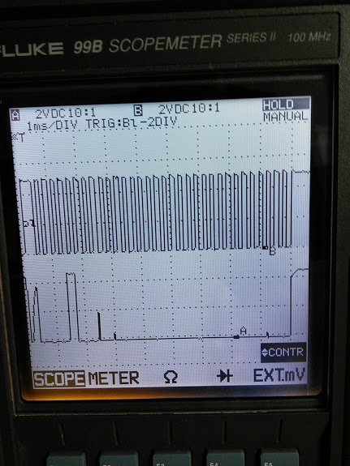Illustration 1: Typical Status Clock/Data sequence

Command Summary

Command | Parameters | Description | Notes
0x00  (Rotate slow) | Speed  [24 bits, 2's comp]  (A->M) | Rotate the motor at the specified rate.  The rate is a 24-bit 2's complement number of motor ticks per 6.55 ms period in an 8.16 fixed point fractional format. | The protocol assumes that the Autostar and motor act as a closed loop.  The changes can be seen as the Autostar converges on a sidereal tracking speed.  See Spreadsheet in Appendix A
0x01  (Rotate fast) | Speed  [24 bits, 2's comp]  (A->M) | Rotate the motor at the specified rate.  The rate is unknown but is specified for rates greater than 2x sidereal.
0x02  (Set offset count) | Error  [16 bits]  (A -> M) | Add the specified offset to the current position value. The servo loop will try to compensate | This is used by the pulse-guide commands to nudge the scope position. For the #497 it's also used to nudge the scope to the correct position after GOTO in some cases.
0x03  (Set LED current) | Led Value  [8 bits]  (A->M) | Sets the LED current used for the encoder LED. | This is stored in the Autostar and sent at initialisation.
0x04 (Calibrate LED) | None | Tells the motor to determine the optimal LED current for the optical encoder | Unknown whether it uses this value, or whether it needs to be read and written to take effect.
0x05  (Stop) | None | Stop the motor | The motor may continue to rotate for a short time after this command is issued
0x06  (Full speed reverse) | None | Rotate the motor at the highest possible speed in the negative direction | Speed = 0x0140FFFF
0x07  (Full speed forward) | None | Rotate the motor at the highest possible speed in the positive direction | Speed = 0xFEB80000
0x08  (Read status) | Relative position change  [16 bits, 2's comp],  PWM duty cycle  [8 bits],  encoder error  [1 bit]  (M -> A) | Read information about the position and activity of the motor.  The position and flag bit is reset after this command. | If the PWM value is 0xff and the position change is zero then it is likely that the motor is stalled  Flag bit - ??  Illegal encoder transition  non gray code  scope moved too quickly for encoder,  or badly calibrated LED
0x09  (Get LED current) | led value  [8 bits]  (M->A) | Get the LED current. | Issued after the calibrate LED command
0x0b  (Get motor type) | motor type  [8 bits]  (M->A) | Get the type of motor attached | The DH motors returns 0x10. Larger values cause the #494 Autostar to indicate the ETX Autostar should be used.
0xe4 (unknown) | None | Unknown.  Used by the Autostar after the stop command, when performing LED calibration, parking the scope, or sleeping the scope | Doesn't seem to clear the status information.  Not sure about “after parking”.

Table 1 HBX Command Summary

Motor Gearing
Detailed Information is in the etx60at-gears.ods file.

Az/RA Motor
The following table summarises the AzRA gear train. The encoder on the motor shaft appears to generate 144 pulses per rotation. This generates a ‘count’ of 1,233,750 for a full rotation (24HR).
Az/RA Motor | Gear1 | Gear2 | Ratio | Hexadecimal
Encoder | 1 | 144
G1 | 18 | 30 | 144
G2 | 12 | 30 | 240
G3 | 12 | 30 | 600
G4 | 12 | 30 | 1,500
G5 | 12 | 42 | 3,750
Worm | 1 | 94 | 13,125
Total |  | 1,233,750 | 1,233,750 | 0x12D356
Solar Count/Hour |  |  | 51,406 | 0xC8CE
Sidereal Count/Hour |  |  | 51,266 | 0xC842
Counts/Worm Tooth |  |  | 13,125 | 0x3345

Table 2 RA/AZ Gear Train

Alt/DEC Motor
The following table summarises the AltDEC gear train. The encoder on the motor shaft appears to generate 144 pulses per rotation. This generates a ‘count’ of 1,315,440 for a full rotation (360˚).
Alt/DEC Motor | Gear1 | Gear2 | Ratio | Hexadecimal
Encoder | 1 | 144 | 144
G1 | 18 | 30 | 240
G2 | 12 | 36 | 720
G3 | 12 | 36 | 2,160
G4 | 12 | 36 | 6,480
G5 | 12 | 42 | 22,680
Worm | 1 | 58 | 1,315,440
Total |  | 1,315,440 | 1,315,440 | 0x141270
Counts/Degree |  |  | 3,654 | 0x0E46
Counts/Worm Tooth |  |  | 22,680 | 0x5898

Table 3 DEC/ALT Gear Train

Az/RA Motor Experimental Data
The following information was collected by sending the appropriate speed command (Rotate Slow Forward at Sidereal Speed) via the HBX interface and noting the responses to ‘read status’ query, which returned the current position. The time noted was elapsed time from the start. The calculated value per hour (51,266) corresponds well to the measured value (51,292).

Rotation (arcmin)) | Measured Counts | Counts/Minute
0 | 0 | 0
6 | 312,192 | 52,032
7.5 | 385,147 | 51,353
9 | 459,399 | 51,044
9.5 | 486,622 | 51,223
11 | 563,099 | 51,191
12 | 616,215 | 51,351
Avg |  | 51,292

Table 4 Experimental Data – Sidereal Counts per Arc Minute

Motor Speed
The following table summarises the speed measurements. The number of counts was measured experimentally for varying times at increasing speeds. The speed was set using the “Rotate Slow” (0x00) command, using the 8.16 twos complement format. The number of counts was then recorded by sending a “Read status” command and recording the cumulative values. Finally, the value was divided by the measurement time to give the rate at which the counts are returned.

Hex Speed  16.8 | Count Value | Time (S) | Command Speed | Rate (Counts/s)
0 | 0 | 0 |  | 0
000001 | 1070 | 1,800 | .004 | 0.6
000020 | 9136 | 480 | .125 | 19.0
000040 | 50213 | 1,320 | .25 | 38.0
000080 | 68340 | 900 | .5 | 75.9
000100 | 127768 | 840 | 1 | 152.1
000200 | 475870 | 1,560 | 32 | 305.0
000400 | 73694 | 120 | 64 | 614.1
000800 | 72003 | 60 | 128 | 1,200.1
001000 | 146215 | 60 | 256 | 2,436.9
002000 | 148719 | 30 | 512 | 4,957.3
004000 | 287023 | 30 | 1024 | 9,567.4

Table 5 Experimental Rate

The calculated rate (152.59 counts/s) corresponded to the measured value (152.34 ticks/s) within experimental error. This calculated rate is based on 6.55mS (from the patent) and other texts.
Handset Speed | Speed Command | Speed Value - ALT |  |  |  | Speed Value - AZ
 |  | Forward |  | Reverse |  | Forward |  | Reverse
 |  | HEX | Decimal | HEX | Decimal | HEX | Decimal | HEX | Decimal
Max | 5, 6 | NA | NA | NA | NA | NA | NA | NA | NA
2 | 1 | 384D61 | 3689825 | C7B29F | 13087391 | 3C073B | 3934011 | C3F8C5 | 12843205
1 | 1 | 16855A | 1475930 | E97AA6 | 15301286 | 180317 | 1573655 | E7FCE9 | 15203561
.5 | 1 | 0C02DA | 787162 | F3FD26 | 15990054 | 0CCE53 | 839251 | F331AD | 15937965
64 | 1 | 06016D | 393581 | F9FE93 | 16383635 | 066729 | 419625 | F998D7 | 16357591
32 | 1 | 0300B6 | 196790 | FCFF4A | 16580426 | 033394 | 209812 | FCCC6C | 16567404
16 | 1 | 01805B | 98395 | FE7FA5 | 16678821 | 0199CA | 104906 | FE6636 | 16672310
8 | 1 | 00C02D | 49197 | FF3FD3 | 16728019 | 00CCE5 | 52453 | FF331B | 16724763
2 | 1 | 00170E | 5902 | FFE8F2 | 16771314 | 001894 | 6292 | FFE76C | 16770924

Table 6 Handset Speed Values to Command Values

Captured Sequences

Original Weasner Site
The following example commands sequences may help understand the interaction of the Autostar and Motor Controller (MC). Note that these are the #494 sequences, but they seem to be the same as the #497 ones. (Values returned by status command often differ due to differences in motor speed and command timing)

Startup
Command |  | Data from MC | Data to MC
0x05 | Stop Motor
0x08 | Read Status | 0x00 0x00 0x00 0
0x0b | Get Motor Type | 0x10
0x03 | Set LED current |  | 0xe7

Initial alignment
Command |  | Data from MC | Data to MC
0x05 | Stop Motor
0x08 | Read Status | 0x00 0x00 0x00 0
0x07 | Full Speed Forward
0x08 | Read Status | 0x00 0x2a 0x00 0
0x08 | Read Status | 0x00 0x2b 0x00 0
The value returned depends on the sampling (status read) time.

Move scope
Command |  | Data from MC | Data to MC
0x08 | Read Status | 0x00 0x00 0x00 0
0x07 | Full Speed Forward
0x08 | Read Status | 0x00 0x2a 0x00 0
0x00 | Set Speed Slow |  | 0x47 0x1c 0x6f

Sleep scope
Command |  | Data from MC | Data to MC
0x05 | Stop Motor
0xE4 | Unknown

Park scope
Command |  | Data from MC | Data to MC
0x00 | Set Speed Slow |  | 0xFF 0xA1 0x57
0x08 | Read Status | 0xFF 0xFF 0x00 0
0x05 | Stop Motor

Calibrate motors
Command |  | Data from MC | Data to MC
0x05 | Stop Motor
0xE4 | Unknown (Sleep?)
Assumed hard reset (using CLK) | Motors move (1-2 sec)
0x05 | Stop Motor
Ox04 | Calibrate LED current
Ox09 | Get LED current | 0xE7
0x08 | Read Status | 0x25 0x6c 0x00 0

Just for info,
when using the x00 or x01 motor commands
to command a constant motor speed,
the 24 bit no sent appears to be derived from
a base value ( that is scope agnostic ) multiplied by the ratio.
This base no is constant across all the Autostars ( incl ASII )
and hence a simplified drive could be made using this rate
as a hardcoded var
ie
BaseRate for 1deg/sec := 1,546,188.4
sooo for an LX200GPS
Motor command value for 1deg/sec := 1,546,188.4 * 7.1111111
:= 10,995,117
Andrew Johansen Melbourne Australia

The LX200s can be run up to 8deg per second using the x00 and x01 commands.
In the 497s, there is an internal speed limit
this is based on the fact that the rate sent to the motor
must be less that x007FFFFE ( 8,388,606 ),
ie the max "controllable" speed is inversely proportional to the ratio.
Above that rate, the full Fwds or Full Reverse commands must be used.

Typical Hardware Setup
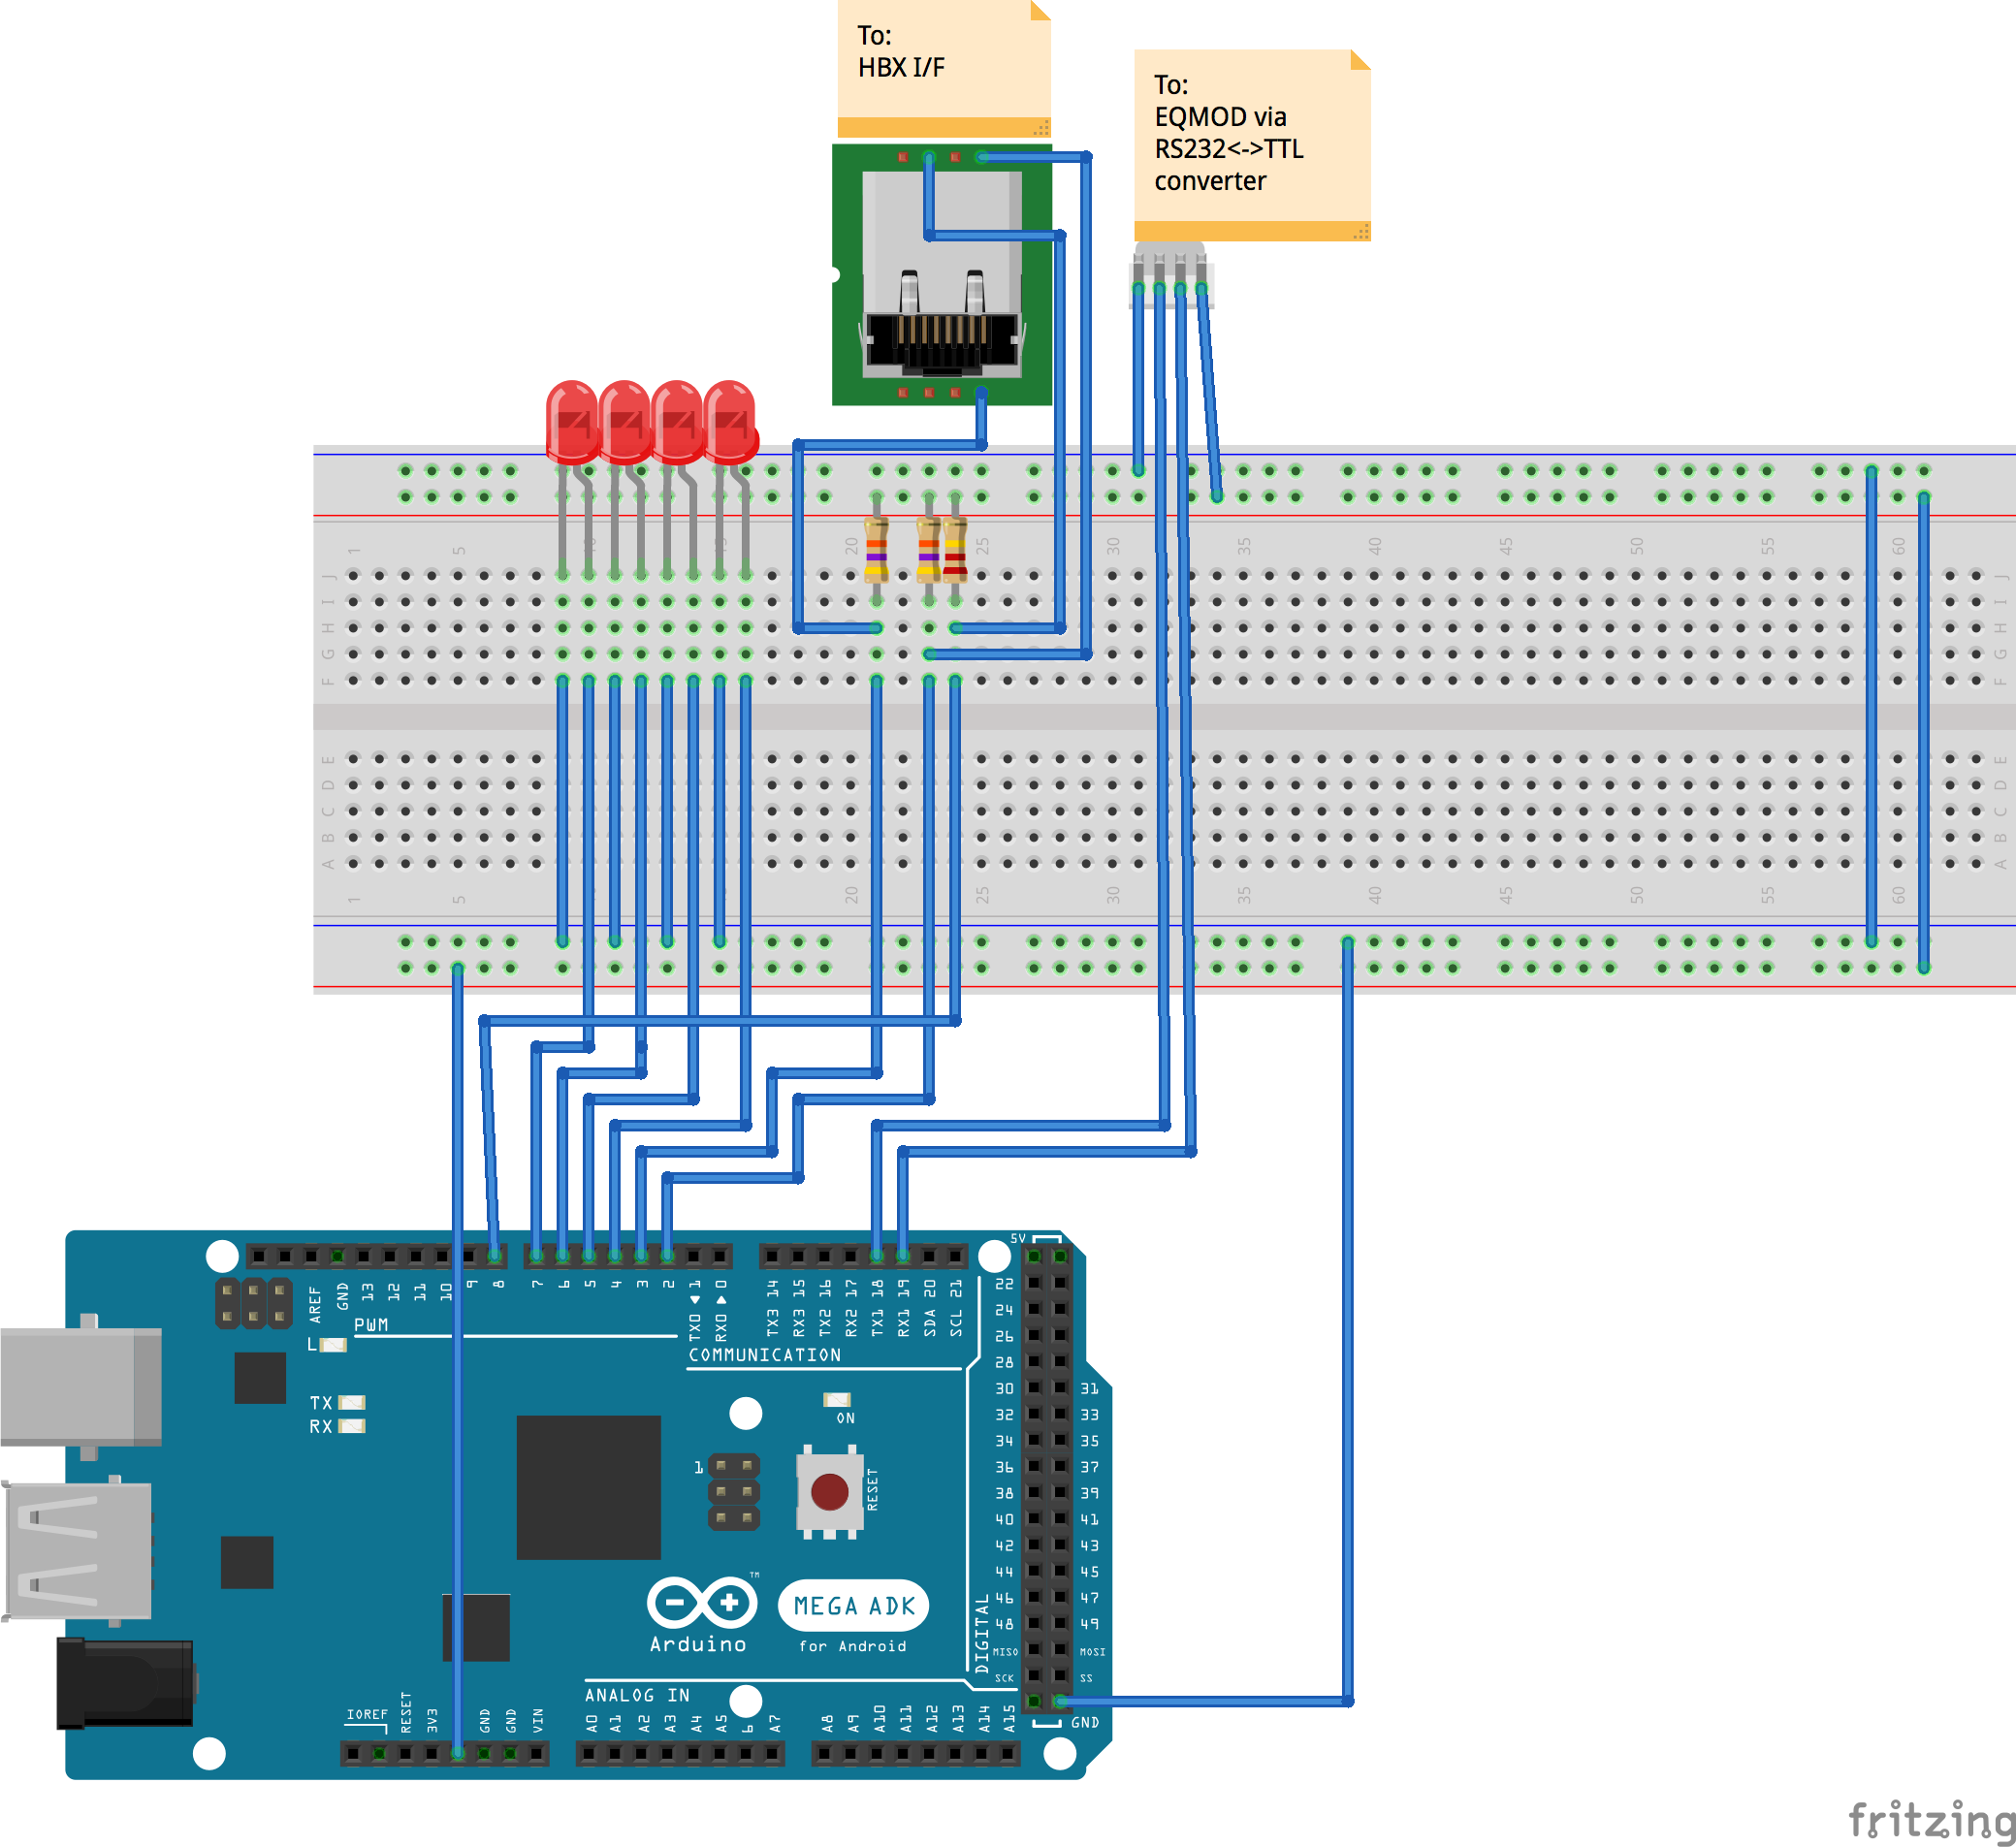

Current Arduino Capture

alignment to achernar
The graphs below are derived from the monitored startup values captured from a #494 doing an EASY alignment. They show the position in counts and speed values set on successive status calls and speed setting.
Values in #494 were set at nov16, 2017, 8.00 pm. See ETXStartup.ods

