

School of Engineering

Department of Electrical and Computer Engineering

**14:332:223 Principles of Electrical Engineering I Laboratory – Fall 2024**

**Lab Experiment #1**

**Laboratory objectives:**

1. Learn how to use a breadboard, resistors color code, LEDs, and implement electric circuits
2. Learn how to use power supply and digital multimeter
3. Learn how to use Arduino
4. Use LTSpice to simulate the behavior of circuits

**PART A: Tutorials**

1. **Breadboard:** prototype tools used to connect circuit elements together. Check this tutorial: <https://learn.sparkfun.com/tutorials/how-to-use-a-breadboard>

***Connecting elements on a breadboard:***many breadboards have numbers and letters marked on various rows and columns. This helps guide you when building your circuit. The ‘terminal strips’ are marked by numbers (column) and letters (row). Points located on the same column number are connected along rows A to E (a single node) or rows F to J (single node). For example, to connect two elements together we can connect one element to column 3 row A and the other element to column 3 row D. Note: A to E node is NOT connected to F to J node even if they are along the same column.

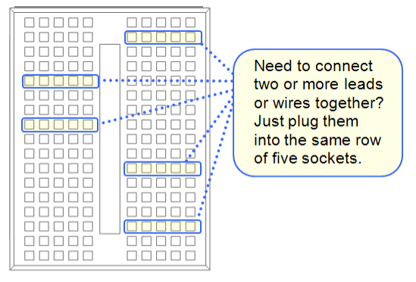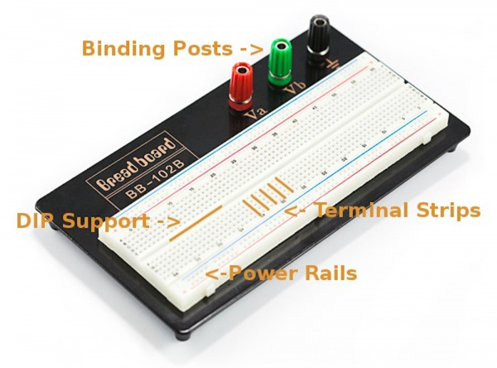

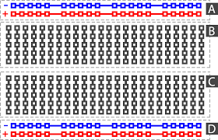

Figure 1: Breadboard layout

*Providing power to a breadboard:* the top and bottom two rows along the long side of the breadboard are the power rails and intended for power supply. The power rails provide easy access to power along the breadboard. Usually they will be labeled with a ‘+’ and a ‘-’ and have a red and blue or black stripe, to indicate the positive and negative side. All points along each row (long side of the breadboard) are connected (short). The rows are not interconnected.

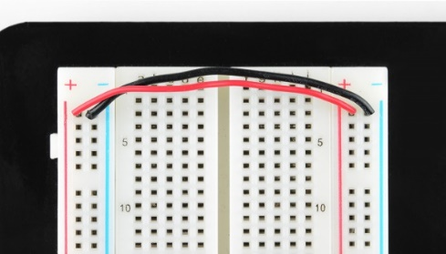Important note: the power rails on either side of the breadboard are not connected, so if you are using both power rails you will need to connect the two sides with jumper wires. all ‘ground’ points from all sources should be grounded to the same point. The ‘-‘ rows along the breadboard should be connected, as illustrated in Figure 2(b). If a single power supply is used, than the ‘+’ rows should be connected as well. We normally use black wires for ground and red for power. Using a banana connector, you can provide power from the supply to the binding posts.

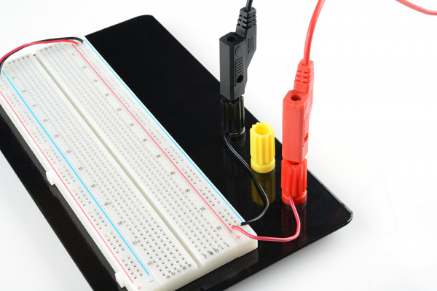 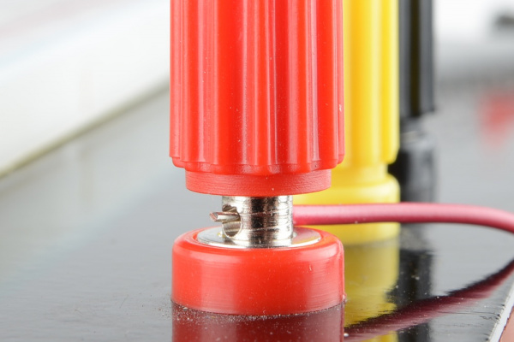

(b) Two jumper wires used to connect the power rails on both sides. Always the ‘-’ to ‘-’.

1. Breadboard power connections (c) connecting wires to the nobs

Figure 2: Breadboard power connectors

1. Power supply: a device that provides a DC (direct current) or AC (alternating current) voltage or current source whose level can be adjusted by a knob on the device.

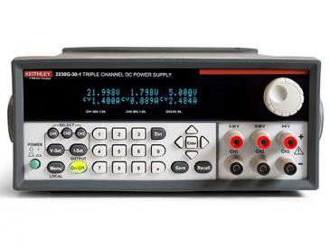Power supply used in the lab is: Keithley 2231-30-3. This model has three channels. Two channels, each capable of supplying up to 30V at 3A each and a third channel that can provide up to 5V at 3A.

Figure 3: Power supply used in the lab is: Keithley 2231-30-3

Training videos: <https://www.tek.com/en/video/how-to/series-2200-programmable-multiple-channel-dc-power-supplies--how-to-configure-a-single-channel-opera>

Additional training videos can be found at: <https://www.tek.com/tektronix-and-keithley-dc-power-supplies/keithley-2220-2230-2231-series>

Please check Appendix B for additional info on the power supply.

**Front-panel Features:** Controls and display elements are shown in the following illustration



* 1. Display
  2. **Top row:** Voltage readings or settings for each channel. **Bottom row:** Current readings or settings for each channel.
  3. Up, down, right, and left arrow keys and Enter button
  4. Multipurpose knob. Rotate to increase or decrease digits or to select menu items
  5. Output connectors
  6. Save and Recall function buttons
  7. Number keys (0 to 9 and Esc) for direct numeric entry
  8. Channel select buttons
  9. V-Set, I-Set, Menu (Local), and Output On/Off function buttons
  10. Power button

**Basic settings:**

1. **Set the Voltage Output or Voltage Limit for a Specific Channel**

You may set the voltage limit from 0 V to the maximum voltage rating shown on the instrument nameplate. To set the voltage limit, do the following:

* 1. The position of the cursor determines which channel will be adjusted. If the cursor is not located in the correct channel, select the correct channel by pressing the appropriate channel Select button.

1. Push V-set.
2. Use the numeric keys and push Enter to set the voltage limit. You can also use the up, down, right and left arrow keys or the multipurpose knob.
3. **Set the Current Output or Current Limit for a Specific Channel**

You may set the current limit from 0 A to the maximum current value of each model. The maximum current rating is shown on the instrument name plate. To set the current limit, do the following:

1. The position of the cursor determines which channel will be adjusted. If the cursor is not located in the correct channel, select the correct channel by pressing the appropriate channel Select button.
2. Push I-set.
3. Use the numeric keys and push Enter to set the current limit. You can also use the up, down, right and left arrow keys or the multipurpose knob.
4. **Enable and Disable Output Channels**

You can enable or disable each output channel using this menu setting. If a channel is disabled, it will remain off after the Output On/Off button is turned on. The default setting is to have all channels enabled.

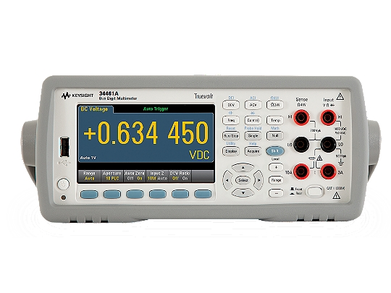**3. Digital Multimeter:** a basic tool in circuits laboratory which is used to measure primary signal variables values, *current* (in amperes, **A**) and *voltage* (in volts, **V**), as well as an important parameter of a resistor called *resistance* (in ohms, ****). There are two common types of multimeters, digital multimeter (DMM) and analog multimeter (AMM).

Digital Multimeter (DMM) used in the lab is: Keysight (Agilent)

Figure 4: DMM used in the lab Keysight (Agilent) 34461A

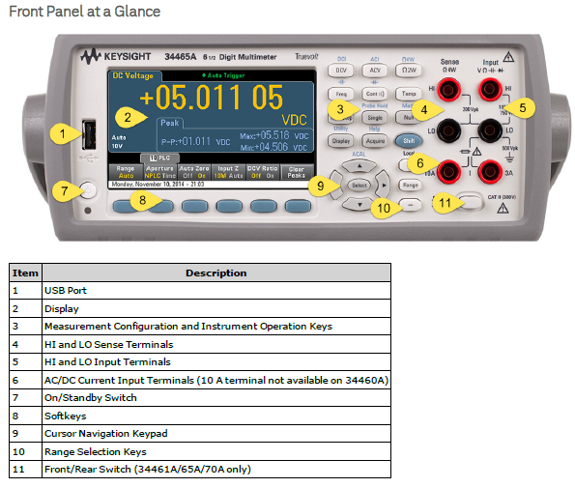

Figure 5: DMM front panel

* 1. ***DC Voltage measurements:*** This section describes how to configure DC voltage measurements.

**Important:** When measuring voltage, you need to connect the + and – terminals of the DMM in **parallel** with a component you wish to measure the voltage drop across. For example, to measure the voltage drop across a resistor R you need to place the DMM red lead on one side (a terminal) of the resistor and the black lead on the other side (b terminal). The voltage will be measured as the difference between terminal a and terminal b, i.e. Vab. Switching the connection between terminals a and b will measure Vba.

A picture containing object

Description generated with high confidence

Figure 6: DMM wiring for voltage measurements

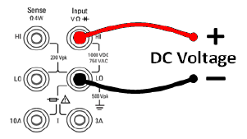**Step 1:** Configure the test leads as shown.

**Step 2:** Press [DCV] on the front panel.

**Step 3:** Press **Aperture** and choose the number of power-line cycles (PLCs) to use for the measurement.

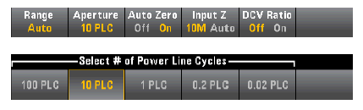

**Step 4:** Press **Range** to select a range for the measurement. You can also use the [+], [-], and [Range] keys on the front panel to select the range. Auto (autorange) automatically selects the range for the measurement based on the input. Autoranging is convenient, but it results in slower measurements than using a manual range. Autoranging goes up a range at 120% of the present range, and down a range below 10%of the present range.





**Step 5:** **Auto Zero**: Autozero provides the most accurate measurements but requires additional time to perform the zero measurement. With autozero enabled (On), the DMM internally measures the offset following each measurement. It then subtracts that measurement from the preceding reading. This prevents offset voltages present on the DMM’s input circuitry from affecting measurement accuracy. With autozero disabled (Off), the DMM measures the offset once and subtracts the offset from all subsequent measurements. The DMM takes a new offset measurement each time you change the function, range, or integration time. There is no autozero setting for 4-wire measurements.



**Step 6:** Specify the **input** impedance to the test leads (Input Z). This specifies the measurement terminal input impedance, which is either Auto or 10 MΩ. The Auto mode selects high impedance (HighZ) for the 100 mV, 1 V and 10 V ranges, and 10 MΩ for the 100 V and 1000 V ranges. In most situations, 10 MΩ is high enough to not load most circuits, but low enough to make readings stable for high impedance cir-cuits. It also leads to readings with less noise than the HighZ option, which is included for situations where the 10 MΩ load is significant.



* 1. ***DC Current measurements:*** This section describes how to configure DC current measurements

**Important:** When measuring current, you need to connect the + and – terminals of the DMM in **series** with a component you wish to measure the current flow through. This means we need to disconnect the circuit at the point of measurement. This is demonstrated in Figure 7. To measure the current flow through resistor R you need to open the connection to one of the resistor’s terminal and connect the DMM red lead on one side of the open and the black lead on the other side of the open circuit. The current will be measured as if it flows from the red lead to the black lead, i.e. iab. Switching the connection between terminals a and b will measure iba.

A picture containing object, device

Description generated with high confidence

Figure 7: DMM wiring for current measurements

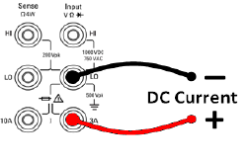

**Step 1:** Configure the test leads as shown.

**Step 2:** Press [DCI] on the front panel.

**Step 3:** the **Aperture** NPLC softkey is selected by default. Use the up/down arrow keys to specify integration time in power-line cycles (PLCs) to use for the measurement.

You can also make measurement using the 10 A terminal, which is recommended when measuring current above 1 A:



**Step 4:** The 3A terminals are selected by default. The **Terminals** softkey toggles between the 3 A terminals and the 10 A input terminals. When you change this to 10 A, the measurement range automatically becomes 10 A.



**Step 5:** Press **Range** to select a range for the measurement. You can also use the [+], [-], and [Range] keys on the front panel to select the range. Auto (autorange) automatically selects the range for the measurement based on the input. Press More to switch between the two pages of settings.







**Step 6:** **Auto Zero** provides the most accurate measurements but requires additional time to perform the zero measurement. With autozero enabled (On), the DMM internally measures the offset following each measurement. It then subtracts that measurement from the preceding reading. This prevents offset voltages present on the DMM’s input circuitry from affecting measurement accuracy. With autozero disabled (Off), the DMM measures the offset once and subtracts the offset from all subsequent measurements. The DMM takes a new offset measurement each time you change the function, range, or integration time. There is no autozero setting for 4-wire measurements.



* 1. ***Resistance measurements:*** This section describes how to configure resistance measurements

**Step 1:** Configure the test leads as shown.

**Step 2:** Press [Ω2W] or [Ω4W] on the front panel. The following menu appears. (The Ω4W menu does not include Auto Zero.)



**Step 3:** se the up/down arrow keys to specify integration time in power-line cycles (PLCs) to use for the measurement. 1, 10, and 100 PLC provide normal mode (line frequency noise) rejection.



**Step 4:** Press **Range** to select a range for the measurement. Auto (autorange) automatically selects the range for the measurement based on the input. Press More to switch between the two pages of settings.





**Step 5:** **Autozero** provides the most accurate measurements but requires additional time to perform the zero measurement. With autozero enabled (On), the DMM internally measures the offset following each measurement. It then subtracts that measurement from the preceding reading. This prevents offset voltages present on the DMM’s input circuitry from affecting measurement accuracy. With autozero disabled (Off), the DMM measures the offset once and subtracts the offset from all subsequent measurements. The DMM takes a new offset measurement each time you change the function, range, or integration time. (There is no autozero setting for 4-wire measurements.)



**PART B: Circuit Theory and Elements**

Ohm's Law

Ohm's Law states that the voltage across a resistor is directly proportional to the current flowing through the resistor. The constant of proportionality is the resistance value of the resistor in ohms ( Capital omega). The circuit symbol for the resistor is shown in Figure 8. For the current and the voltage shown, Ohm's Law is

(1.1)

where *R*> 0 is the resistance in ohms (****), *v*is the voltage in volts (**V**), and *i* is the current in amps (**A**).

**R**



+

✵ **i**

**V**

-

Figure 8: Ohm’s Law

We can calculate the instantaneous power consumed by a resistor in several ways:

(1.2)

G=1/R (1.3)

where Gis the conductance in -1.

## LED Modeling (approximation)

## LEDs (light-emitting diodes) are nonlinear devices with I-V curves that can be approximated by the I-V curves in Figure 9.

## https://www.electronicdesign.com/sites/electronicdesign.com/files/uploads/2013/01/IFD2527_fig2a_b.gif

## 

c.

Figure 9: Modeling of LED voltage versus current behavior (a) circuit modeling (b) approximated I-V (c) more realistic I-V behavior

## PART C: Pre-Lab

## C.1 Design a circuit with one voltage source of 6V and one resistor such that the current

## flowing in the circuit is 20mA.

## 

## C.2 For a given resistor, what happens to the voltage drop across that resistor if the current

## Flowing through it is cut in half?

## The voltage drop is also cut in half.

## Diagram, schematic Description automatically generatedC.3 Assume R1 is 100Ω, R2 is 500Ω, R3 is 1kΩ, and 5V for your power supply.

Calculate the voltage drop across each resistor (V­R1, VR2, and VR3) and fill in the

Table below.

|  |  |
| --- | --- |
| **Voltage** | **Calculated Voltage Drop** |
| **VR1** | 0.3125 |
| **VR2** | 1.5625 |
| **VR3** | 3.125 |

## PART D: In Lab Experiments

**14:332:223 Principles of Electrical Engineering I Laboratory – Fall 2024**

**Lab Experiment #1**

## Date of lab experiment: ____________________

## Lab section: __________ GROUP (A/B): ______

## Team members: ___________________________________________________

## 

**Laboratory instruments:**

* Power supply: Keithley 2231-30-3
* Digital Multimeter (DMM): Keysight (Agilent) 34461A
* Breadboard/Arduino set
* 1K to 10 K resistors by design resistor

## Experiment # 1.1: Ohm Law

## Wiring: Build the circuit in Figure 10 on your breadboard.

* Choose resistor value for R1 in the range of 2k to 10k. Mark the actual resistor value in the circuit below.
* Connect the binding post to the power lines on the breadboard
* Use banana connectors for the binding posts. These will later be used to connect to power.

Please have your TA verify and sign BEFORE you connect power to the circuit

TA Verification: _____________

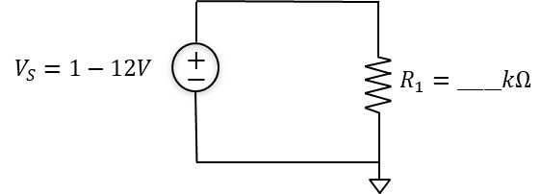

Figure 10: Schematic Diagram of circuit for V-I measurement

As a matter of safe practice and convenience, get in the habit of following these rules:

1. Wire always from the load toward the source, not vice-versa.
2. Never make the final connection to the power supply without instructor's approval.Wrong wiring may damage the equipment and delay your work.
3. While ammeters must be hardwired into the circuit, it is usually better to **add voltmeters last**, on top of the existing functional circuit so to speak. (This makes it easy to change a voltmeter connection or to remove it temporarily for a resistance check or some other use.)
4. Make sure that an ammeter is always placed in series with a circuit element through which you want to measure the current. Never connect another copper wire in parallel with the ammeter, because it will disable the ammeter.
5. Make sure that a voltmeter is always placed in parallel with the terminals across which you want to measure the voltage.

## Measurements:

**Important:** ***Do not connect your board to the source BEFORE the instructor has approved your connections!***

* Connect the source with an initial output voltage of 0 volts.
* Slowly increase the output voltage of the power supply from 0V to 12V in increments of 1V and read the current ***i*1** on the ammeter.
* Enter the data in Table 1 (**V** vs. ***i*1**)

**Table 1: Set values and measured values** (**V** vs. ***i*1**)

|  |  |  |
| --- | --- | --- |
| Vnominal [V] | *i*1 [A] | R (calculated) [k] |
| 1 |  |  |
| 2 |  |  |
| 3 |  |  |
| 4 |  |  |
| 5 |  |  |
| 6 |  |  |
| 7 |  |  |
| 8 |  |  |
| 9 |  |  |
| 10 |  |  |
| 11 |  |  |
| 12 |  |  |

* Use the DMM to directly measure the resistance R1 = ________ [k]
* Find resistor R1 resistance in two other ways:

1. Calculate the resistance R1 by using Ohms law with the values measured in Table 1.
2. Record the five color bars of the resistor and find the resistance value based on it **(See Appendix A).** Use the DMM to directly measure the resistance R1.

## Experiment # 1.2: LED-Based Electric Circuit

## Wiring: Build the circuit in Figure 11 and Figure 12 on your breadboard.

* Choose two resisters with a resistance of 220 and 2.2k (or close values)
* Use the first resistor (220 or a close value). Locate it on the breadboard between two different columns. Note: *you will need to repeat the experiment with each of the other two resistors*
* Connect the short lead of the LED to Arduino ‘GND’ pin using the breadboard, where the Arduino GND pin is connected to the ‘-‘ of the breadboard power rails and the LED short lead connects to it as well. Connect the long lead of the LED to one of the resistor terminals.
* Connect the other resistor terminal to the 5V pin on the Arduino using the breadboard, where the Arduino 5V pin is connected to the ‘+‘ of the breadboard power rails and the resistor terminal connects to it as well.
* Connect Analog I/O A0 to on of the resistor’s terminals and connect analog I/O A1 to the other terminal of the resistor.

Please have your TA verify and sign BEFORE you connect power to the Arduino

TA Verification: _____________

A circuit board

Description generated with very high confidence

Figure 11: Wiring Diagram of circuit for V-I measurement

## A picture containing object, yellow Description generated with high confidence

Figure 12: Schematic Diagram of the circuit

## Software: As a templet for the Arduino sketch use the ‘BareMinimum’ sketch under File>Examples>01.Basics’. Make the changes marked in red in the following text:

void setup() {

// initialize serial communication at 9600 bits per second:

Serial.begin(9600);

}

// the loop function runs over and over again forever

void loop() {

// read the input on analog pin 0 and pin 1:

int sensorValue1 = analogRead(A0);

int sensorValue2 = analogRead(A1);

// print out the value you read:

Serial.println(sensorValue1);

Serial.println(sensorValue2);

delay(1); // delay in between reads for stability

}

**Note:** analogRead()will map input voltages between 0 and 5 volts into integer values between 0 and 1023. This yields a resolution between readings of: 5 volts / 1024 units or, .0049 volts (4.9 mV) per unit.

## Measurements:

**Important:** ***Do not connect your board to the source BEFORE the instructor has approved your connections!***

* Connect the USB connector from the computer to the Arduino.
* Record the readings on pins A0 and A1 using the ‘Serial Monitor’.
* Enter the data in Table 2.

**Table 2: Readings from PINS A0 & A**

Resistor R1 Value: _________

|  |  |  |
| --- | --- | --- |
|  | A0 | A1 |
| 1 |  |  |
| 2 |  |  |
| 3 |  |  |
| 4 |  |  |
| 5 |  |  |
| 6 |  |  |
| 7 |  |  |
| 8 |  |  |
| 9 |  |  |
| 10 |  |  |
| Average |  |  |

* Calculate the voltage at point A0 and point A1 using the step constant and mark these values in Table 2.
* Find the averages and the difference between A1 to A0: ________________
* Use the DMM to directly measure the voltage drop across resistor R1 and the LED.

Voltage drop across LED: _____________________________

Voltage drop across resistor R1 : _________________________

* Pay attention to the **LED light intensity** and take a picture of the LED, if possible.
* Disconnect USB connector and replace the resistor R1 from 220 to 2.2k (or close value).
* Connect the USB connector from the computer back to the Arduino.
* Record the readings on pins A0 and A1 using the ‘Serial Monitor’.
* Enter the data in Table 3.
* Use the DMM to measure the resistance of both resistors used in the lab:
  + R1 – first case measured resistance: _________________
  + R1 – second case measured resistance: _________________

**Table 3: Readings from PINS A0 & A**

Resistor R1 Value: _________

|  |  |  |
| --- | --- | --- |
|  | A0 | A1 |
| 1 |  |  |
| 2 |  |  |
| 3 |  |  |
| 4 |  |  |
| 5 |  |  |
| 6 |  |  |
| 7 |  |  |
| 8 |  |  |
| 9 |  |  |
| 10 |  |  |
| Average |  |  |

* Calculate the voltage at point A0 and point A1 and mark these values in Table 3.
* Find the averages and the difference between A1 to A0: ________________
* Use the DMM to directly measure the voltage drop across resistor R1 and the LED.

Voltage drop across LED: _____________________________

Voltage drop across resistor R1 : _________________________

* Pay attention to the **LED light intensity** and take a picture of the LED, if possible. Is there any difference compared with the first case? ________________________________________________________________________

## PART E: Post-Lab Report

The lab report should include a filled and signed copy of part D and analysis of the data based on the following questions and required simulation.

1. **Analysis for experiment 1.1:** 
   1. Use the resistor tolerance to calculate the range of potential values for the resistor used in the experiment. For example, a 1k± resistor can have a resistance in the range of 0.9 k to 1.1 k.
   2. Plot your current and voltage measurements using excel where x-axis represents ***i*** and y-axis represents ***v***.
   3. Calculate R for each pair of measured current and voltage and find the average values for R.
   4. Discussion: compare the average measured value with the DMM resistance measurement and the color-coded value. Is it within the resistance tolerance range?
2. **Analysis for experiment 1.2:**
   1. Provide code file used with Arduino.
   2. Analog I/O A0 and A1 measure the node voltage on each side of the resistor and thus the difference between them represent the voltage drop across the resistor. Find the voltage drop across the R1 resistor for both cases (220 to 2.2k) by averaging the 10 measurements obtained in experiment 1.2.
   3. Compare the Arduino averaged measurement to the DMM voltage measurements for both cases.
   4. Calculate the current flowing through the resistor R1 for both cases using the DMM measurements for voltage and resistance.
   5. Calculate the power generated by the 5V source on the Arduino for both cases, given that the current flow through the resistor is the same as the current flowing out of the source.
   6. How much power does the LED consumes in each case?
   7. Discussion: the current flowing through the resistor is equal to the current flowing through the LED and the current flowing from the 5V source on the Arduino.
      * Compare the results for the current flowing through the LED with the light intensity for both R1 values. How did the current change between the cases and how does it relate to the light intensity?
      * How does the power, consumed by the LED, change between the two cases?

1. **Simulation:** 
   1. Develop a LTSpice model for the circuit given in Figure 13.
   2. Find voltage, current, and power for each element in the circuit (all resistors and sources) using the LTSpice model.
   3. Use the power balance equation to verify your results.
   4. Include the LTSpice simulation with your submission.
   5. Develop a TinkerCAD model for the circuit in Figure 13.
   6. Connect a voltage meter to measure the voltage drop across R1 and R2.
   7. Provide a URL to your TinkerCAD simulation and a PDF of the schematic.

A close up of a logo

Description generated with very high confidence

Figure 13: Wiring Diagram of circuit for V-I measurement

## Appendix A: Resistors Color Codes

## Resistors values are marked using colored bands. Each color, in a specific position, has a corresponding numerical value associated with it, as seen in the image hereafter.

## A picture containing screenshot Description generated with high confidence

## Appendix B: Power supply Keithley 2231-30-3

## 

## 

## 

## 

## 