**TREE OF LIFE PARTITION**

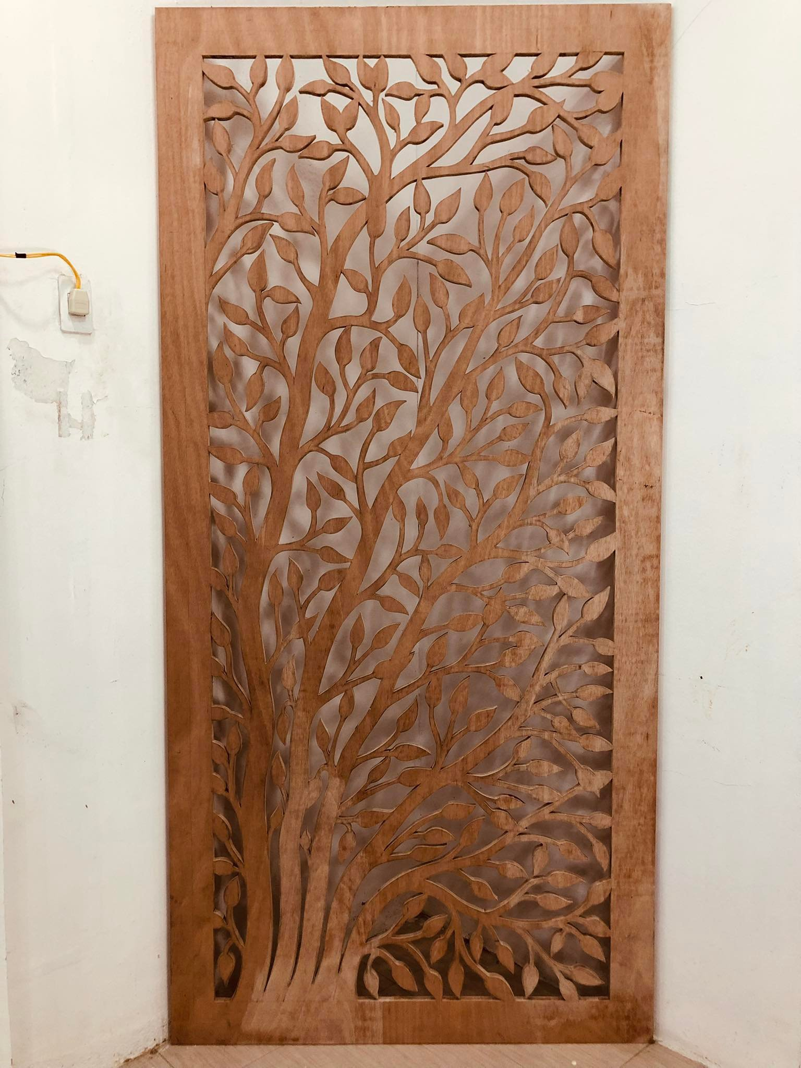

DIMENSIONS: HEIGHT – 96 INCHES

WIDTH – 48 INCHES

THICKNESS – ¾” PLYBOARD

FINISH : RAW