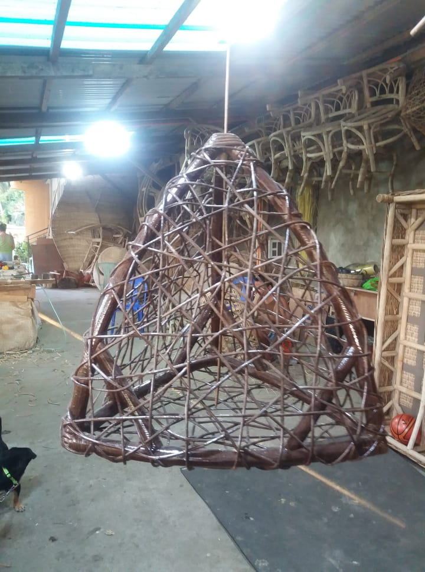

**Triangle Chandelier**

**PRICE: Php 750** without lighting fixture

**Php 1200 with lighting fixture**