**VAUGHN ROCKING** 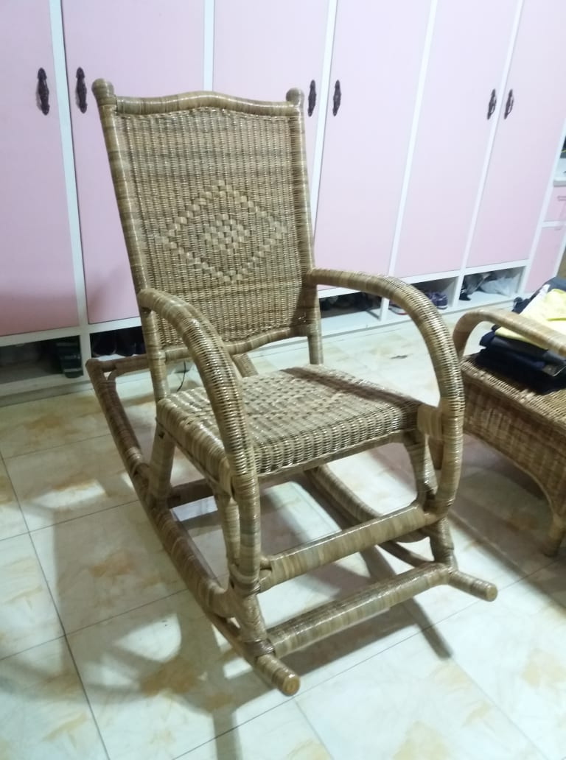

DIMENSIONS: HEIGHT –40 INCHES

WIDTH – 20 INCHES

LENGTH –48 INCHES

WEAVING: 4mm WICKER

FINISH : NATURAL HIGH GLOSS