VICENTE & GREGORIA THRONE SET

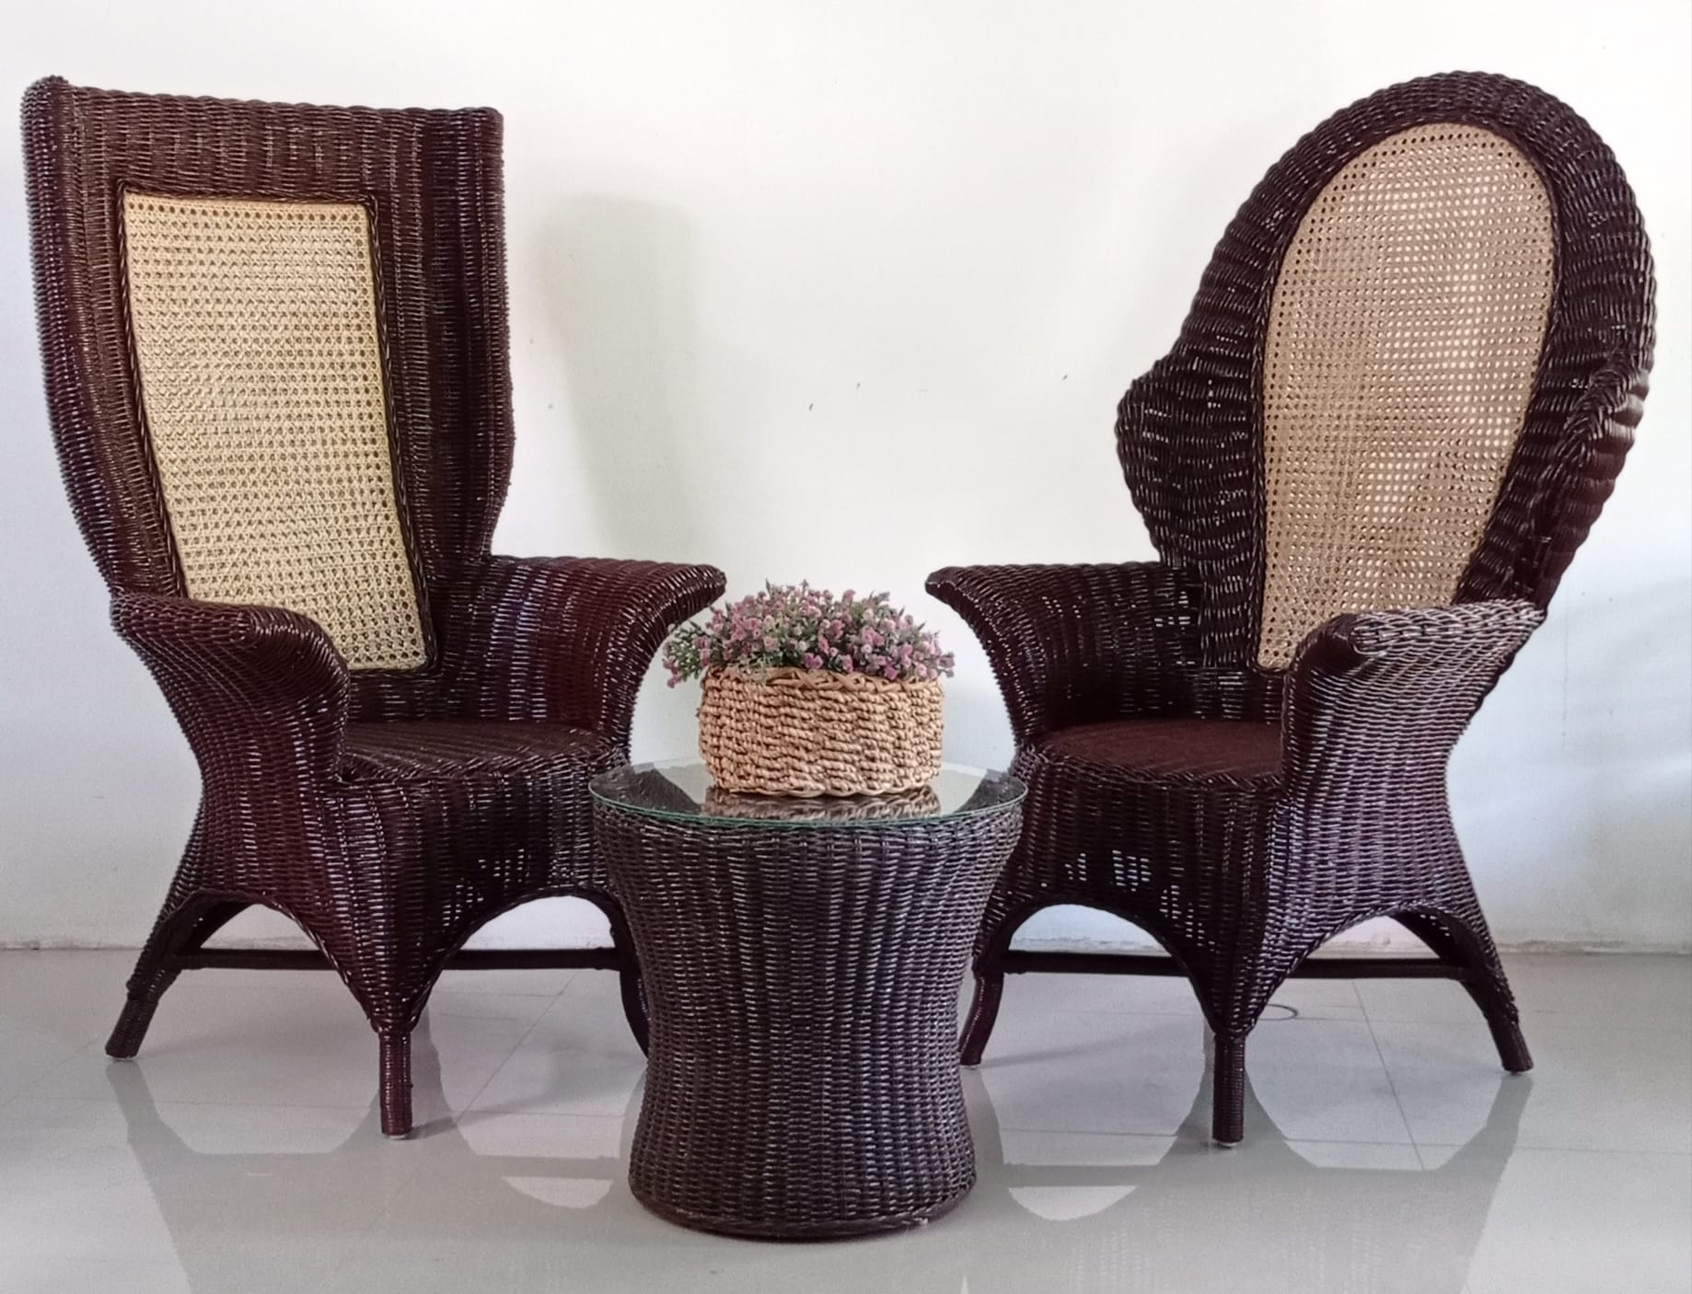

**P30,000**