**CHAISE LOUNGE WITH VINCE TABLE**

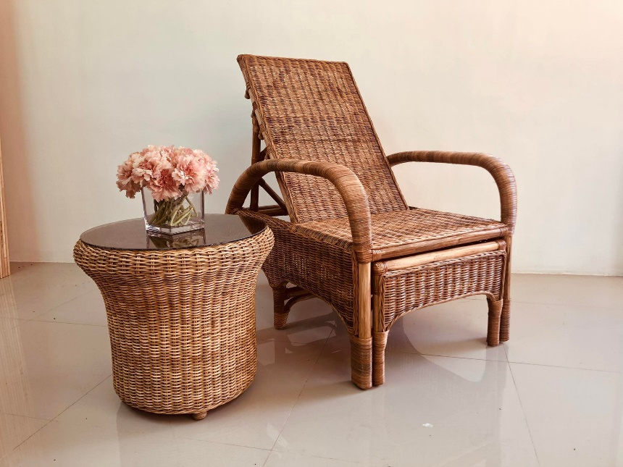 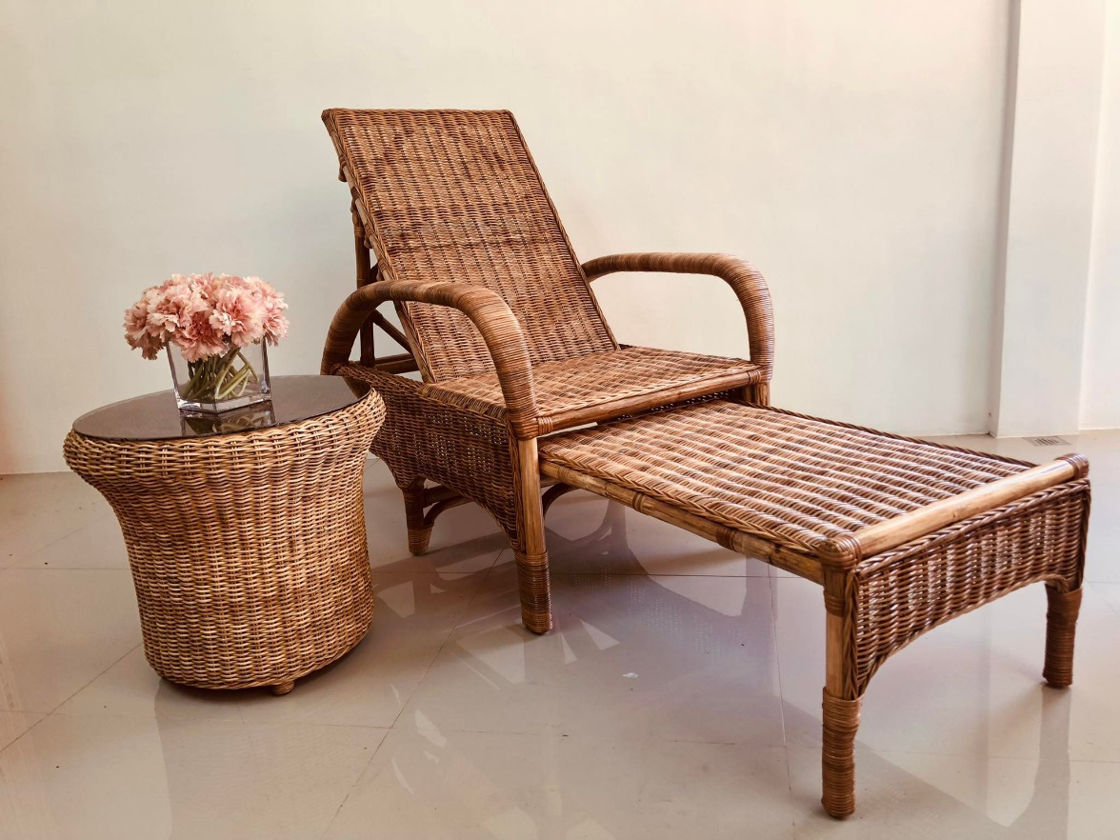

**P15,000**