RIGA TECHNICAL UNIVERSITY

FACULTY OF COMPUTER SCIENCE AND INFORMATION TECHNOLOGY

INSTITUTE OF APPLIED COMPUTER SYSTEMS

Practical assignment #3

“Database Management Systems”

**Forms & Reports**

Author: Özcan Karabacak

Course, group: Database Management Systems, Group 8

Student card no.: 200ADB020

Checked: Andrejs Gaidukovs

2019/ 2020 study year

**Content**

1 Task 3

2 Database description 4

3 Application description 5

4 Conclusions 12

# Task

1. Create application (application in this task – set of forms that are related between each other. for examples: multiple forms can be accessible in navigation form; form of individual employee can be opened for editing or for entering new employee from list of employees) that uses/do/include:
   1. Nafigation form;
   2. Subforms;
   3. Form with list of records;
   4. Form open/close, data entry/editing (validation) operations for sinlge record;
   5. Buttons, listboxes, comboboxes;
   6. Search functionality;
   7. Records sorting;
   8. AutoExec;
   9. RecordSet.
2. Create one report with at least 2 levels of grouping and aggregation functions;, e.g., date printed, page X of N, etc.;
3. Conclusions

Grading:

4-5: only standard MS Access tools are used without customization;

6-8: forms are customized, there is at least one form, where you can open single record for editing from list of record (Examlpe: form of individual employee can be opened for editing or for entering new employee from list of employees);

9-10: RecordSet and search functionality is used.

# Database description

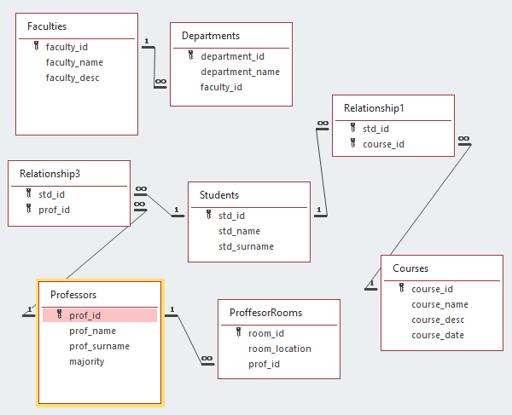

This database contains information about university records. Above there are the relationships between tables. Tables are connected to each other with different kinds of relationships. Relationship1 and Relationship3 are created for this database because some tables have N-M relationships.

# Application description

## Sub Forms

For each table, sub forms are created. These forms will be used for navigation form.

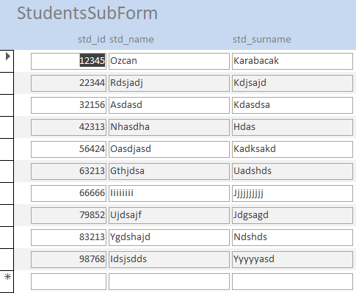

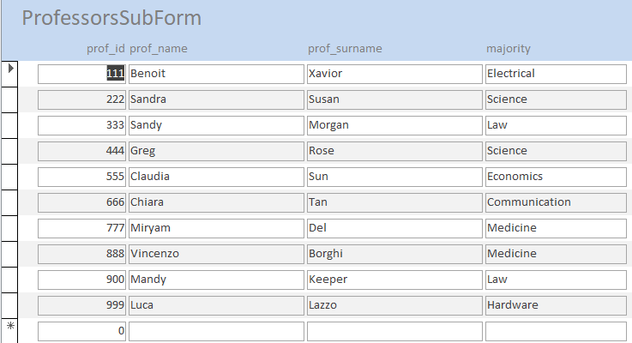

## Navigation Form

Navigation form makes changing forms possible. Navigation form is created and each sub forms are added. The navigation form can be seen below.

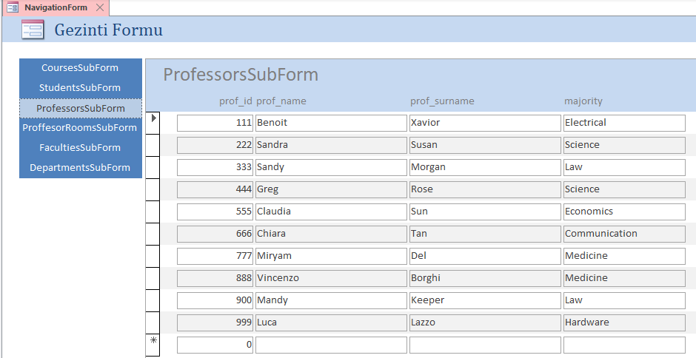

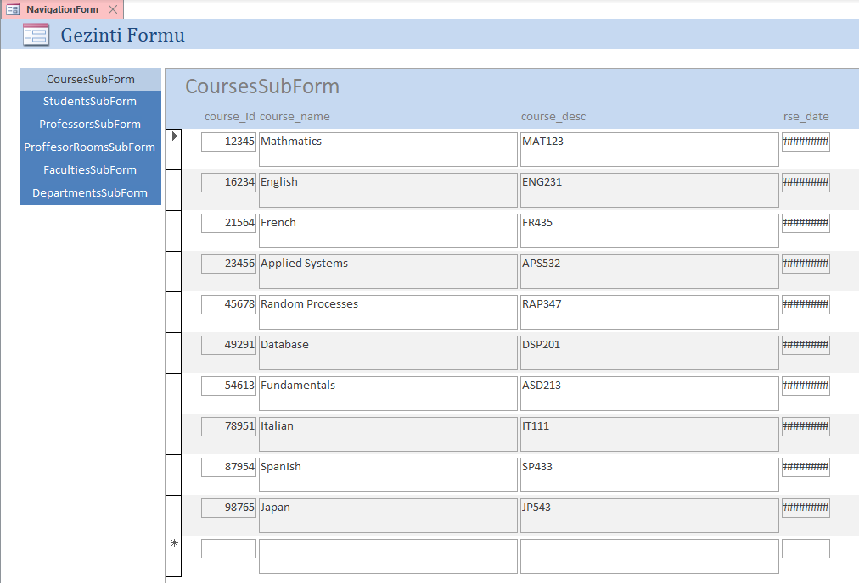

## Form with List of Records

That form is created to show list of records in the Professors table.

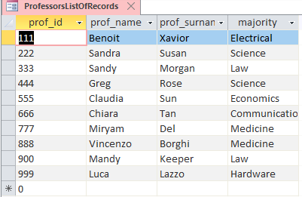

## Data Search/Delete/Update/Add Functions

This form is created to edit records in Students table.

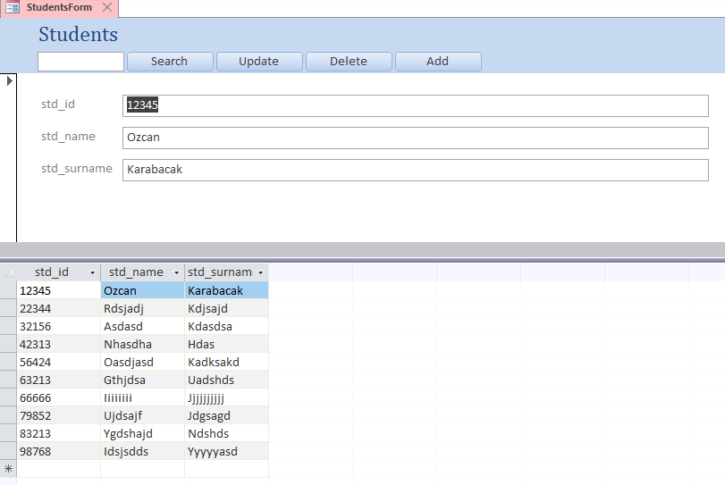

With that form each student could be searched by their names. To do that, macro is assigned to the search button. The button uses ApplyFilter and the condition is to search all the list related to the data in the textbox. Example is below.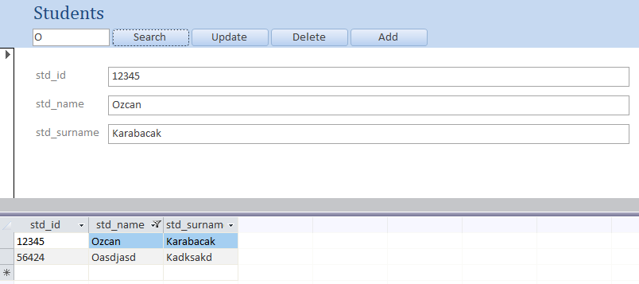

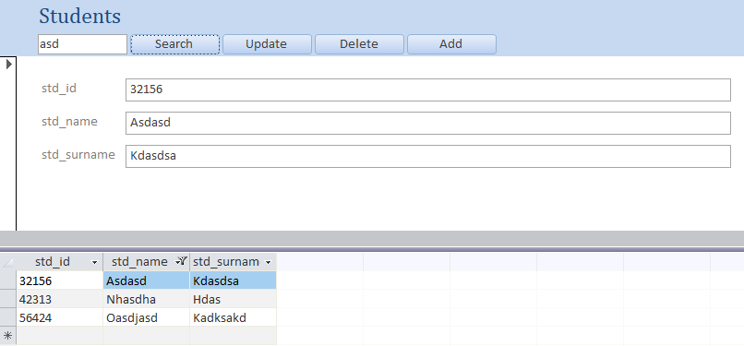

Update button also works properly. The screenshot below shows records before updating specific record.

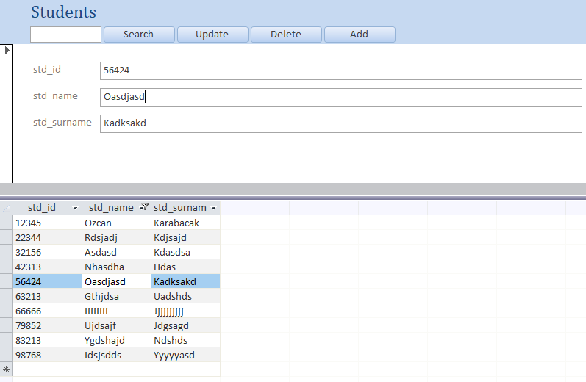

And the screenshot below shows the updated records. 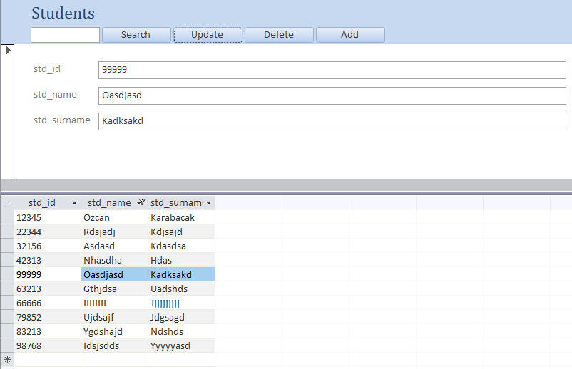

For deleting a database, another button is added. When clicked, it deletes specific record.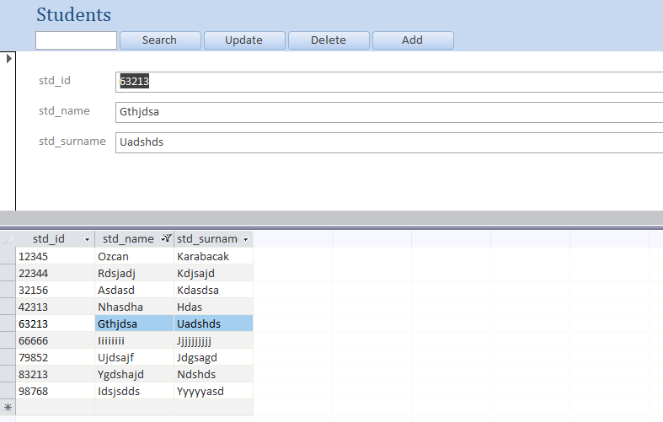

The student with std_id:99999 is deleted after clicked.

To add a new record, add button is added.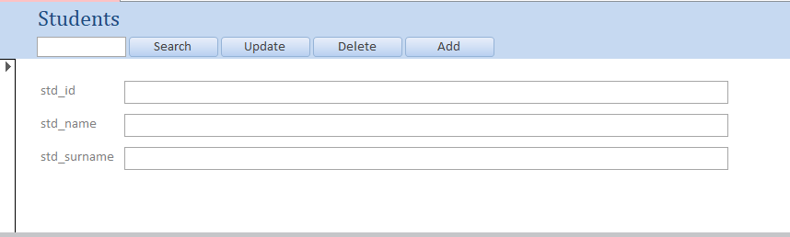

After filling the fields, the list of record is being updated with the new record.

## Report with Date Printed

This is an example of a record which was created for Courses table.

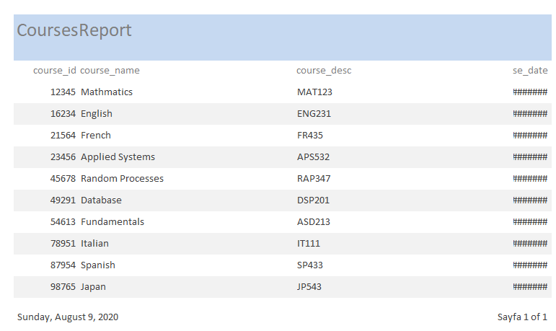

# Conclusions

This home assignment was mainly about creating and managing forms. During the process 14 forms are created. There are sub forms, navigation form and to be able to search, add, update, delete functions there are other forms as well. This home assignment also includes reports.

The most challenging part to create macros during the assignment. In the search function, it is designed for searching names. For example, if there are records including ‘a’ letter in the textbox, it searches and shows every record which has ‘a’ letter inside. It does not have to be in the beginning or in the end. During the process, another challenging part was to decide what kind of sub forms to use for the navigation form because when adding multiple forms with buttons which have macros, they were not compatible with each other. That is why the navigation form only includes basic sub forms with records. If people who wish to use those forms would like to use some functions like add, update, delete, search for specific tables, there are forms for specifically created for those purposes. Each button and function work correctly. There were some unsolved problems in that assignment. One of them is in the section 3.5. The course_date attribute has Date type and when using a report in MS Access, it does not show the dates directly. Instead, it shows a sign like “#######”. Overall, that home assignment was an opportunity to practice about MS Access more deeply and with that, navigation forms, sub forms, using macros, textboxes and buttons will be easier from now.