

**Department of Computer Engineering**

**CSE5041 Database Design & Development  
Project Report**

News Portal Database

**Due Date:** 11.12.2017

|  |  |  |
| --- | --- | --- |
|  | **ID** | **Name & Surname** |
|  | **1401020055** | **Özcan Özgür** |

**TABLE OF CONTENTS**

**1 INTRODUCTION** 4

1.1 PROJECT DESCRIPTION 4

**2 ENTITY RELATIONAL MODEL** 6

2.1 ENHANCED ER DIAGRAM 6

2.2 RELATIONAL SCHEMA & MAPPING 7

**3 NORMALIZATION** 8

3.1 FUNCTIONAL DEPENDENCIES 8

3.2 UNNORMALISED FORM 8

3.3 FIRST NORMAL FORM 8

3.4 SECOND NORMAL FORM 8

3.5 THIRD NORMAL FORM 8

**LIST OF FIGURES**

Figure 1: EER diagram of the News Portal Database ............................................. 6

# INTRODUCTION

## PROJECT DESCRIPTION

**News Portal DB:**

The News Portal Database stores information about the users, admins, the news, the authors, the comments and the suggestions. The following data have been identified in the requirements collection and analysis phase:

• The Portal has users. Each user has a unique username, password, a unique user ID, a name, a surname and an e-mail. The database keeps track of the number of users when a user signs up. Users may write comments and suggestions. Users may read news.

• The Portal has guests. Guests may read news without sign up. They can easily write comments by write with their names.

• All readers can filter news by authors and news type also they can filter authors by author name. They can see top 5 the breaking news, top 5 the most readed news and separately user comments with news title and guest comments with news title.

• The database has administrators. Admins manages advertisements, comments, users and authors. Admin has a name, a surname, a password, a unique username, a unique ID. Admins may add or delete advertisements and authors. They also may delete users, comments and news. Admins can see the entire processes name and also which one is done in which day.

• The authors manage news and managed by admin. Each author has popularity rate from 1 to 5 and all suggestions belong to authors. The author has a unique username, a password, an author news count, a suggestion count, a name, a surname and a unique author ID. All authors can add news.

• The portal has advertisements. Each advertisement has an area, a fee, a title, a description, a type, a date and duration. Ads area is 10 units. The size of the ad can be chosen by the ads company and they have to pay the price by the ad size and the ad duration. The database can calculate the fee by the entering the size and duration.

Also can view expired ad.

• The suggestions can be written by only the users. They can review the authors by this section and It’s have a date, a title, a description, a unique suggestion ID and the author point.

• The comments can be written by guests and users. It’s has a title, a description, a date, a unique comment ID.

• News has contents. Contents have a title, a description and a type. This information will be automatically added through the news. Additionally news has a location, date and a priority from 1 to 3.

# ENTITY RELATIONAL MODEL

## ENHANCED ER DIAGRAM

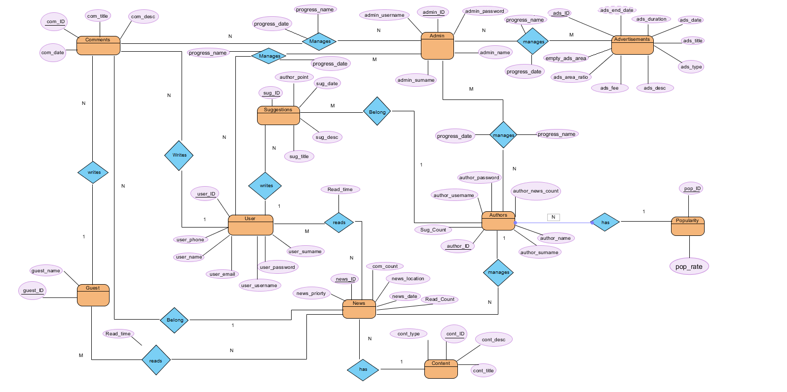

**Figure 1:** EER diagram of the News Portal Database

## RELATIONAL SCHEMA & MAPPING

Guest(Guest_ID(PK), Guest_Name);

User(User_ID(PK), User_Name, User_SurName, User_Phone, User_Password, User_UserName, User_EmaiI);

Content(Cont_ID (PK), Cont_Desc, Cont_Type, Cont_TitIe);

Authors(Author_ID(PK), Author_UserName, Author_Password, Author_Name, Author_SurName, Sug_Count, Author_Rate, Author_News_Count);

Popularity(Pop_ID(PK), Pop_Rate, Author_ID(FK from Author));

Suggestions(Sug_ID(PK), Sug_Date, Sug_TitIe, Sug_Desc, Author_Point, Author_ID(FK from Author),User_ID(FK from User)) ;

News(News_ID(PK), News_Location, News_Priority, New_Date, Com_Count, Read_Count Author_ID(FK from Authors), Cont_ID(FK from Content )) ;

Comments(Com_ID(PK), Com_TitIe, Com_Desc, Com_Date, Guest_ID(FK From Guest), User_ID(FK From User), News_ID(FK from News));

Readed_News(Readed_News_ID(PK), Read_Time, User_ID(FK from User), News_ID(FK from News));

Guest_ReadedNews(Guest_Readed_News_ID(PK), Read_Time, Guest_ID(FK from Guest), News_ID (FK from News));

Advertisements(Ads_ID(PK), Ads_Duration, Ads_Date, Ads_End_Date, Ads_TitIe, Ads_Type, Ads_Desc, Ads_Area, Empty_Ads_Area, Ads_Fee);

Admin(Admin_ID(PK), Admin_UserName, Admin_Password, Admin_Name, Admin_SurName);

ManageComment(Manage_Comment_ID(PK), Admin_ID(FK from Admin), Com_ID(FK from Comments));

ManageUser(Manage_User(PK), Admin_ID(FK from Admin), User_ID(FK from Users));

ManageAuthor(Manage_Author_ID(PK), Admin_ID(FK from Admin), Author_ID(FK from Authors));

ManageAdvertisement(Manage_Advertisement_ID(PK), Admin_ID(FK from Admin), Ads_ID(FK from Advertisement) );

# NORMALIZATION

## UNNORMALISED FORM

|  |  |
| --- | --- |
| GUEST ID | NEWS ID |
| 5 | 5,1,5 |
| 6 | 7,2,7,7 |
| 7 | 8,8,6 |

|  |  |
| --- | --- |
| USER ID | NEWS ID |
| 1 | 1,2,6,1,6 |
| 2 | 3,3 |
| 3 | 7,7,6 |

## FIRST NORMAL FORM

|  |  |
| --- | --- |
| USER ID | NEWS ID |
| 1 | 1 |
| 1 | 2 |
| 1 | 6 |
| 1 | 1 |
| 1 | 6 |
| 2 | 3 |
| 2 | 3 |
| 3 | 7 |
| 3 | 7 |
| 3 | 6 |

|  |  |
| --- | --- |
| GUEST ID | NEWS ID |
| 5 | 5 |
| 5 | 1 |
| 5 | 5 |
| 6 | 7 |
| 6 | 2 |
| 6 | 7 |
| 6 | 7 |
| 7 | 8 |
| 7 | 8 |
| 7 | 6 |