Cognitive Robotics Project
completed all tutorials till 10. Integrating ROS2 with py_trees. I follow Point 11. Simulate TurtleBot with BT. Gazebo starts but it does not pause or wait for me to hit the play button. Gazebo process die as I can read in the log due to Timed out waiting for transform from base_link to odom to become available.
You have zero TF publishers → your system cannot function
odom → base_link
ros2 topic echo /joint_states
ros2 node list | grep robot_state_publisher
ros2 run tf2_tools view_frames
Quick Test (It adds a bit more…but still exit.)
ros2 run tf2_ros static_transform_publisher 0 0 0 0 0 0 odom base_link
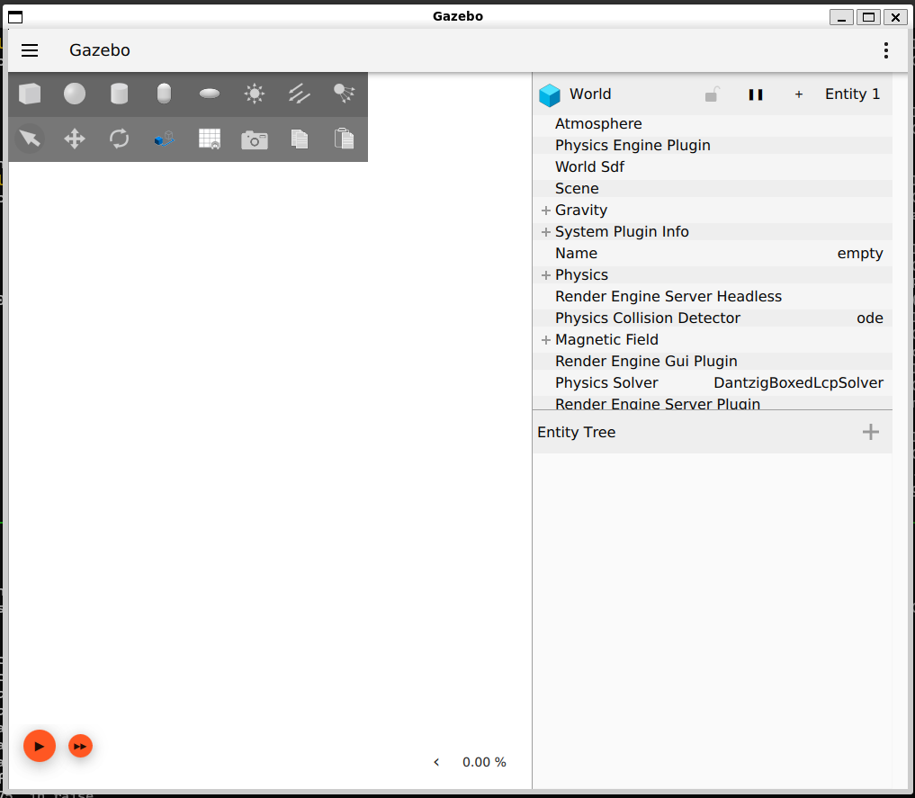
export TURTLEBOT3_MODEL=burger
export ROS_DOMAIN_ID=11
You need this to work.
export TURTLEBOT3_MODEL=waffle export GAZEBO_MODEL_PATH=$GAZEBO_MODEL_PATH:/opt/ros/humble/share/turtlebot3_gazebo/models
alias cls='clear'
alias domain='export ROS_DOMAIN_ID=11'
alias burger='export TURTLEBOT3_MODEL=burger'
alias echodomain='echo $ROS_DOMAIN_ID'
alias echomodel='echo $TURTLEBOT3_MODEL'
alias gazebomodel='export GAZEBO_MODEL_PATH=$GAZEBO_MODEL_PATH:$(ros2 pkg prefix turtlebot3_gazebo)/share/turtlebot3_gazebo/models/'
export GAZEBO_MODEL_PATH=$GAZEBO_MODEL_PATH:/opt/ros/humble/share/turtlebot3_gazebo/models
alias echogazebo='echo $GAZEBO_MODEL_PATH'

To clear this error when you call ROS2 Planning System console
2026-04-30 19:38:49.088 [RTPS_TRANSPORT_SHM Error] Failed init_port fastrtps_port10185: open_and_lock_file failed -> Function open_port_internal
rm -fr /dev/shm/fastrtps_port*

AWS

https://www.youtube.com/watch?v=6R_CImH8DYs
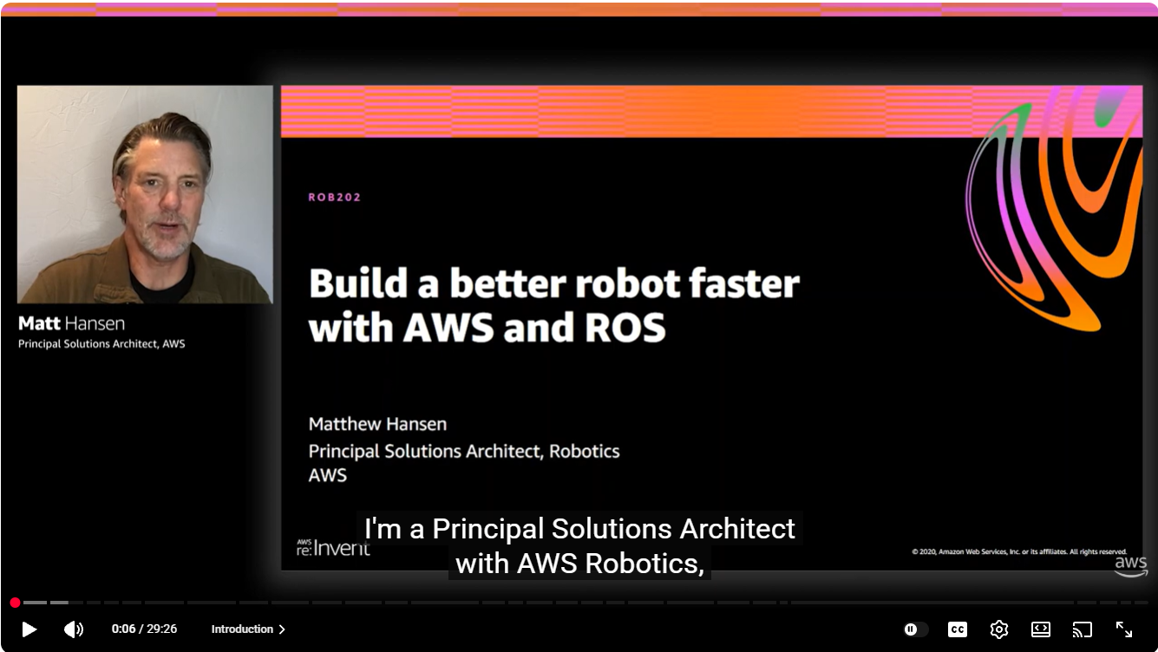

https://www.youtube.com/watch?v=nxXoTNIrXQk
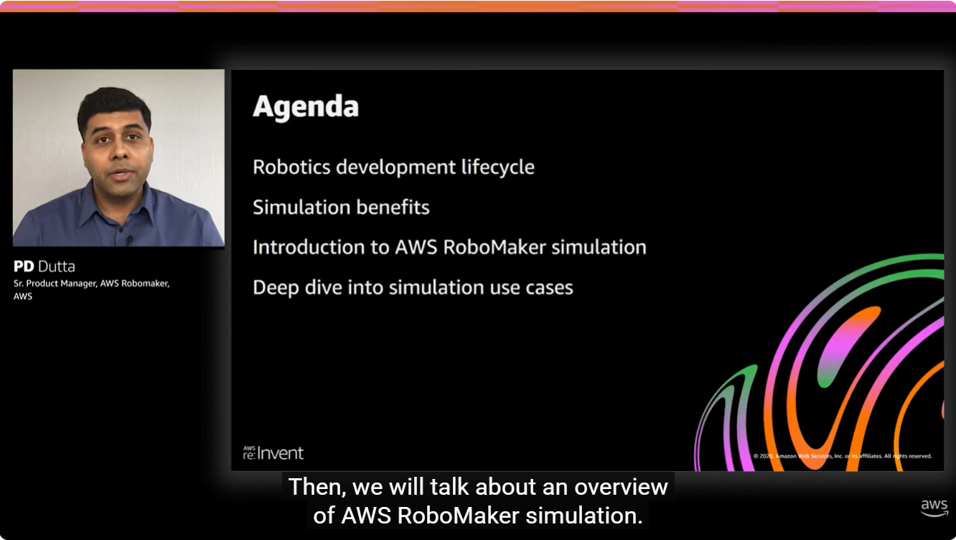

Launch Navigation: Ensure you have launched the Nav2 stack alongside Gazebo. For TurtleBot3, this is usually:
ros2 launch nav2_bringup tb3_simulation_launch.py use_sim_time:=true

Verify the Action Server: Open a new terminal and list the available actions. Look for /navigate_to_pose:
ros2 action list

Wait for Localization: Nav2 often won't start the navigate_to_pose server until it has a valid global localization (until you set the "2D Pose Estimate" in RViz or start a map).

ozcascante@Antonios-Laptop:~/plansys2_ws$ ros2 action list
/assisted_teleop
/backup
/compute_path_through_poses
/compute_path_to_pose
/drive_on_heading
/execute_plan
/follow_path
/follow_waypoints
/navigate_through_poses
/navigate_to_pose
/smooth_path
/spin
/wait

export TURTLEBOT3_MODEL=waffle
ros2 launch nav2_bringup tb3_simulation_launch.py headless:=False use_sim_time:=true
What This Command Does:
- headless:=False: This tells the system to start the gzclient (the 3D visual window) so you can actually see the robot move.
- use_sim_time:=true: This ensures RViz, Nav2, and Gazebo all stay perfectly synced to the virtual clock.
- tb3_simulation_launch.py: This is an "all-in-one" script that starts Gazebo, RViz, and the Nav2 stack simultaneously. [1, 2, 3]

Steps I have.

- /plansys2_ws$ ros2 launch plansys2_bt_example plansys2_bt_example_launch.py use_sim_time:=true
rm -rf /tmp/plansys2_*
- ~/plansys2_ws$ ros2 launch nav2_bringup tb3_simulation_launch.py headless:=False use_sim_time:=true autostart:=True
- Make sure everything is running with ros2 action list
- ~/plansys2_ws$ ros2 run plansys2_terminal plansys2_terminal
rm -fr /dev/shm/fastrtps_port*
- Source commands.txt
- Run

Fix: Try launching Gazebo and waiting for 2–3 minutes. Alternatively, manually clear the cache with rm -rf ~/.gazebo/models and restart to force a fresh attempt.
rm -rf ~/.gazebo/models

rm -rf /tmp/plansys2_*

Create a file with these commands.
For example, setup_tb3.sh
Put this inside

#!/bin/bash
# Set environment variables
export ROS_DOMAIN_ID=11
export TURTLEBOT3_MODEL=waffle
export GAZEBO_MODEL_PATH=$GAZEBO_MODEL_PATH:$(ros2 pkg prefix turtlebot3_gazebo)/share/turtlebot3_gazebo/models/
# Print variables to verify
echo "ROS_DOMAIN_ID: $ROS_DOMAIN_ID"
echo "TURTLEBOT3_MODEL: $TURTLEBOT3_MODEL"
echo "GAZEBO_MODEL_PATH: $GAZEBO_MODEL_PATH"
# Keep the shell open with the variables active
$SHELL

Save and make it executable
chmod +x setup_tb3.sh
To Run
source setup_tb3.sh

export LIBGL_ALWAYS_SOFTWARE=1
export SVGA_VGPU10=0

ros2 launch nav2_bringup tb3_simulation_launch.py headless:=False use_sim_time:=true world:=$(ros2 pkg prefix turtlebot3_gazebo)/share/turtlebot3_gazebo/worlds/turtlebot3_world.world

The plansys2_bt_example does not actually manage the map itself; it relies on the Navigation2 (Nav2) stack running in the background to handle environment representation.
Here is how the coordination works:
- Map Source: Nav2's map_server node is responsible for loading the .yaml and .pgm files you specify in your simulation launch.
- PlanSys2 Role: PlanSys2 acts as a "high-level boss." It looks at its PDDL domain and problem files to decide what needs to happen (e.g., "move the robot to wp1").
- BT Execution: When PlanSys2 triggers a "move" action, it executes the Behavior Tree (like your my_tree.xml) via a bt_action_node.
- Nav2 Interaction: Inside that Behavior Tree, specific nodes (like a NavigateToPose action node) send goals to the Nav2 Action Server. Nav2 then uses the map it has already loaded to plan a path and move the robot. https://docs.ros.org/en/humble/p/nav2_map_server/#:~:text=CLI%2Dusage-,Map%20Server,__params:=map_server_params.yaml

How to ensure PlanSys2 uses your new house map:
- Launch Nav2 with the House Map: When you start your simulation, you must ensure the map argument points to your house_explored.yaml.
bash
ros2 launch turtlebot_simulation start_simu.launch.py map:=/path/to/house_explored.yaml

map:=../Turtle_Navigation/turtle_slam/maps/house_explored.yaml
Define Waypoints: Since PlanSys2 moves between named waypoints (like wp1, wp2), you must update your waypoints to coordinates that exist within the free space of your new house map. If the old waypoints are now "inside" a wall in the house map, Nav2 will fail to find a path. https://docs.nav2.org/tuning/index.html#:~:text=the%20flipped%20orientation.-,Nav2%20Launch%20Options,in%20the%20package's%20maps/%20directory.

Latest Way to Start

- /plansys2_ws$ ros2 launch plansys2_bt_example plansys2_bt_example_launch.py use_sim_time:=true
rm -rf /tmp/plansys2_*
- ~/plansys2_ws$ ros2 launch nav2_bringup tb3_simulation_launch.py headless:=False use_sim_time:=true autostart:=True map:=/home/ozcascante/Turtle_Navigation/turtle_slam/maps/house_explored.yaml world:=/opt/ros/humble/share/turtlebot3_gazebo/worlds/turtlebot3_house.world

- Make sure everything is running with ros2 action list
- ~/plansys2_ws$ ros2 run plansys2_terminal plansys2_terminal
rm -fr /dev/shm/fastrtps_port*
- Source commands.txt
- Run

Teleoperation
ros2 run turtlebot3_teleop teleop_keyboard
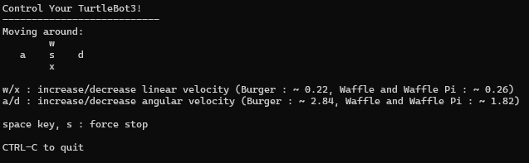
Tutorial to change the map and navigate around.
https://github.com/hildebrandt-carl/ROSSimulationTutorial

2. Approximate House World Coordinates
If you are using the standard turtlebot3_house world, here are the approximate safe center-points for those rooms:
PlanSys2 Zone | House Room | Approximate \([X, Y, Z]\)
wheels_zone | Kitchen | [-1.0, -2.5, 0.0]
steering_wheels_zone | Dining | [1.0, -1.0, 0.0]
body_car_zone | Bathroom | [1.5, 2.0, 0.0]
assembly_zone | Room 1 | [-1.5, 1.0, 0.0]
recharge_zone | Room 2 | [-2.0, -0.5, 0.0]
3. Update your YAML File
Replace the old values in your params.yaml with your new coordinates. For example:
move_1:
ros__parameters:
waypoint_coords:
wheels_zone: [-1.0, -2.5, 0.0] # Kitchen
steering_wheels_zone: [1.0, -1.0, 0.0] # Dining
body_car_zone: [1.5, 2.0, 0.0] # Bathroom
assembly_zone: [-1.5, 1.0, 0.0] # Room 1
recharge_zone: [-2.0, -0.5, 0.0] # Room 2

4. Verify in Simulation
After updating the file, rebuild your workspace (colcon build) and try to command the robot to a specific zone. If it hits a wall, adjust the coordinate in that direction by 0.1 or 0.2 meters.
Pro Tip: In RViz, you can also add a "Marker" display to visualize where these waypoints are located on the map to ensure they aren't inside furniture or walls.

Dinning X= -2.39, Y = 2.35
Kitchen X= -6.2, Y= 3.1
Utility X= -6.35 Y= -1.61
Bedroom2 X= 6.23 Y= -1.88
Bedroom1 X= 4.85 Y= 1.68
Bathroom X= 1.18 Y= 4.05

RTPS_TRANSPORT_SHM Error
killall -9 plansys2_node bt_action_node assemble_action_node gzserver gzclient rviz2
sudo rm /dev/shm/fastrtps*

The file tb3_nav_param.yaml is a core configuration file for the TurtleBot3 navigation stack in ROS 2
opt/ros/humble/share/turtlebot3_navigation2/param/waffle.yaml
1. Speed & Movement (Controller/Local Planner) [1]
These settings control how the robot physically moves toward its goal while avoiding obstacles. [1, 2]
- max_vel_x / min_vel_x: Sets the top speed and minimum speed for forward/backward movement.
- max_vel_theta: Controls the maximum rotational (turning) speed.
- acc_lim_x / acc_lim_theta: Sets how quickly the robot accelerates or brakes to prevent jerky movements.
- xy_goal_tolerance / yaw_goal_tolerance: Defines how close the robot must get to its destination to consider the task "finished". [1, 2, 3, 4]
2. Obstacle Avoidance (Costmaps) [1]
Costmaps represent where it is safe for the robot to drive.
- inflation_radius: This is one of the most commonly tuned parameters. It creates a "buffer zone" around obstacles to keep the robot from getting too close and bumping into walls.
- cost_scaling_factor: Adjusts how much the robot "dislikes" being near an obstacle. Higher values make the robot stay further away from walls.
- robot_radius or footprint: Tells the navigation system exactly how large the robot is so it doesn't try to squeeze through gaps that are too small. [1, 2]
3. Path Planning (Global Planner) [1]
These parameters affect the long-term path the robot calculates across the entire map. [1]
- use_dijkstra: You can switch this to false to use the A* algorithm instead, which can be faster for path calculation.
- allow_unknown: Determines if the robot is allowed to plan a path through areas of the map it hasn't explored yet. [1]
4. Localization (AMCL)
If your robot is getting "lost" or its position on the map is drifting, you can adjust these:
- min_particles / max_particles: Controls the "cloud" of possible locations the robot considers. More particles increase accuracy but use more CPU.
- alpha1 to alpha5: These represent the expected noise in the robot's movement (odometry) and sensor data. [1]
Pro-Tip for Editing
If you are working in a simulation (Gazebo), ensure use_sim_time: True is set at the top of the file so the navigation nodes sync with the simulator's clock. [1, 2]

Lets Try to modify the Patrol Example

- Launch the House Simulation
  - export TURTLEBOT3_MODEL=waffle_pi
  - ros2 launch turtlebot3_gazebo turtlebot3_house.launch.py

- Align your PDDL problem with the house's layout.
  - Mapping: You must first create and save a map of the house. Load this map into Nav2 so PlanSys2 has valid coordinates for each room.
  - Identify Room Coordinates: In RViz, find the \((x, y)\) coordinates for the center of each of the 5 rooms (e.g., kitchen, bedroom, living room).
  - Update PDDL Problem: In your PlanSys2 terminal or initialization node, define the rooms as instances of the room type and connect them based on the house layout.
    - set instance kitchen room
    - set instance bedroom room
    - set predicate (connected kitchen living_room)

- Use the Patrol Example
  - The plansys2_patrol_navigation_example provides a ready-made "move" action that interfaces with Nav2 (Tutorial)
  - ros2 launch plansys2_patrol_navigation_example patrol_example_launch.py
  - Add a Plan: Use the PlanSys2 terminal to set a goal like (and (robot_at tb3 room5)). The system will automatically calculate the path through intermediate rooms based on your "connected" predicates.
  - (Tutorial)
- Required Components
  - PlanSys2 Domain: Defines the move action.
  - Nav2 Stack: Must be running and localized using your house map.
  - Action Performers: You need a node (provided in the example) that takes the PlanSys2 "move" command and sends it to the Nav2 navigate_to_pose action server

Started by copy plansys2_patrol_navigation_example and rename to turtlebot3_house_navigation
Update package.xml and CMakeLists.txt to have the new name.
ros2 launch turtlebot3_house_navigation patrol_example_launch.py use_sim_time:=true

ros2 launch nav2_bringup tb3_simulation_launch.py headless:=False use_sim_time:=true autostart:=True map:=/home/ozcascante/Turtle_Navigation/turtle_slam/maps/house_explored.yaml world:=/opt/ros/humble/share/turtlebot3_gazebo/worlds/turtlebot3_house.world

ros2 launch turtlebot3_gazebo turtlebot3_house.launch.py
ros2 launch turtlebot3_navigation2 navigation2.launch.py use_sim_time:=True map:=/home/ozcascante/Turtle_Navigation/turtle_slam/maps/house_explored.yaml

ros2 launch turtlebot3_house_navigation patrol_example_launch.py use_rviz:=false

1. The Fix: Slow down the "Brain"
You need to adjust your nav2_params.yaml file (the one you found at the very beginning of our chat) to lower the update rates.
Open your params/nav2_params.yaml and find/change these values:
- expected_planner_frequency: Change from 20.0 or 10.0 to 1.0 or 2.0. (The robot doesn't need to re-plan the long path every second).
- controller_frequency: Change from 20.0 to 5.0. (This controls how often it calculates wheel speeds).
- bt_loop_duration: Look for this inside the bt_navigator section and increase it from 10 to 100 or 200.
2. Why it stops mid-way
When the "tick rate is exceeded" too many times, Nav2 assumes the system has frozen or become unsafe. As a safety precaution, it sends a zero-velocity command to the wheels to stop the robot until the CPU catches up.
3. Check for Obstacles
In your log, the robot is trying to go to (4.80, 1.70).
- Verify: Is that point inside a wall or very close to a piece of furniture?
- If the Inflation Radius in your costmap (from that same .yaml file) is too high, the robot might think the doorway is blocked and give up. Try lowering inflation_radius to 0.2 or 0.3.

What I have done so far.

- Completed all Tutorials – ran all examples successfully. Installed all libraries in my laptop using WSL and installed all libraries in the memory stick with Ubuntu. Both worked ok.
- Focus on PlanSys2 Examples
  - Explored PlanSys2_bt_example
  - Changed world and map.
  - Copy Turtle_Navigation/turtle_slam example into my WSL to use house_explored.yaml and house_explored.pgm.
  - Modify starting commands to:
- ros2 launch turtlebot3_house_navigation patrol_example_launch.py use_sim_time:=true
- ros2 launch nav2_bringup tb3_simulation_launch.py headless:=False use_sim_time:=true autostart:=True map:=/home/ozcascante/Turtle_Navigation/turtle_slam/maps/house_explored.yaml world:=/opt/ros/humble/share/turtlebot3_gazebo/worlds/turtlebot3_house.world

- Started Project using a simpler example. PlanSys2_patrol_navigation_example
  - Copy this example as starting point.
  - Change name to turtlebot3_house_navigation
    - Modified: CMakeLists.txt & package.xml
    - Keep /pddl/patrol.pddl unchanged.
    - Modify launch/patrol_example_launch.py. comment out nav2_cmd as it was causing Rviz to show the house map and the turtleworld.
    - Modify src/ move_action_node.cpp to include each house room coordinate and added a room6.
wp.pose.position.x = -2.4;
wp.pose.position.y = 2.3;
waypoints_["room1"] = wp;
wp.pose.position.x = -6.2;
wp.pose.position.y = 3.1;
waypoints_["room2"] = wp;
wp.pose.position.x = -6.3;
wp.pose.position.y = -1.6;
waypoints_["room3"] = wp;
wp.pose.position.x = 4.8;
wp.pose.position.y = 1.7;
waypoints_["room4"] = wp;
wp.pose.position.x = 6.2;
wp.pose.position.y = -1.9;
waypoints_["room5"] = wp;
wp.pose.position.x = 1.2;
wp.pose.position.y = 4.0;
waypoints_["room6"] = wp;
    - My laptop was struggling with the simulation, so I found changing some parameters in the param/nav2_params.yaml. Also decrease the Inflation Radius. (Robot struggling in corridor)
      - expected_planner_frequency: Change from 20.0 to 2.0. (The robot doesn't need to re-plan the long path every second).
      - controller_frequency: Change from 20.0 to 5.0. (This controls how often it calculates wheel speeds).
      - bt_loop_duration: increase it from 10 to 200.
      - If the Inflation Radius in costmap is too high, the robot thinks the doorway is blocked and give up. Lower inflation_radius to 0.2

- Created a commands.txt file. (made it executable).
set instance leia robot
set instance room1 waypoint
set instance room2 waypoint
set instance room3 waypoint
set instance room4 waypoint
set instance room5 waypoint
set instance room6 waypoint

set predicate (connected room1 room2)
set predicate (connected room2 room1)
set predicate (connected room2 room3)
set predicate (connected room3 room2)
set predicate (connected room1 room4)
set predicate (connected room4 room1)
set predicate (connected room4 room5)
set predicate (connected room5 room4)
set predicate (connected room4 room6)
set predicate (connected room6 room4)

set predicate (robot_at leia room3)
set goal (and (robot_at leia room6))

- Run
ros2 launch turtlebot3_gazebo turtlebot3_house.launch.py x_pose:=-6.3 y_pose:=-1.6 use_sim_time:=True headless:=False autostart:=True
ros2 launch turtlebot3_navigation2 navigation2.launch.py use_sim_time:=True headless:=False autostart:=True map:=turtlebot3_house_navigation/maps/house_explored.yaml
- Used 2D Pose to set the robot in RViz
ros2 launch turtlebot3_house_navigation patrol_example_launch.py use_sim_time:=True
ros2 run plansys2_terminal plansys2_terminal
- source commands.txt
- run

- Created a small script to set the environment. Setup_tb3.sh. (as I have been typing this forever!!!)
#!/bin/bash
#source setup.bash
source install/setup.bash
# Set environment variables
export ROS_DOMAIN_ID=11
export TURTLEBOT3_MODEL=waffle
export GAZEBO_MODEL_PATH=$GAZEBO_MODEL_PATH:$(ros2 pkg prefix turtlebot3_gazebo)/share/turtlebot3_gazebo/models/
# Improves Gazebo performance
export LIBGL_ALWAYS_SOFTWARE=1
export SVGA_VGPU=0
# Print variables to verify
echo "ROS_DOMAIN_ID: $ROS_DOMAIN_ID"
echo "TURTLEBOT3_MODEL: $TURTLEBOT3_MODEL"
echo "GAZEBO_MODEL_PATH: $GAZEBO_MODEL_PATH"
echo "LIBGL_ALWAYS_SOFTWARE: $LIBGL_ALWAYS_SOFTWARE"
echo "SVGA_VGPU: $SVGA_VGPU"

Ramdom Room start

Im still working on my Plansys2 project. I started from plansys2_patro_navigation_example. Change it to use house_explore.yaml. Use teleoperate to recorde coordinates of the center of each room. Put the coordinates in move_action_node. Left the pddl un-touched and created a simple knowledge to let the robot navigate from different rooms (waypoints) to other waypoints. That worked well. I input the starting point manually in this command (ros2 launch turtlebot3_gazebo turtlebot3_house.launch.py x_pose:=-6.3 y_pose:=-1.6). This is my current knowledge. set instance leia robot set instance room1 waypoint set instance room2 waypoint set instance room3 waypoint set instance room4 waypoint set instance room5 waypoint set instance room6 waypoint set predicate (connected room1 room2) set predicate (connected room2 room1) set predicate (connected room2 room3) set predicate (connected room3 room2) set predicate (connected room1 room4) set predicate (connected room4 room1) set predicate (connected room4 room5) set predicate (connected room5 room4) set predicate (connected room4 room6) set predicate (connected room6 room4) set predicate (robot_at leia room3) set goal (and (robot_at leia room6)) How can I start the robot in a random room? without me typing the coordinates

Create a Random Launcher
import subprocess
import random

# Coordinates you recorded earlier
rooms = {
"room1": {"x": -6.3, "y": -1.6},
"room2": {"x": -4.0, "y": 1.0},
"room3": {"x": 2.5, "y": 3.0},
# Add all your rooms here...
}

# Pick a random room
selected_room, coords = random.choice(list(rooms.items()))
print(f"Starting leia in {selected_room} at x={coords['x']}, y={coords['y']}")

# Launch Gazebo with these coordinates
cmd = [
"ros2", "launch", "turtlebot3_gazebo", "turtlebot3_house.launch.py",
f"x_pose:={coords['x']}", f"y_pose:={coords['y']}"
]
subprocess.run(cmd)

- Automate the Knowledge Base Update
- To avoid typing set predicate (robot_at leia roomX) every time, you can pipe the initialization into the PlanSys2 terminal or use a launch file. [1]
- Option A: Simple Bash Script
Wrap the random logic in a bash script that launches Gazebo and then sends the specific room name to PlanSys2: [1]
- # ... (logic to pick random room 'ROOM_NAME' and 'X/Y' coords) ...

- # 1. Start Gazebo in background
- ros2 launch turtlebot3_gazebo turtlebot3_house.launch.py x_pose:=$X y_pose:=$Y &

- # 2. Wait for PlanSys2 to be ready, then set the starting predicate
- sleep 5
- ros2 run plansys2_terminal plansys2_terminal -f commands.psys <<EOF
- set predicate (robot_at leia $ROOM_NAME)
- EOF
Option B: PlanSys2 Planning Controller (Recommended)
For a more robust project, use a Planning Controller node. This node can: [1]
- Read the current Gazebo ground truth from the /gazebo/model_states or /get_entity_state topic to determine which room it is closest to.
- Programmatically call the plansys2::KnowledgeBaseClient to set (robot_at leia roomX) based on that position before requesting a plan. [1, 2]
Summary of Workflow
- Step 1: Store your room coordinates in a central YAML or Python dictionary.
- Step 2: Use a script to pass a random set of those coordinates to the turtlebot3_house.launch.py.
- Step 3: Use a small script or Planning Controller to set the initial robot_at predicate in PlanSys2 based on the room chosen in Step 2. [1]

The Planning Controller is a high-level ROS 2 node that acts as the "brain" of your system. While your current workflow involves you manually typing commands into the plansys2_terminal, a controller automates this by programmatically talking to PlanSys2. [1]
To solve your "random room" problem, the controller will:
- Initialize Knowledge: Detect the robot's coordinates and set the correct (robot_at leia roomX) predicate.
- Set the Goal: Define what the robot should achieve.
- Execute: Trigger the planner to create a plan and tell the executor to run it. [1, 2, 3]
Example Python Planning Controller
You can create a new Python node in your package (e.g., house_controller.py). This node uses the ProblemExpertClient to update the knowledge base without the terminal. [1]
import rclpy
from rclpy.node import Node
from plansys2_msgs.msg import ActionExecutionInfo
from plansys2_msgs.srv import GetProblemInstances, GetProblemPredicates
from plansys2_helpers.plan_solver_client import PlanSolverClient
from plansys2_helpers.problem_expert_client import ProblemExpertClient
from plansys2_helpers.executor_client import ExecutorClient

class HouseController(Node):
def __init__(self):
super().__init__('house_controller')

# Clients to talk to PlanSys2 modules
self.problem_expert = ProblemExpertClient()
self.executor_client = ExecutorClient()

# Define room boundaries (from your teleop recording)
self.rooms = {
"room1": {"x": -6.3, "y": -1.6},
"room2": {"x": -4.0, "y": 1.0},
# ... add others
}

def init_simulation(self, start_room):
# 1. Add Instances (equivalent to 'set instance ...')
self.problem_expert.add_instance("leia", "robot")
for room in self.rooms.keys():
self.problem_expert.add_instance(room, "waypoint")

# 2. Set Start Predicate based on the chosen room
self.problem_expert.add_predicate(f"(robot_at leia {start_room})")

# 3. Add Connections (you can loop through your list)
self.problem_expert.add_predicate("(connected room1 room2)")
# ...

def run_mission(self, target_room):
# Set the goal
self.problem_expert.set_goal(f"(and (robot_at leia {target_room}))")

# Start execution
if self.executor_client.start_plan_execution():
self.get_logger().info("Plan started!")
Key Benefits for Your Project
- Automatic Initialization: Instead of a .psys file, this node can run at startup, look at where the robot actually is in Gazebo, and set the starting room dynamically.
- Dynamic Goals: You can change the goal based on sensor data (e.g., "if battery low, set goal to room with charger") instead of hardcoding it in the terminal.
- Error Handling: If an action fails (e.g., the robot gets stuck), the controller can receive a callback and trigger a "re-plan" automatically. [1, 2, 3]
How to use it with your Random Start
- Your Launch Script (from the previous answer) picks a random room and starts Gazebo.
- Your Planning Controller starts up, sees which room was picked (or reads the robot's Pose), and calls add_predicate(f"(robot_at leia {chosen_room})").
- The robot is now ready to plan from its current random location. [1, 2]
Do you want to see how to add a listener to the Controller so it automatically re-plans if a "connected" path is blocked?

Summary of specific YAML edits:
Section | Parameter | New Value
Both Costmaps | robot_radius | Remove and use footprint instead
Inflation Layer | cost_scaling_factor | 10.0
Inflation Layer | inflation_radius | 0.24
Controller | min_y_velocity_threshold | 0.01
Local Costmap | update_frequency | 2.0

