Article
High-Throughput and Low-Latency DrDoS Detection Using Quantized ONNX Models
Salih Eren ^{1,} Alperen Gültekin ^{1,} Ömer Özkan ¹ and İlker Özçelik ^{2,*}
¹ Department of Computer Engineering, Faculty of Engineering and Architecture, Eskisehir Osmangazi University, Eskisehir 26040, Türkiye; saliheren266@gmail.com (S.E.); alperen06gultekin@gmail.com (A.G.); o.ozkan4393@gmail.com (Ö.Ö.)
² Department of Software Engineering, Faculty of Engineering and Architecture, Eskisehir Osmangazi University, Eskisehir 26040, Türkiye
* Correspondence: ilker.ozcelik@ogu.edu.tr
Abstract
Distributed Reflection Denial of Service (DrDoS) attacks represent significant threats that induce service disruption by generating high-volume traffic via spoofed IP addresses. A prominent example, DNS Amplification, leverages small queries to generate disproportionately larger responses, magnifying the impact. Although deep learning methods effectively detect DrDoS attacks, their deployment in operational environments often results in substantial resource overhead and latency. Consequently, it is essential to evaluate operational performance alongside predictive accuracy. This study optimizes a Multilayer Perceptron (MLP) model for DNS-based DrDoS detection using ONNX and quantization techniques. The CIC-DDoS 2019 dataset was used for training and evaluation. Optimization involved comparing standard ONNX, dynamic quantization, and static quantization. Results show that the initial 0.57 MB Keras model (99.91% accuracy) exhibited latencies of 42 microseconds (CPU) and 49 microseconds (GPU). Converting to ONNX maintained accuracy while reducing latencies to 1.1 microseconds (CPU) and 64 nanoseconds (ns) (GPU). Dynamic quantization further reduced the model size by 89% to 0.06 MB. The study also discusses batch sizes and hardware configurations for operational deployment. These findings support developing lightweight, efficient solutions for real-time network security.
Keywords: DrDoS; DDoS; DNS amplification; ONNX; quantization; deep learning; intrusion detection; MLP; real-time detection; network security

1. Introduction
The Domain Name System (DNS), a cornerstone of contemporary digital infrastructure, enables users to access internet resources through memorable domain names instead of IP addresses. However, DNS was architected during the internet's formative stages, a period when security was not a primary design consideration. Consequently, the system remains inherently vulnerable to Distributed Denial of Service (DDoS) attacks [1]. These threats primarily manifest as DNS reflection and DNS resource exhaustion, where attackers exploit DNS servers as reflection vectors to generate high-volume traffic. This escalating threat landscape is evidenced by 2023 data showing a DNS component in 60% of all DDoS incidents [2], followed by a staggering 80% surge in such attacks during the first quarter of 2024 [3].
As the complexity and dynamic nature of these threats outpace traditional security solutions, deep learning-based methods have emerged as a robust alternative for intrusion detection. By leveraging large-scale network traffic data, these approaches can effectively identify anomalous behavior that evades rule-based systems. Although these models demonstrate high detection accuracy, their practical deployment is hindered by a significant operational hurdle. This challenge primarily concerns the necessity for real-time operation within critical infrastructure, such as Internet Service Providers (ISPs) and Internet Exchange Points (IXPs).
In these high-demand environments, model size and inference speed are of paramount importance [4]. The substantial memory requirements and prolonged latency associated with conventional deep learning architectures often create severe performance bottlenecks [5]. Consequently, the operational success of anomaly-based detection now depends heavily on model optimization and compression techniques. Among these, quantization has become indispensable, offering a means to significantly reduce both model footprint and execution time by converting model weights into lower-precision numerical formats [6].
Although a comprehensive intrusion detection pipeline entails several consecutive operations; including packet capture, line-rate parsing, flow aggregation, and classification; this study specifically isolates and benchmarks the deep learning inference stage. In modern high-speed security architectures, upstream network telemetry and preprocessing tasks are increasingly offloaded to high-performance kernel spaces or hardware acceleration interfaces (e.g., eBPF/XDP or DPDK), leaving the deep learning model itself as the primary software bottleneck. Thus, isolating the inference stage allows us to systematically evaluate model optimization and compression frameworks without introducing confounding variables from volatile network-stack performance. Within this scope, the primary contributions of this study to literature are summarized below:
- We establish a systematic, side-by-side comparative optimization framework evaluating the integration of ONNX conversion and quantization (both static and dynamic) across three structurally distinct neural network architectures (MLP, CNN, and GRU) developed for DNS DrDoS detection. To the best of our knowledge, no existing study provides such a comprehensive, multi-architecture benchmark under a single experimental setup.
- We demonstrate that integrating the ONNX Runtime with hardware acceleration yields dramatic efficiency gains. Based on a statistically rigorous 100-run evaluation of the baseline MLP model, CPU/GPU optimization reduced average inference latency from 4.3284 µs in the original Keras CPU model to 99.6ns (0.0996 µs) in the GPU-accelerated ONNX model (representing an approximately 43-fold speedup), while dynamic quantization reduced the model memory footprint by 89.4% (from 0.592 MB to 0.0629 MB).
- We provide extensive, multi-dimensional analysis mapping training and inference behavior across both CPU and GPU environments. By systematically varying batch sizes, we identify the exact trade-off thresholds where hardware acceleration offsets overhead, serving as a practical deployment guide for real-time systems.
The remainder of this paper is organized as follows: Section 2 reviews related studies and methodologies in literature. Section 3 provides a theoretical classification of DrDoS attack types and their characteristics. Section 4 details the experimental setup, dataset preprocessing, and feature selection procedures. The performance metrics utilized in the study are presented in Section 5. Section 6 introduces the proposed MLP architecture, while Section 7 explains the ONNX conversion and quantization optimization processes. Section 8 presents the experimental results. Finally, Section 9 concludes with discussion and concluding remarks.

2. Literature Review
While existing studies in the literature provide significant contributions to DrDoS attack detection, they often overlook the real-time performance requirements essential for high-volume traffic environments. This section examines studies that address this gap by evaluating model size and inference speed alongside anomaly detection performance.
In a study conducted by R. Doriguzzi-Corin et al. (2020), a lightweight and practical deep learning model titled LUCID (Lightweight Usable CNN in DDoS Detection) was proposed. This model utilizes a Convolutional Neural Network (CNN) architecture to classify traffic flows as either malicious or benign by processing them within time windows. Evaluated on the UNB201X dataset, LUCID achieved an F1 score of 0.9946. The authors reported that the model operates approximately 40 times faster than comparable models providing similar accuracy, with a processing capacity of 55,000 samples per second. When tested on low-power edge devices such as the NVIDIA Jetson TX2, the system demonstrated high efficiency and low resource consumption, proving its suitability for real-time intrusion detection [7].
Ibrahim et al. (2025) analyzed machine learning approaches based on feature optimization to enhance DDoS detection processes using the CICDDoS2019 dataset. By reducing the feature set from 24 to 10 variables, the researchers achieved an accuracy of 99.85% with both Random Forest and Decision Tree models. The study reported inference times of 4 milliseconds (ms) for the Decision Tree and 240 ms for the Random Forest model [8].
Hernandez et al. (2025) analyzed GPU-accelerated deep learning models using multivariate time series data for real-time DDoS detection in high-speed networks. The study found that the TCN architecture maintained consistent performance regardless of window size, achieving an F1 score of 99.86% with a low average inference time ranging between 20 and 55 microseconds [9].
Sever and Öğüt (2021) conducted a comparative analysis of the inference latency of deep learning models converted to the ONNX format across different execution environments. In their research, a two-layer neural network developed in PyTorch was converted to Torch Script and ONNX formats, then executed on CPU and GPU via a C++ interface. Results indicated that the ONNX + TensorRT (GPU) combination provided the lowest latency at 390 microseconds. The study concludes that the combination of ONNX and TensorRT offers an effective infrastructure for high-speed AI inference on edge devices [10].
Alemayehu et al. (2026) proposed a Deep Reinforcement Learning-based PPO agent for real-time DDoS detection in Industrial IoT (IIoT) environments. The policies were converted to the ONNX format, facilitating a reduction in model size to 1–2 MB and an inference latency of less than 23 microseconds per sample, with detection accuracy of up to 99.3% [11].
Sharmila and Nagapadma (2023) introduced a Quantized Autoencoder (QAE) model for network anomaly detection on resource-constrained IoT edge devices. The QAE-u8 variant achieved a 70.01% reduction in average memory usage, a 92.23% reduction in model size, and a 27.94% reduction in CPU utilization on the RT-IoT2022 dataset [12].
In a study by Khantouchi et al. (2024), the Eye-Net model was proposed for DDoS detection in IoT environments. Using Quantization-Aware Training (QAT) with INT8 precision, the model reportedly achieved 99.99% accuracy and an F1 score of 99.99% on the CICDDoS2019 dataset [13].
Nkoom et al. (2026) proposed a federated learning framework for real-time DDoS detection on Internet of Robotic Things (IoRT) devices. Using QAT with differential privacy-based clustering, the model size was compressed from 0.52 MB to 0.13 MB. Inference speed was increased 433-fold, reducing latency to below 150 microseconds [14].
Most studies focusing on DrDoS and DDoS detection in the literature aim to reduce inference times to the millisecond range through lightweight architectures (LUCID [7]) or feature optimization [8]. In contrast, the ONNX-based MLP model presented in this study achieves an inference time of 64 nanoseconds on the GPU, significantly outperforming the performance metrics of Nkoom et al. [14].
Regarding model compression and memory efficiency, Sharmila and Nagapadma [12] achieved a 92.23% reduction in size using a QAE. In this study, the application of Post-Training Quantization (PTQ) and ONNX optimization achieved an 89.09% reduction in file size without requiring complex retraining processes. Furthermore, the proposed system can process over 10 million inferences per second at a batch size of 4096, compared to the throughput of 55,000 samples per second achieved by the LUCID [7] model.

3. Classification of DrDoS Attacks
DNS Distributed Reflection and Amplification (DrDoS) attacks represent a significant security threat that leverages the DNS infrastructure to cause service disruption and network congestion. By exploiting open DNS resolvers and the inherent discrepancies in response sizes within the DNS protocol, these attacks aim to overwhelm targeted systems with massive volumes of spoofed traffic [15]. DrDoS DNS attacks can be categorized into four primary classifications based on [16]:
- DNS Record Type Employed
- Amplification Factor
- Targeted DNS Infrastructure
- Attack Vector

3.1. Classification Based on the DNS Record Type Employed
Attackers utilize various DNS record types to maximize the reflection and amplification effects. While ANY queries generate high-volume traffic by producing large responses that include all available DNS records, attacks based on TXT records allow for massive responses to be derived from small queries due to the length of text-based entries. Similarly, attacks leveraging MX and NS records result in large responses containing lists of multiple mail servers or authoritative name servers. Furthermore, AAAA records increase the response size due to the length of IPv6 addresses, while CNAME records can indirectly escalate the traffic load by triggering additional recursive queries.

3.2. Classification Based on the Amplification Factor
The potential impact of an attack is determined by the amplification factor, which denotes the ratio of the response size received to the size of the submitted query. Although low amplification factor attacks generate responses with lower volumes, their impact is compounded by a high frequency of queries. In medium amplification factor attacks, the responses are larger, making the attack's impact more pronounced. Finally, high amplification factor attacks enable attackers to elicit exceptionally large responses using minimal query data.

3.3. Classification Based on the Targeted DNS Infrastructure
DrDoS attacks can target various components of the DNS infrastructure within a network. Based on these targets, attack types are classified as Recursive Resolver attacks, which utilize open resolvers as reflectors. Alternatively, authoritative name servers may be targeted directly to induce resource exhaustion. Vulnerabilities in DNSSEC are also frequently exploited, as its validation processes require intensive computational resources.

3.4. Classification Based on the Attack Vector
The diversity of techniques employed by attackers allows for classification by attack vector. Single-vector DNS DrDoS attacks are relatively straightforward operations involving a single type of query. Conversely, multi-vector DNS DrDoS attacks, which combine different query types, exhibit a more complex and high-volume structure.

4. Experimental Setup
In this study, a deep learning model was developed and trained to detect DNS-based reflection attacks (DrDoS), a specific variant of Distributed Denial-of-Service (DDoS) attacks. For the model training phase, the DNS DrDoS subset of the CIC-DDoS-2019 dataset [17] was utilized. The implementation was executed in a Google Colab A100 GPU environment. To ensure reproducibility of the experimental results, the dataset train/test partitioning, neural network weight initializations and the exact software environment, including library dependencies, package versions and hardware profiling parameters, are exhaustively cataloged in the Supplementary Materials. The systematic research workflow followed during this process is illustrated in Figure 1.
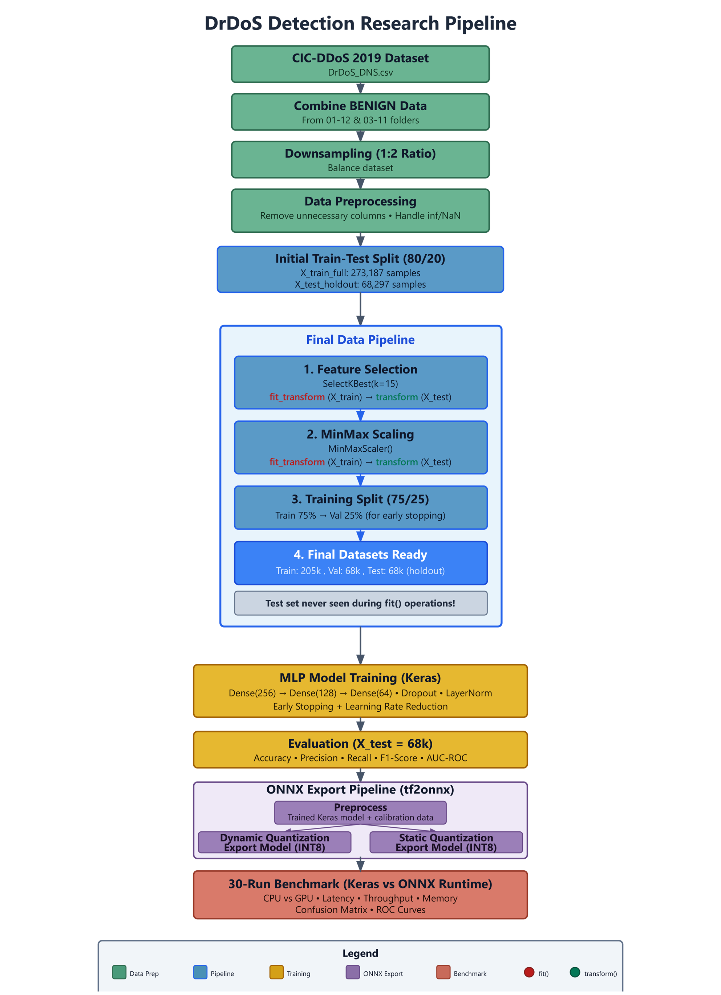
Figure 1. Research Workflow.

4.1. Dataset Selection and Characteristics
The CIC-DDoS-2019 dataset is a comprehensive repository derived from real-world network traffic, encompassing various types of DDoS attacks. Since this study focuses specifically on DNS-based reflection and amplification (DrDoS) attacks, the relevant subset of the dataset was employed. An analysis of the class distribution in the original DrDoS_DNS file revealed 3,402 Benign traffic samples and 5,071,011 DrDoS attack samples. This substantial class imbalance represents a critical factor that must be addressed during the model training process.

4.2. Data Pre-processing Stage
Data preprocessing is vital to model success, transforming raw network captures into a machine-learning-ready format. The target day of the DrDoS attack in the CIC-DDoS-2019 dataset contains a massive volume of attack packets but a severely limited representation of normal traffic. To establish a robust background baseline of normal network behavior, we gathered and consolidated all available benign packets across the other recording days of the official CIC-DDoS-2019 dataset, yielding a total of 113,828 benign samples. Despite this consolidation, the ratio of benign to DrDoS packets remained heavily imbalanced at approximately 1:44. To prevent biased learning while fully retaining our valuable normal traffic, downsampling was applied exclusively to the majority DrDoS attack class. All 113,828 benign samples were preserved, while the massive DrDoS attack pool was uniformly and randomly subsampled to 227,656 samples. This established a controlled 1:2 (Benign to DrDoS) ratio, resulting in a balanced benchmark dataset of 341,484 packets. Because this uniform downsampling of the homogeneous attack class was executed without parameterized transformations or cross-sample dependencies, it does not introduce any data leakage across the subsequent train-test partition.
During the analysis of the features, the cardinality of each column was examined. Identifying fields such as 'Flow ID', 'Source IP', 'Destination IP', and 'Protocol' — which exhibit low diversity and could negatively impact generalization — were removed, along with the 'SimillarHTTP' column, which could not be converted into a numerical format.
In the data cleaning process, missing values were handled using SimpleImputer by replacing them with the mean values of the respective columns, while infinite values were replaced with NaN. Additionally, twelve columns containing constant values with zero variance were eliminated (e.g., Bwd PSH Flags, Fwd URG Flags, Bwd URG Flags, FIN Flag Count, PSH Flag Count, ECE Flag Count, Fwd Avg Bytes/Bulk, Fwd Avg Packets/Bulk, Fwd Avg Bulk Rate, Bwd Avg Bytes/Bulk, Bwd Avg Packets/Bulk, and Bwd Avg Bulk Rate). These steps enabled the model to produce more stable and accurate results.
Data scaling is a critical step to prevent machine learning models from being adversely affected by large discrepancies in the range of feature values. It is essential to perform the scaling stage after the data splitting process to avoid data leakage. If scaling is conducted on the entire dataset, the statistics of the training set would influence the test and validation sets, potentially leading to a biased evaluation of real-world performance [18]. In this study, the dataset was first partitioned into 80% training and 20% test sets; subsequently, Min-Max scaling was applied using only the statistics derived from the training set. The learned scaling parameters were then applied to the test set, thereby preventing leakage. Min-Max scaling was preferred as it maps input data to a fixed range, providing the limited value interval required by the quantization algorithm.

4.3. Feature Selection
A filter-based feature selection method was implemented to enhance model performance, reduce computational complexity, and improve interpretability. In this study, the Mutual Information method was chosen for its capacity to capture non-linear relationships between variables. In machine learning-based systems developed for DrDoS detection, accurate feature selection plays a critical role in ensuring model generalizability and consistent performance across diverse network environments. During the feature selection process, it was observed that rate-based features such as Flow Bytes/s, Flow Packets/s, and Fwd Packets/s achieved high scores [19].
To prevent data leakage, the SelectKBest algorithm was fitted exclusively on the training data, and the learned transformation was subsequently applied to the test data. Three distinct feature sets consisting of 5, 10, and 15 features were created based on Mutual Information scores. The features utilized for the model tests are presented in Table 1, Table 2, and Table 3, respectively.

Table 1. Top 5 Features Ranked by Mutual Information Score.
Category | Features
Packet Size Features | Min Packet Length, Fwd Packet Length Min, Fwd Packet Length Mean, Avg Fwd Segment Size, Average Packet Size
Table 2. Top 10 Features Ranked by Mutual Information Score.
Category | Features
Packet Size Features | Min Packet Length, Fwd Packet Length Min, Avg Fwd Segment Size, Fwd Packet Length Mean, Average Packet Size, Packet Length Mean, Fwd Packet Length Max
Flow Statistics | Inbound, Flow Bytes/s, Flow Packets/s
Table 3. Top 15 Features Ranked by Mutual Information Score.
Category | Features
Packet Size Features | Min Packet Length, Fwd Packet Length Min, Avg Fwd Segment Size, Fwd Packet Length Mean, Average Packet Size, Packet Length Mean, Fwd Packet Length Max, Max Packet Length
Flow Statistics | Inbound, Flow Bytes/s, Flow Packets/s, Fwd Packets/s
Time Features | Flow Duration, Bwd IAT Total, Fwd IAT Max, Fwd IAT Mean
Header / Flag Features | URG Flag Count
Ratio Based Features | Down/Up Ratio

5. Model Performance Metrics
The metrics utilized to evaluate the performance of a classification model are predicated on the correlation between the model's predictions and the ground truth labels. Within this framework, four fundamental measurement parameters are established:
True Positive (TP): Represents the count of instances that are positive (e.g., an attack) and are correctly identified as positive by the model.
True Negative (TN): Denotes the number of instances that are negative (e.g., normal behavior) and are accurately classified as negative by the model.
False Positive (FP): Refers to instances that are negative but are erroneously categorized as positive by the model.
False Negative (FN): Refers to instances that are positive but are erroneously categorized as negative by the model.
The following evaluation metrics are derived utilizing these four primary parameters:

5.1. Accuracy
This metric is defined as the ratio of correctly predicted instances to the total number of samples within the dataset.
Accuracy = (TP + TN) / (TP + TN + FP + FN) (1)

5.2. Precision
This metric indicates the proportion of instances classified as positive that are truly positive.
Precision = TP / (TP + FP) (2)

5.3. Recall (Sensitivity)
This metric measures the proportion of actual positive instances that were correctly identified by the model.
Recall = TP / (TP + FN) (3)

5.4. F1-Score
Defined as the harmonic mean of precision and recall, this metric provides a more robust performance measure, particularly in the context of imbalanced datasets.
F1 Score = 2 × (Precision × Recall) / (Precision + Recall) (4)
Evaluating these metrics in conjunction facilitates a comprehensive analysis of attack detection performance, moving beyond a singular focus on overall accuracy.

6. Multi-Layer Perceptron Model and Architecture
A machine learning model was trained using the prepared balanced dataset following the application of feature selection. This study utilizes the Multi-Layer Perceptron (MLP) algorithm due to its inherent capacity to learn non-linear relationships. MLP serves as an effective methodology for modeling complex attack patterns, particularly high-volume and time-sensitive DDoS attacks such as DrDoS-DNS. Furthermore, the high compatibility of MLP with the Open Neural Network Exchange (ONNX) format facilitates seamless model portability across diverse platforms and enables low-latency execution within real-time systems. Existing literature corroborates the successful implementation of MLP in detecting DDoS and specifically DNS-based reflection attacks, noting that it yields superior accuracy and F1-scores compared to traditional classical methods [20].
MLP is a feed-forward artificial neural network model characterized by one or more hidden layers situated between the input and output layers. To enhance generalization capability and mitigate overfitting, Dropout and Layer Normalization layers were integrated following the hidden layers. While Dropout layers reduce the model's over-reliance on specific features by randomly deactivating a set proportion of neuronal connections during training, Layer Normalization stabilizes the learning process at each layer, ensuring more consistent training dynamics.
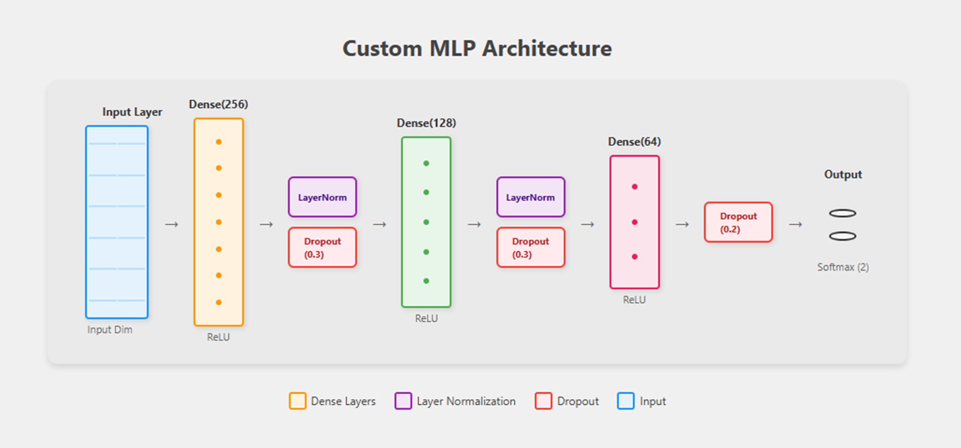
Figure 2. MLP Model Structure.
To facilitate model training and the instantaneous monitoring of the learning process, the dataset was partitioned using stratified sampling — to preserve class balance — into an 80% training set and a 20% test (hold-out) set. The initial training block was further subdivided into 75% training and 25% validation data. Consequently, the total dataset was effectively distributed as 60% training, 20% validation, and 20% testing.
As illustrated in Figure 2, the developed MLP model consists of an input layer, three hidden layers, and an output layer. The hidden layers comprise 256, 128, and 64 neurons, respectively, with each layer employing the ReLU activation function. Following the first two hidden layers, both Layer Normalization and a 30% Dropout rate were applied. A 20% Dropout rate was implemented after the third hidden layer. Finally, a Softmax activation function was utilized in the output layer to calculate class probabilities.
The model was compiled using the Adam optimization algorithm and the sparse categorical cross-entropy loss function, with accuracy serving as the primary performance metric. The training process was supported by an early stopping mechanism monitored against the validation loss. Furthermore, ReduceLROnPlateau was implemented to decrease the learning rate upon stagnation of the validation loss, and ModelCheckpoint was utilized to record the optimal weights. The training phase was capped at a maximum of 20 epochs.
To evaluate the performance differential between Keras and ONNX models, training duration and throughput were measured across various batch sizes. As demonstrated in the Throughput vs. Batch Size analysis in Figure 4, the performance gap becomes significant starting from a batch size of 1024. Consequently, a batch size of 1024 was adopted for this study, as this trend remained consistent across the Keras, ONNX, and quantized versions.

7. ONNX and Quantization
To enhance the operational efficiency of machine learning models, models trained via TensorFlow/Keras were converted into the Open Neural Network Exchange (ONNX) format. Although this conversion was facilitated by the tf2onnx tool — particularly for Sequential architectures — it required the manual specification of certain technical parameters, such as output_names. Consequently, the model was initially encapsulated within the Functional API and transformed into a standard tf.keras.Model structure to ensure compatibility.
Significant reductions in both memory footprint and inference latency were achieved by applying quantization techniques to the converted model. Conversely, it was observed that auxiliary steps such as model simplification (ONNX Simplifier) and graph-level optimization, performed independently of quantization, provided no measurable improvement in this specific study.
Within the scope of dynamic quantization, only the model weights were converted to INT8 format, while activations were maintained as FP32 during runtime. In static quantization, however, both weights and activations were converted to INT8. This configuration enabled the utilization of optimized operators such as QLinearMatMul, facilitating more efficient, hardware-accelerated inference. Nevertheless, this approach resulted in a marginally higher degradation in accuracy compared to the dynamic method.

8. Experimental Results

8.1. Batch Size Selection
Figure 3 illustrates the variation in the total training duration required for 20 epochs, categorized by batch size and hardware type. The data obtained indicates that an increase in batch size leads to reduction in training time across both hardware configurations.
- On the CPU, the training duration, which was measured at 376.1 seconds with a batch size of 32, decreased by 91.4% to 32.2 seconds when the batch size was scaled to 4096.
- Similarly, the initial duration of 351.6 seconds on the GPU dropped to 24.5 seconds at a batch size of 4096.
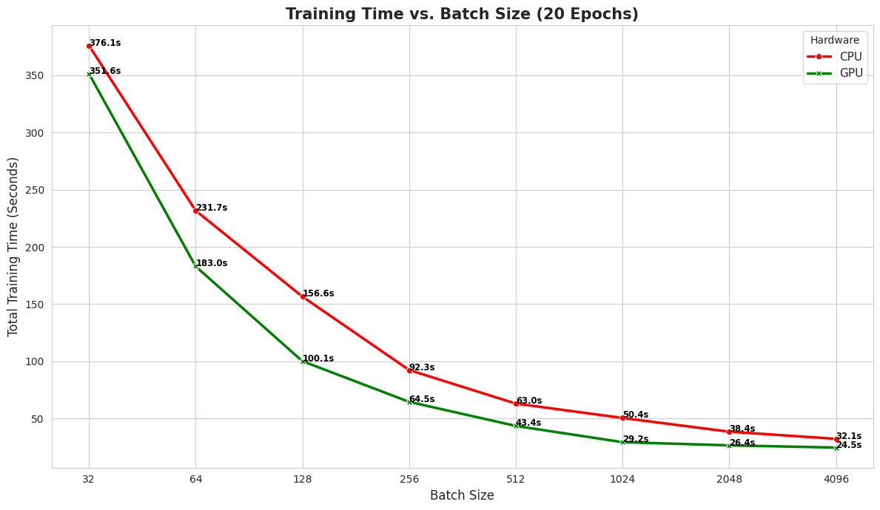
Figure 3. Training Time vs Batch Size.
Figure 4 illustrates the throughput values — representing the number of inferences per second — achieved by various model formats and hardware configurations. According to the analysis results:
- The highest throughput was attained by the standard ONNX-GPU configuration. This setup exhibited an exponential performance increase as the batch size expanded, exceeding 1.0 × 10⁷ inferences per second at a batch size of 4096.
- On the GPU, the statically quantized ONNX model demonstrated the second-highest performance, trailing only the standard ONNX model. However, it was observed to fall behind the standard ONNX model at larger batch sizes (2048 and 4096).
- The throughput of Keras-based models (both CPU and GPU) remained limited despite the increase in batch size, consistently performing below models utilizing the ONNX runtime.
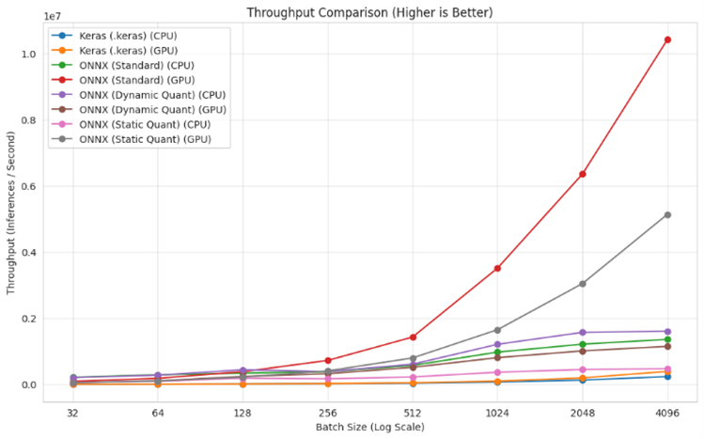
Figure 4. Throughput vs Batch Size.
Figure 5 presents the results of the latency analysis, which defines the average time elapsed to process a single instance. This metric holds critical significance, especially for real-time applications.
- At smaller batch sizes (32 and 64), a substantial performance disparity was recorded between the model formats. With a batch size of 32, the average latency of Keras models was approximately 350 microseconds, whereas all ONNX variants maintained values below 50 microseconds.
- As the batch size increased to 256 and beyond, the latency of Keras models declined owing to augmented parallel processing capabilities, eventually converging toward the performance levels of the ONNX-based models.
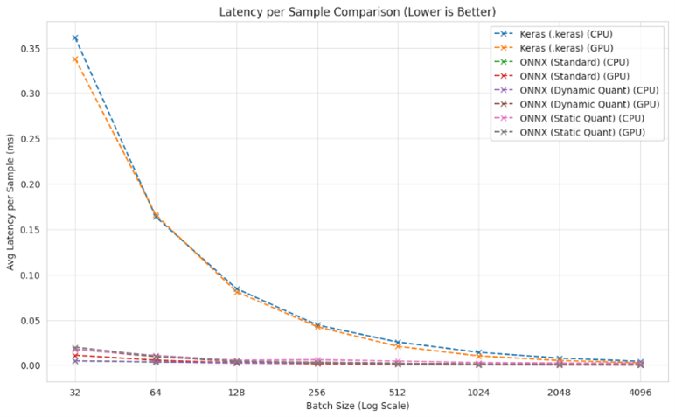
Figure 5. Latency vs Batch Size.

8.2. Performance Test Results
To evaluate the model's efficacy, tests were conducted on a dataset balanced through down sampling. The performance of models trained with varying numbers of selected features was assessed based on training, validation, and testing metrics. Three distinct MLP models were trained using the top 5, 10, and 15 features, followed by a comparative analysis of their respective results.
To ensure statistical robustness and consistency, 30 training iterations were performed for each feature set, and an optimal threshold was uniquely determined for each iteration. The performance evaluations presented in Table 4 represent the mean values derived from these 30 rounds.
Table 4. Comparison of Three Deep Learning Models Metrics (Keras).
Metric | MLP | CNN | GRU
Train Accuracy | 0.9976 | 0.9980 | 0.9970
Validation Accuracy | 0.9983 | 0.9984 | 0.9977
Train Loss | 0.0108 | 0.0093 | 0.0129
Test Accuracy | 0.9985 | 0.9984 | 0.9977
Test Precision | 0.9993 | 0.9991 | 0.9987
Test Recall | 0.9984 | 0.9985 | 0.9979
Test F1-score | 0.9988 | 0.9988 | 0.9983
Test AUC | 0.9999 | 0.9999 | 0.9997
According to the data in Table 4, the model trained with 15 features achieved a test accuracy of 99.79% and a training loss of 0.0094, representing the lowest error rate observed. For models utilizing 10 and 5 features, the test accuracy was recorded at 99.78% and 99.74%, respectively. As the number of features decreased, the training loss exhibited an upward trend, reaching 0.0128 in the 5-feature model.
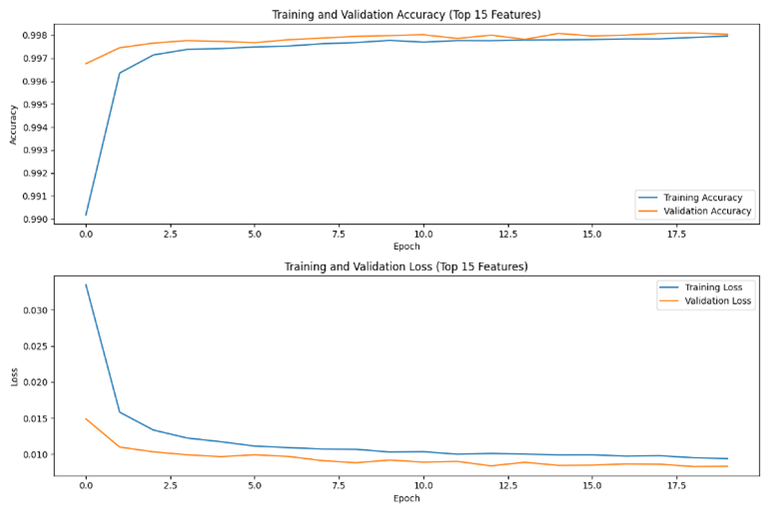
Figure 6. Validation-Training Loss and Accuracy Graphs for the Top 15 Features.
Figure 6 demonstrates that both training and validation loss decreased as the epochs progressed. The AUC for the optimal 15-feature model was calculated as 0.9998. The corresponding AUC values for the 10-feature and 5-feature models were 0.9997 and 0.9995, respectively. As shown in Figure 7, the ROC curves for all models consistently trend toward the upper-left corner of the plot.
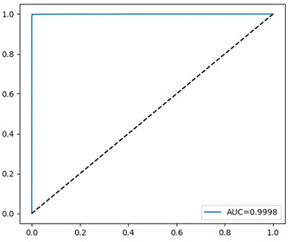
Figure 7. Test ROC Curve for the Top 15 Features Model.
The classification distribution for the model trained with 15 features is detailed in the confusion matrix in Figure 8. Within the test dataset, 22,742 of the 22,766 benign traffic instances were correctly classified as True Negatives (TN), while 24 instances were mislabeled as False Positives (FP). Regarding the Attack class, 45,475 out of 45,531 samples were identified as True Positives (TP), with only 56 samples recorded as False Negatives (FN).

8.3. ONNX Conversion and Inference Performance Comparison
The impact of converting the Keras-trained MLP model to the ONNX format on inference performance was investigated. Comparisons were conducted between ONNX models at various precision levels (FP32, Dynamic Quantization, and Static Quantization) and Keras models across CPU and GPU hardware. Average inference latency per sample and model size for these configurations are detailed in Table 5.
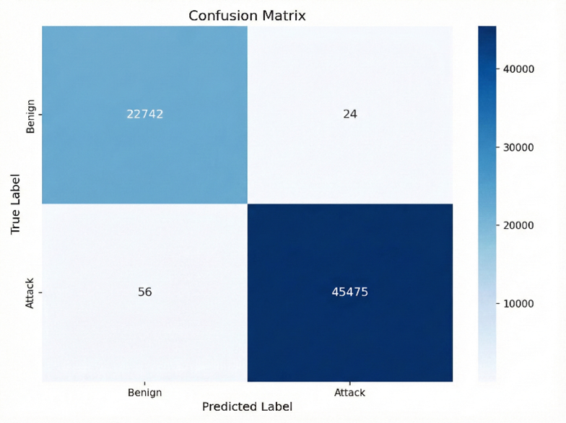
Figure 8. Confusion Matrix.
The conversion and quantization processes did not result in any degradation of the model's classification capability. Experimental results showed that Accuracy, Precision, Recall, and F1-Score remained stable at approximately 0.9988 across all formats. The AUC was maintained at approximately 0.9999. These findings demonstrate that the model's predictive efficacy was preserved during the compression process.
In contrast, models converted to the ONNX format achieved a significant reduction in inference latency compared to the original Keras model. The top-performing ONNX-GPU configuration (64 nanoseconds) executed inference approximately 660 times faster than the Keras-CPU configuration (42.73 microseconds). The initial Keras model size of 0.573 MB was decreased to 0.063 MB under Dynamic Quantization, representing a reduction of over 89%.
Table 5. Comparison Summary.
Model | Environment | Inference Time (µs) | File size (MB)
Keras | CPU | 42.7359 | 0.5732
Keras | GPU | 49.2048 | 0.5732
ONNX | CPU | 1.1798 | 0.1858
ONNX | GPU | 0.0642 | 0.1858
Dynamic Quantized ONNX | CPU | 1.0028 | 0.0625
Dynamic Quantized ONNX | GPU | 0.8498 | 0.0625
Static Quantized ONNX | CPU | 3.2957 | 0.0873
Static Quantized ONNX | GPU | 0.1007 | 0.0873
To evaluate the model's efficiency in real-time applications, the impact of various batch sizes on throughput was analyzed. At low batch sizes (e.g., 32–128), throughput remains relatively low due to the dominance of data transfer overhead. However, a distinct acceleration in GPU throughput was observed when the batch size was increased to 512 and above. Specifically, the combination of ONNX Runtime and CUDAExecutionProvider (GPU) achieved over 10 million inferences per second at a batch size of 4096. These findings indicate that large batch sizes and GPU-based acceleration are critical for ensuring the system operates without bottlenecks in high-traffic network environments.
The impact of different batch sizes on the average latency per sample was also examined. As the batch size increases, the parallel processing capacity of the GPU allows fixed costs to be distributed across thousands of samples, resulting in amortization. ONNX models — especially the quantized versions — exhibited a lower and more stable latency profile even at small batch sizes.
An analysis of training durations reveals a clear inverse relationship between batch size and training time. At a batch size of 32, the training duration was measured at 376.1 seconds on the CPU and 351.6 seconds on the GPU, representing only a marginal improvement. This performance convergence at low batch sizes can be explained by Kernel Launch Overhead. Consequently, at a batch size of 4096, training durations dropped to 32.2 seconds on the CPU and 24.5 seconds on the GPU.

9. Discussion and Conclusion
This study focuses on the real-time detection of DrDoS attacks, which pose severe network security threats and generate devastating impacts through techniques such as DNS Amplification. While traditional detection systems provide high accuracy rates, their substantial computational costs and sluggish inference times have been identified as primary performance bottlenecks that hinder instantaneous response. This research presents a comprehensive methodology for the end-to-end optimization of a Multi-Layer Perceptron (MLP) model trained on the CIC-DDoS 2019 dataset using the ONNX format and advanced quantization techniques. Throughout the study, we systematically analyzed not only model accuracy but also runtime efficiency across various hardware architectures (CPU/GPU) and batch sizes.
To evaluate our optimized models under conditions that mirror actual high-throughput network operations, we focus on batch-averaged latency configurations rather than single-sample B = 1 processing. In realistic, high-speed line-rate environments, packet processing engines do not typically execute tasks in a strictly sequential, single-packet blocking mode. Modern frameworks like DPDK or SmartNIC architectures natively leverage burst-based queueing (processing packet batches, e.g., B≥32) to minimize CPU interrupt overheads and optimize packet-processing rings. Consequently, evaluating batch-averaged execution time represents a highly practical operational paradigm for network security engineers designing systems to handle bursty, high-throughput line-rate traffic.
Experimental data indicate that standard ONNX conversion preserved the core classification metrics including accuracy, precision, recall, and F1-score, yielding performance identical to the original Keras model. Under dynamic quantization, classification metrics experienced a statistically negligible decline in both CPU and GPU environments. This outcome confirms that the model maintains its predictive efficacy despite being reduced to 8-bit integer (INT8) precision. In the static quantization approach, loss rates increased marginally, reaching approximately 0.00059% (CPU) and 0.00039% (GPU) for classification metrics.
Regarding operational efficiency, inference latency improved by 97.24% on the CPU and 99.87% on the GPU for the standard ONNX model. Dynamic quantization further enhanced this improvement to 97.65% on the CPU, while static quantization achieved acceleration of up to 99.80% on the GPU. While standard ONNX conversion reduced the file size by 67.58%, dynamic and static quantization achieved compression rates of 89.09% and 84.76%, respectively.
In addition to quantization, advanced processing techniques such as model simplification via ONNX Simplifier and graph-level optimization were evaluated; however, these steps did not yield meaningful performance gains. Experimental observations revealed that graph optimization specifically increased latency by approximately twofold. Consequently, such additional processes are unnecessary for the lean MLP model utilized in this study.
In conclusion, this research provides a critical contribution to the literature regarding the operational efficiency of deep learning-based intrusion detection systems. By accelerating the reference MLP model approximately 760 times using ONNX Runtime and CUDA integration on a GPU and reducing inference time to the 64 nanoseconds level, this study proves that latency in real-time network traffic analysis can be rendered nearly negligible. This dramatic optimization of speed and size, achieved while maintaining high accuracy, is expected to serve as a strategic guide for cybersecurity experts in designing operational systems and fostering the development of low-latency, scalable defense architectures.
While the optimization pipelines evaluated in this study demonstrate significant performance acceleration, it is important to establish that all absolute execution times and latency ceilings documented in this work are fundamentally hardware dependent. The benchmarking suite was executed on an enterprise-grade computing stack comprising an Intel Xeon processor and an NVIDIA $A100$ Tensor Core GPU.
Deploying these compiled and quantized architectures on alternative execution environments such as commodity host CPUs, standard user workstations, or resource-constrained edge gateways will yield higher absolute execution latencies. However, the relative speedup trends are expected to remain consistent across different computing platforms.
To build upon these findings, our future work will focus on performing an end-to-end hardware-in-the-loop system evaluation, integrating our optimized models with kernel-level frameworks like eBPF/XDP and hardware-accelerated interfaces like DPDK to empirically measure overall system latency under high-bandwidth, live traffic conditions.

Author Contributions: Conceptualization, İ.O.; methodology, İ.Ö.; investigation, S.E. and A.G.; validation, S.E. and A.G.; software, S.E. and A.G.; writing—original draft preparation, S.E., A.G. and Ö.Ö.; writing—review and editing, İ.O.; supervision, İ.O. All authors have read and agreed to the published version of the manuscript.
Funding: This research was funded by Doruk İletişim ve Otomasyon Sanayi ve Ticaret A.Ş. (DORUKNET) under funding number DRK.BGDT.DDOS.001.
Data Availability Statement: The original contributions presented in this study are included in the article. Further inquiries can be directed to the corresponding author.
Acknowledgments: This material is based upon work supported by Doruk İletişim ve Otomasyon Sanayi ve Ticaret A.Ş. (DORUKNET). The authors gratefully acknowledge this support and take responsibility for the contents of this report. The views and conclusions contained herein are those of the authors and should not be interpreted as necessarily representing the official policies or endorsements, either expressed or implied, of Doruk İletişim ve Otomasyon Sanayi ve Ticaret A.Ş. (DORUKNET).
Conflicts of Interest: The authors declare no conflict of interest.

References
- 1. Shohan, N.J.; et al. Enhancing network security: A hybrid approach for detection and mitigation of distributed denial-of-service attacks using machine learning. In Proceedings of the International Conference on Advanced Network Technologies and Intelligent Computing; Springer: Cham, Switzerland, 2023; pp. 81–95.
- 2. Dummer, S.H.; Rath, S. A retrospective on ddos trends in 2023 and actionable strategies for 2024. 2024. Available online: https://www.akamai.com/blog/security/a-retrospective-on-ddos-trends-in-2023 (accessed on 5 January 2025).
- 3. Yoachimik, O. Cloudflare DDoS threat report for 2022 Q4. 2023. Available online: https://blog.cloudflare.com/ddos-threat-report-2022-q4 (accessed on 20 January 2023).
- 4. Jakkani, A.K. Real-time network traffic analysis and anomaly detection to enhance network security and performance: Machine learning approaches. J. Electron. Comput. Netw. Appl. Math. 2024, 4, 32–44.
- 5. Jain, A.; et al. Efficient execution of quantized deep learning models: A compiler approach. arXiv 2020, arXiv:2006.10226.
- 6. Wu, H.; et al. Integer quantization for deep learning inference: Principles and empirical evaluation. arXiv 2020, arXiv:2004.09602.
- 7. Doriguzzi-Corin, R.; et al. LUCID: A practical, lightweight deep learning solution for DDoS attack detection. IEEE Trans. Netw. Serv. Manag. 2020, 17, 876–889.
- 8. Ibrahim, A.J.; Répás, S.R.; Bektaş, N. Feature-Optimized Machine Learning Approaches for Enhanced DDoS Attack Detection and Mitigation. Computers 2025, 14, 472.
- 9. Hernandez, D.V.; Lai, Y.-K.; Ignatius, H.T.N. Real-time DDoS detection in high-speed networks: A deep learning approach with multivariate time series. Electronics 2025, 14, 2673.
- 10. Sever, M.; Öğüt, S. A performance study depending on execution times of various frameworks in machine learning inference. In Proceedings of the 2021 15th Turkish National Software Engineering Symposium (UYMS); IEEE: Piscataway, NJ, USA, 2021; pp. 1–5.
- 11. Alemayehu, M.; et al. Real-Time DDoS Detection in Industrial IoT Using Proximal Policy Optimisation and Deep Reinforcement Learning. 2026.
- 12. Sharmila, B.S.; Nagapadma, R. Quantized autoencoder (QAE) intrusion detection system for anomaly detection in resource-constrained IoT devices using RT-IoT2022 dataset. Cybersecurity 2023, 6, 41.
- 13. Khantouchi, R.; Gasmi, I.; Ferrag, M.A. Eye-Net: A Low-Complexity Distributed Denial of Service Attack-Detection System Based on Multilayer Perceptron. J. Sens. Actuator Netw. 2024, 13, 45.
- 14. Nkoom, M.; et al. Federated DDoS Detection with Clustered Quantization-Aware Training Models for IoRT. In Proceedings of the 2026 IEEE 23rd Consumer Communications & Networking Conference (CCNC); IEEE: Piscataway, NJ, USA, 2026.
- 15. Özçelik, İ.; Brooks, R. Distributed Denial of Service Attacks: Real-World Detection and Mitigation; CRC Press: Boca Raton, FL, USA, 2020.
- 16. Anagnostopoulos, M.; et al. DNS amplification attack revisited. Comput. Secur. 2013, 39, 475–485.
- 17. Sharafaldin, I.; et al. Developing realistic distributed denial of service (DDoS) attack dataset and taxonomy. In Proceedings of the 2019 International Carnahan Conference on Security Technology (ICCST); IEEE: Piscataway, NJ, USA, 2019.
- 18. Bouke, M.A.; Abdullah, A. An empirical study of pattern leakage impact during data preprocessing on machine learning-based intrusion detection models reliability. Expert Syst. Appl. 2023, 230, 120715.
- 19. Kolias, C.; et al. DDoS in the IoT: Mirai and other botnets. Computer 2017, 50, 80–84.
- 20. Mekala, S.; Dasari, K.; Katta, D. DNS DDoS Amplification Attack Detection Using Multi-Layer Perceptron Classification Algorithm. In Proceedings of the 2024 IEEE 3rd World Conference on Applied Intelligence and Computing (AIC); IEEE: Piscataway, NJ, USA, 2024; pp. 1355–1360.

Disclaimer/Publisher’s Note: The statements, opinions and data contained in all publications are solely those of the individual author(s) and contributor(s) and not of MDPI and/or the editor(s). MDPI and/or the editor(s) disclaim responsibility for any injury to people or property resulting from any ideas, methods, instructions or products referred to in the content.

