
ФЕДЕРАЛЬНОЕ ГОСУДАРСТВЕННОЕ АВТОНОМНОЕ ОБРАЗОВАТЕЛЬНОЕ УЧРЕЖДЕНИЕ ВЫСШЕГО ОБРАЗОВАНИЯ «САМАРСКИЙ НАЦИОНАЛЬНЫЙ ИССЛЕДОВАТЕЛЬСКИЙ УНИВЕРСИТЕТ ИМЕНИ АКАДЕМИКА С.П. КОРОЛЕВА
(САМАРСКИЙ УНИВЕРСИТЕТ)»

ИНСТИТУТ ИНФОРМАТИКИ И КИБЕРНЕТИКИ
Кафедра программных систем

ОТЧЕТ
по лабораторной работе №1
по дисциплине «Нейронные сети»

«Нейросеть своими руками»

Студент: Фокин Е.А.
Группа: 6303-020302D

Проверил:
профессор Тюгашев А.А.

Дата: _________________

Самара
2026
СОДЕРЖАНИЕ

ПОСТАНОВКА ЗАДАЧИ 3
ИСХОДНЫЙ ТЕКСТ ПРОГРАММЫ 4
ПРОТОКОЛ ИСПОЛНЕНИЯ 14
ЗАКЛЮЧЕНИЕ 17
СПИСОК ИСПОЛЬЗОВАННЫХ ИСТОЧНИКОВ 17

ПОСТАНОВКА ЗАДАЧИ
Целью данной работы является изучение основных принципов работы искусственных нейронных сетей на примере реализации формального нейрона и создания простейшей однослойной нейронной сети (персептрона) на его основе. В рамках поставленной задачи необходимо:
- изучить основы языка Python;
- написать функцию на Python, имитирующую одиночный формальный нейрон
- создать класс «формальный нейрон» на Python, на его основе создать простейшую однослойную нейронную сеть, «персептрон».

ИСХОДНЫЙ ТЕКСТ ПРОГРАММЫ
import math
import os
import random

BASE_DIR = os.path.dirname(os.path.abspath(__file__))
MPLCONFIG_DIR = os.path.join(BASE_DIR, ".matplotlib_cache")
os.makedirs(MPLCONFIG_DIR, exist_ok=True)
os.environ.setdefault("MPLCONFIGDIR", MPLCONFIG_DIR)
os.environ.setdefault("XDG_CACHE_HOME", MPLCONFIG_DIR)

import matplotlib

matplotlib.use("Agg")
import matplotlib.pyplot as plt
import numpy as np
import pandas as pd

SEED = 42
DATA_DIR = os.path.join(BASE_DIR, "data")
ARTIFACTS_DIR = os.path.join(BASE_DIR, "artifacts")
PROTOCOL_DIR = os.path.join(BASE_DIR, "protocol")
DATASET_PATH = os.path.join(DATA_DIR, "student_performance_dataset.csv")
TRAINING_LOG_PATH = os.path.join(ARTIFACTS_DIR, "training_log.csv")
TRAINING_HISTORY_PATH = os.path.join(ARTIFACTS_DIR, "training_history.png")
PROTOCOL_HISTORY_PATH = os.path.join(PROTOCOL_DIR, "protocol_6_training_history.png")

FEATURE_COLUMNS = [
"attendance_percent",
"homework_completion_percent",
"average_test_score",
"study_hours_per_week",
"sleep_hours",
"stress_level",
"missed_deadlines",
]

label_mapping = {
"усилить подготовку": 0,
"держать темп": 1,
"готов к экзамену": 2,
}
reverse_label_mapping = {index: label for label, index in label_mapping.items()}

def relu(value):
return max(0.0, value)

def relu_derivative(value):
return 1.0 if value > 0.0 else 0.0

def sigmoid(value):
if value >= 0:
exp_value = math.exp(-value)
return 1.0 / (1.0 + exp_value)
exp_value = math.exp(value)
return exp_value / (1.0 + exp_value)

def sigmoid_derivative(value):
activated = sigmoid(value)
return activated * (1.0 - activated)

def tanh(value):
return math.tanh(value)

def tanh_derivative(value):
activated = math.tanh(value)
return 1.0 - activated * activated

def softmax(values):
shifted = values - np.max(values)
exp_values = np.exp(shifted)
return exp_values / np.sum(exp_values)

def activation_forward(value, activation):
if activation == "relu":
return relu(value)
if activation == "sigmoid":
return sigmoid(value)
if activation == "tanh":
return tanh(value)
return value

def activation_derivative(value, activation):
if activation == "relu":
return relu_derivative(value)
if activation == "sigmoid":
return sigmoid_derivative(value)
if activation == "tanh":
return tanh_derivative(value)
return 1.0

def clamp(value, lower, upper):
return max(lower, min(upper, value))

def class_from_readiness(readiness_score):
if readiness_score < 40.0:
return "усилить подготовку"
if readiness_score < 60.0:
return "держать темп"
return "готов к экзамену"

def generate_student_dataset(path, rows=540, seed=SEED):
rng = random.Random(seed)
records = []

for _ in range(rows):
attendance = clamp(rng.gauss(78.0, 14.0), 35.0, 100.0)
homework = clamp(rng.gauss(73.0, 18.0), 20.0, 100.0)
average_test_score = clamp(rng.gauss(69.0, 16.0), 25.0, 100.0)
study_hours = clamp(rng.gauss(11.0, 5.0), 1.0, 28.0)
sleep_hours = clamp(rng.gauss(7.0, 1.1), 4.5, 9.5)
stress_level = clamp(rng.gauss(5.2, 2.2), 0.0, 10.0)
missed_deadlines = int(clamp(round(rng.gauss(2.0, 1.6)), 0, 8))

readiness_score = (
0.24 * attendance
+ 0.23 * homework
+ 0.31 * average_test_score
+ 1.55 * study_hours
+ 2.10 * sleep_hours
- 2.35 * stress_level
- 3.70 * missed_deadlines
+ rng.uniform(-4.0, 4.0)
- 19.0
)

records.append(
{
"attendance_percent": round(attendance, 1),
"homework_completion_percent": round(homework, 1),
"average_test_score": round(average_test_score, 1),
"study_hours_per_week": round(study_hours, 1),
"sleep_hours": round(sleep_hours, 1),
"stress_level": round(stress_level, 1),
"missed_deadlines": missed_deadlines,
"recommended_action": class_from_readiness(readiness_score),
}
)

dataframe = pd.DataFrame(records)
dataframe = dataframe.sample(frac=1.0, random_state=seed).reset_index(drop=True)
dataframe.to_csv(path, index=False)
return dataframe

def load_dataset(path):
dataframe = pd.read_csv(path)
features = dataframe[FEATURE_COLUMNS].astype(float)
labels = dataframe["recommended_action"].map(label_mapping).astype(int)
return dataframe, features, labels

def split_dataset(features, labels, seed=SEED):
rng = np.random.default_rng(seed)
indices = rng.permutation(len(features))
train_end = int(len(indices) * 0.70)
validation_end = train_end + int(len(indices) * 0.15)

train_indices = indices[:train_end]
validation_indices = indices[train_end:validation_end]
test_indices = indices[validation_end:]

return train_indices, validation_indices, test_indices

def normalize_by_train(features, train_indices):
train_features = features.iloc[train_indices]
minimums = train_features.min()
maximums = train_features.max()
scale = (maximums - minimums).replace(0, 1)
normalized = (features - minimums) / scale
return normalized.to_numpy(dtype=float), minimums, maximums

class Neuron:
def __init__(self, input_size, activation="linear", rng=None):
self.activation = activation
self.rng = rng or np.random.default_rng(SEED)
limit = math.sqrt(6.0 / (input_size + 1))
self.weights = self.rng.uniform(-limit, limit, input_size)
self.bias = 0.0
self.last_inputs = None
self.last_z = 0.0
self.weight_gradients = np.zeros(input_size)
self.bias_gradient = 0.0

def forward(self, inputs):
self.last_inputs = np.array(inputs, dtype=float)
self.last_z = float(np.dot(self.weights, self.last_inputs) + self.bias)
return activation_forward(self.last_z, self.activation)

def backward(self, output_gradient):
local_gradient = output_gradient * activation_derivative(self.last_z, self.activation)
self.weight_gradients += local_gradient * self.last_inputs
self.bias_gradient += local_gradient
return local_gradient * self.weights

def update(self, learning_rate, batch_size):
self.weights -= learning_rate * self.weight_gradients / batch_size
self.bias -= learning_rate * self.bias_gradient / batch_size
self.weight_gradients.fill(0.0)
self.bias_gradient = 0.0

class DenseLayer:
def __init__(self, input_size, output_size, activation="linear", rng=None):
self.neurons = [
Neuron(input_size, activation=activation, rng=rng)
for _ in range(output_size)
]

def forward(self, inputs):
return np.array([neuron.forward(inputs) for neuron in self.neurons], dtype=float)

def backward(self, output_gradients):
input_gradients = np.zeros_like(self.neurons[0].weights)
for neuron, gradient in zip(self.neurons, output_gradients):
input_gradients += neuron.backward(float(gradient))
return input_gradients

def update(self, learning_rate, batch_size):
for neuron in self.neurons:
neuron.update(learning_rate, batch_size)

class NeuralNetwork:
def __init__(self):
self.layers = []

def add_layer(self, layer):
self.layers.append(layer)

def forward(self, inputs):
outputs = np.array(inputs, dtype=float)
for layer in self.layers:
outputs = layer.forward(outputs)
return outputs

def predict(self, inputs):
logits = self.forward(inputs)
probabilities = softmax(logits)
return int(np.argmax(probabilities)), probabilities

def compute_loss(self, probabilities, target):
return -math.log(max(float(probabilities[target]), 1e-12))

def compute_gradients(self, probabilities, target):
gradients = probabilities.copy()
gradients[target] -= 1.0
return gradients

def train_on_batch(self, batch_features, batch_targets, learning_rate):
batch_loss = 0.0
batch_correct = 0

for inputs, target in zip(batch_features, batch_targets):
logits = self.forward(inputs)
probabilities = softmax(logits)
prediction = int(np.argmax(probabilities))
batch_correct += int(prediction == target)
batch_loss += self.compute_loss(probabilities, target)

gradients = self.compute_gradients(probabilities, target)
for layer in reversed(self.layers):
gradients = layer.backward(gradients)

for layer in self.layers:
layer.update(learning_rate, len(batch_features))

return batch_loss / len(batch_features), batch_correct / len(batch_features)

def evaluate(self, features, targets):
total_loss = 0.0
correct = 0

for inputs, target in zip(features, targets):
prediction, probabilities = self.predict(inputs)
total_loss += self.compute_loss(probabilities, target)
correct += int(prediction == target)

return total_loss / len(features), correct / len(features)

def train(
self,
train_features,
train_targets,
validation_features,
validation_targets,
epochs=100,
batch_size=32,
learning_rate=0.08,
decay=0.985,
target_val_loss=0.35,
):
rng = np.random.default_rng(SEED)
history = []

for epoch in range(1, epochs + 1):
indices = rng.permutation(len(train_features))
current_learning_rate = learning_rate * (decay ** (epoch - 1))
batch_losses = []
batch_accuracies = []

for start in range(0, len(indices), batch_size):
batch_indices = indices[start:start + batch_size]
batch_loss, batch_accuracy = self.train_on_batch(
train_features[batch_indices],
train_targets[batch_indices],
current_learning_rate,
)
batch_losses.append(batch_loss)
batch_accuracies.append(batch_accuracy)

train_loss = float(np.mean(batch_losses))
train_accuracy = float(np.mean(batch_accuracies))
validation_loss, validation_accuracy = self.evaluate(
validation_features,
validation_targets,
)

history.append(
{
"epoch": epoch,
"learning_rate": current_learning_rate,
"train_loss": train_loss,
"train_accuracy": train_accuracy,
"val_loss": validation_loss,
"val_accuracy": validation_accuracy,
}
)

if epoch == 1 or epoch % 10 == 0 or validation_loss < target_val_loss:
print(
f"Epoch {epoch:03d}: "
f"Train Loss={train_loss:.4f}, Train Acc={train_accuracy:.4f}, "
f"Val Loss={validation_loss:.4f}, Val Acc={validation_accuracy:.4f}, "
f"LR={current_learning_rate:.4f}"
)

if validation_loss < target_val_loss:
print(f"Early stopping: Val Loss {validation_loss:.4f} < {target_val_loss:.2f}")
break

return history

def save_training_plot(history):
epochs = [row["epoch"] for row in history]
train_loss = [row["train_loss"] for row in history]
val_loss = [row["val_loss"] for row in history]
train_accuracy = [row["train_accuracy"] for row in history]
val_accuracy = [row["val_accuracy"] for row in history]

plt.figure(figsize=(10, 5.6))
plt.subplot(1, 2, 1)
plt.plot(epochs, train_loss, label="Train Loss", linewidth=2)
plt.plot(epochs, val_loss, label="Val Loss", linewidth=2)
plt.axhline(0.35, color="gray", linestyle="--", linewidth=1, label="Target Val Loss")
plt.xlabel("Epoch")
plt.ylabel("Loss")
plt.title("Ошибка обучения")
plt.grid(True, alpha=0.3)
plt.legend()

plt.subplot(1, 2, 2)
plt.plot(epochs, train_accuracy, label="Train Accuracy", linewidth=2)
plt.plot(epochs, val_accuracy, label="Val Accuracy", linewidth=2)
plt.xlabel("Epoch")
plt.ylabel("Accuracy")
plt.title("Точность классификации")
plt.ylim(0.0, 1.05)
plt.grid(True, alpha=0.3)
plt.legend()

plt.tight_layout()
plt.savefig(TRAINING_HISTORY_PATH, dpi=160)
plt.savefig(PROTOCOL_HISTORY_PATH, dpi=160)
plt.close()

def save_text_protocol(filename, _title, lines):
path = os.path.join(PROTOCOL_DIR, filename)
height = max(3.0, 0.55 + 0.34 * len(lines))
plt.figure(figsize=(10, height))
plt.axis("off")
plt.text(
0.02,
0.95,
"\n".join(lines),
fontsize=11,
family="monospace",
va="top",
)
plt.tight_layout()
plt.savefig(path, dpi=160)
plt.close()

def format_mapping():
return [f"{index}: {label}" for label, index in label_mapping.items()]

def class_distribution(series):
counts = series.value_counts().reindex(label_mapping.keys(), fill_value=0)
return [f"{label}: {int(count)}" for label, count in counts.items()]

def main():
random.seed(SEED)
np.random.seed(SEED)
os.makedirs(DATA_DIR, exist_ok=True)
os.makedirs(ARTIFACTS_DIR, exist_ok=True)
os.makedirs(PROTOCOL_DIR, exist_ok=True)

print("Лабораторная работа 1. Нейросеть своими руками")
print("Задача: классификация рекомендации по подготовке студента к экзамену")
print()

dataframe = generate_student_dataset(DATASET_PATH)
loaded_dataframe, features, labels = load_dataset(DATASET_PATH)

print("1. Загрузка данных")
print(f"CSV создан и загружен: {DATASET_PATH}")
print(f"Количество строк: {len(loaded_dataframe)}")
print(f"Признаки: {', '.join(FEATURE_COLUMNS)}")
print("Метки классов:")
for item in format_mapping():
print(f" {item}")
print("Распределение классов:")
for item in class_distribution(loaded_dataframe["recommended_action"]):
print(f" {item}")
print()

train_indices, validation_indices, test_indices = split_dataset(features, labels)
normalized_features, minimums, maximums = normalize_by_train(features, train_indices)
targets = labels.to_numpy(dtype=int)

train_features = normalized_features[train_indices]
validation_features = normalized_features[validation_indices]
test_features = normalized_features[test_indices]
train_targets = targets[train_indices]
validation_targets = targets[validation_indices]
test_targets = targets[test_indices]

print("2. Разбиение выборки")
print(f"Train: {len(train_features)} строк")
print(f"Validation: {len(validation_features)} строк")
print(f"Test: {len(test_features)} строк")
print("Нормализация min-max рассчитана только по train-части")
print()

rng = np.random.default_rng(SEED)
network = NeuralNetwork()
network.add_layer(DenseLayer(len(FEATURE_COLUMNS), 14, activation="relu", rng=rng))
network.add_layer(DenseLayer(14, len(label_mapping), activation="linear", rng=rng))

print("3. Создание нейронной сети")
print(f"Входной слой: {len(FEATURE_COLUMNS)} признаков")
print("Скрытый слой: 14 нейронов, ReLU")
print(f"Выходной слой: {len(label_mapping)} нейрона, Softmax")
print("Функция ошибки: cross-entropy")
print()

print("4. Обучение")
history = network.train(
train_features,
train_targets,
validation_features,
validation_targets,
epochs=100,
batch_size=32,
learning_rate=0.08,
decay=0.985,
target_val_loss=0.35,
)
pd.DataFrame(history).to_csv(TRAINING_LOG_PATH, index=False)
print(f"Лог обучения сохранен: {TRAINING_LOG_PATH}")
print()

test_loss, test_accuracy = network.evaluate(test_features, test_targets)
print("5. Оценка на тестовых данных")
print(f"Test Loss: {test_loss:.4f}")
print(f"Test Accuracy: {test_accuracy:.4f}")
print()

save_training_plot(history)
print("6. График обучения")
print(f"График сохранен: {TRAINING_HISTORY_PATH}")
print()

print("7. Примеры предсказаний")
prediction_lines = []
for number, index in enumerate(test_indices[:5], start=1):
inputs = normalized_features[index]
prediction, probabilities = network.predict(inputs)
actual = targets[index]
row = dataframe.iloc[index]
probability_text = ", ".join(
f"{reverse_label_mapping[class_index]}={probability:.2f}"
for class_index, probability in enumerate(probabilities)
)
line = (
f"{number}. факт: {reverse_label_mapping[actual]}; "
f"прогноз: {reverse_label_mapping[prediction]}; "
f"вероятности: {probability_text}"
)
print(line)
prediction_lines.append(
f"{number}. явка={row['attendance_percent']:.1f}, дз={row['homework_completion_percent']:.1f}, "
f"тест={row['average_test_score']:.1f}, часы={row['study_hours_per_week']:.1f} -> "
f"факт: {reverse_label_mapping[actual]}, прогноз: {reverse_label_mapping[prediction]}"
)
prediction_lines.append(f" {probability_text}")

final_epoch = history[-1]
stop_reason = (
f"Val Loss {final_epoch['val_loss']:.4f} < 0.35"
if final_epoch["val_loss"] < 0.35
else "достигнут лимит эпох"
)

save_text_protocol(
"protocol_1_loading.png",
"1. Загрузка и генерация данных",
[
f"CSV: {os.path.basename(DATASET_PATH)}",
f"Количество записей: {len(loaded_dataframe)}",
f"Количество признаков: {len(FEATURE_COLUMNS)}",
"Признаки:",
*[f" - {column}" for column in FEATURE_COLUMNS],
"Классы:",
*[f" - {item}" for item in format_mapping()],
"Распределение:",
*[f" - {item}" for item in class_distribution(loaded_dataframe["recommended_action"])],
],
)
save_text_protocol(
"protocol_2_split.png",
"2. Разбиение и нормализация",
[
f"Train: {len(train_features)} строк (70%)",
f"Validation: {len(validation_features)} строк (15%)",
f"Test: {len(test_features)} строк (15%)",
"Min-max нормализация рассчитана по train-выборке.",
"Диапазоны train:",
*[
f" - {column}: {minimums[column]:.2f} .. {maximums[column]:.2f}"
for column in FEATURE_COLUMNS
],
],
)
save_text_protocol(
"protocol_3_network.png",
"3. Создание нейронной сети",
[
f"Вход: {len(FEATURE_COLUMNS)} числовых признаков",
"DenseLayer 1: 14 нейронов, activation=relu",
f"DenseLayer 2: {len(label_mapping)} нейрона, activation=linear",
"Вероятности классов вычисляются функцией softmax.",
"Ошибка: categorical cross-entropy.",
"Обратное распространение ошибки реализовано вручную.",
],
)
save_text_protocol(
"protocol_4_training.png",
"4. Обучение сети",
[
"Параметры: epochs=100, batch_size=32, learning_rate=0.08, decay=0.985",
f"Остановка: {stop_reason}",
f"Итоговая эпоха: {int(final_epoch['epoch'])}",
f"Train Loss: {final_epoch['train_loss']:.4f}",
f"Train Accuracy: {final_epoch['train_accuracy']:.4f}",
f"Val Loss: {final_epoch['val_loss']:.4f}",
f"Val Accuracy: {final_epoch['val_accuracy']:.4f}",
f"Лог сохранен: {os.path.basename(TRAINING_LOG_PATH)}",
],
)
save_text_protocol(
"protocol_5_test.png",
"5. Оценка на тестовой выборке",
[
f"Test rows: {len(test_features)}",
f"Test Loss: {test_loss:.4f}",
f"Test Accuracy: {test_accuracy:.4f}",
"Классификация выполняется по максимальной вероятности softmax.",
],
)
save_text_protocol(
"protocol_7_predictions.png",
"7. Примеры предсказаний",
prediction_lines,
)

print()
print("Артефакты обновлены:")
for artifact in [
DATASET_PATH,
TRAINING_LOG_PATH,
TRAINING_HISTORY_PATH,
PROTOCOL_HISTORY_PATH,
os.path.join(PROTOCOL_DIR, "protocol_1_loading.png"),
os.path.join(PROTOCOL_DIR, "protocol_2_split.png"),
os.path.join(PROTOCOL_DIR, "protocol_3_network.png"),
os.path.join(PROTOCOL_DIR, "protocol_4_training.png"),
os.path.join(PROTOCOL_DIR, "protocol_5_test.png"),
os.path.join(PROTOCOL_DIR, "protocol_7_predictions.png"),
]:
print(f" {artifact}")

if __name__ == "__main__":
main()

ПРОТОКОЛ ИСПОЛНЕНИЯ
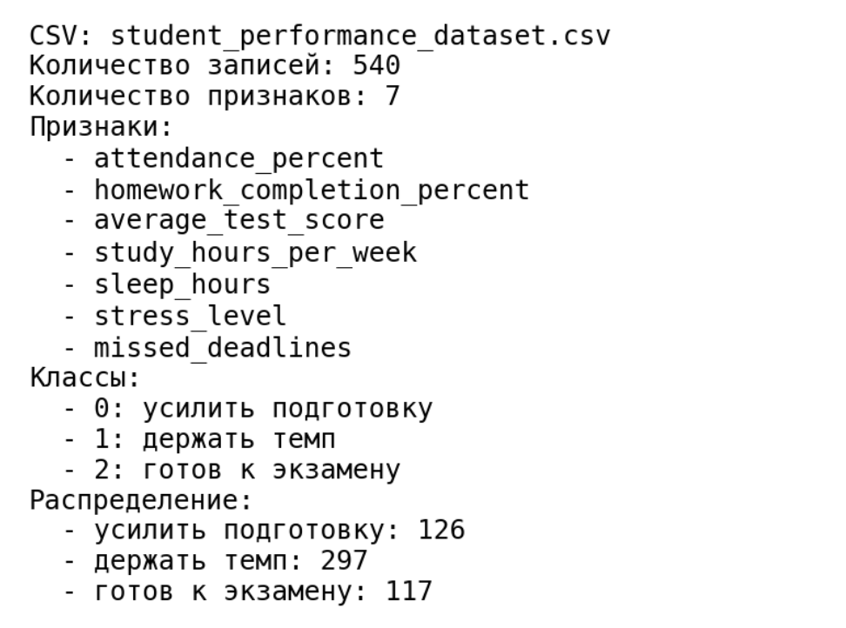
Рисунок 1 – Загрузка данных
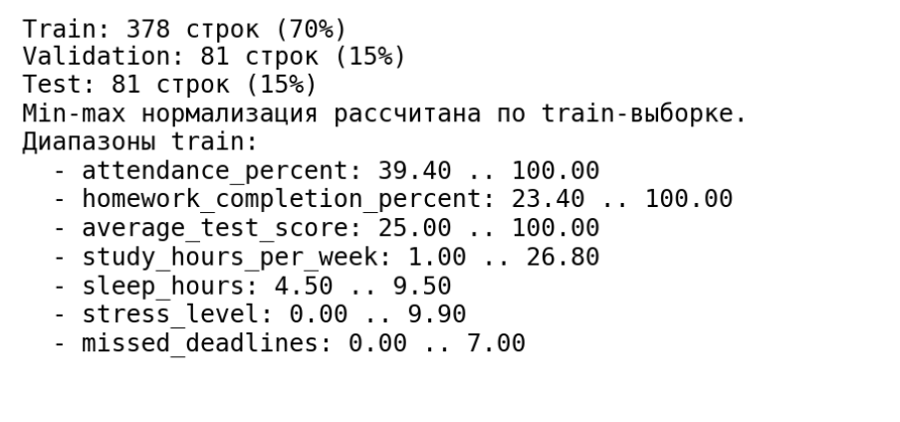
Рисунок 2 – Разделение на обучающую, валидационную и тестовую выборки
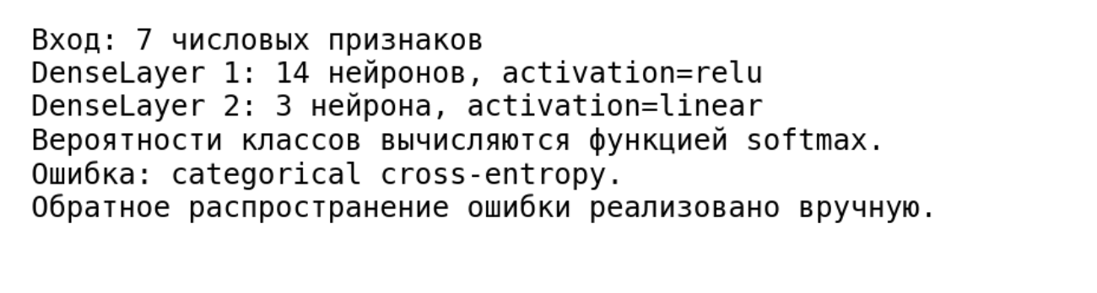
Рисунок 3 – Создание нейронной сети
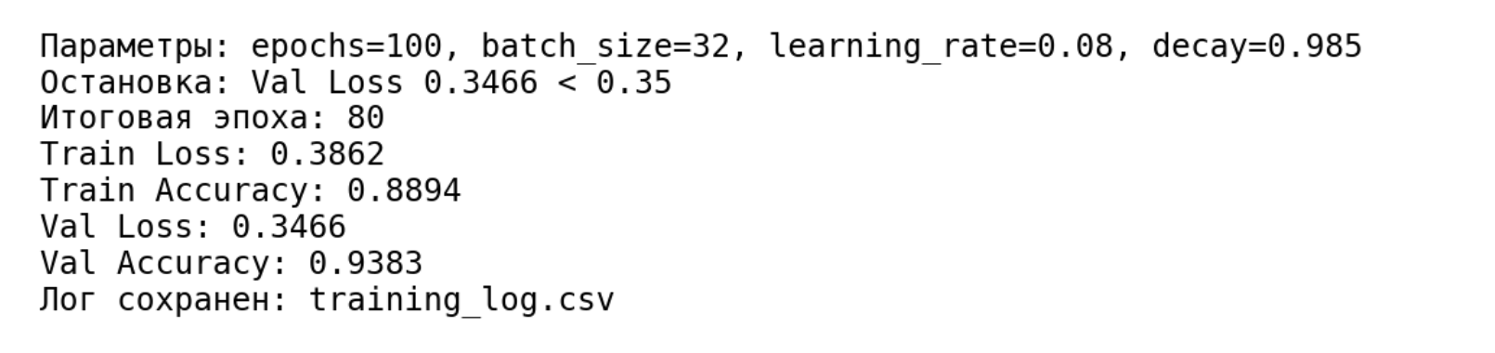
Рисунок 4 – Обучение сети с остановкой при Val Loss < 0.4
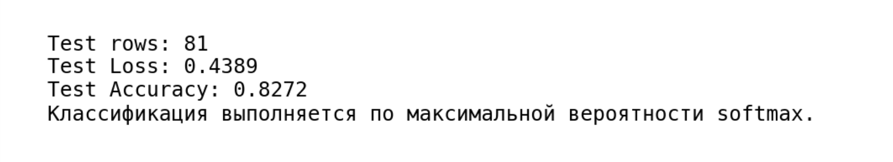
Рисунок 5 – Оценка на тестовых данных
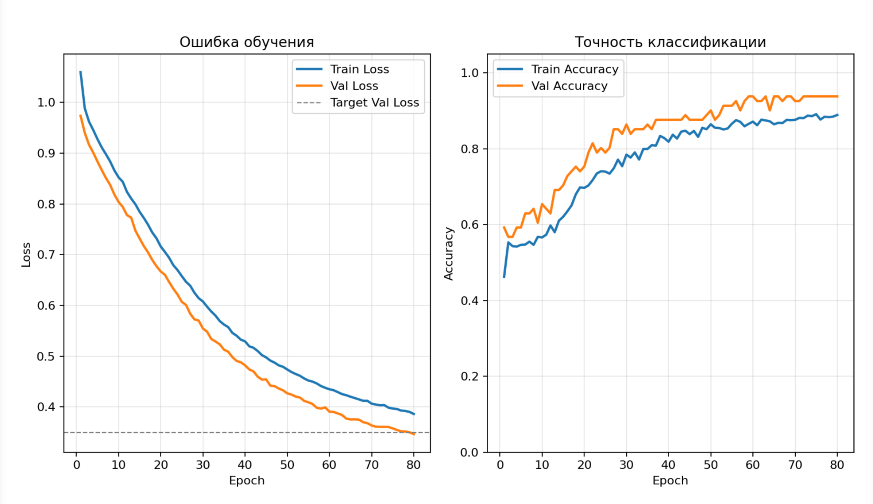
Рисунок 6 – Визуализация процесса обучения
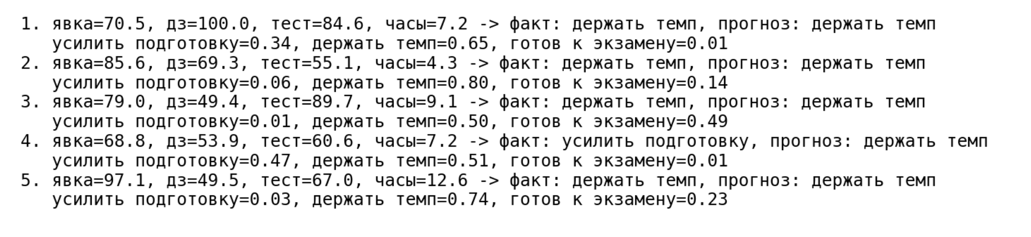
Рисунок 7 – Примеры предсказаний

ЗАКЛЮЧЕНИЕ
В процессе выполнения работы были рассмотрены основы языка Python, а затем с помощью среды Google Colab и языка Python был разработан программный модуль, имитирующий работу формального нейрона, и создан класс нейронной сети, представляющий собой полносвязную многослойную нейронную сеть.

СПИСОК ИСПОЛЬЗОВАННЫХ ИСТОЧНИКОВ
- Тюгашев А.А. Нейронные сети: учеб. пособие. – 179 с.
- Kaggle [Электронный ресурс] // Smartphone Battery Health Prediction Dataset. URL: https://www.kaggle.com/datasets/vishardmehta/smartphone-battery-health-prediction-dataset (дата обращения 09.04.2026).

