DEPARTMENT OF COMPUTER ENGINEERING
2025-2026 ACADEMIC YEAR
SPRING TERM
BM401 COMPUTER ENGINEERING PROJECT DESIGN / BM498 GRADUATION THESIS
ASSIGNMENT REPORT
Design and Development of a Web Platform for Cross-Cultural Opinion Analysis
Prepared by:
Mustafa Salih Özdal
Student No: 211015047
Advisor:
[Advisor Title and Name]
May 2026

DECLARATION
I declare that this assignment report has been prepared for academic submission based on the WorldDeciding project repository and related project documentation. The report content explains the design, implementation, limitations, and evaluation of the project in accordance with academic and ethical rules. All referenced third-party technologies and sources are acknowledged in the references section.
May 2026
(Signature)

Mustafa Salih Özdal

GENERATIVE AI USE DECLARATION
During the preparation of this report, generative AI support may have been used for drafting, language refinement, summarization, and document organization. The technical claims, project structure, and final responsibility for the submitted content remain with the student. Any AI-assisted text was reviewed and adapted to match the actual repository and implementation.
May 2026
(Signature)

Mustafa Salih Özdal

ABSTRACT
DESIGN AND DEVELOPMENT OF A WEB PLATFORM FOR CROSS-CULTURAL OPINION ANALYSIS
Mustafa Salih Özdal
Duzce University
Faculty of Engineering, Computer Engineering
Supervisor: Dr. Huseyin Bodur
May 2026
This assignment report summarizes the completed WorldDeciding project from an implementation and deliverable perspective. It explains the project purpose, repository structure, implemented features, technologies, installation model, user workflows, documentation outputs, limitations, and future work. The report is written as a concise academic assignment submission and is based on the actual project artifacts, including backend projects, frontend source code, Docker files, screenshots, presentations, user guide, installation instructions, and license information.
Keywords: assignment report, WorldDeciding, implementation summary, web application, Docker, documentation.

TABLE OF CONTENTS
Page numbers should be updated in Microsoft Word after final review.
1. PROJECT OVERVIEW 1
2. IMPLEMENTATION SUMMARY 3
3. INSTALLATION AND EXECUTION 7
4. DELIVERABLES 9
5. LIMITATIONS AND FUTURE WORK 11
6. CONCLUSION 13
REFERENCES 14

1. PROJECT OVERVIEW
WorldDeciding is a full-stack web application developed to collect votes on controversial questions and show how opinions differ across countries and demographic groups. The project includes public browsing, account registration, secure login, voting, comments, likes, replies, statistics, country comparison, leaderboard pages, profile pages, category pages, administrator screens, AI-assisted summaries, privacy pages, and Docker-based deployment support.

1.1 Problem Addressed
The project addresses the problem that simple online polls usually hide cultural and demographic differences, while formal surveys are not interactive public systems. WorldDeciding positions itself as an exploratory web prototype. Its results are platform participation data and should not be presented as representative national statistics.

1.2 Target Users
- Visitors browse public questions, categories, leaderboards, and statistics.
- Registered users vote, comment, like, reply, manage profiles, and request AI summaries.
- Administrators create categories, import questions, publish or archive questions, and review platform content.
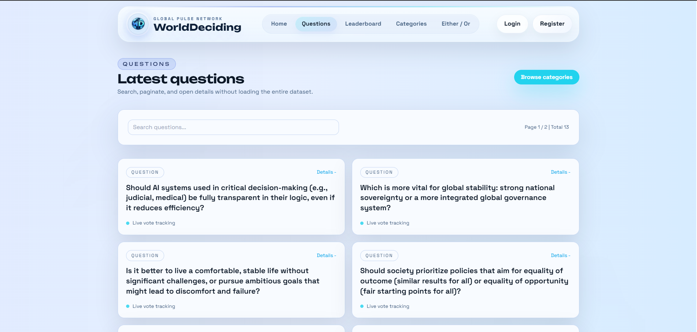
Figure 1.1. Public question discovery page.

2. IMPLEMENTATION SUMMARY

2.1 Technology Stack
Table 2.1. Technologies used in the project.
Layer | Technology
Backend | .NET 8, ASP.NET Core Web API, MediatR, FluentValidation, AutoMapper
Persistence | PostgreSQL, Entity Framework Core, Npgsql
Caching and protection | Redis and Redis-backed abuse/rate counters
Identity and security | ASP.NET Core Identity, JWT bearer authentication, HttpOnly refresh-token cookies
Frontend | React, TypeScript, Vite, React Query, Axios, Zustand, Tailwind CSS
Deployment | Dockerfiles and Docker Compose
AI support | Gemini API integration for discussion and comparison assistance

2.2 Repository Structure
- WorldDeciding contains the ASP.NET Core API project, controllers, startup configuration, middleware, and appsettings files.
- WorldDeciding.Application contains commands, queries, DTOs, validators, interfaces, and application logic.
- WorldDeciding.Domain contains entity and identity model definitions.
- WorldDeciding.Infrastructure contains EF Core persistence, migrations, seed data, Redis, email, GeoIP, token, AI, and reader services.
- worlddeciding-frontend contains the React/Vite frontend source and static build output.
- documentation contains generated thesis, presentations, screenshots, user guide, installation instructions, and license information.

2.3 Implemented Features
The main implemented workflow starts with public discovery, continues through authenticated voting, and ends with statistics and discussion. Users can inspect global option percentages, country distributions, demographic breakdowns, and country-to-country comparison. Administrators can manage content lifecycle and import questions in bulk. The project also includes consent-aware analytics behavior and privacy pages.
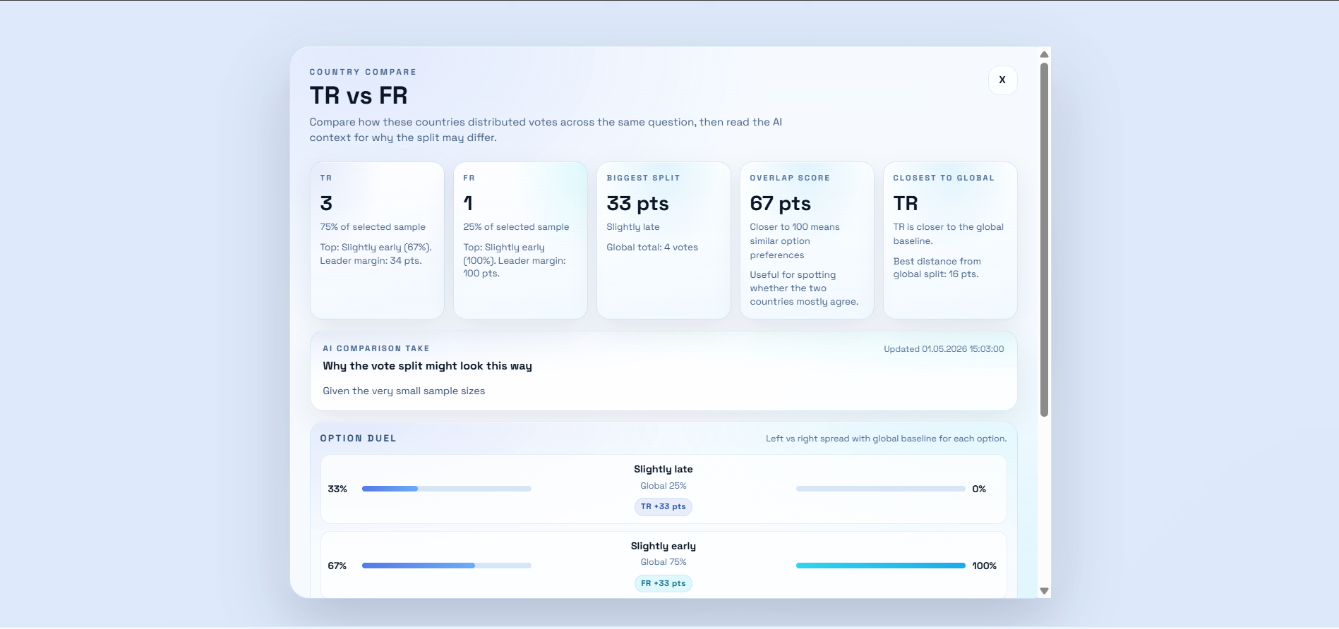
Figure 2.1. Country comparison interface.

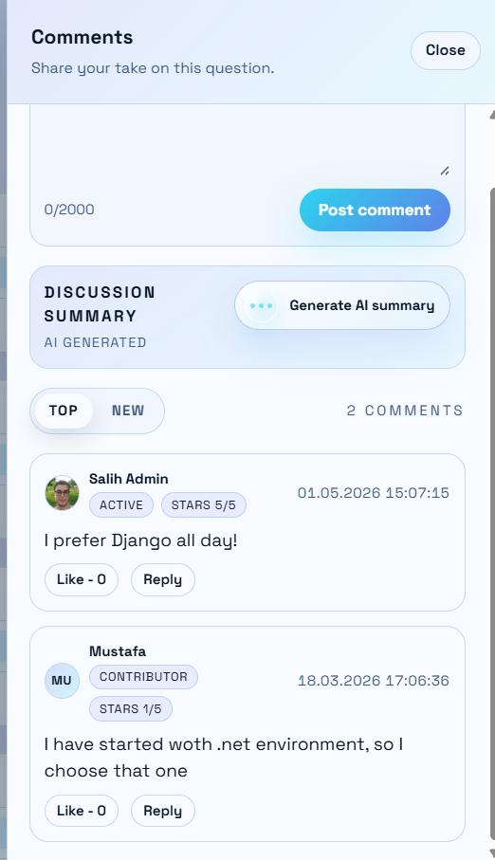
Figure 2.2. Comment and discussion interface.

3. INSTALLATION AND EXECUTION
The project does not include a classic installer such as MSI, MSIX, setup.exe, DMG, or PKG. The practical execution model is source-based development or Docker Compose deployment. The backend debug build includes WorldDeciding.exe, but the application requires PostgreSQL, Redis, configured secrets, and environment settings to run correctly.

3.1 Docker Compose Execution
- Create or update the .env file with POSTGRES_PASSWORD, JWT_KEY, REFRESHTOKEN_PEPPER, PRIVACY_IPSALT, GEMINI_API_KEY, and PGADMIN_PASSWORD.
- Run docker compose up -d --build from the repository root.
- Use docker compose ps to verify postgres, redis, api, pgadmin, and redisinsight containers.
- Stop services with docker compose down when the environment is no longer needed.

3.2 Development Execution
- Restore and build the backend with dotnet restore WorldDeciding.sln and dotnet build WorldDeciding.sln.
- Run the API with dotnet run --project WorldDeciding/WorldDeciding.csproj after configuring the database and required secrets.
- Install frontend packages with npm install in worlddeciding-frontend.
- Run the frontend development server with npm run dev or build static output with npm run build.

4. DELIVERABLES
Table 4.1. Documentation deliverables.
Deliverable | Purpose
WorldDeciding_Thesis_Main.docx | Main thesis-style documentation of the project.
01-05 presentation PDFs | Term start, literature review, design and development, results/demo, and final defense presentations.
WorldDeciding User Guide.pdf | English guide for visitors, users, and administrators.
WorldDeciding Installation Instructions.pdf | English setup and execution instructions.
WorldDeciding_License_Information.txt | License status and third-party dependency notice.
WorldDeciding_Project_Design_Report.docx | Project design report generated from the provided template.
WorldDeciding_Assignment_Report.docx | Concise assignment report generated from the provided template.

4.1 Verification Performed
The documentation generation was verified by checking the existence and sizes of deliverable files. Presentation PDFs were regenerated and inspected for slide/page counts. Early presentations were produced without embedded images, while design and development content includes development-stage screenshots. The generated reports in this request use the provided Word template and English content.

5. LIMITATIONS AND FUTURE WORK
- Platform participation is self-selected and not representative of national populations.
- GeoIP country inference can be inaccurate under VPN, proxy, or mobile routing conditions.
- Small sample groups should be hidden or clearly warned in production.
- Moderation, reporting, audit logs, CI/CD, backups, observability, dependency scanning, and formal privacy workflows should be expanded.
- Automated tests should be added for application handlers, API integration, database behavior, Redis limits, and frontend workflows.

6. CONCLUSION
The WorldDeciding project delivers a working full-stack prototype for exploratory cross-cultural opinion analysis. It combines modern backend and frontend technologies with authenticated voting, statistics, comments, AI summaries, admin tools, and Docker-based deployment support. The assignment outcome is a complete web application and a documentation package that explains usage, installation, design, implementation, limitations, and future work.

REFERENCES
[1] World Values Survey. Center for Political Studies, University of Michigan. International research program studying social, political, economic, religious, and cultural values across countries.
[2] European Social Survey. Methodology overview. Cross-national attitude measurement and survey methodology guidance.
[3] Pang, B. and Lee, L.. Opinion Mining and Sentiment Analysis, Foundations and Trends in Information Retrieval, 2008.
[4] Microsoft Learn. Configure ASP.NET Core Identity. Authentication, password, lockout, claims, and cookie configuration.
[5] Redis Documentation. Rate limiting and cache usage concepts for protecting service stability and fair usage.
[6] Npgsql Documentation. .NET data provider and Entity Framework Core provider for PostgreSQL.
[7] OWASP ASVS. Application Security Verification Standard for authentication, access control, validation, cryptography, API, and configuration review.
[8] Docker Documentation. Docker Compose overview for defining and running multi-container applications.

