DUZCE UNIVERSITY
Faculty of Engineering
Department of Computer Engineering
Design and Development of a Web Platform for Cross-Cultural Opinion Analysis
Undergraduate Thesis / Graduation Project
Prepared by: [Student Name Surname]
Student No: [Student Number]
Supervisor: [Academic Title, Name Surname]
Project: WorldDeciding
Duzce, May 1, 2026

BM401 COMPUTER ENGINEERING PROJECT DESIGN / BM498
GRADUATION THESIS
EVALUATION AND ORAL EXAM MINUTES
STUDENTS (NUMBER / NAME-SURNAME):
SUPERVISOR:
Evaluation Criterion | Score  Range | Score
Written Work Format Evaluation (10 Points)
Is the study prepared according to the thesis/project writing guide? | 0-10
Is the problem definition clearly stated? | 0-5
Is the literature review sufficient, current, and systematic? | 0-5
Is the architecture of the software/hardware explained with a block diagram or data flow diagram? | 0-5
Are the materials and method explained at a sufficient level? | 0-5
Are the project datasets managed according to FAIR principles? | 0-5
Are design and implementation issues discussed with solution methods? | 0-5
What is the difficulty level of the completed work? | 0-5
Was the presentation successful? | 0-8
Was the student competent in answering questions? | 0-7
Did the student prepare the required progress reports regularly? | 0-10
Ethics and Professional Responsibility (15 Points)
Is the project ethically appropriate? (Plagiarism declaration, ethical declaration, data and generative AI use, human data use, Helsinki Declaration, etc.)  ☐ Plagiarism declaration exists. ☐ References follow the required citation style. ☐ Ethics approval / consent exists if human data is used. ☐ Helsinki Declaration principles are considered. | 0-5
Did the project show awareness of engineering ethics and professional responsibility? | 0-5
Were national/international standards such as ISO 9001, ISO 17025, or IEEE mentioned and applied where relevant? | 0-5
Were project management, risk management, and change management approaches applied? (Work plan, task distribution, risk analysis) | 0-4
Was the entrepreneurship and innovation dimension evaluated? (Original solution, added value, commercial potential) | 0-4
Was the sustainable development perspective considered? (Environmental, economic, and social sustainability) | 0-4
Was the reproducibility principle in sustainable software development applied? | 0-3
Total | 0-100

DECLARATION
I declare that this thesis is my own work; that I have not acted against academic and ethical principles at any stage from planning to writing; that I obtained all information in this thesis in accordance with academic and ethical rules; that I cited all information and interpretations not produced by this thesis and included those sources in the reference list; and that I did not violate any patent or copyright during the preparation and writing of this thesis.
April 3, 2026
(Signature)
(Student Name Surname)

GENERATIVE ARTIFICIAL INTELLIGENCE USE DECLARATION
April 3, 2026
I declare that, while preparing this thesis, I did / did not receive support from generative artificial intelligence tools such as ChatGPT, Gemini, DALL-E, etc. During the preparation of my thesis, I used generative artificial intelligence tools for support such as language editing and access to scientific information. I confirm that I checked the accuracy of the information received from generative artificial intelligence tools.
If any statement contrary to this declaration is detected at any time, I accept all moral and legal consequences that may arise.
(Signature)
(Student Name Surname)

ACKNOWLEDGEMENTS
I would like to express my sincere gratitude to my valuable supervisor Prof. Dr. Xxxxx Xxxxx for all support and guidance during my undergraduate education and the preparation of this thesis.
I also thank my co-supervisor Prof. Dr. Wwwww Wwwwww for valuable contributions throughout the thesis study.
I extend my deepest thanks to my family and colleagues for their continuous help and support during this work.
This thesis study was supported by Duzce University Scientific Research Project BAP-XXX-WWW.
April 3, 2026 Name Surname

TABLE OF CONTENTS
Page No
LIST OF FIGURES vii
LIST OF TABLES viii
LIST OF MAPS ix
ABBREVIATIONS x
SYMBOLS xi
SUMMARY xii
ABSTRACT xiii
1. INTRODUCTION 1
2. LITERATURE REVIEW 5
2.1. Cross-Cultural Public Opinion Research 5
2.2. Online Opinion Mining and Summarization 6
2.3. Web Security and Abuse Prevention 7
3. REQUIREMENTS AND SCOPE 9
4. MATERIALS AND METHODS 12
5. SYSTEM ARCHITECTURE 16
6. DATA MODEL AND PERSISTENCE 21
7. IMPLEMENTATION 26
8. SECURITY, PRIVACY, AND ETHICS 34
9. TESTING, DEPLOYMENT, AND OPERATIONS 40
10. RESULTS AND DISCUSSION 44
11. CONCLUSION AND FUTURE WORK 49
12. REFERENCES 52
APPENDIX A. SCREENSHOTS 55
APPENDIX B. API AND MODULE SUMMARY 61

LIST OF FIGURES
Figure 5.1. WorldDeciding home screen with live question and platform metrics. 18
Figure 6.1. Question statistics page with option, country, age, and gender breakdowns. 24
Figure 7.1. Binary voting page with confirmation and live statistics interaction. 28
Figure 7.2. AI-generated comment summary in the discussion panel. 30
Figure 7.3. Country comparison screen with option split and AI insight. 32
Figure 7.4. Administrative question management page. 33
Figure 7.5. User profile and activity information. 34

LIST OF TABLES
Table 4.1. Technologies used in the project. 13
Table 4.2. Project risks and mitigations. 15
Table 5.1. High-level architecture components. 17
Table 6.1. Main entities and responsibilities. 22
Table 8.1. Threat model summary. 38
Table 10.1. Requirement evaluation. 46

LIST OF MAPS
Map 1. Country distribution and comparison visualization. 32

ABBREVIATIONS
Abbreviation | Meaning
API | Application Programming Interface
CQRS | Command Query Responsibility Segregation
DTO | Data Transfer Object
EF Core | Entity Framework Core
GA4 | Google Analytics 4
GeoIP | IP-based geographic inference
JWT | JSON Web Token
ORM | Object Relational Mapper
RBAC | Role-Based Access Control
SPA | Single Page Application
TTL | Time To Live

SYMBOLS
No special mathematical symbols are used in this thesis. The software architecture, data model, and system behavior are explained through text, tables, and figures.

SUMMARY
This thesis presents the design and development of WorldDeciding, a web platform built to collect, compare, and visualize user opinions on controversial topics whose responses may differ across cultural contexts. The platform includes registration, login, email verification, voting, commenting, category-based discovery, country-based comparison, demographic statistics, leaderboard views, an administrator panel, spam protection, and AI-assisted summarization.
The system is developed with .NET 8 ASP.NET Core Web API, a React and TypeScript frontend, PostgreSQL, Redis caching and rate limiting, Docker-based deployment, and Gemini AI integration. The backend follows a layered architecture composed of Domain, Application, Infrastructure, and API projects. Security controls include ASP.NET Core Identity, JWT access tokens, HttpOnly refresh token cookies, role-based authorization, IP hashing, CORS restrictions, security headers, and Redis-backed abuse counters.
As a result, the study presents an interactive, extensible, and privacy-aware web platform prototype for cross-cultural opinion analysis. The platform does not claim scientific survey representativeness; its results should be interpreted as platform participation data. Future work should strengthen sampling balance, minimum display thresholds, moderation workflows, automated test coverage, and production security processes.
Keywords: cross-cultural opinion analysis, web platform, public opinion, .NET Web API, React, PostgreSQL, Redis, data privacy, rate limiting, statistical visualization.

ABSTRACT
This thesis presents the design and development of WorldDeciding, a web platform for collecting, comparing, and visualizing public opinions on controversial and culturally sensitive topics. The core purpose of the platform is to let authenticated users vote on questions, participate in comments, and inspect the resulting opinion distribution through statistical views such as option breakdowns, country-level comparison, gender and age-band summaries, leaderboards, and AI-assisted discussion summaries. The system is implemented as a modern full-stack web application with a .NET 8 ASP.NET Core Web API backend, a React and TypeScript frontend, PostgreSQL for persistent relational data, Redis for cache and abuse counters, and Docker-based deployment support.
The backend follows a layered architecture shaped around Domain, Application, Infrastructure, and API projects. CQRS-style request handlers are implemented with MediatR, validation is implemented with FluentValidation, persistence is implemented with Entity Framework Core and Npgsql, and authentication relies on ASP.NET Core Identity, JWT access tokens, and rotating refresh tokens stored in HttpOnly cookies. The platform includes security and privacy controls such as password rules, email confirmation, role-based administration, IP hashing, country inference without raw IP persistence, CORS allowlisting, security headers, Redis-backed rate limiting, and analytics consent. The frontend provides a responsive user experience for registration, login, question exploration, voting, comments, AI summaries, statistics, country comparison, profile pages, categories, leaderboards, and administrative question management.
The study demonstrates how a web platform can combine opinion collection, cross-cultural comparison, privacy-aware data handling, and operational safeguards in one practical system. The final discussion evaluates the implementation against functional requirements and identifies future work, including improved sampling controls, moderation workflows, minimum-threshold privacy suppression, expanded automated tests, and stronger production secret governance.
Keywords: cross-cultural opinion analysis, web platform, public opinion, .NET Web API, React, PostgreSQL, Redis, data privacy, rate limiting, statistical visualization.

1. Introduction

1.1 Problem Definition
Public opinion is increasingly expressed through digital platforms, but many ordinary polling interfaces only show global totals and do not explain how views differ across countries, age groups, genders, or discussion communities. For controversial topics, a simple total can hide important cross-cultural patterns. A question may appear balanced globally while one country strongly prefers one option, another country prefers a different option, and a third group has insufficient sample size to support interpretation.
WorldDeciding addresses this problem by collecting structured votes and comments and then presenting the results through comparative statistics. The application is not a replacement for a scientific national survey, because it does not use controlled sampling or weighting. Instead, it is a web platform prototype that demonstrates how opinion collection, country comparison, and privacy-aware implementation can be combined in an interactive public system.

1.2 Aim of the Project
The aim of this thesis is to design and implement a web platform that enables users to express opinions on controversial topics, compare the results across countries and demographic dimensions, and discuss the topics through moderated interaction mechanisms. The engineering goal is to produce a maintainable, containerized, security-conscious, and extensible full-stack system.

1.3 Contributions
- A layered .NET and React implementation for cross-cultural opinion collection.
- Country-aware voting and comparison using declared or inferred country codes.
- Statistical screens for option, country, gender, age-band, view, and vote metrics.
- Redis-backed anti-abuse mechanisms for login, password reset, voting, and views.
- AI-assisted summarization for comments and tentative country comparison insight.
- Administrative tools for categories, question lifecycle, and bulk import.
- Privacy features including IP hashing, consent handling, analytics control, and security headers.

1.4 Thesis Organization
The remainder of the thesis reviews related work, defines the project requirements, explains the selected technologies and architecture, describes the data model and implementation, discusses security and ethics, presents results from the developed prototype, and concludes with limitations and future work.

2. Literature Review

2.1 Cross-Cultural Public Opinion Research
Cross-cultural opinion analysis has a long tradition in social science. Large programs such as the World Values Survey investigate social, political, economic, religious, and cultural values across countries and waves of data collection [1]. These projects show that values and attitudes are not only individual properties but also form patterns that can vary by national and cultural context. The European Social Survey similarly emphasizes that measuring attitudes cross-nationally requires methodological rigor, because language, sampling, measurement equivalence, and country context affect comparability [2].
WorldDeciding borrows the motivation of comparative attitude research but adapts it to a web engineering context. Instead of long questionnaire waves with representative samples, the platform supports short controversial questions, fast participation, and interactive visualization. This makes the system useful as a prototype for exploratory opinion signals, but it also requires careful labeling so users understand that the results are platform samples rather than nationally representative estimates.

2.2 Online Opinion Mining and Summarization
Opinion mining and sentiment analysis research studies the computational treatment of opinion, sentiment, subjectivity, and evaluative text [3]. Pang and Lee argue that the growth of opinion-rich online resources created both opportunities and challenges for systems that help people understand what others think. WorldDeciding uses a structured voting model for quantitative signals and a comment model for qualitative discussion. The AI summarization component is not used to decide the result; it is used to condense discussion or provide tentative explanatory language for country comparison.

2.3 Web Security and Abuse Prevention
A public voting platform is exposed to fake accounts, repeated voting attempts, credential stuffing, automated scraping, and view inflation. ASP.NET Core Identity provides configurable password, lockout, token, claims, and cookie options that support secure authentication workflows [4]. Redis documentation defines rate limiting as a technique for controlling request rates to preserve stability, security, and fair usage [5]. OWASP ASVS provides a broad verification framework for authentication, session management, access control, validation, cryptography, API security, and configuration review [7]. These references inform the security controls and recommendations in this project.

2.4 Gap Addressed by the Project
Existing large surveys provide rigor but are slow and institutionally heavy, while many web polls provide speed but weak identity, privacy, and cross-country analysis. WorldDeciding sits between these categories: it is an engineering prototype that demonstrates fast opinion collection with country-aware comparison, user discussion, and practical security safeguards. Its research value is in the design and implementation of a full platform rather than in proving a new statistical theory.

2.5 Design Lessons Taken from the Literature
The reviewed literature leads to four design lessons. First, the system should expose sample size and context instead of presenting percentages alone, because cross-national interpretation is weak when the number of observations is small. Second, country labels should be treated as metadata with a known source, not as absolute truth. Third, structured votes and free-text comments should be handled separately: votes are useful for measurable distributions, while comments help explain why users may have selected an option. Fourth, the platform should explicitly separate exploratory platform data from representative public opinion research. These lessons shaped the statistics UI, the country comparison DTOs, and the AI prompts that use tentative wording.
The project also reflects an engineering lesson from security literature: voting accuracy is not only a statistical problem. If authentication, session management, rate limiting, and duplicate prevention are weak, the resulting data can be manipulated before statistical analysis begins. For this reason, abuse prevention is treated as part of the opinion analysis pipeline.

3. Requirements and Scope

3.1 Functional Requirements
- Users shall be able to register with email, password, country, birth date, and gender.
- The platform shall confirm email accounts and support password reset through email.
- Authenticated users shall be able to vote on published binary or multi-option questions.
- Each authenticated user shall have one active vote per question, with a cooldown before changing the vote.
- The system shall record view counts while avoiding repeated daily counting from the same hashed IP.
- The system shall show question statistics by option, country, gender, and age band.
- Users shall be able to compare two countries for a question and see option splits against the global baseline.
- Authenticated users shall be able to add comments, replies, and likes.
- The platform shall produce AI-assisted summaries for comments and country comparison insight.
- Administrators shall manage categories, questions, publishing, archiving, and bulk imports.
- The frontend shall include pages for home, questions, detail, statistics, categories, leaderboard, profile, login, registration, privacy, and cookies.

3.2 Non-Functional Requirements
- Security: enforce authentication, role checks, token validation, anti-abuse counters, and secure cookie settings.
- Privacy: avoid storing raw IP addresses, limit analytics until consent, and make country inference transparent.
- Maintainability: separate domain, application, infrastructure, and API concerns.
- Performance: cache frequently requested statistics and aggregate daily counters for leaderboards.
- Deployability: support Dockerized PostgreSQL, Redis, API, frontend, pgAdmin, and RedisInsight services.
- Usability: provide a responsive interface with clear flows for voting, comments, comparison, and administration.

3.3 Scope Boundaries
The project implements a working web platform prototype. It does not claim representative polling accuracy, automated content moderation, formal psychometric validation, or complete legal compliance for every jurisdiction. These items are discussed as future work and operational requirements before public-scale deployment.

4. Materials and Methods

4.1 Technologies Used
Layer | Technology | Purpose
Frontend | React 18, TypeScript, Vite | Single page application and client-side routing
Frontend state/data | React Query, Zustand, Axios | Server state, auth state, API calls, token refresh
UI and visuals | Tailwind CSS, Three.js, OGL | Responsive screens, globe/stat scenes, visual presentation
Backend | .NET 8, ASP.NET Core Web API | REST API, middleware, controllers, hosting
Application | MediatR, FluentValidation, AutoMapper | CQRS-style handlers, validation, DTO mapping
Identity | ASP.NET Core Identity, JWT | Users, roles, password rules, access tokens
Persistence | PostgreSQL 16, EF Core, Npgsql | Relational data and migrations [6]
Cache and rate limit | Redis 7, StackExchange.Redis | Stats cache, live question cache, abuse counters
AI | Gemini API client | Comment and country comparison summaries
Operations | Docker Compose, Nginx, Serilog | Container orchestration, static frontend serving, logging

4.2 Development Method
The implementation was reviewed from the repository structure and source files. Backend responsibilities are separated into Domain, Application, Infrastructure, and API projects. Frontend responsibilities are separated into pages, entities, features, components, widgets, shared API helpers, and application providers. The method used in this thesis is constructive software development: requirements were mapped to modules, modules were implemented, and the result was documented through code inspection, screenshots, and build verification.

4.3 Data Collection Model
The platform collects platform-native opinion data: question votes, country codes, user demographic fields, comments, likes, view events, and profile metadata. No raw IP address is persisted in the vote or view entities. IP addresses are used transiently to calculate salted SHA-256 hashes for uniqueness and abuse prevention. Country codes are stored as ISO-3166-1 alpha-2 strings when available. The data model can support FAIR-oriented management through explicit schema, migrations, timestamps, controlled import format, and documented entity semantics.

4.4 Project Management Method
The project was managed as an incremental engineering implementation. The first increment focused on the core data model and authentication. The second increment added question listing, voting, statistics, and country metadata. The third increment added comments, AI summaries, profile and leaderboard behavior. The fourth increment added administration, Docker deployment, privacy consent, and documentation. This sequence reduced risk because the most central data flow, authenticated voting, was implemented before secondary features.
Risk | Impact | Mitigation
Duplicate or automated voting | Distorted statistics | Authenticated votes, unique database index, Redis vote-attempt counter, vote cooldown.
Wrong country attribution | Misleading country comparison | Declared and inferred country source metadata, confidence field, registration country check.
Sensitive opinion exposure | Privacy and ethics risk | No raw IP storage, consent pages, future threshold suppression recommendation.
AI overclaiming | Misleading explanations | Prompt instructs tentative language and fallback text when data or provider is unavailable.
Operational secret leakage | Account or infrastructure compromise | Production env vars already supported; recommendation to remove all secrets from appsettings.
Low automated test coverage | Regression risk | Focused future test plan for vote, auth, comments, admin, and abuse flows.

4.5 Reproducibility Method
Reproducibility is supported through source-controlled projects, EF Core migrations, seed data for initial categories and sample questions, Dockerfiles for the API and frontend, and Docker Compose definitions for PostgreSQL and Redis. A future academic submission should include exact commit hash, environment variables template, database migration command, and a test dataset description. The generated documentation in this folder is also reproducible through the generate-deliverables.mjs script.

5. System Architecture

5.1 Architectural Style
WorldDeciding uses a layered architecture close to Clean Architecture. The Domain project contains entities and identity models. The Application project contains commands, queries, DTOs, interfaces, validators, and business rules. The Infrastructure project implements persistence, security, caching, email, GeoIP, AI, and reader services. The Web API project wires dependency injection, authentication, authorization, CORS, middleware, Swagger, and controllers.
Most business actions are expressed as MediatR commands or queries. Controllers are thin and delegate behavior to handlers. This separation makes it easier to test application rules independently from HTTP details and allows infrastructure implementations to be replaced through interfaces.

5.2 High-Level Architecture
Component | Responsibility
React SPA | Renders user journeys, calls REST endpoints, stores access token in memory, refreshes tokens through cookie endpoint.
ASP.NET Core API | Exposes authentication, voting, questions, comments, categories, profile, leaderboard, privacy, live question, and admin endpoints.
Application handlers | Apply use-case rules such as vote cooldown, stats query aggregation, country comparison, comment summary, and imports.
PostgreSQL | Stores users, roles, questions, options, votes, comments, categories, refresh tokens, views, summaries, and daily stats.
Redis | Stores short-lived counters and cached data for abuse prevention, rate limiting, live question behavior, and stats caching.
Gemini | Provides optional summarization for comments and country comparison insight, with fallback text if unavailable.
Docker Compose | Runs PostgreSQL, Redis, API, pgAdmin, RedisInsight, and supports environment-based production configuration.

5.3 Request Flow
- A user opens the React SPA and browses questions, categories, or the live question.
- For protected actions, the frontend attaches a JWT access token through the Axios interceptor.
- If the access token expires, the frontend calls the refresh endpoint with the HttpOnly refresh cookie.
- The API validates the JWT issuer, audience, signing key, and role claims.
- A controller sends a command or query to MediatR.
- The handler reads/writes PostgreSQL through IAppDbContext and uses Redis, GeoIP, or AI services when required.
- The API returns DTOs to the frontend, which updates React Query caches and screen state.
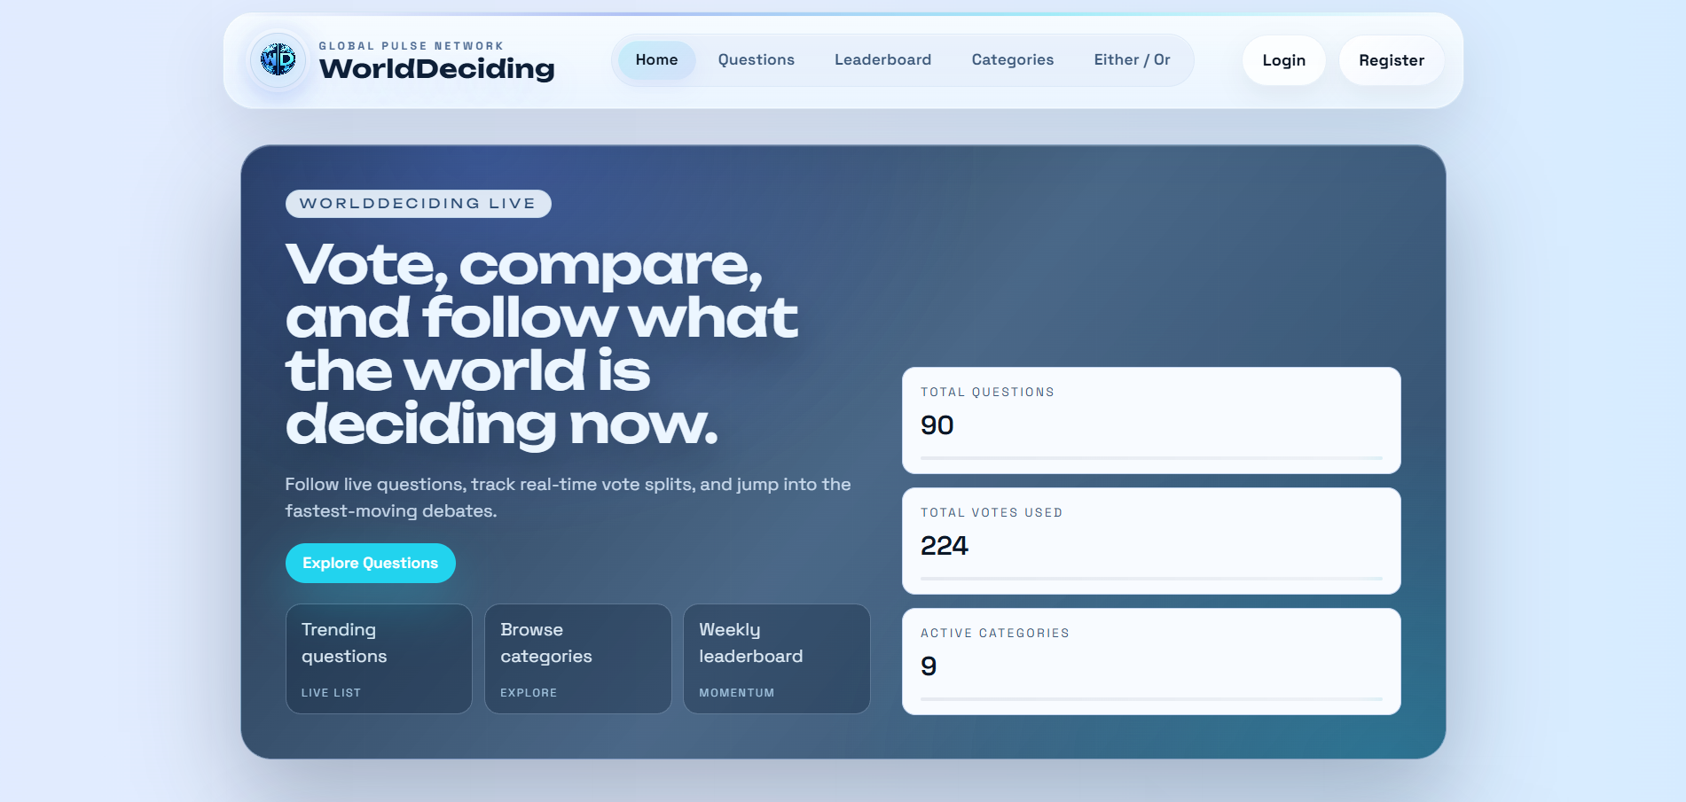
Figure 5.1. WorldDeciding home screen with live question and platform metrics.

5.4 Backend Middleware and Dependency Injection
Program.cs is the composition root of the backend. It configures Serilog request logging, EF Core with PostgreSQL, Identity, JWT bearer authentication, Redis multiplexer, distributed Redis cache, CORS, FluentValidation, MediatR, AutoMapper, Swagger, security headers, forwarded headers, and the custom rate-limit exception middleware. The API also seeds roles, categories, and starter questions at startup through EnsureSeededAsync. This startup structure makes the runtime dependencies explicit and allows environment-specific configuration through appsettings, user secrets, or Docker environment variables.
The middleware order is significant. Forwarded headers must be read before authentication and IP-based logic so that reverse proxy deployments can identify the real client address. The rate-limit exception middleware is placed before controller execution so application-level TooManyRequestsException values can be converted into HTTP 429 responses. CORS, authentication, and authorization are applied before controllers are mapped.

5.5 Frontend Architecture
The frontend is a Vite React application written in TypeScript. Its structure follows a practical feature-oriented organization: pages define route-level views, entities define reusable domain APIs and types, features implement task-specific logic such as voting or admin APIs, shared contains API and UI utilities, widgets contain larger shared UI sections such as the navbar, and app contains providers for cookies and analytics. React Query is used for server-state fetching and invalidation, while Zustand stores authentication state.
The Axios client stores the access token in memory and attaches it to outgoing API requests. If a protected API call receives 401, the interceptor calls the refresh endpoint once and queues other failed requests until a new access token is available. This approach avoids storing the access token in localStorage while still preserving user sessions through the refresh cookie.

6. Data Model and Persistence

6.1 Main Entities
Entity | Main Fields | Role in the System
AppUser | Id, Email, CountryCode, BirthDate, Gender, DisplayName, Bio, AvatarUrl, Score | Identity and profile data for authenticated users.
Question | Id, Title, Type, Status, CategoryId, Language, TagsJson, Source | Voting prompt managed by administrators.
Option | Id, QuestionId, Text | Selectable answer for binary or multi-option questions.
Vote | QuestionId, OptionId, UserId, CountryCode, CountrySource, CountryProvider, CountryConfidence, IpHash | Opinion record used for statistics and country comparison.
Comment | QuestionId, UserId, ParentId, Text, CreatedAt, LikeCount | Threaded discussion data.
CommentLike | CommentId, UserId | Prevents duplicate likes and supports like toggling.
Category | Slug, Name | Question organization.
RefreshToken | TokenHash, FamilyId, CreatedAt, ExpiresAt, RevokedAt, ReplacedByTokenHash | Rotating refresh session state.
QuestionView | QuestionId, UserId, IpHash, ViewDate | Daily unique view tracking.
QuestionStatsDaily | QuestionId, Date, Views, Votes | Pre-aggregated counters for dashboards and leaderboards.
QuestionCommentSummary | QuestionId, SummaryText, GeneratedAt, IsStale, Model | Cached AI summary for a question's discussion.

6.2 Database Constraints and Indexes
The EF Core model defines important integrity constraints. Options are unique by question and text. Votes have a unique index on QuestionId and UserId, which enforces one active vote per user per question. Country comparison is optimized by indexes on QuestionId, CountryCode, and OptionId. Question views use unique indexes for daily deduplication by user or hashed IP. Comments are indexed for question, parent, like count, and creation time to support sorting and threaded replies.

6.3 Aggregation Strategy
Daily view and vote counters are maintained in QuestionStatsDaily through PostgreSQL upsert statements. This design reduces repeated expensive aggregation for leaderboards and allows time-window queries such as 24 hours, 7 days, 30 days, and all-time. Detailed question statistics are still computed from votes and user demographics when needed, and short-lived Redis cache entries reduce repeated work.

Figure 6.1. Question statistics page with option, country, age, and gender breakdowns.

6.4 Data Lifecycle and FAIR Considerations
Findability is supported by stable GUID identifiers, category slugs, question titles, status flags, and timestamps. Accessibility is supported through REST endpoints and admin screens, although production access should remain role-controlled. Interoperability is supported through ISO-style country codes, JSON DTOs, EF Core migrations, and clear separation between data entities and view models. Reusability is supported by explicit schema design and seed data, but a public research dataset would require additional metadata, anonymization policy, consent records, and export documentation.
The data lifecycle begins with administrator-created or imported questions. Users then create votes and comments. Vote events update daily counters and invalidate caches. Comment creation marks the AI summary as stale. Statistics can be served from live aggregation or cache depending on endpoint. For long-term research use, retention schedules should define when raw comments, account data, logs, and derived aggregates are archived or deleted.

7. Implementation

7.1 Authentication and Account Flow
The AuthController implements registration, email confirmation, login, password reset, token refresh, logout, country detection for registration, and resend confirmation. Password policy is configured in Program.cs with length, digit, uppercase, lowercase, and non-alphanumeric requirements. Accounts must be email-confirmed before login. Access tokens are short-lived JWTs, while refresh tokens are random opaque values stored as hashes in the database and delivered through an HttpOnly cookie.

7.2 Voting Flow
The CastVoteHandler validates that the selected option belongs to the question, resolves the authenticated user ID from claims, hashes the client IP, resolves country information, checks Redis-backed abuse limits, and inserts or updates the vote. A new vote increases the user's score and increments daily vote statistics. If a user tries to change a vote too soon, the handler enforces a 24-hour cooldown. This rule prevents rapid vote manipulation while still allowing users to revise an opinion later.
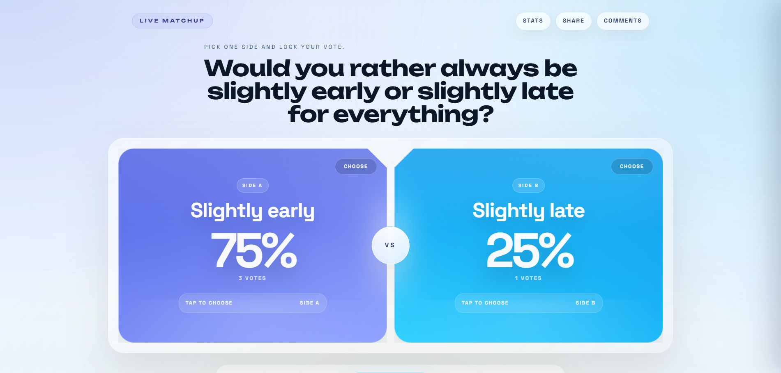
Figure 7.1. Binary voting page with confirmation and live statistics interaction.

7.3 Comment and AI Summary Flow
Comments are protected actions. Users can add root comments, add replies, and toggle likes. Comment text is trimmed and limited to 2000 characters. When a new comment is added, the associated QuestionCommentSummary is marked stale. The summary handler gathers recent and top-liked comments, applies a short user-level Redis rate limit, calls the AI summarizer, and stores the result with generation metadata.
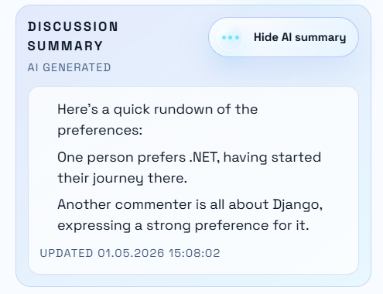
Figure 7.2. AI-generated comment summary in the discussion panel.

7.4 Country Comparison Flow
Country comparison receives two ISO country codes and aggregates vote counts by country and option. It also calculates a global baseline. The frontend visualizes option-by-option differences, top options, overlap score, sample sizes, global distance, and AI-generated tentative explanations. The implementation intentionally uses cautious language and fallback text when the AI provider is unavailable.
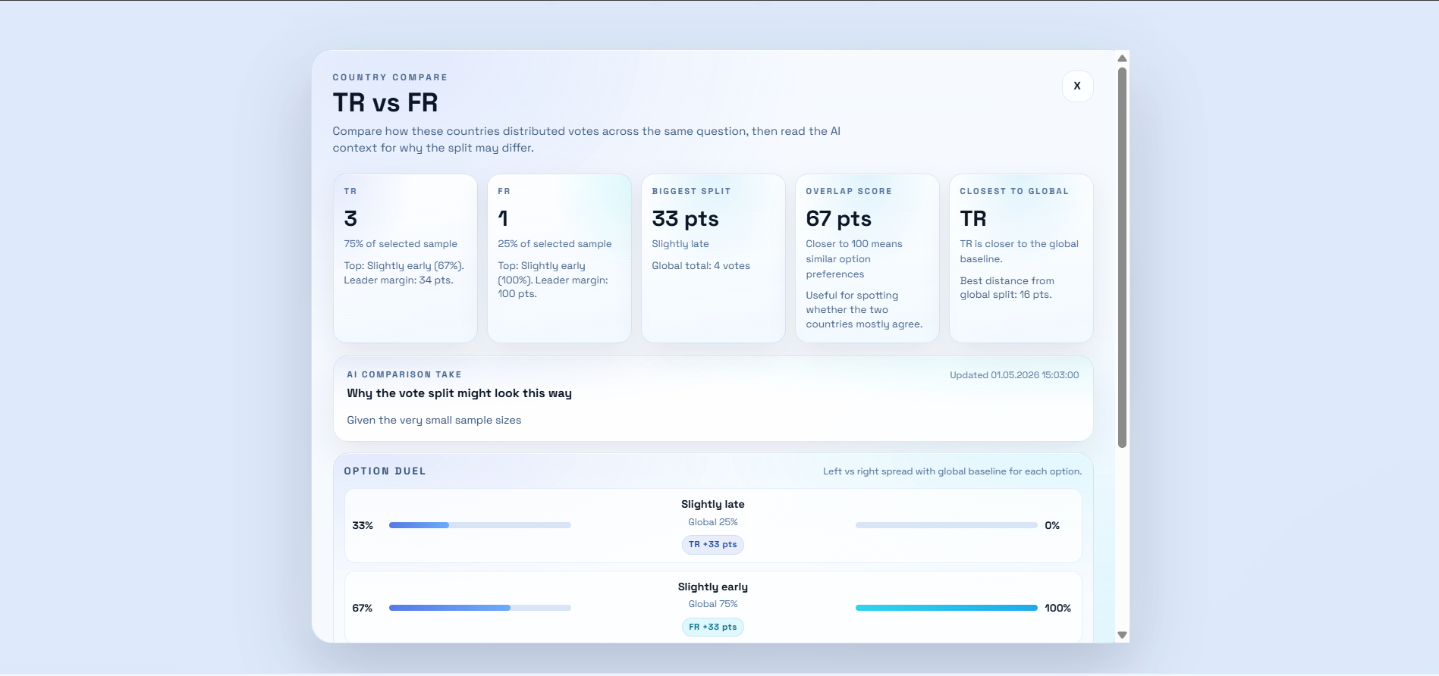
Figure 7.3. Country comparison screen with option split and AI insight.

7.5 Administration Flow
Administrators can create, list, publish, archive, inspect, and bulk import questions. Bulk import validates question length, options, category slug, language, source, and duplicate title-language combinations. Categories can also be created, updated, and deleted by users with the Admin role. This workflow supports controlled content generation and avoids exposing question creation to untrusted users.
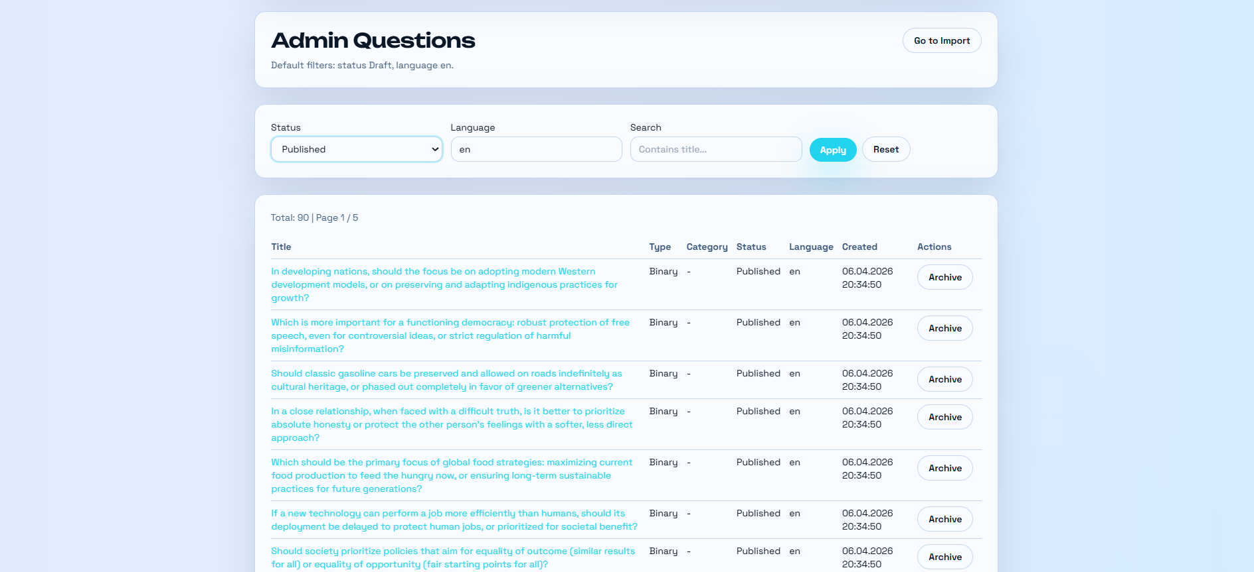
Figure 7.4. Administrative question management page.

7.6 Live Question and Leaderboard
The live question service exposes a current question and a statistics endpoint. The home page polls these endpoints to show the current live prompt and its vote distribution. The leaderboard uses QuestionStatsDaily and raw SQL through Npgsql to rank questions by views or votes over time windows such as 24 hours, 7 days, 30 days, or all time. This combination supports both immediate engagement and broader trend discovery.

7.7 Profile and Gamification
The profile module lets users manage display name, biography, avatar URL, country, birth date, and gender. Public profiles expose selected activity metadata. The score service adds points for first-time votes, and badge resolvers classify users into simple achievement categories such as First Vote, Contributor, Popular, and Active. This gamification layer encourages participation but should be monitored so it does not incentivize low-quality or spam behavior.
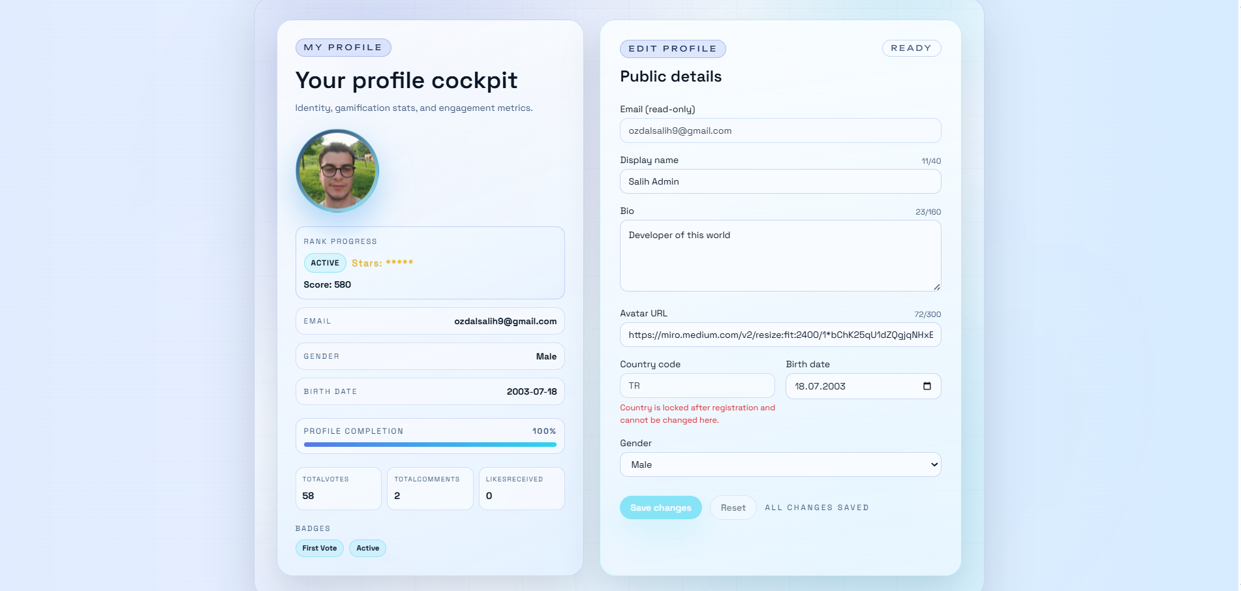
Figure 7.5. User profile and activity information.

7.8 Privacy and Analytics Implementation
The privacy controller stores a lightweight consent DTO in the wd_consent cookie. The frontend reads this state through CookieConsentProvider and only enables GA4 tracking when analytics consent is true. Page-view events are sent manually after consent rather than automatically on initial load. This design keeps optional analytics disabled by default and makes the consent state visible to the application.

8. Security, Privacy, and Ethics

8.1 Implemented Security Controls
- ASP.NET Core Identity password policy and lockout configuration.
- Email confirmation before login and password reset through email token links.
- JWT issuer, audience, signing key, and short access-token lifetime validation.
- Rotating refresh tokens with database hashes, token family IDs, revocation, and reuse detection.
- HttpOnly refresh cookie with environment-specific Secure and SameSite settings.
- Role-based authorization for administrative endpoints.
- CORS configured from an allowlist and credentials enabled only for trusted frontend origins.
- Security headers for content type sniffing, framing, referrer policy, and permissions policy.
- Redis counters for login attempts, forgot-password requests, vote attempts, view attempts, and AI summary requests.
- Unique database indexes for one vote per user per question and daily unique views.

8.2 Privacy Controls
The code avoids storing raw IP addresses in vote and view records. Instead, it stores salted SHA-256 hashes for deduplication and abuse control. Country information is stored as a short code with source metadata, provider metadata, and confidence. The frontend includes optional analytics consent, and GA4 tracking is only enabled after consent. Analytics is configured with IP anonymization.

8.3 Ethical Considerations
The platform processes personal and opinion data, which can reveal sensitive cultural, political, or social preferences. A production deployment should present clear informed consent, explain country inference, provide privacy notices, allow data deletion requests where legally required, and avoid displaying small-country or small-demographic groups in a way that could expose individuals. The current implementation includes 13+ age validation and privacy-aware IP hashing, but final deployment should include a formal ethics review if real human-subject data is used for academic research.

8.4 Security Gaps and Recommendations
- Move all secrets, including SMTP credentials and API keys, out of appsettings files and into user secrets, environment variables, or a secret manager.
- Add rate limits for comment creation, reply creation, and like toggling to reduce discussion spam.
- Add CSRF protection or double-submit checks for cookie-backed refresh and other credentialed cookie flows where applicable.
- Apply minimum sample thresholds or suppression to country and demographic comparison before showing small groups.
- Add content reporting, moderation queues, and audit logs for controversial discussion management.
- Introduce dependency scanning, container scanning, and OWASP ASVS-based security checklist review [7].
- Increase automated test coverage for vote uniqueness, refresh-token reuse, country mismatch, abuse limits, and admin imports.

8.5 Threat Model Summary
Threat | Current Control | Residual Risk
Credential stuffing | Identity lockout settings and Redis login attempt counter. | Distributed attacks may require device fingerprinting, CAPTCHA, or external WAF controls.
Vote manipulation | Authentication, unique vote index, cooldown, Redis vote-attempt limit. | Coordinated fake accounts can still distort results.
View inflation | Daily unique hashed IP view record and Redis silent drop. | NAT/shared networks and distributed botnets can reduce accuracy.
Country spoofing | GeoIP, declared country, confidence metadata, registration check. | VPN/proxy users can still be misclassified or blocked incorrectly.
Comment spam | Authentication and text length validation. | Dedicated comment rate limits and moderation are still required.
Refresh token theft | HttpOnly cookie, token hashing, rotation, reuse family revocation. | Device compromise or cookie theft still requires anomaly monitoring.
Sensitive group exposure | Raw IP is not stored. | Small-country and demographic threshold suppression is not yet implemented.
AI misuse | Prompt asks for neutral and tentative summaries, fallback text. | Prompt injection and summary bias need evaluation and moderation controls.

9. Testing, Deployment, and Operations

9.1 Current Test Status
The repository contains a unit test project, but the current test file is only a placeholder. Therefore, the strongest verification presently comes from build checks and code inspection. For a thesis defense, the project should include focused unit and integration tests around the most important business rules.

9.2 Recommended Test Plan
Area | Example Tests
Authentication | Register validation, email confirmation, login failure, login success, password reset, refresh rotation, refresh reuse revocation.
Voting | Option-question mismatch, one vote per user, vote change cooldown, country assignment, cache invalidation, stats increments.
Statistics | Option percentages, country grouping, gender and age-band grouping, zero-vote behavior.
Comments | Length validation, parent validation, reply listing, like toggle, stale summary flag.
Abuse | Redis threshold behavior for login, forgot-password, vote, view, and AI summary requests.
Admin | Bulk import validation, duplicate detection, publish/archive transitions, category CRUD.
Frontend | Protected routes, token refresh interceptor, consent flow, vote confirmation, country compare modal.

9.3 Deployment Model
The docker-compose.yml file defines PostgreSQL 16, Redis 7, the API, pgAdmin, and RedisInsight. The frontend Dockerfile builds the React application with Node 20 and serves the generated static files through Nginx. The API Dockerfile publishes the .NET 8 application and exposes port 8080. Production settings are injected through environment variables, including database connection string, JWT key, refresh token pepper, IP salt, Gemini key, and CORS origins [8].

9.4 Operational Checklist
- Run database migrations before serving traffic and verify seed data completes successfully.
- Use strong production values for JWT key, refresh token pepper, IP salt, database password, SMTP password, and Gemini API key.
- Configure CORS origins to exact production frontend domains only.
- Terminate TLS at a reverse proxy and preserve X-Forwarded-For and X-Forwarded-Proto headers safely.
- Monitor API 401, 403, 409, 429, and 5xx responses to detect authentication, abuse, and reliability issues.
- Back up PostgreSQL volumes and test restore procedures.
- Limit access to pgAdmin and RedisInsight to trusted networks or disable them in production.
- Enable dependency and container image scanning in the CI/CD pipeline.

10. Results and Discussion

10.1 Implemented User Experience
The screenshots show that WorldDeciding has a complete interaction flow: a live home page, question discovery, binary voting, statistics visualization, country comparison, comments, profiles, categories, leaderboards, login, registration, and administration. The application is not merely a static prototype; the UI maps directly to API endpoints and data models in the repository.
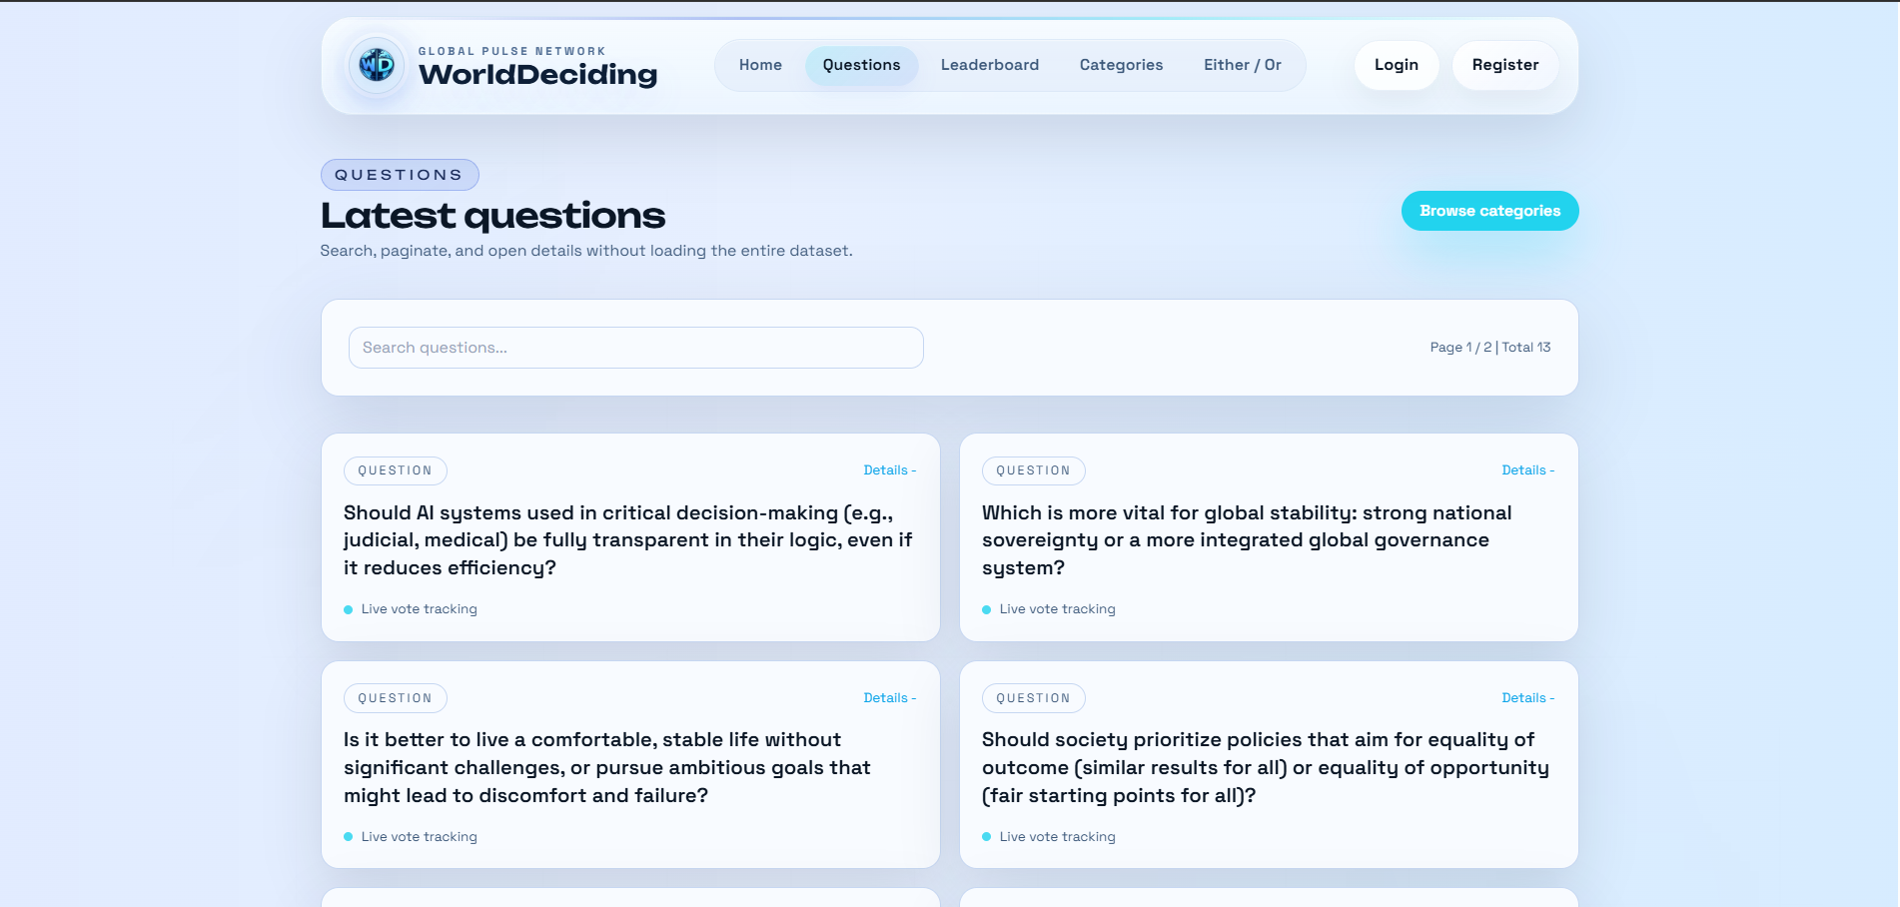
Figure 10.1. Question listing page.
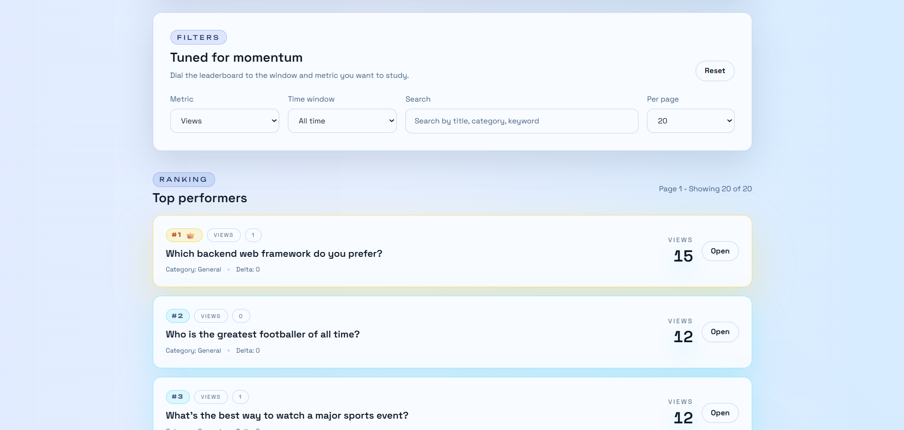
Figure 10.2. Leaderboard page.

10.2 Engineering Evaluation
The implementation demonstrates appropriate separation of concerns for a graduation project. Controllers remain mostly thin, use cases are concentrated in handlers, infrastructure services hide implementation details, and frontend modules follow page/entity/feature/shared boundaries. PostgreSQL provides relational consistency for identity, votes, comments, and stats. Redis supports fast, expiring counters and cached responses. Docker Compose supports reproducible local and production-like deployment.

10.3 Limitations
- The system currently provides platform-sample opinion analysis, not representative survey inference.
- Country inference can be affected by VPNs, proxies, mobile networks, and GeoIP database accuracy.
- Small sample sizes can create misleading country or demographic comparisons if not suppressed.
- Automated test coverage is still minimal and should be expanded before production use.
- AI summaries can simplify or misinterpret discussion, so summaries must remain explicitly labeled as AI-generated and tentative.
- Moderation and abuse controls should be expanded for comments, profiles, and uploads before public launch.

10.4 Discussion
The project successfully implements the major thesis goal: a web platform that collects opinions and presents cross-cultural comparison. Its strongest engineering elements are the layered backend, vote uniqueness rules, country-aware aggregation, Redis-backed rate controls, rotating refresh-token model, and polished statistics UI. Its main research limitation is sampling: without recruitment, weighting, or response-bias correction, the data should be interpreted as participation data from the platform community. This limitation is acceptable for a software engineering thesis if it is explained clearly and not overstated as scientific public opinion measurement.

10.5 Evaluation Against Requirements
Requirement | Implementation Evidence | Status
Registration and login | AuthController, Identity configuration, frontend login/register pages. | Implemented
Email confirmation and reset | Confirm-email, resend-confirmation, forgot-password, reset-password endpoints. | Implemented
Authenticated voting | VotesController and CastVoteHandler with JWT user resolution. | Implemented
Duplicate vote prevention | Unique index on QuestionId and UserId, conflict handling. | Implemented
Country comparison | CountryCompareHandler and statistics frontend modal. | Implemented
Demographic statistics | GetQuestionStatsHandler reads user gender and birth date. | Implemented
Comments and likes | CommentsController, AddCommentHandler, ToggleCommentLikeHandler. | Implemented
AI summaries | GptSummarizer, GetQuestionSummaryHandler, country comparison summary. | Implemented with provider fallback
Spam protection | Redis counters for login, forgot password, vote, view, and AI summary. | Partially implemented
Admin tools | AdminQuestionsController and category admin endpoints. | Implemented
Automated tests | Unit test project exists but contains no effective tests. | Needs work

10.6 Example Use Case Walk-Through
A typical user lands on the home page and sees the current live question. The user opens the question, selects an option, and is asked to sign in or register if not authenticated. During registration, the user provides country and demographic fields; in production, the country can be compared against GeoIP-derived metadata. After login, the user submits a vote. The backend validates the option, checks abuse counters, stores the vote with country metadata, increments daily statistics, and invalidates cached stats. The frontend then updates the option distribution and offers navigation to the statistics page.
On the statistics page, the user can inspect vote distribution by option and country. Selecting two countries opens the comparison modal. The modal displays each country's vote distribution, global baseline, biggest option gap, overlap score, and AI-generated interpretation. The user can also open the comment drawer, read the discussion, request an AI summary, post a reply, or like existing comments. Administrators manage the content supply through bulk import and publish/archive controls.

11. Conclusion and Future Work
This thesis documented the design and development of WorldDeciding, a full-stack web platform for cross-cultural opinion analysis. The platform supports account creation, secure login, voting, comments, country comparison, statistical dashboards, AI-assisted summaries, administration, privacy consent, and containerized deployment. The implementation shows that modern web technologies can be combined to produce an extensible system for exploring how opinions differ across cultural and geographic contexts.
Future work should focus on scientific validity, operational safety, and production maturity. Scientific validity can be improved through sampling strategies, weighting, survey metadata, confidence intervals, and minimum display thresholds. Operational safety can be improved through moderation tools, report workflows, rate limits for all write actions, audit logging, and security testing. Production maturity can be improved through secret management, CI/CD, observability, backups, automated tests, and formal privacy impact assessment.

Future Work Items
- Add confidence intervals and sample-size warnings to statistics pages.
- Introduce demographic and country threshold suppression to reduce re-identification risk.
- Add moderation, reporting, and admin review workflows for comments and profiles.
- Create integration tests with Testcontainers for PostgreSQL and Redis.
- Add API versioning and OpenAPI-based client generation.
- Improve AI governance with prompt-injection defenses and summary quality review.
- Add data export, deletion, and consent-history workflows for privacy compliance.

12. References
[1] R. Inglehart et al., World Values Survey, Center for Political Studies, University of Michigan. The WVS is an international research program studying social, political, economic, religious, and cultural values across more than 120 countries. Accessed: May 1, 2026.
https://cps.isr.umich.edu/projects/world-values-survey-wvs/
[2] European Social Survey, Methodology Overview. The ESS highlights the methodological difficulty of measuring attitudes cross-nationally and the need for high quality comparative survey design. Accessed: May 1, 2026.
https://www.europeansocialsurvey.org/methodology/methodology-overview
[3] B. Pang and L. Lee, Opinion Mining and Sentiment Analysis, Foundations and Trends in Information Retrieval, vol. 2, no. 1-2, pp. 1-135, 2008, doi: 10.1561/1500000011.
https://www.nowpublishers.com/article/Details/INR-011
[4] Microsoft Learn, Configure ASP.NET Core Identity. Identity supports configurable password, lockout, claims, and cookie options for web applications. Accessed: May 1, 2026.
https://learn.microsoft.com/en-us/aspnet/core/security/authentication/identity-configuration
[5] Redis, Rate Limiting. Rate limiting controls the number of requests a client can make during a period to protect system stability, security, and fair use. Accessed: May 1, 2026.
https://redis.io/glossary/rate-limiting/
[6] Npgsql Documentation, Npgsql - .NET Access to PostgreSQL. Npgsql is an open source ADO.NET provider and includes an Entity Framework Core provider for PostgreSQL. Accessed: May 1, 2026.
https://www.npgsql.org/
[7] OWASP Developer Guide, Application Security Verification Standard. ASVS is used to identify security gaps and verify web applications across authentication, session management, access control, validation, cryptography, and API controls. Accessed: May 1, 2026.
https://devguide.owasp.org/en/11-security-gap-analysis/01-guides/02-asvs/
[8] Docker Documentation, Compose overview. Docker Compose is used to define and run multi-container applications with services, networks, and volumes. Accessed: May 1, 2026.
https://docs.docker.com/compose/

Appendix A. Screenshots
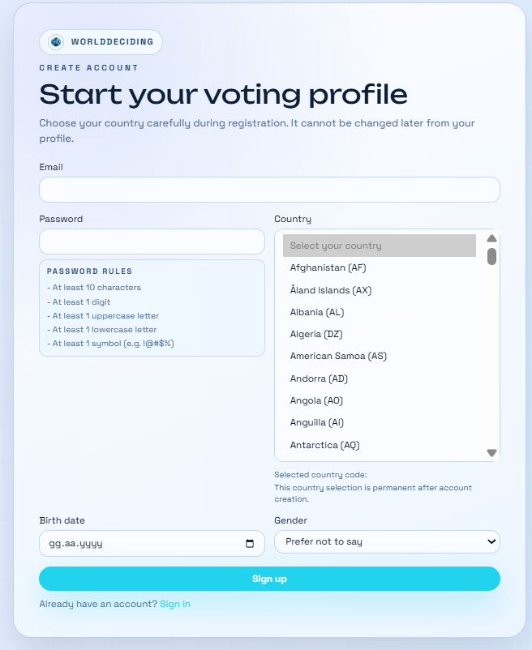
Figure A.1. Registration page.

Figure A.2. Login page.
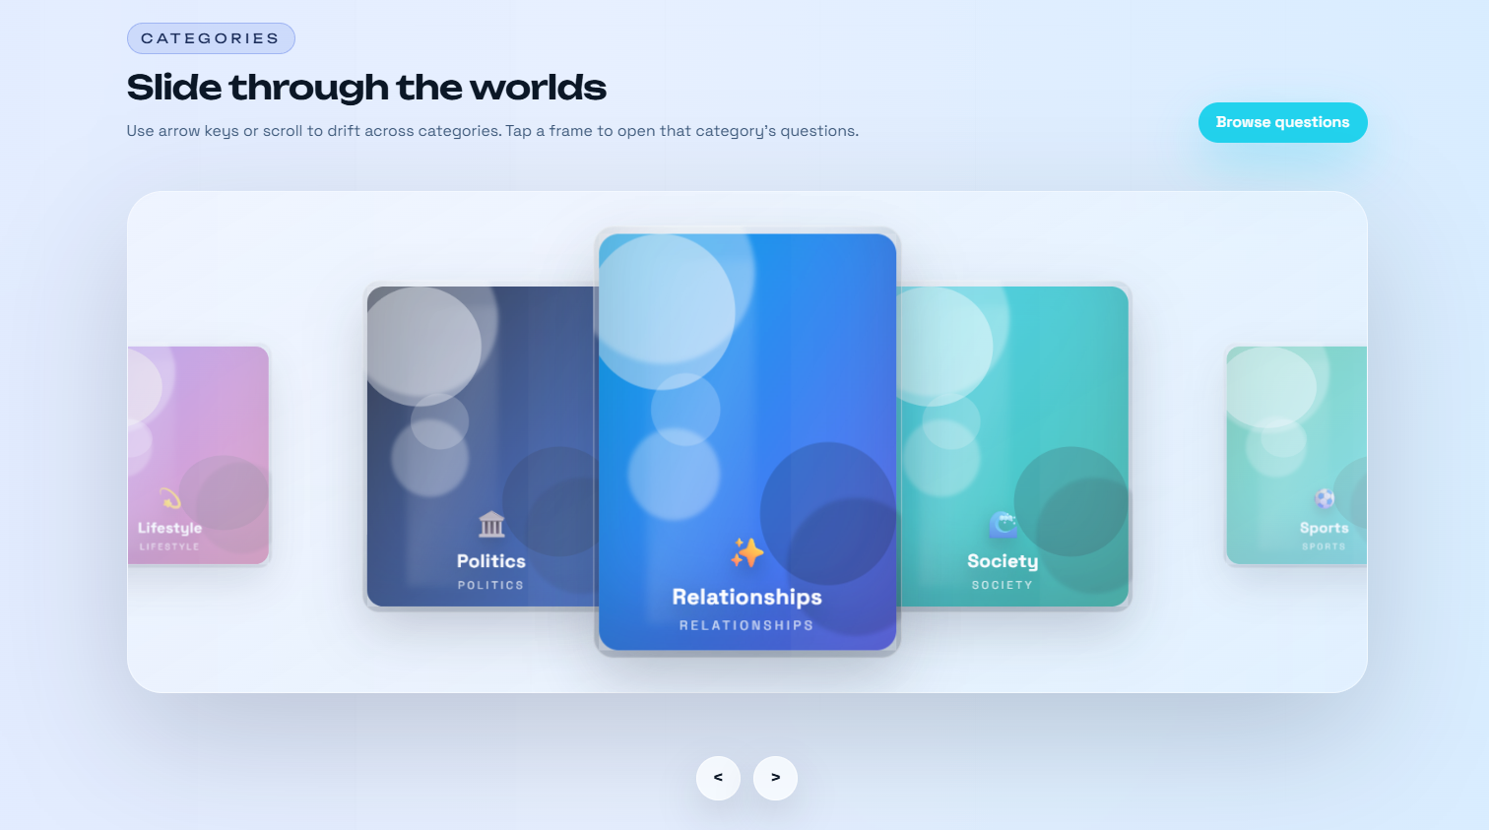
Figure A.3. Categories page.

Figure A.4. Authenticated profile page.
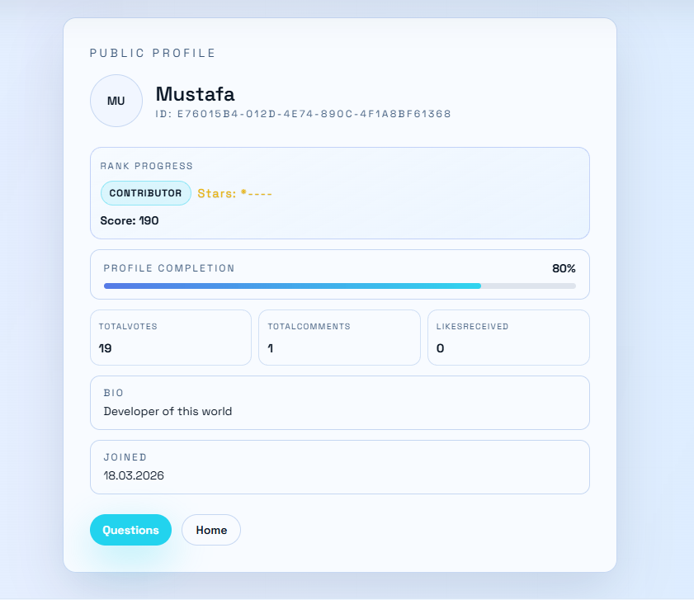
Figure A.5. Public profile page.
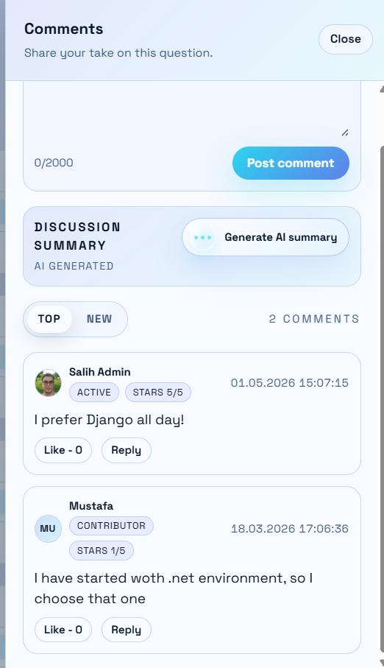
Figure A.6. Comment panel.
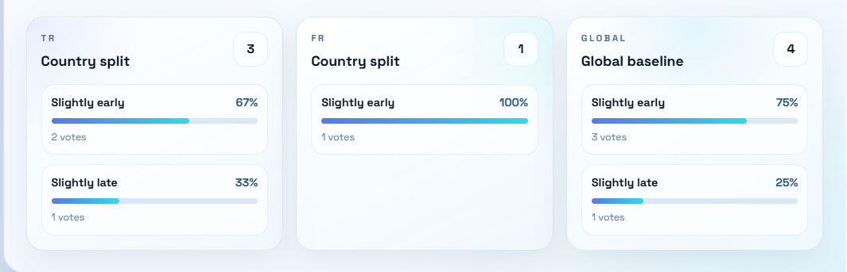
Figure A.7. Country comparison detail panel.
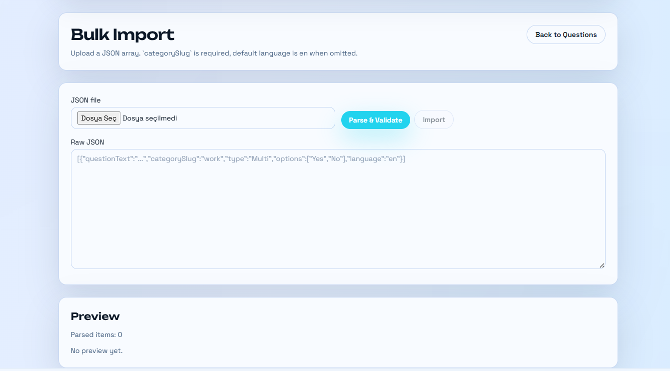
Figure A.8. Bulk import page.
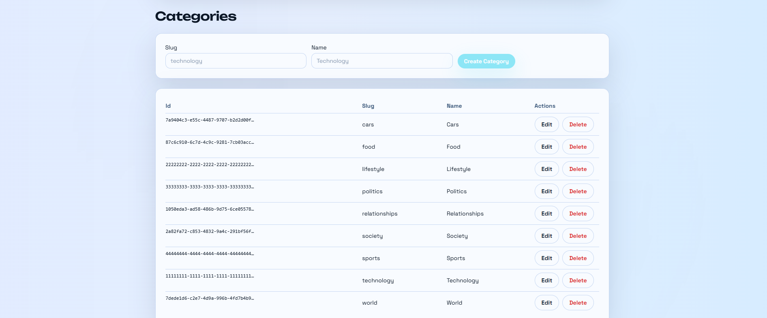
Figure A.9. Admin categories page.
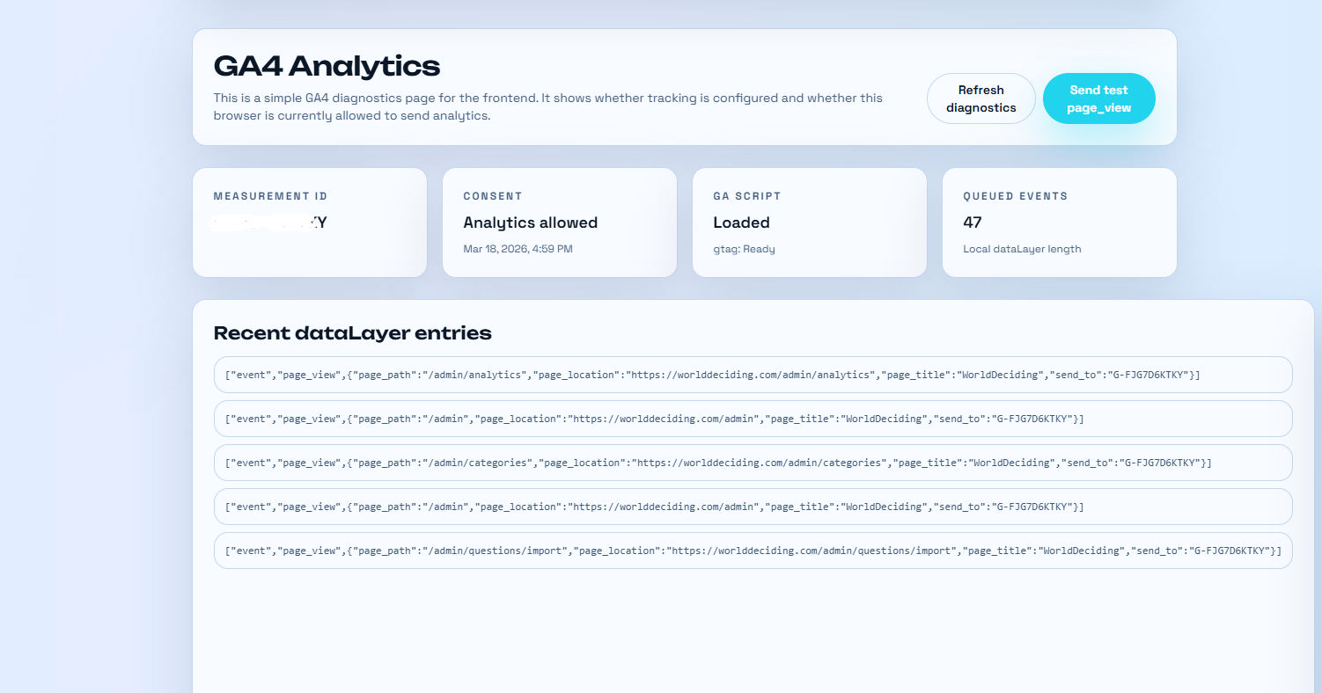
Figure A.10. GA4 analytics page used for operational review.

Appendix B. API and Module Summary
Area | Representative Endpoints
Authentication | GET /api/auth/register-country, POST /api/auth/register, POST /api/auth/login, POST /api/auth/refresh, POST /api/auth/logout
Questions | GET /api/questions, GET /api/questions/{id}, GET /api/questions/{id}/stats, POST /api/questions/{id}/view
Voting | POST /api/votes
Country comparison | GET /api/questions/{id}/country-compare?left=TR&right=US
Comments | GET/POST /api/questions/{id}/comments, GET /api/comments/{id}/replies, POST /api/comments/{id}/like
Categories | GET /api/categories, GET /api/categories/{id}/questions, admin POST/PUT/DELETE category endpoints
Profile | GET /api/profile/me, PUT /api/profile/me, GET /api/profile/{userId}
Leaderboard and live | GET /api/leaderboard, GET /api/live, GET /api/live/stats
Admin questions | GET /api/admin/questions, POST /api/admin/questions/bulk-import, publish/archive/detail endpoints
Privacy | GET /api/privacy/consent, POST /api/privacy/consent

