Mobile Apps Development Orestis Zoidis 40428588

**OrderOnTheGo**

1.

OrderOnTheGo is an application designed for small businesses such as restaurants, cafeterias or small pubs in order to take and manage orders. It is designed for waiters/waitresses and it simplifies the process of taking table orders. It is developed on Android Studio available for Android devices.

The idea to develop this app came from personal experiences in the hospitality and Food industry. The application covers basic ordering functionalities, such as taking orders, viewing orders, menu layout and cash management.

2.

**Software Design**

The application was developed in Android Studio using JAVA. It consists of multiple layouts containing various design objects, such as Buttons, TextViews and a RecyclerView. The navigation path is straight forward and the user interaction is very user friendly.

***Classes and Objects***

The design of the classes and their association was a complicated subject when developing the app as the interaction between the layouts and the object in them required the implementation of the Parcelable interface which proved to be quite a challenge when the class structure adopted inheritance and aggregation.

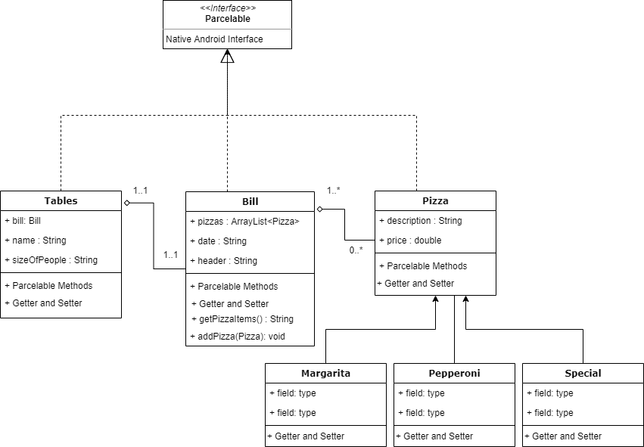

|  |  |  |
| --- | --- | --- |
| Main Menu | Tables View | Table layout |
| Order Input from Menu | Table Order Overview | Non interactive Menu |

3.

***Navigation Map***

4.

**Evaluation**

The development of the application turned out to be a satisfactory attempt covering many basic functionalities required in a small business environment.

From start to finish, the application development cycle exhibited ups and downs regarding the complexity of implementing the technical aspects of Android Studio and lots of time was spent on researching solutions to problems arising.

The most time consuming and complicated stage of the development cycle was making the objects flexible to be transported to the following layouts and robust enough to be able to save their current state and being present even after closing the application.

The properties of allowing such functionality to the application was possible by using the Parcelable Interface to move custom objects in-between layouts and the SharedPreferences class to store data locally.

Compare to similar applications found in the same category, OrderOnTheGo provides basic functionality and is aimed for small businesses. The App store provides some very well-designed ordering apps for the same purpose and will be an inspiration for further improvement.

Further improvement for the future is adding additional menu items, card payment selection and storing data on the cloud.

5.

**Resources**

Vectors and icons created from other creators were used in the application and the creators are credited for the authorship of the icons.

***References***

Images:

(pizza_slice) "Icon made by **Freepik** from [www.flaticon.com](http://www.flaticon.com)"

 (mail) "Icon made by **Wichai.wi** from [www.flaticon.com](http://www.flaticon.com)"

 (order) "Icon made by **Nikita Golubev** from [www.flaticon.com](http://www.flaticon.com)"

(cash-register) "Icon made by **Icongeek26** from [www.flaticon.com](http://www.flaticon.com)"

(table_item) "Icon made by **Freepik** from [www.flaticon.com](http://www.flaticon.com)"

 (tables) "Icon made by **Freepik** from [www.flaticon.com](http://www.flaticon.com)"

 (menu) "Icon made by **Freepik** from [www.flaticon.com](http://www.flaticon.com)"

Codinginflow. 23 November 2017. Youtube. [Online]. [28/03/2020]. Available from: <https://www.youtube.com/watch?v=WBbsvqSu0is&t=80s>

Codeinflow. NA. CodeInFlow. [Online]. [12/03/2020]. Available from: <https://codinginflow.com/tutorials/android/save-arraylist-to-sharedpreferences-with-gson>

Codingwithmitch. 2 January 2018. Youtube. [Online]. [1/03/2020]. Available from: <https://www.youtube.com/watch?v=ZXoGG2XTjzU>

Cyberpride. NA. Inducesmile. [Online]. [4/03/2020]. Available from: <https://inducesmile.com/android-programming/how-to-create-a-nested-parcelable-object-in-android/>

Ekene , E.Z.E. 28 May 2017. Medium. [Online]. [24/03/2020]. Available from: <https://medium.com/@peterekeneeze/passing-data-between-activities-2d0ef122f19d>

Geeksforgeeks. 23 November 2017. Geeksforgeeks. [Online]. [NA]. Available from: <https://www.geeksforgeeks.org/java-util-arraylist-indexof-java/>

nikhil , D.H.Y.A.N.I. 2018. Medium. [Online]. [5/03/2020]. Available from: <https://medium.com/@nikhildhyani365/understand-parcelable-in-android-27ce420d695b>

Snæbjørn. 13 May 2017. Inducesmile. [Online]. [4/03/2020]. Available from: <https://stackoverflow.com/questions/14178736/how-to-make-a-class-with-nested-objects-parcelable>