Activity 11 Creature Registry Evidence
Myles Miller and Eziz Bagshiyev
Undergraduate track | Shared build only
Repository: https://github.com/ozemoya/incl11
This document answers two Ghost Hunt prompts using the Nightfall Registry build, automated Flutter checks, and screenshots captured on the Pixel 7 Pro Android emulator. The tables link each observed result to its test or screenshot.

The Poltergeist Field
Rotating this build did not erase the name, visible password, birth date, or Black Cat selection. The name and password text live in controllers inside _SignupScreenState, while _obscurePassword, _birthDate, and _selectedCreatureType are State fields; _dateController mirrors the displayed date. Rotation changes the layout but keeps the existing State, so the values stay available. Leaving the signup route is different: dispose releases the controllers, and reopening the form creates empty fields with the password hidden again. If a value disappeared during an ordinary rebuild, the smallest fix would be to move its owner out of build and into State, while process-death recovery would require a separate design that avoids restoring passwords.
Value | Owner | Observed after rotation
Name and password | TextEditingControllers | Myles Miller and test input retained
Password visibility | _obscurePassword | Still visible
Birth date | _birthDate and _dateController | 1/1/2008 retained
Creature | _selectedCreatureType | Black Cat retained
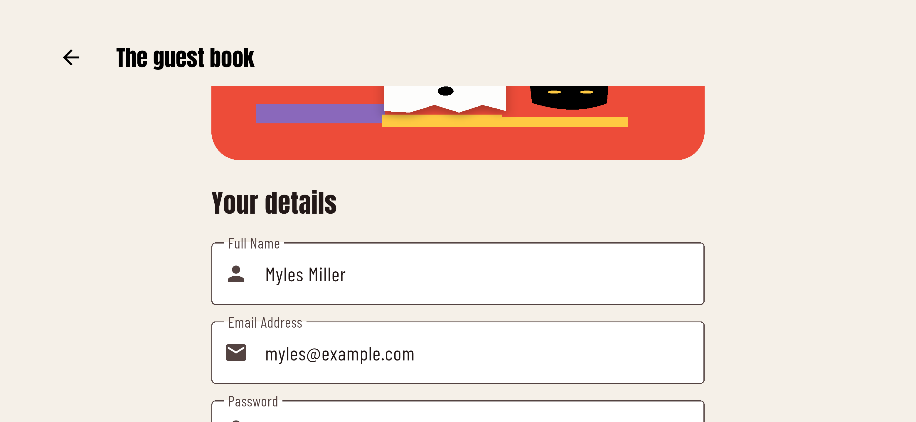
Landscape capture from integration_test/registry_test.dart. The test also asserts the date and creature value even when they are below the viewport. The visible password is disposable test data.

The Clairvoyant Ghost
The five dates below check both sides of the proposed 1990 cutoff, a later year, the current date, and a future date. A picker ending in 1990 would incorrectly reject the 2008 and current-date rows, so testing only old birthdays would miss that bug. In this build, _pickBirthDate uses firstDate: DateTime(1920) and lastDate: DateUtils.dateOnly(DateTime.now()), and the Android run accepted all four allowed dates. Entering October 30, 2026 kept the picker open with “Out of range,” which matches the expected rejection of a future birthday. These results apply to the device date of October 29, 2026; the automated test calculates today and tomorrow again when rerun.
Input | Expected | Observed on emulator
12/31/1989 | Accept | Accepted and displayed
1/1/1990 | Accept | Accepted and displayed
1/1/2008 | Accept | Accepted and displayed
10/29/2026 today | Accept | Accepted and displayed
10/30/2026 tomorrow | Reject | Out of range; dialog stayed open
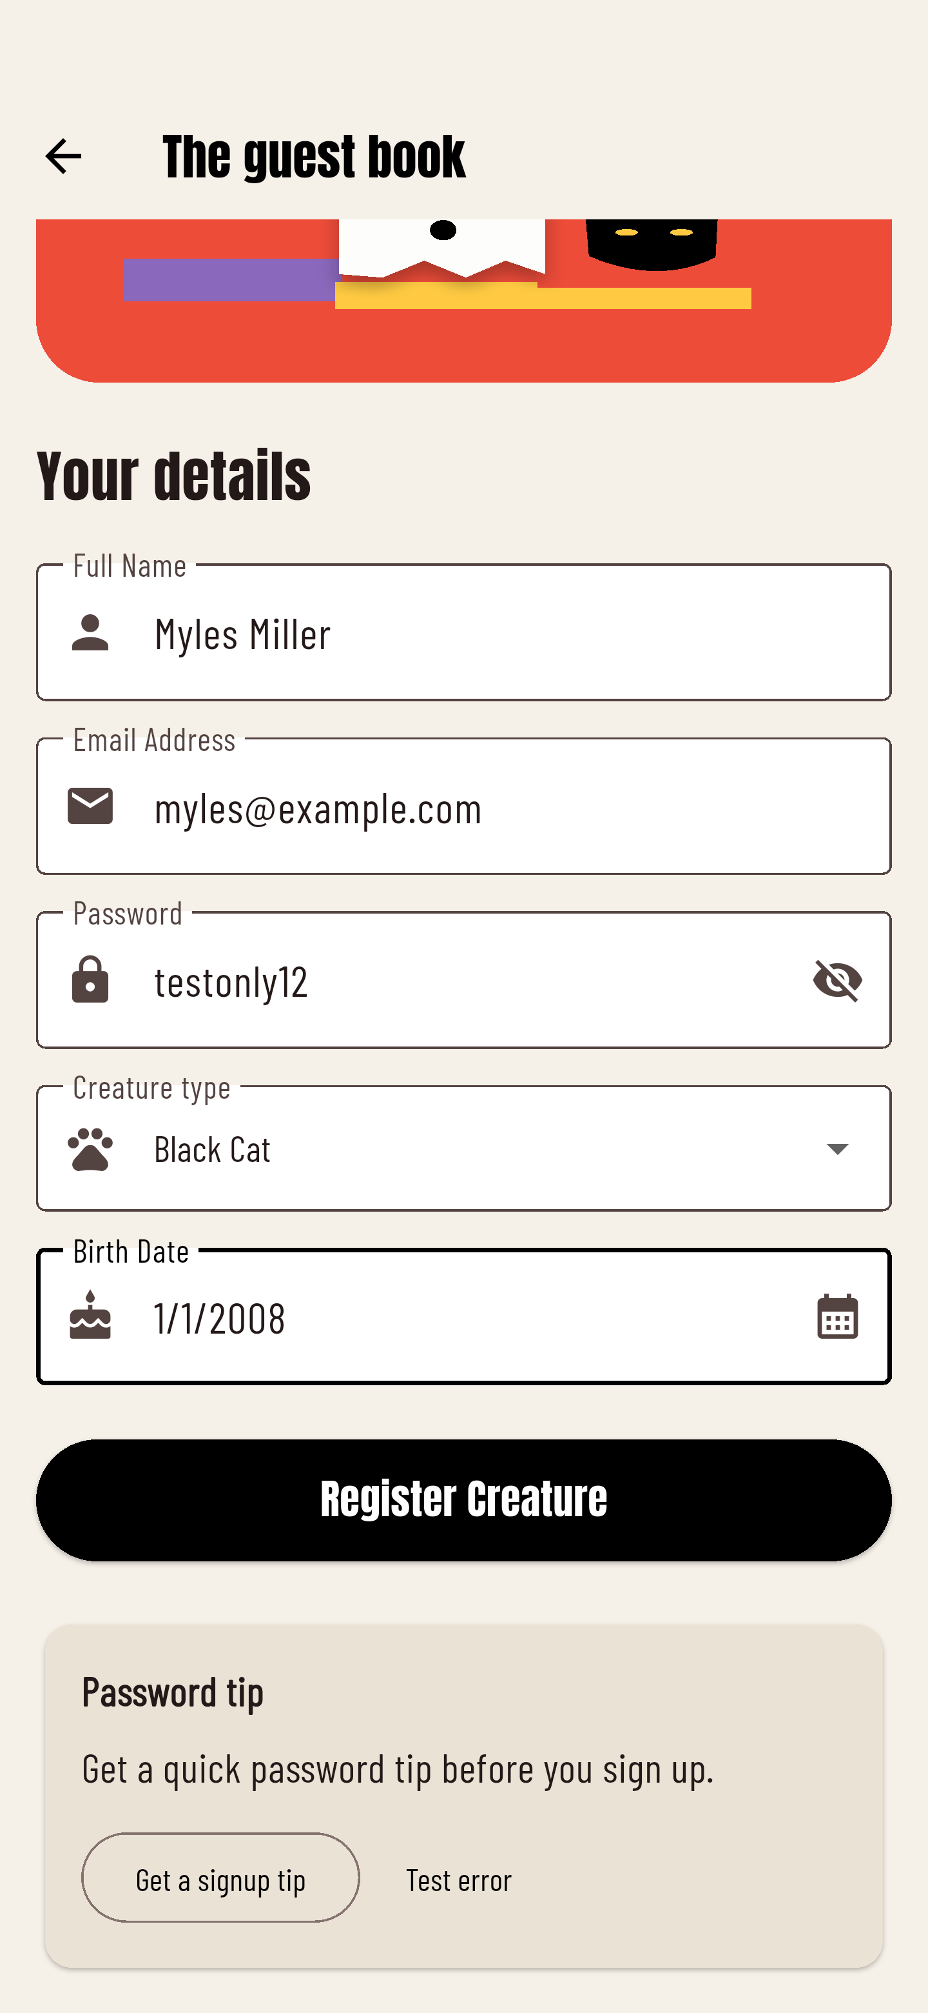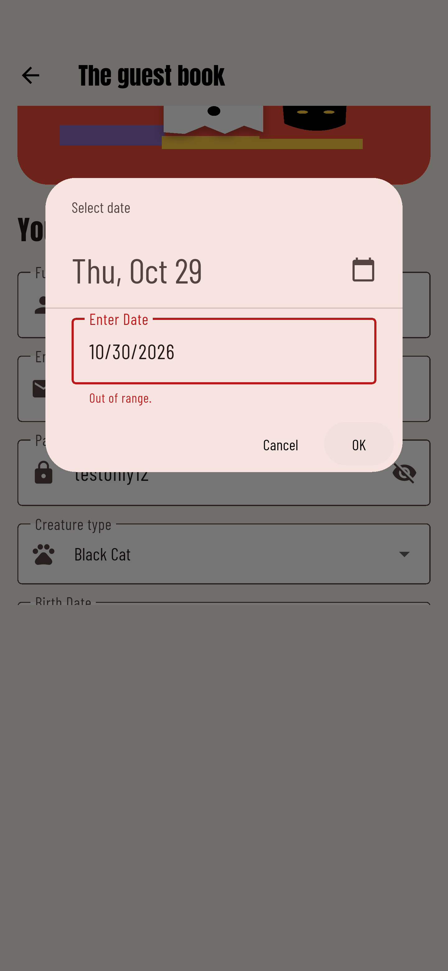
Left: a 2008 date accepted in the guest book. Right: tomorrow rejected by the date input. Other accepted-date captures are retained in docs/.
Code trace: SignupScreen → _pickBirthDate → showDatePicker → mounted check → setState updates _birthDate and _dateController. Cancelling the picker returns without changing the previous selection.

Flow and validation checks
Verification on October 29 2026: flutter analyze found no issues; 14 widget tests and one Android integration test passed. The table distinguishes checks run in the widget suite from those also run on the emulator.
Check | Observed result | Evidence
Empty registration | All five required-field errors appeared | Widget and Android
Email without @ and 5-character password | Both original validation messages appeared | Widget test
All five creatures | Each reached a confirmation with its own type | Five widget cases
Eye toggle | Show and hide changed password visibility | Widget and Android
Date rules | Empty blocked; future rejected; valid dates kept | Widget and Android
Back from signup | Foyer returned; new form was empty | Widget and Android
Back from success | Foyer returned; signup was not underneath | Widget test
Loading | Register button disabled; one success screen | Widget test
Exit during loading | No success route or disposed-state exception | Widget test
Confetti and return | Success opened; foyer and new form opened safely | Android integration
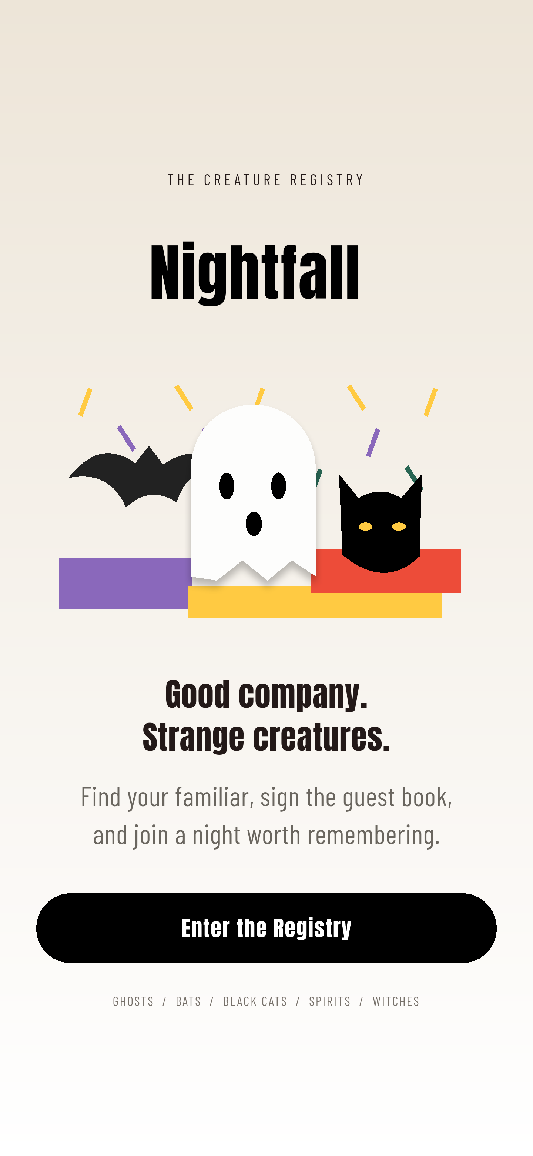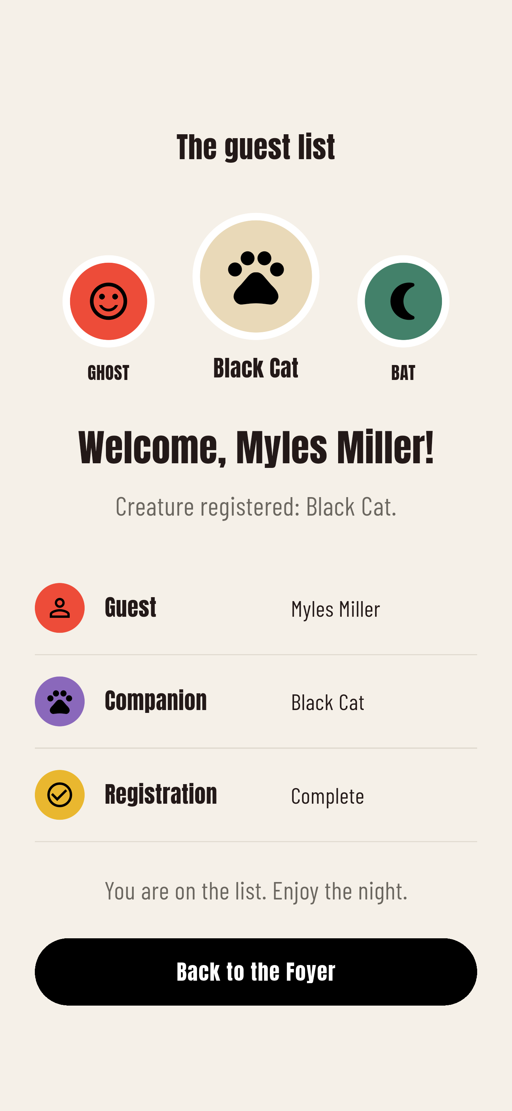
The entry screen and personalized ballroom, captured from the running Android app. The form is replaced on success, so the previous guest book cannot be resubmitted with Back.

