Revision History

|  |  |  |  |
| --- | --- | --- | --- |
| **Date** | **Version** | **Description** | **Author** |
| 26/10/2020 | 0.1 | Updated sections from 1.1 to 1.4. | Burcu Arslan  Özge Yılgür |
| 26/10/2020 | 0.2 | Updated sections 2.1 and 2.4 | Aleyna Ölmezcan  Abdullah Saydemir |
| 26/10/2020 | 0.3 | Added package diagram | Emin Sadikhov  Esad Simitcioglu |
| 31/10/2020 | 0.4 | Added Use Case and Sequence diagram | Emin Sadikhov  Esad Simitcioğlu |
| 04/11/2020 | 1.0 | Revised sections 2.1 and 2.4 | Aleyna Ölmezcan  Abdullah Saydemir |
| 05/11/2020 | 1.1 | Added missing requirements to sections 2.1 and 2.4. Also revised some requirements to provide enhanced and clearer definitions. | Aleyna Ölmezcan  Abdullah Saydemir |
| 07/11/2020 | 1.2 | Revised sections 2.1 and 2.4 and deleted unnecessary requirements. | Burcu Arslan  Aleyna Ölmezcan  Emin Sadikhov  Abdullah Saydemir  Esad Simitçioğlu  Özge Yılgür |
| 13/11/2020 | 2.0 | Revised sections 2.1 and 2.4 and deleted unnecessary requirements. Updated Sequence, Use Case and Package diagram. Added an Activity diagram | Burcu Arslan  Aleyna Ölmezcan  Emin Sadikhov  Abdullah Saydemir  Esad Simitçioğlu  Özge Yılgür |

**TABLE OF CONTENTS**

Revision History 1

1 INTRODUCTION 3

1.1 Document overview 3

1.2 System overview 3

1.3 Abbreviations 3

1.4 References 3

1.5 Conventions 3

2 REQUIREMENTS 4

2.1 User Requirements Specification 4

2.2 System Architecture 5

2.3 Use Cases and Usage Scenarios 6

2.4 System Requirements Specification 8

# INTRODUCTION

## Document overview

This document presents the software requirements specifications of OZU-Garage software development project. It describes functional requirements, quality requirements, constraints, use cases, and usage scenarios. It also provides an overview of the system architecture.

## System overview

OzU-Garage is a desktop-based software application that allows OzU students to sell/buy products such as books, furniture, electronics and tickets. Students can log in with OzU mails and become buyers or sellers. They can open the advertisements of the products they want to sell or as a buyer, they can review the advertisements and choose the suitable for them.

## Abbreviations

OzU-G: OzU-Garage

UML: Unified Modeling Language

IDE: Integrated Development Environment

JDK: Java Development Kit

SRS: Software Requirement Specification

STP: Software Test Plan

SDD: Software Design Document

SDP: Software Development Plan

STR: Software Test Report

## References

|  |  |  |
| --- | --- | --- |
| # | Document Identifier | Document Title |
| [R1] | Ozu-G-SDP-2 | Software-Development-Plan |

## Conventions

Requirements listed in this document are constructed according to the following structure:

**SRS-Ozu-G-001**

Description of Ozu-Garage-001 requirement

Every system requirement id includes the id of the corresponding user requirement as a prefix.

**SRS-Ozu-G-000.1**

Description of *OzU-G-000.1 system requirement, which is related to the user requirement OzU-G-000.1*

# REQUIREMENTS

## User Requirements Specification

**SRS-OzU-G-001**

OzU-Garage shall enable Özyeğin University students to buy and sell their electronic, furniture and ticket items.

**SRS-OzU-G-002**

OzU-Garage shall validate that the user has an internet connection.

**SRS-OzU-G-003**

OzU-Garage shall provide a sign-up button if the user is not registered to the system.

**SRS-OzU-G-004**

OzU-Garage shall ask the user to provide credentials to login and shall ensure that the user is registered to the system.

**SRS-OzU-G-005**

OzU-Garage shall enable users to view the products currently being sold on the main page and in a page specific to that product.

**SRS-OzU-G-006**

OzU-Garage shall give users ability to publish a post to sell a product.

**SRS-OzU-G-007**

OzU-Garage shall give users ability to leave a comment to the products post which they are interested in.

**SRS-OzU-G-008**

OzU-Garage shall provide a search bar to the user to search if a certain product is being sold.

**SRS-OzU-G-009**

OzU-Garage shall provide a refresh button, which refreshes the data shown in that specific page.

**SRS-OzU-G-010**

OzU-Garage shall provide profile button, covered with user’s photo.

**SRS-OzU-G-011**

OzU-Garage shall give the user permission to view the user info and change it.

## System Architecture

GUI desktop based

Database

Cloud Server

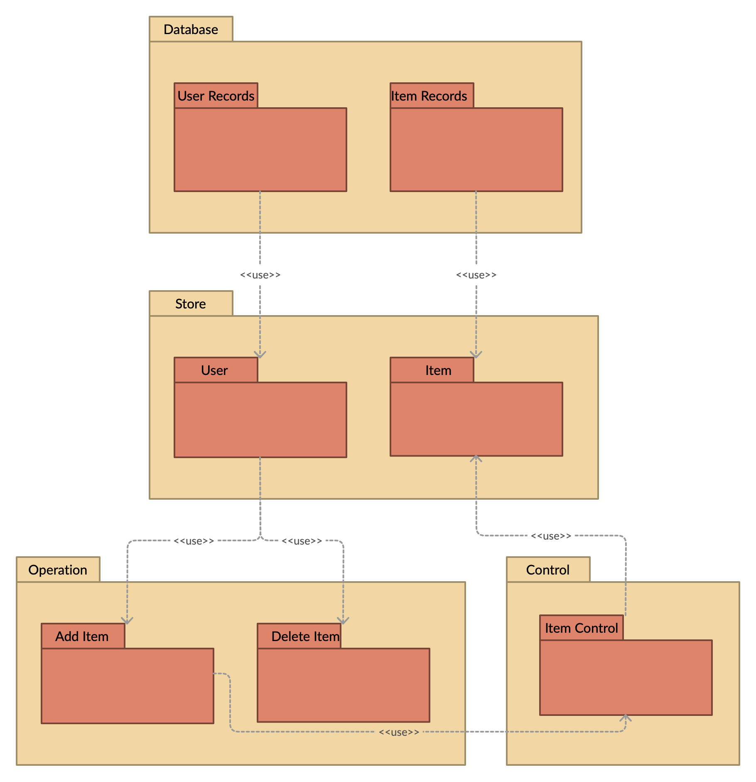

## Use Cases and Usage Scenarios

Use Case Diagram:

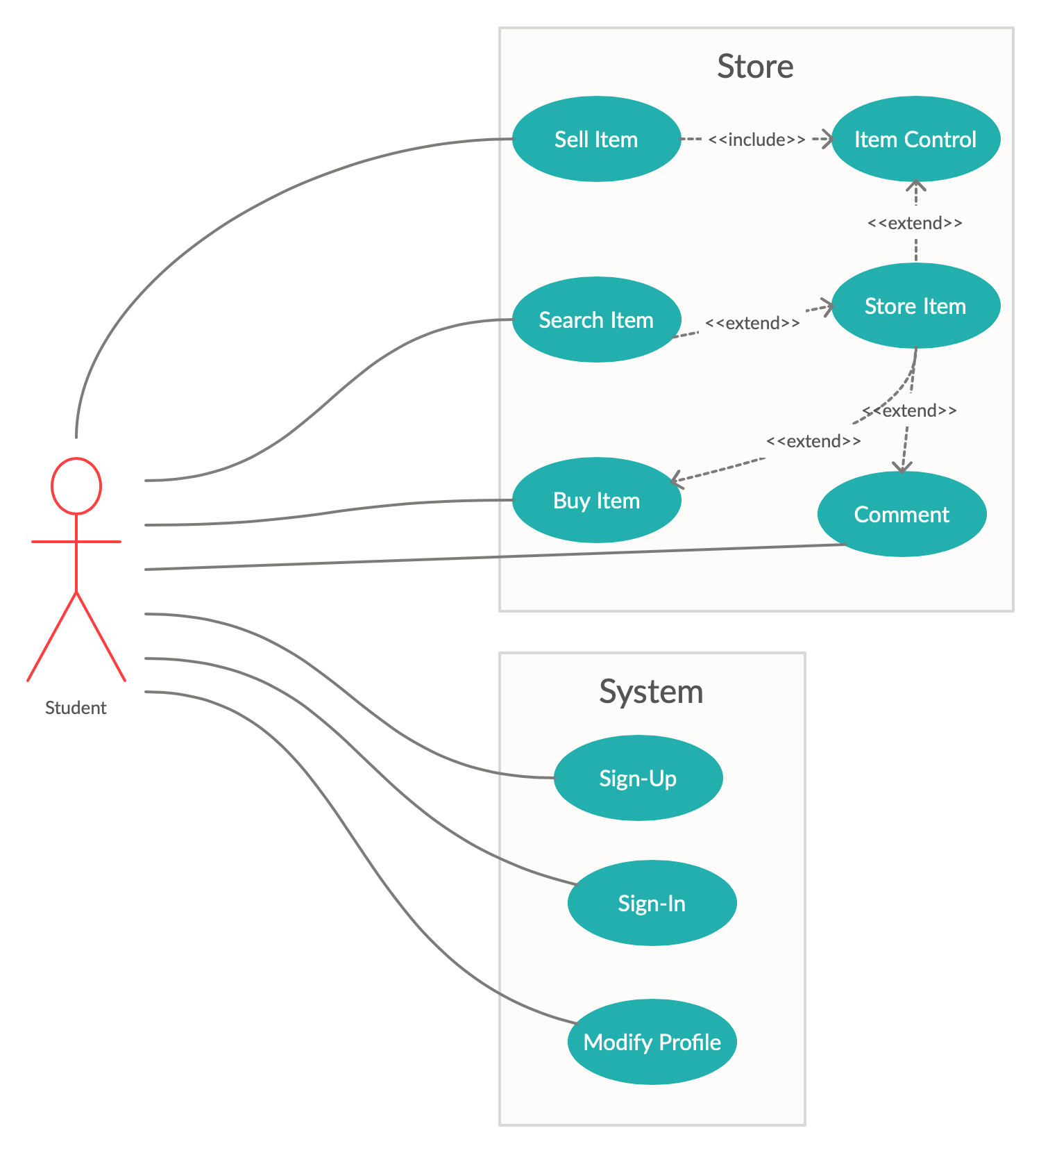

Sequence Diagram:

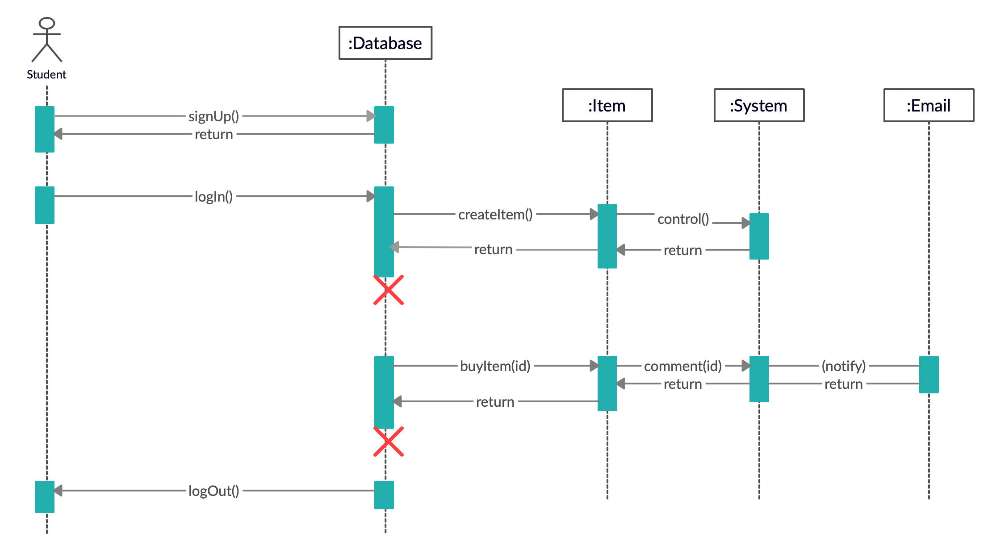

Activity Diagram :

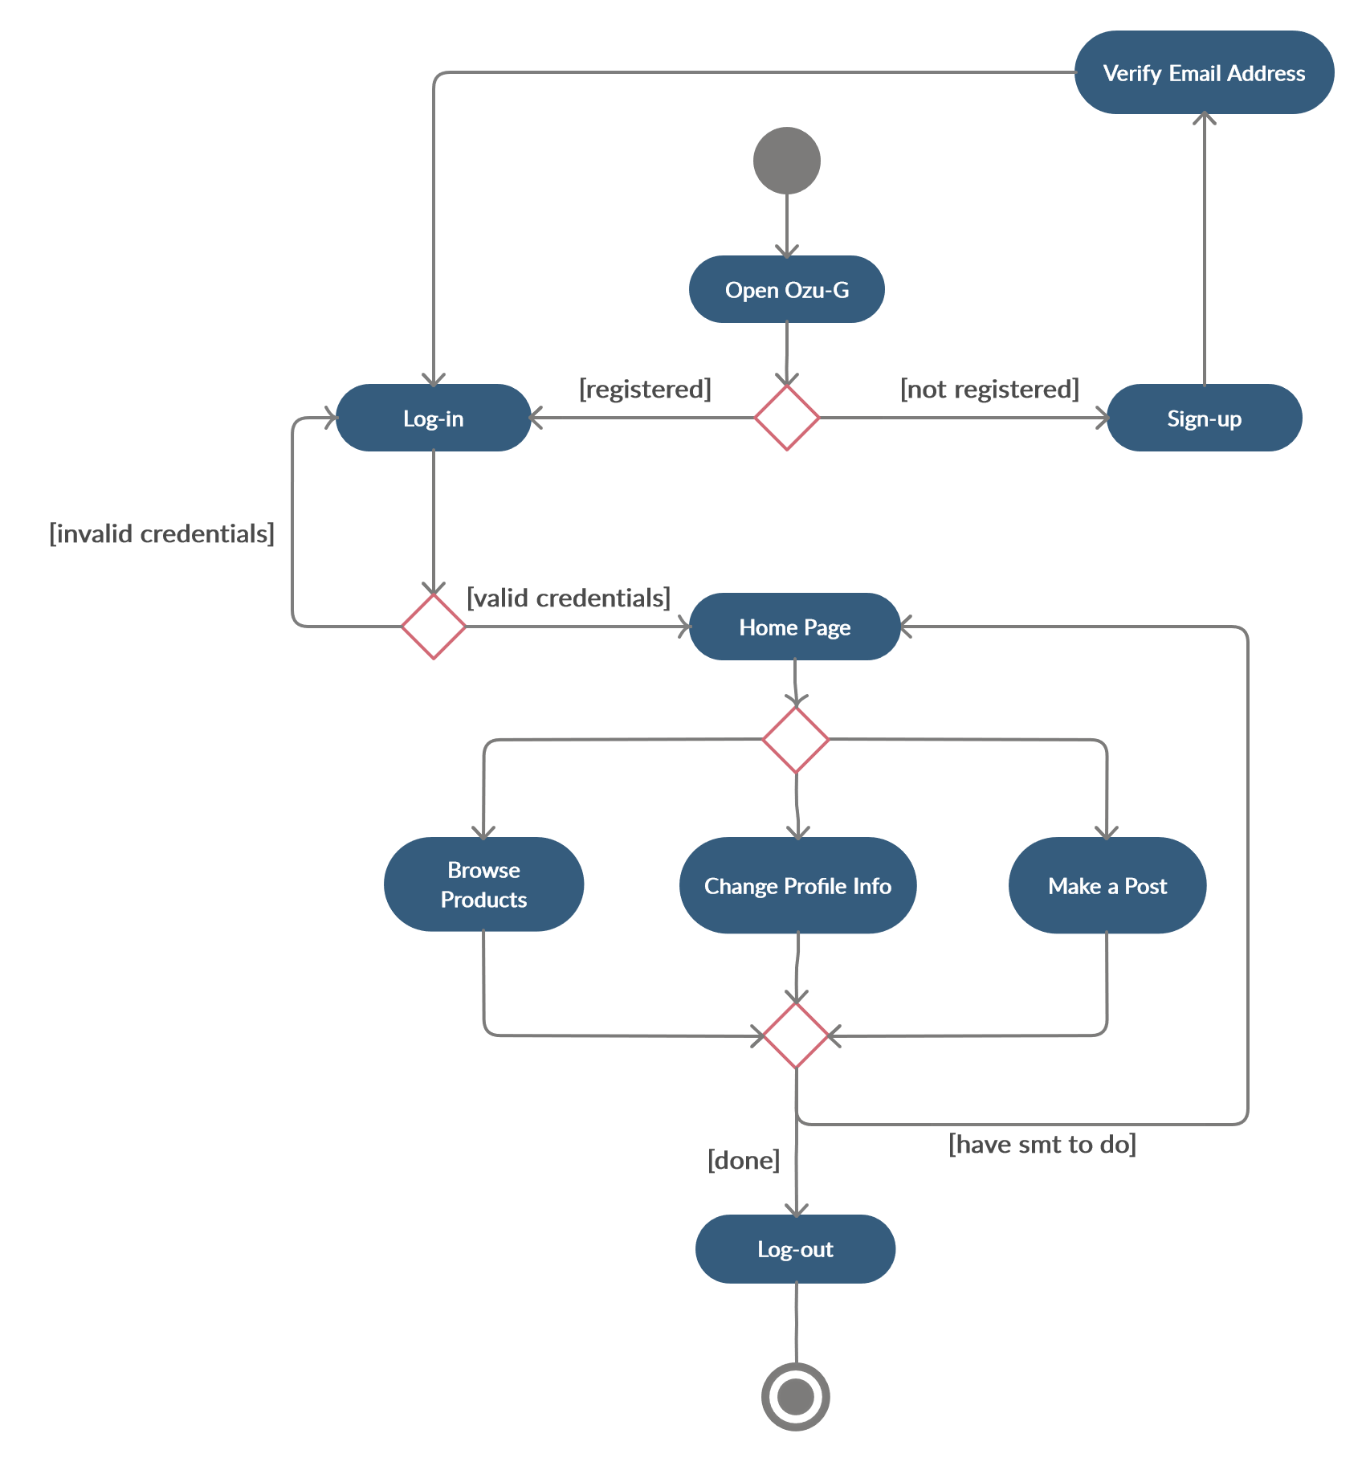

## System Requirements Specification

**SRS-OzU-G-001.1**

When the application is first started, it tries to connect with the database, if not, it will warn the user as “No Internet connection”.

**SRS-OzU-G-002.1**

For creating an account OzU-Garage shall ask user for the following information:

* Ozu Email
* Password
* Password (Check)

**SRS-OzU-G-002.2**

OzU-Garage shall validate the user’s e-mail address. If it does not have the “ozu.edu.tr” extension, it shall not allow user to register.

**SRS-OzU-G-003.1**

OzU-Garage shall take the login credentials and search the list of registered users. If there exist a user, and mail-password pair matches, then it shall navigate to the main page. If not, it should provide an error message and one of the error types listed below:

* No user with specified mail address
* Password is not correct

**SRS-OzU-G-004.1**

Products are listed on the homepage in the order of publication date by default. OzU-Garage shall provide filters to user about display order of products which are:

* Price (Increasing)
* Price (Decreasing)
* Date Added (New-to-Old)
* Date Added (Old-to-New)

**SRS-OzU-G-004.2**

When users press the product they are interested in, the detailed window of the product opens. OzU-Garage shall ensure that the product data is displayed to user, which are:

* Name
* Category
* Photo(s)
* Price
* Comment(s) (If exists)
* Seller Info
* Product features

**SRS-OzU-G-005.1**

To publish a product post, following pieces information about the product shall be given:

* Name
* Category
* Price
* Features

**SRS-OzU-G-005.2**

Result message shall be displayed after post attempt. It should be either “Successfully added” or “Error publishing post”.

**SRS-OzU-G-005.3**

The post will be published after getting the approval of the system.

**SRS-OzU-G-006.1**

OzU-Garage shall send sellers notifications when someone comments on their posts.

**SRS-OzU-G-007.1**

OzU-Garage shall automatically determine the words that the user has typed in the search button and display the appropriate posts containing the word to the screen.

**SRS-OzU-G-007.2**

Search bar must be available for all screens except for login panel and profile panel.

**SRS-OzU-G-008.1**

Refresh button must be available for all screens except for login panel. When clicked it shall refresh the page shown.

**SRS-OzU-G-009.1**

Profile button must be available for all screens except for login panel. When clicked it shall take the user to his/her profile.

**SRS-OzU-G-010.1**

Users can update his/her profile photo and password.