Revision History

|  |  |  |  |
| --- | --- | --- | --- |
| **Date** | **Version** | **Description** | **Author** |
| 20/11/2020 | 1.0 | Added sequence and diagram to Component 2 (View) | Aleyna Ölmezcan  Abdullah Saydemir |
| 20/11/2020 | 1.1 | Added sequence and diagram to Component 1 (Model) | Emin Sadikhov  Esad Simitcioğlu |
| 20/11/2020 | 1.2 | Added sequence and diagram to Component 3 (Controller) | Özge Yılgür  Burcu Arslan |
| 26/11/2020 | 1.3 | Added interface information to 3.2.1 | Aleyna Ölmezcan  Abdullah Saydemir |
| 26/11/2020 | 1.4 | Added interface information to 3.1.1 | Emin Sadikhov  Esad Simitcioğlu |
| 26/11/2020 | 1.5 | Added interface information to 3.3.1 | Özge Yılgür  Burcu Arslan |

**TABLE OF CONTENTS**

Revision History 1

1 Introduction 3

1.1 References 3

1.1.1 Project References 3

2 Software Architecture overview 3

3 Software design description 4

3.1 Component 1 4

3.1.1 Component interfaces 4

3.1.2 Component design description 5

3.1.3 Workflows and algorithms 6

3.1.4 Software requirements mapping 6

3.2 Component 2 7

3.2.1 Component interfaces 7

3.2.2 Component design description 7

3.2.3 Workflows and algorithms 8

3.2.4 Software requirements mapping 8

3.3 Component 3 9

3.3.1 Component interfaces 9

3.3.2 Component design description 9

3.3.3 Workflows and algorithms 10

3.3.4 Software requirements mapping 10

4 COTS Identification 10

# Introduction

This document describes the design of the OzU-G software system.

## References

### Project References

| # | Document Identifier | Document Title |
| --- | --- | --- |
| [SRS] | OzU-G-SRS-1 | OzU-G Software Requirements Specifications |
| [SDP] | OzU-G-SDP-1 | OzU-G Software Development Plan |

# Software Architecture overview

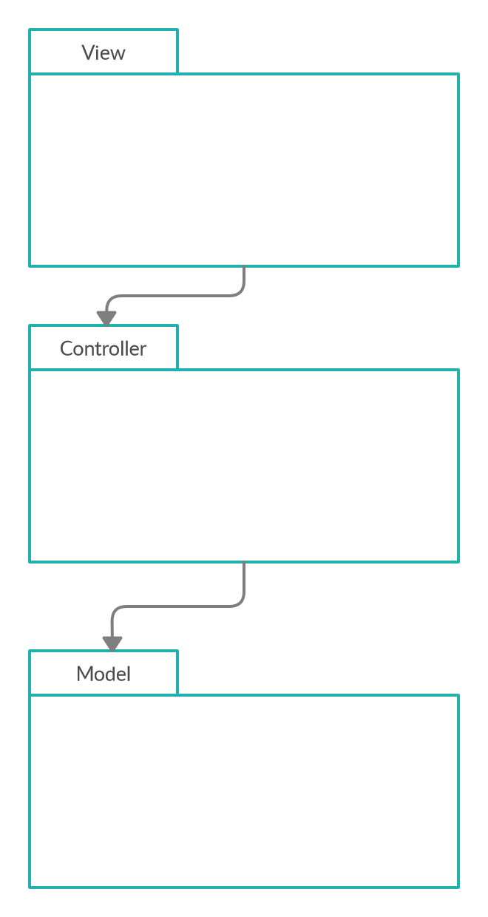

There are three main packages: Model, View and Controller. The Controller uses Model, and View uses Controller. When interacted with View, Controller updates the Model and View according to the interaction.

# Software design description

## Component 1

### Component interfaces

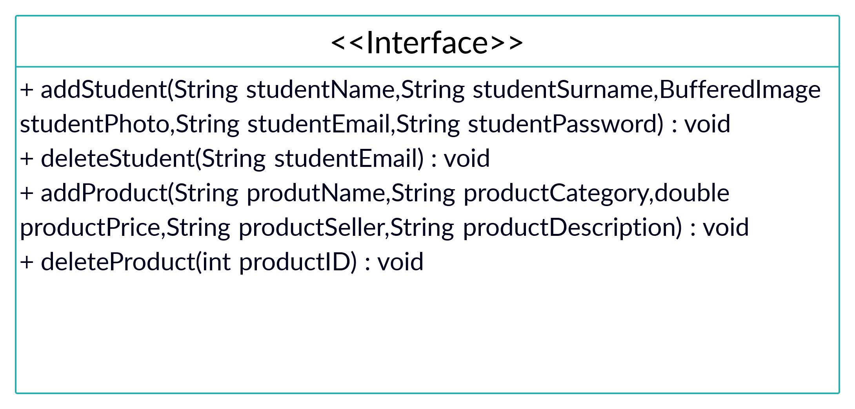

### Component design description

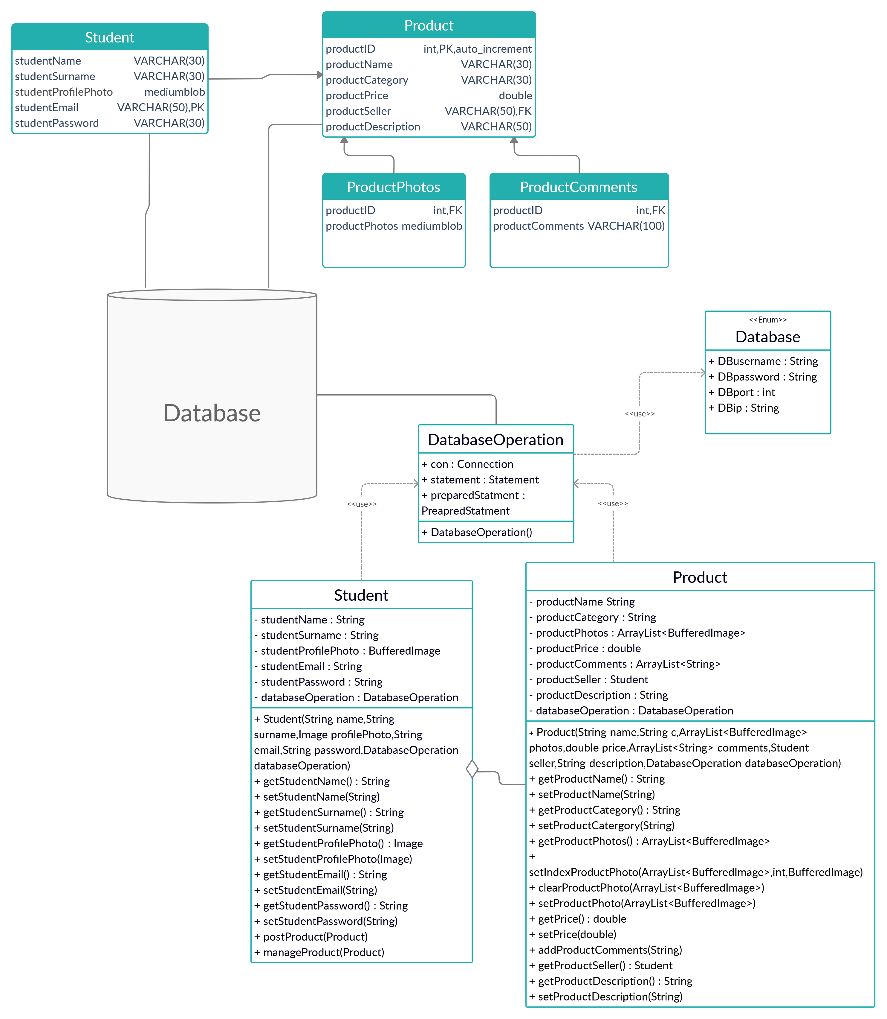

### Workflows and algorithms

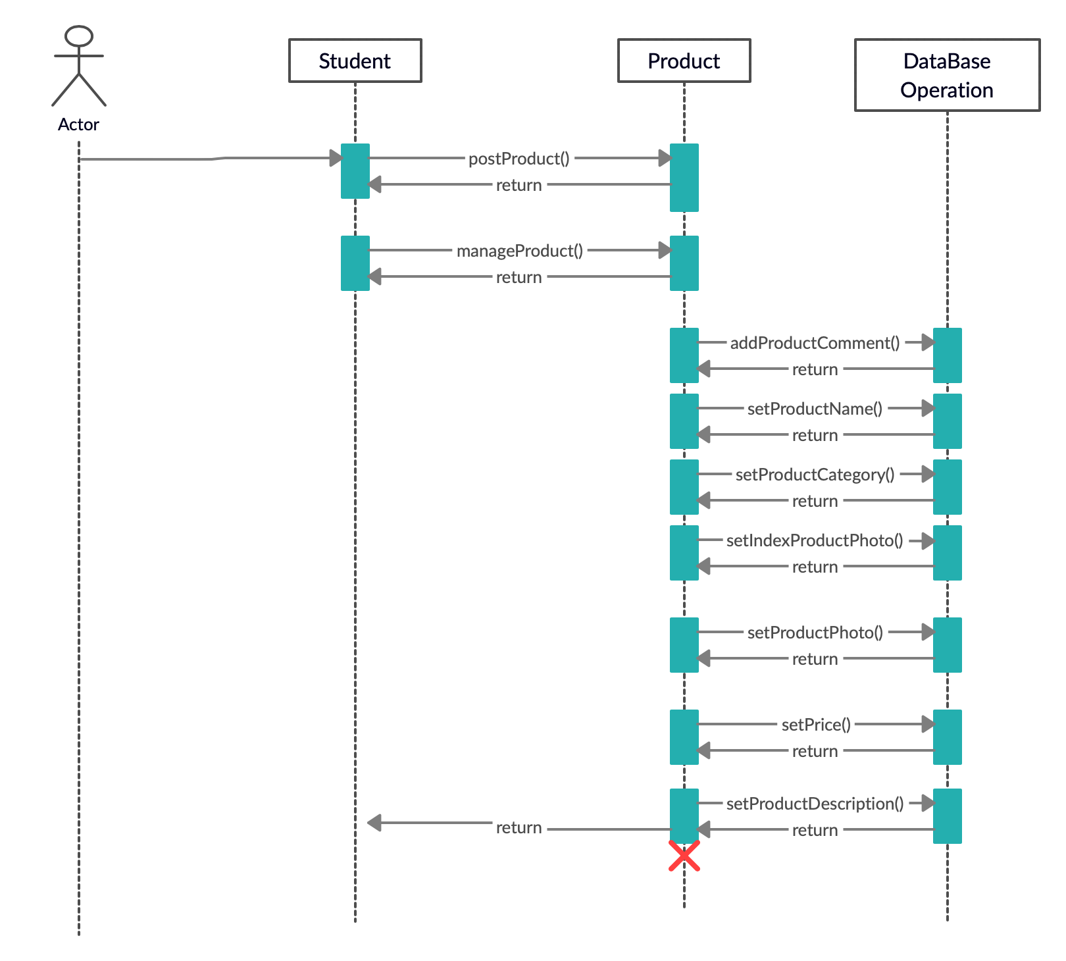

### Software requirements mapping

SRS-OzU-G-006

SRS-OzU-G-007

## Component 2

### Component interfaces

There no interfaces used in GUI Component.

### Component design description

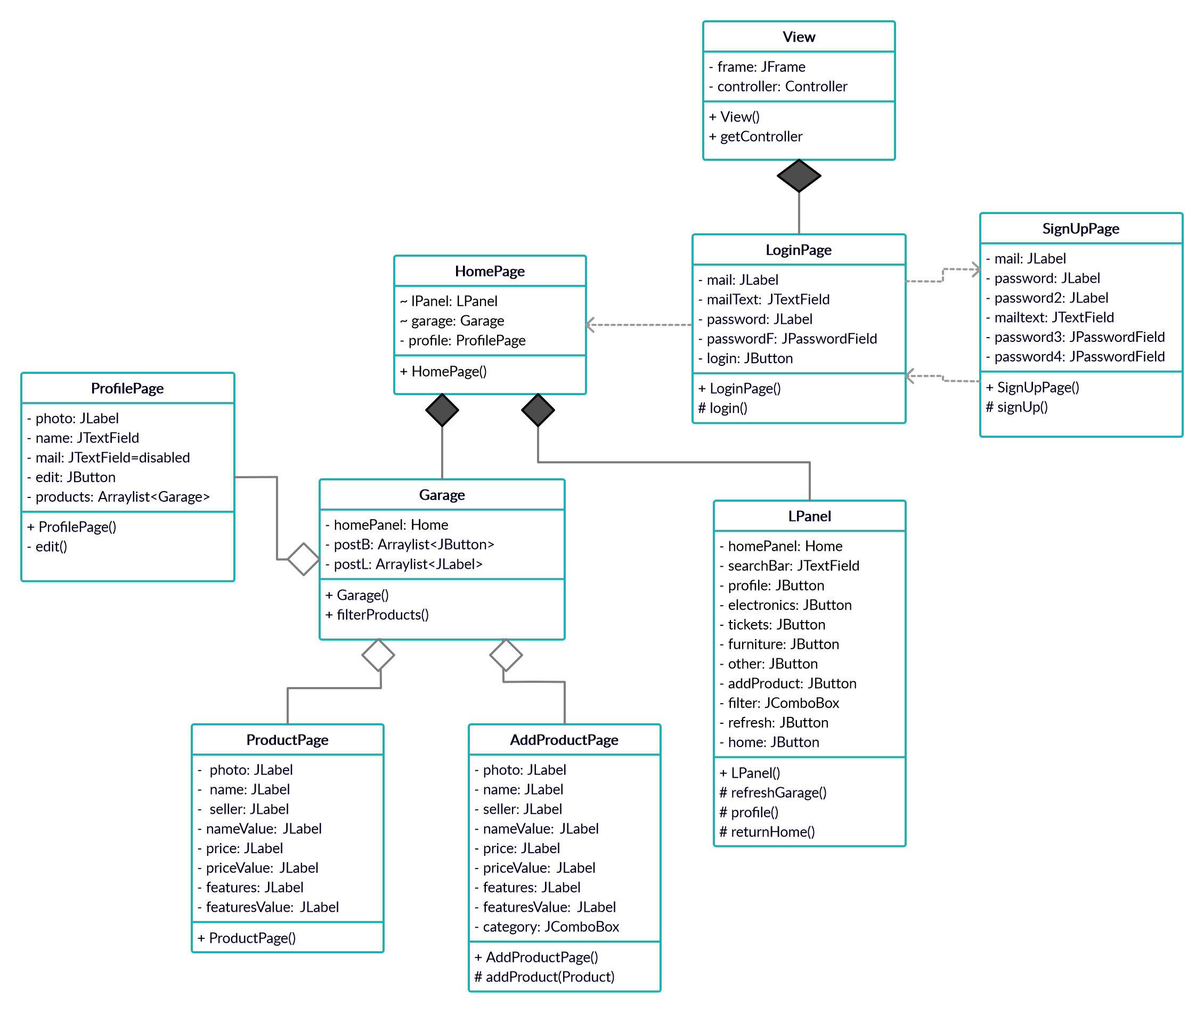

### Workflows and algorithms

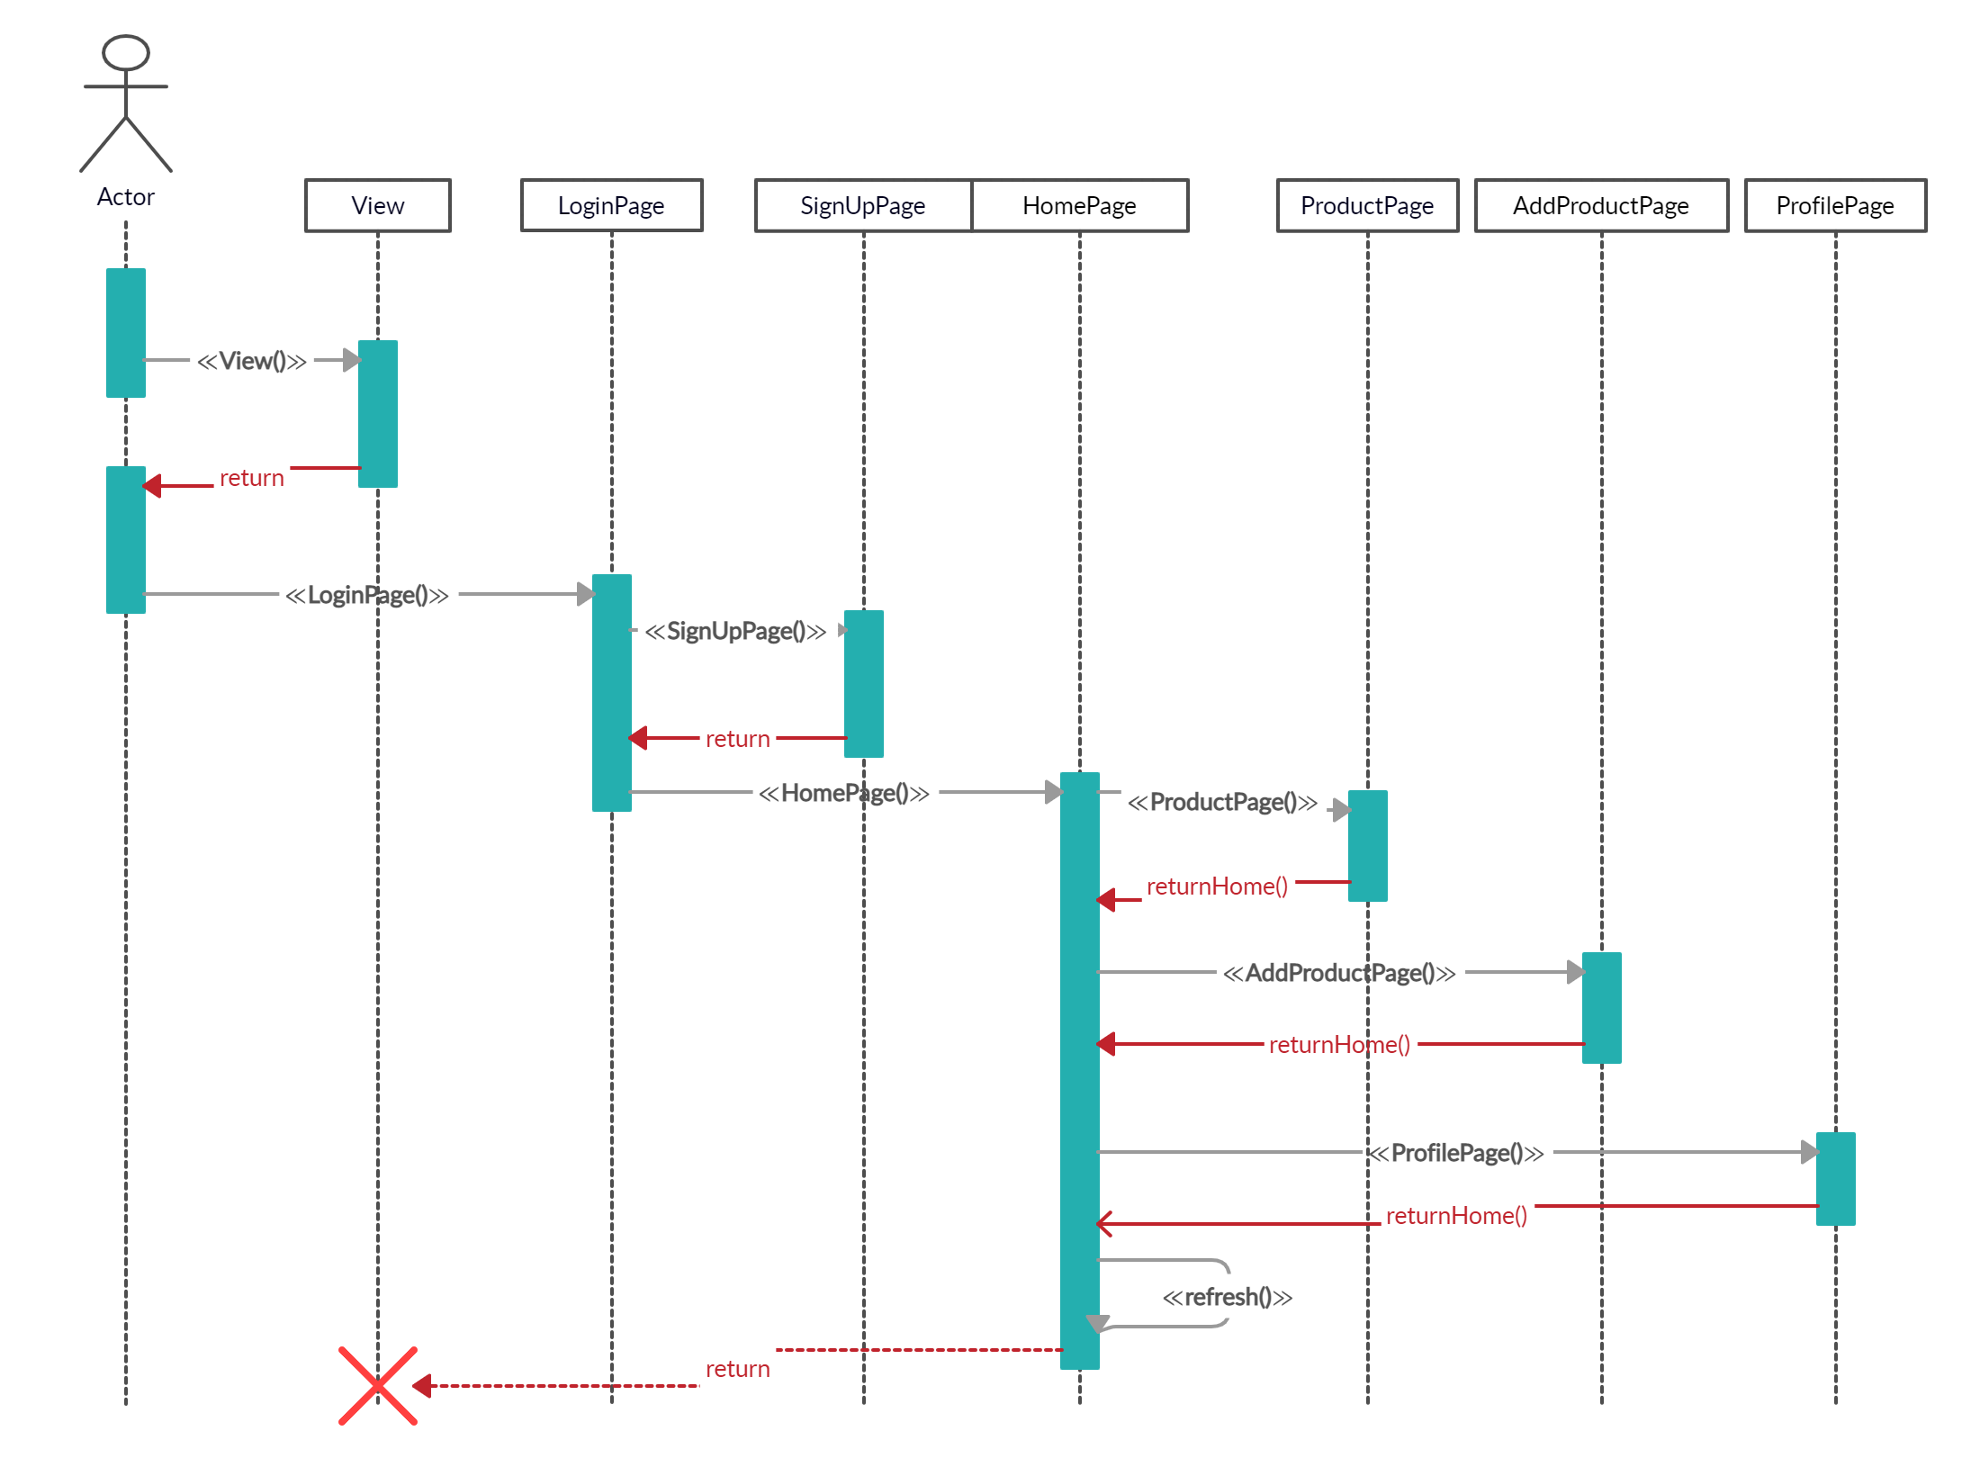

### Software requirements mapping

SRS-OzU-G-003

SRS-OzU-G-004

SRS-OzU-G-005

SRS-OzU-G-006

SRS-OzU-G-008

SRS-OzU-G-009

SRS-OzU-G-010

## Component 3

### Component interfaces

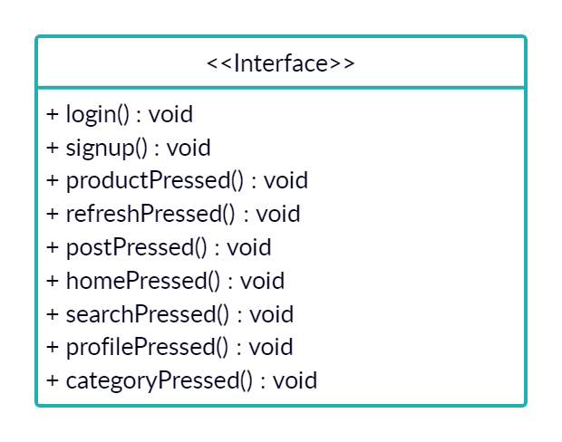

### Component design description

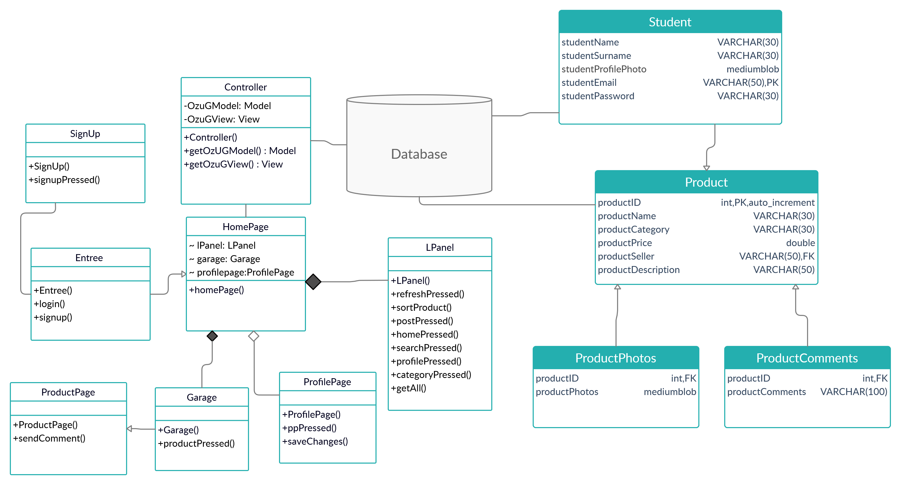

### Workflows and algorithms

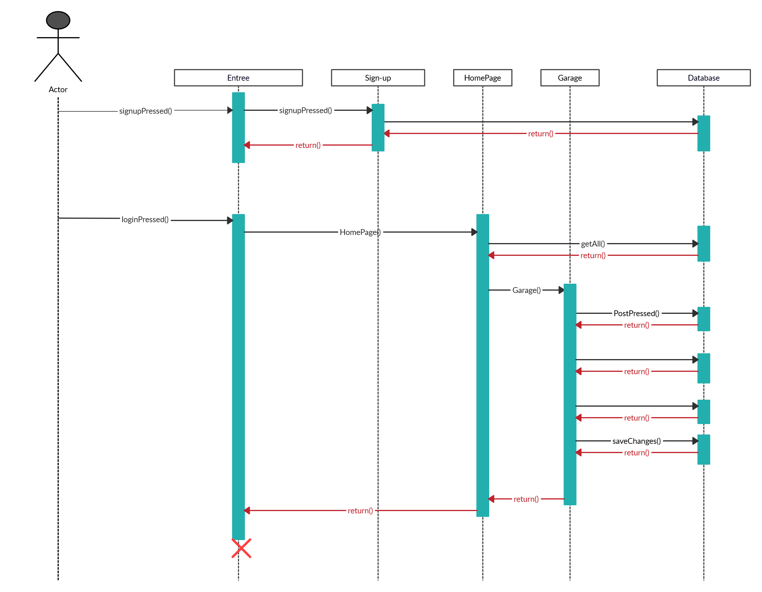

### Software requirements mapping

SRS-OzU-G-001

SRS-OzU-G-002

SRS-OzU-G-003

SRS-OzU-G-007

SRS-OzU-G-010

# COTS Identification

Amazon Web Service will be used to maintain users’ and products’ data for the OzU-G. We use 12 months free trial option.