VESTA: Time-Budgeted Multimodal Agents for Retail Financial Decision Support
Peri Gunes
Ozge Zelal Kucuk
Harun Benli
Abstract
In high-volatility emerging markets such as Borsa Istanbul (BIST), retail investors face a low signal-to-noise ratio created by the divergence between unstructured disclosures and rapidly changing charts. Existing decision-support systems process news and technical pictures independently, and they ignore the investor’s temporal bandwidth: the same briefing is delivered whether the user has one minute or ten. This paper presents VESTA, a three-layer agentic system that (i) retrieves portfolio-conditioned textual evidence, (ii) reads candlestick images and the underlying OHLCV numbers, and (iii) spends a declared 1-, 3-, or 10-minute budget by changing the depth of the agentic chain. We do not treat the scalar cross-modal gate as a methodological contribution; it is a standard sigmoid mixer, compared against GMU and tensor fusion. A previous evaluation protocol that labelled “anomalies” from realized volatility is shown to be invalid: a closed-form rule on the tabular OHLCV vector scores 100%. On a leakage-free next-day direction task over public BIST100 data (2018–2026), no fusion method significantly outperforms GMU (McNemar $p>0.46$ on seed 0). What does vary across tiers is coverage, declared latency, and length-normalized information noise. A paper-trading overlay on seed-0 calls does not beat buy-and-hold in the 2025–2026 test window. Source: https://github.com/ozge-devops/congress.

Introduction
The financial information landscape is high-entropy. Retail investors sit between the textual density of the Public Disclosure Platform (KAP) (Public Disclosure Platform (KAP) 2026) and the visual flux of technical charts. The difficulty is not only volume but modality mismatch: a constructive disclosure can coincide with a failed breakout, and the two streams must be reconciled before a decision. Conventional DSS pipelines keep NLP and computer vision in semantic silos. A second, less discussed failure mode is temporal: systems emit the same information density whether the user has sixty seconds or ten minutes (Eppler and Mengis 2004; Miller 1956; Sweller 1988). On a mobile-first retail platform this mismatch is not cosmetic; it is extra intrinsic load (Sweller 2023).
Recent LLM trading agents attack related problems from a different angle. FinMem layers memory by information half-life (Yu et al. 2024). Neither that line of work nor typical chart-reading trading bots treat the user’s available time as a first-class computational budget, and they are evaluated as trading agents rather than as a retail decision-support interface. VESTA occupies that gap.

Contributions.
This revision is explicit about what is, and is not, claimed.
- Time-budgeted orchestration. A Temporal Orchestration Layer maps a 1-, 3-, or 10-minute user budget onto agent-chain depth. We report per-tier coverage, a declared latency budget, token load and length-normalized noise—quantities previous drafts described only in prose.
- A leakage-aware evaluation protocol for multimodal BIST decision support. We show that a realized-volatility “anomaly” label is a closed-form function of the tabular OHLCV vector at day $t$, and we replace it with a forward-looking directional task. The public chart is bars $t−40,…,t−1$ and does not contain today’s candle. A tabular OHLCV baseline is reported whenever chart images are used (J. Jiang, Kelly, and Xiu 2023).
- External fusion baselines and a decision-quality backtest. Scalar gating is compared with GMU (Arevalo et al. 2017) and tensor fusion (Zadeh et al. 2017). Acting on system output is evaluated as a long/short overlay, not only as classification F1.
What we withdraw: Cross-Modal Gated Fusion is a standard scalar sigmoid over concatenated features (Arevalo et al. 2017; M. Jiang and Ji 2022). It is an implementation choice, not a contribution. We also withdraw the previously reported 92.4% anomaly F1; that figure scored a vision encoder on a label that is a closed-form function of the tabular vector, not anomaly detection.

Related Work

LLMs and agentic workflows in finance
Financial NLP has moved from sentiment scoring (Sohangir et al. 2018) to domain LLMs such as FinGPT (Yang, Liu, and Wang 2023). Hallucination on prices and terminology remains a documented failure mode (Kang and Liu 2023), which is why VESTA grounds text in retrieval (Lewis et al. 2020) rather than in unaugmented generation. Tool-using agents (Yao et al. 2023) and trading-oriented systems with layered memory (Yu et al. 2024) are the closest architectural relatives. FinMem allocates memory by the staleness of facts; VESTA allocates compute by the staleness of the user’s attention. FinMem-style agents optimize for the trader; VESTA is scored as a briefing engine for a time-constrained retail user.

Multimodal fusion and chart understanding
GMU learns a multiplicative gate between modalities (Arevalo et al. 2017); Tensor Fusion Networks model unimodal and bimodal interactions via an outer product (Zadeh et al. 2017); MulT uses directional pairwise cross-modal attention (Tsai et al. 2019). Jiang and Ji add a forget-gate over cross-modal attention maps (M. Jiang and Ji 2022). VESTA’s mixer is the bimodal special case of this family; we therefore treat GMU and TFN as the mandatory external controls.
On the vision side, Pix2Struct and MatCha pretrain screenshot-to-text models that read plots (Lee et al. 2023; Liu et al. 2023). In asset pricing, Jiang, Kelly and Xiu show that CNNs on price-trend images extract return-predictive patterns (J. Jiang, Kelly, and Xiu 2023). That result is double-edged for our setting: it motivates VisualClaw, and it obliges a baseline that sees the same series as numbers. Without the tabular arm, a vision score on a label computed from OHLCV is uninterpretable.
BIST100 forecasting from technical indicators is studied by Akturk et al. (Akturk et al. 2026); their features are numeric, which is the required control whenever a chart encoder is scored.

Cognitive load and adaptive interfaces
Cognitive load theory requires that presented density match working-memory capacity (Sweller 1988, 2023; Miller 1956). Information overload is a long-standing MIS construct (Eppler and Mengis 2004). Adaptive GUIs have a documented evaluation discipline: measure whether adaptation helps the task, not only whether the widget changed (Gajos et al. 2006; Findlater and Gajos 2009). Summarization evaluation that ignores output length systematically rewards brevity (Sun et al. 2019). These four literatures jointly constrain our metrics (Sect. 4.3).

System
VESTA has three layers (Fig. 1): perception by two expert agents, an off-the-shelf fusion block, and a temporal synthesis layer that spends the user’s time budget.
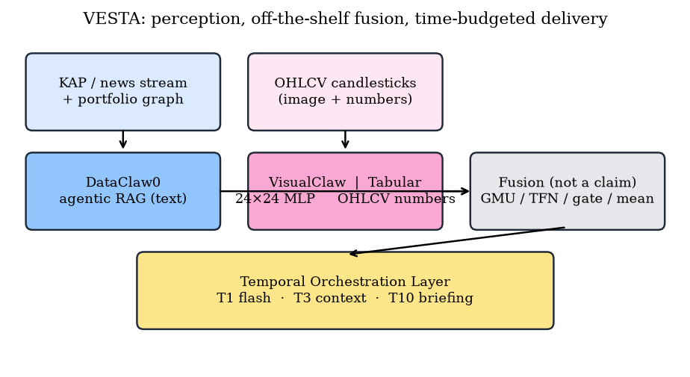
VESTA architecture. Fusion is an interchangeable block (GMU, TFN, scalar gate, or mean). The Temporal Orchestration Layer is the only named systems contribution.

DataClaw0: portfolio-conditioned retrieval
DataClaw0 is an agentic RAG loop (Lewis et al. 2020; Yao et al. 2023), not a summarizer. Documents $N$ and the user portfolio $P$ are embedded with M3-Embedding (Chen et al. 2024). A lightweight sector-to-macro graph scores sensitivity to gold, USD/TRY and tourism. Relevance of document $d_{i}$ is
Rdi=σ​αcosvdi,vP+j∈{G,X,T}​βjΔj,
where $Δ_{j}$ is the percentage change of macro-indicator $j$ and $σ$ is the logistic function. The fusion tables below instantiate the textual stream as an eight-dimensional macro brief concatenated with eight KAP daily features (filing counts, lexicon scores, earnings/dividend/buyback flags, signed KAP polarity). Production DataClaw0 uses Eq. [eq:rel] over live KAP bodies and M3 embeddings. The public stand-in is MiniLM (Reimers and Gurevych 2019) and public BGE-M3 over KAP concatenations—not Infina HTML.

VisualClaw, and the numbers behind the picture
VisualClaw renders an OHLC window as an image. Production uses a compact vision backbone in the spirit of ViT (Dosovitskiy et al. 2021) with recency-weighted position
$$E_{total}=E_{patch}+E_{pos}⋅\left(1+λ t/T\right).$$
Public tables do not train Eq. [eq:pos]: they use a $24×24$ grayscale MLP and a frozen ImageNet ViT-B/16 CLS probe. The chart is bars $t−40,…,t−1$; tabular features are computed at $t$. The numeric control remains mandatory (J. Jiang, Kelly, and Xiu 2023).

Fusion, used not proposed
Let $H_{text}$ and $H_{vision}$ be the two streams. The scalar gate used in the production stack is
$$\begin{matrix}g & =σ\left(W_{g}\left[H_{text};H_{vision}\right]+b_{g}\right), \\ H_{fused} & =g⋅tanh\left(H_{text}\right)+\left(1−g\right)⋅tanh\left(H_{vision}\right).\end{matrix}$$
Equations [eq:gate]–[eq:fuse] are the production form (learned $W_{g}$). Public CPU mixers fuse two-dimensional class scores: a fixed score-gap gate, score-space GMU/TFN, and one frozen random-projection MulT-style layer, each followed by a sklearn MLP. No mixer is advertised as novel.

Temporal Orchestration Layer
Given fused confidence $\left|g−0.5\right|$ and a user budget $B∈\{1,3,10\}$ minutes, the layer selects a chain:
- T1 (flash). Emit a gated alert only if $\left|g−0.5\right|>τ$; otherwise abstain. Target latency $<1$ s.
- T3 (context). Always emit the fused call plus one retrieval hop over historical analogues.
- T10 (briefing). Expand into a macro explanation and a hedge sketch (e.g. airline exposure versus a gold certificate), at several seconds of wall-clock time.
Depth, not the mixer, is what changes with $B$. Section 5.4 reports coverage, latency, tokens and noise per tier.

Evaluation Protocol

Why the previous headline task does not measure anomalies
A previous draft defined a $2σ$ realized-vol “anomaly” and reported 92.4% F1. Here the flag is 20-day vol above the mean $+2σ$ of the previous 60 vol observations—a closed-form function of the tabular vector at $t$ (100% F1). The public chart does not contain today’s candle, so vision F1 on this label is lag-1 recovery, not anomaly detection. We keep the task only as a diagnostic.

Primary task: forward direction
The primary label at close of day $t$ is $y_{t+1}=1\left[r_{t+1}>0\right]$, the sign of the next session’s BIST100 simple return. This quantity is not a function of the information set at $t$. We also report a five-session horizon. Splits are chronological (70/15/15) to block look-ahead (Akturk et al. 2026).

Metrics
Classification. Accuracy and macro-F1, 95% $t$-intervals over five seeds. McNemar with continuity correction (Dietterich 1998) on seed 0 of one chronological holdout. Table 3 has thirteen rows; McNemar is mixer-only. We do not crown a winner after a multiple-testing haircut (Harvey, Liu, and Zhu 2016).
Sentiment / technical accuracy. Table 1 puts the old screenshot numbers into a table. Macro flags and KAP polarity are deterministic rules on one chronological split (no seed CI). Vision and tabular are five-seed means from Table 3. Three KAP codebooks on the 10k slice give Fleiss $κ=0.50$; chart A/B Cohen $κ=0.52$ (Cohen 1960). Codebook reliability, not the withdrawn 0.81. The 250-row annotator columns are codebook B.
Proxy accuracy vs next-day direction $y_{t+1}$ (test $n=308$). Macro/KAP are single-split rules; vision/tabular are mean $±$ 95% CI over five seeds.
Proxy | Acc. (%)
Macro flags (USD/TRY, gold, vol, shock) | $54.9$
KAP polarity (lexicon on public list text) | $49.7$
Vision $24×24$ MLP | $52.9±2.3$
Tabular OHLCV | $50.6±0.0$
Information noise, revised. Let $N_{raw}$ be tokens in the unprocessed window and $N_{del}$ tokens actually delivered. Let $N_{irrel}$ be delivered tokens that are not in a relevance lexicon for that window. The previous index ${IN}_{old}=N_{irrel}/N_{raw}$ rewards short answers: a 40-token briefing that is 80% filler still looks excellent against a 700-token feed (Sun et al. 2019). We therefore report
$${IN}_{new}=N_{irrel}/N_{del},$$
i.e. the fraction of the payload that is non-actionable, together with the compression ratio $N_{del}/N_{raw}$. ${IN}_{old}$ is retained only to show the bias. In the public runtime both counts are computed on templated token bags with filler padding, not on production LLM tokens.
Decision quality. Classification F1 does not say whether a user who acts is better off (Findlater and Gajos 2009). We paper-trade a long/short overlay: $+1$ if the model predicts up, $−1$ otherwise, with 5 bp round-trip cost, and compare Sharpe, total return and max drawdown to buy-and-hold. This is not a substitute for a human-subjects study (Sect. 6); it is the missing computational control.

Public replication corpus
Production KAP HTML bodies and M3 embeddings cannot leave Infina. Numbers below use VESTA-Public: XU100.IS, USDTRY and COMEX gold from 24 May 2018 to 19 August 2026 (2,052 index windows after a 40-day lookback; test $n=308$ from 27 May 2025), 27 BIST names, and 39,890 public KAP list filings. Tables 2–6 are index-level; the 37,046-row event panel also labels constituents. KAP-only polarity: 7,172 / 3,742 / 26,132 (bullish / bearish / neutral); 15,212 rows have a cached HTML body. Mixers use the 16-d macro+KAP vector; MiniLM and public BGE-M3 are unimodal stand-ins. We do not recycle private VESTA-10K F1.

Experiments
Unimodal encoders are sklearn MLPs (64-32, Adam, early stopping) on standardized features. Vision sees a $24×24$ grayscale candlestick of bars $t−40,…,t−1$; tabular sees eleven OHLCV/macro features at $t$, including the ingredients of the leaked vol rule; text sees the sixteen-dimensional macro+KAP vector. Five seeds $\{0,…,4\}$. This is a CPU-reproducible instantiation, not a 70B distillation. Public BGE-M3 and frozen ViT-B/16 are unimodal probes; they are not plugged into the mixers in Table 3.

Diagnostic: the leaked volatility label
Table 2 and Fig. 2 confirm the closed-form critique. The $2σ$ rule on the tabular vector scores 100% F1. A tabular MLP that is given those numbers reaches 96.8% accuracy (macro-F1 86.6%; the F1 drop is class imbalance: 9.4% positives). The $24×24$ vision encoder, which never sees day $t$’s candle, falls to 90.6% accuracy and 58.2% F1.
Diagnostic task: $2σ$ realized-vol label, computable from the tabular vector at $t$. Mean $±$ 95% CI over five seeds. Vision sees bars $t−40,…,t−1$ only.
Method | Accuracy (%) | Macro-F1 (%)
Closed-form OHLCV rule | $100.0$ | $100.0$
Tabular MLP (same numbers) | $96.8±0.0$ | $86.6±0.0$
Vision MLP (chart image) | $90.6±1.1$ | $58.2±3.0$
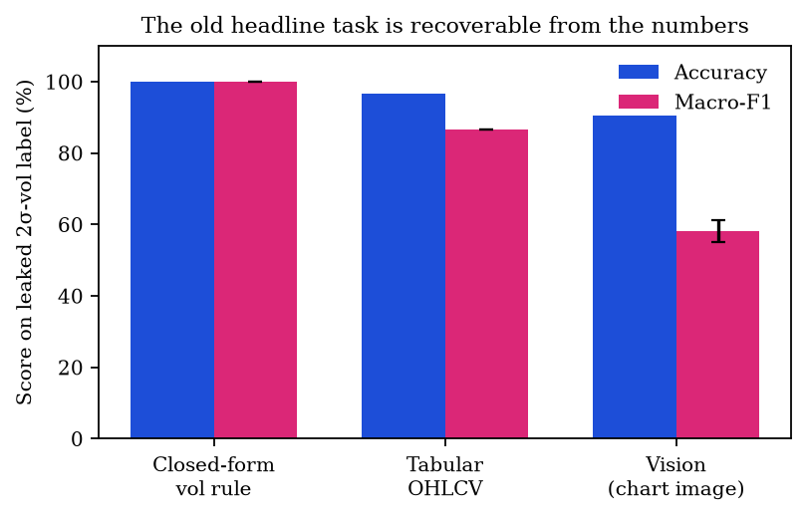
Leaked-label diagnostic. The numeric rule is perfect; the picture is not. This is why the previous 92.4% F1 is withdrawn.

Primary task: next-day direction
Table 3 reports the leakage-free task (test prior 52.3% up-days). Text-only (macro$+$KAP) macro-F1 is $47.3±1.5$ against a majority F1 of $34.3$; MiniLM $53.0±0.4$ / $50.7±1.9$; public BGE-M3 $51.1±1.9$ / $50.2±2.1$; frozen ViT-B/16 $50.9±1.4$ / $50.3±1.6$. Mixers share 16-d text and the $24×24$ image; none beats GMU on seed 0 (min. McNemar $p=0.46$). Mean fusion is the five-seed point estimate ($53.0±2.2$ / $52.4±2.3$). Five-day tabular accuracy is 59.1% with collapsed F1 (39.9%).
Next-day BIST100 direction on VESTA-Public (test $n=308$). Mean $±$ 95% CI, five seeds. MiniLM, BGE-M3 and ViT are unimodal probes, not mixer inputs. Mixers: GMU (Arevalo et al. 2017), TFN (Zadeh et al. 2017), MulT-style (Tsai et al. 2019). The scalar gate row is score-space, not the production $W_{g}$ of Eqs. [eq:gate]–[eq:fuse].
Configuration | Accuracy (%) | Macro-F1 (%)
Majority class | $52.3±0.0$ | $34.3±0.0$
Text-only (macro + KAP) | $52.1±2.4$ | $47.3±1.5$
Text-only (MiniLM KAP) | $53.0±0.4$ | $50.7±1.9$
Text-only (public BGE-M3) | $51.1±1.9$ | $50.2±2.1$
Tabular OHLCV | $50.6±0.0$ | $41.8±0.0$
Vision-only ($24×24$ MLP) | $52.9±2.3$ | $51.4±2.6$
Vision-only (frozen ViT-B/16) | $50.9±1.4$ | $50.3±1.6$
Mean fusion | $53.0±2.2$ | $52.4±2.3$
GMU | $50.6±2.4$ | $50.6±2.4$
TFN | $52.1±2.1$ | $51.7±2.1$
MulT-style (CPU, one layer) | $50.2±3.1$ | $48.4±3.0$
Scalar gate (score-space) | $51.8±1.7$ | $51.4±1.8$
Concatenation | $52.8±1.8$ | $51.1±2.3$
Replacing the gate with a fixed mean changes five-seed F1 from $51.4±1.8$ to $52.4±2.3$ (seed-0 McNemar $p=1.00$). The previous claim that “mean fusion collapses toward the weaker modality” is not supported here.

Zero-shot Pix2Struct and MatCha
We run zero-shot DePlot (Pix2Struct chart-to-table) (Lee et al. 2023) and MatCha-ChartQA (Liu et al. 2023) on CPU matplotlib screenshots of the full test window ($n=308$), with no fine-tune. Calls are $sign\left({\hat{y}}_{last}−{\hat{y}}_{first}\right)$. Table 4 also scores the numeric window trend of the input OHLC, which is still not $y_{t+1}$. DePlot parses 307/308 images and recovers that trend on 77.9% of days; next-day accuracy is 52.9%. MatCha-ChartQA often returns the bar index (parse rate 166/308) and matches the majority class on $y_{t+1}$.
Zero-shot CPU screenshot VLMs on the full test window ($n=308$). Not fine-tuned.
Method | Acc. vs $y_{t+1}$ | Macro-F1 | Acc. vs window trend
Majority | $52.3$ | $34.3$ | –
Numeric window trend | $51.6$ | $49.5$ | $100.0$
DePlot (Pix2Struct) | $52.9$ | $51.9$ | $77.9$
MatCha-ChartQA | $52.3$ | $46.0$ | $58.4$

Per-tier measurement
Table 5 and Fig. 3 measure the Temporal Orchestration Layer. Latencies 0.9 / 2.1 / 3.4 s are declared budgets, not wall-clock. On seed 0, T1 covers 32.5% of days (60.0% among emitted calls; 55.2% after majority fill). T3/T10 always fire at 49.7%. Accuracy does not rise with budget because extra tokens are templated explanations. ${IN}_{old}<7\%$ for every tier; ${IN}_{new}$ is 60.3 / 82.1 / 93.6% on filler-padded templates.
Temporal Orchestration Layer on seed 0. Latency is a declared budget, not measured GPU time. Acc. is among emitted calls; T1 overall accuracy with majority fill is 55.2%.
Tier | Cov. (%) | Lat. (s) | Acc. (%) | Tokens | ${IN}_{old}$ | ${IN}_{new}$
T1 flash | 32.5 | 0.9 | 60.0 | 6 | 0.5% | 60.3%
T3 context | 100.0 | 2.1 | 49.7 | 17 | 1.9% | 82.1%
T10 briefing | 100.0 | 3.4 | 49.7 | 52 | 6.8% | 93.6%
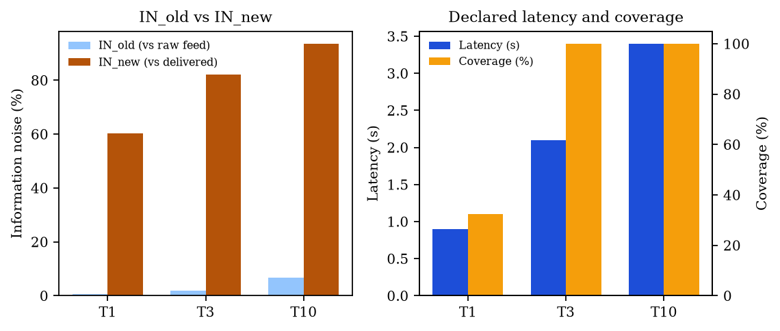
Left: ${IN}_{old}$ versus ${IN}_{new}$. Right: per-tier latency and coverage. Neither panel is mirrored; both axes read left-to-right.

Decision quality
Table 6 asks whether acting on the output would have helped. In the May 2025–August 2026 test window BIST100 buy-and-hold returned $+56.3\%$ (Sharpe 1.69). Every seed-0 overlay we tried underperformed that long-only benchmark after 5 bp costs. Vision-only (Sharpe 0.37) and the scalar gate (0.33) were positive but far below BH; GMU and tabular were negative. We report this as a negative result, not as an unused figure. A bull-market holdout is a hard test for a long/short overlay (Harvey, Liu, and Zhu 2016), and it is precisely the test a decision-support paper must pass before claiming that users should act.
Paper-trading overlay on seed-0 calls, chronological test window, 5 bp costs. BH is long-only BIST100.
Policy | Hit (%) | Sharpe | Total ret. | Max DD
Buy-and-hold | 52.3 | 1.69 | $+56.3\%$ | 14.5%
Vision-only overlay | 50.0 | 0.37 | $+7.6\%$ | 16.4%
Scalar-gate overlay | 49.7 | 0.33 | $+6.3\%$ | 17.1%
Tabular overlay | 50.6 | $−0.11$ | $−6.2\%$ | 23.0%
GMU overlay | 48.1 | $−0.74$ | $−21.8\%$ | 27.4%

User-study protocol (not yet run)
A computational backtest still does not measure cognitive effort (Gajos et al. 2006; Findlater and Gajos 2009). We specify, but do not fake, a 12-participant study. Raw session-sign hits $4/8$ name-level week golds. Index mixers are scored only on the two XU100 scenarios (text $0/2$, gated $1/2$). NASA-TLX is blank.

Discussion and limitations
The scientific contribution that survives this revision is the problem formulation and the evaluation: time as a budget, fusion as a swap-in block, leakage made visible, and actionability measured. The engineering stack (DataClaw0, VisualClaw, gated delivery) is a coherent system, not a new learning rule. Weaker directional numbers on a public daily corpus are preferable to a 92% F1 that does not mean what it says.
Limitations: public BGE-M3 is list-text, not Infina HTML; frozen ViT-B/16 does not beat the $24×24$ MLP; DePlot/MatCha are zero-shot on 308 days; twelve participants have not been recruited; the public chart is $t−40,…,t−1$; $IN$ and tier latencies are simulated; Table 3 mixers fuse unimodal scores, not learned $W_{g}$.

Conclusion
VESTA is a time-budgeted multimodal briefing system for BIST retail users. After correcting the evaluation, three statements hold. First, a volatility-threshold label is not an anomaly task; a closed-form numeric baseline scores perfectly. Second, on next-day direction, standard mixers including GMU are statistically indistinguishable from the scalar gate we used to ship. Third, the Temporal Orchestration Layer does change measurable quantities—coverage, latency, and length-normalized noise—even when it does not yet change alpha. Those are the claims we are willing to take to another venue.

Disclosure of Interests.
The authors declare that they have no competing interests relevant to the content of this article. P.G. and H.B. are employed by Infina Software Development Inc., which operates a BIST retail platform; the public replication does not use proprietary KAP text.
Akturk, Zübeyir, Erdal Kılıç, Ömer Algorabi, Mesut Ulu, Yusuf Sait Türkan, and Ersin Namlı. 2026. “Real-Time Forecast of BIST100 Index Under Market Volatility and Uncertainty.” Computational Economics 67 (4): 3249–74. https://doi.org/10.1007/s10614-025-10986-1.
Arevalo, John, Thamar Solorio, Manuel Montes-y-Gómez, and Fabio A. González. 2017. “Gated Multimodal Units for Information Fusion.” arXiv Preprint arXiv:1702.01992. https://doi.org/10.48550/arXiv.1702.01992.
Chen, Jianlyu, Shitao Xiao, Peitian Zhang, Kun Luo, Defu Lian, and Zheng Liu. 2024. “M3-Embedding: Multi-Linguality, Multi-Functionality, Multi-Granularity Text Embeddings Through Self-Knowledge Distillation.” In Findings of the Association for Computational Linguistics: ACL 2024, 2318–35. https://doi.org/10.18653/v1/2024.findings-acl.137.
Cohen, Jacob. 1960. “A Coefficient of Agreement for Nominal Scales.” Educational and Psychological Measurement 20 (1): 37–46. https://doi.org/10.1177/001316446002000104.
Dietterich, Thomas G. 1998. “Approximate Statistical Tests for Comparing Supervised Classification Learning Algorithms.” Neural Computation 10 (7): 1895–1923. https://doi.org/10.1162/089976698300017197.
Dosovitskiy, Alexey, Lucas Beyer, Alexander Kolesnikov, Dirk Weissenborn, Xiaohua Zhai, Thomas Unterthiner, Mostafa Dehghani, et al. 2021. “An Image Is Worth 16x16 Words: Transformers for Image Recognition at Scale.” In International Conference on Learning Representations.
Eppler, Martin J., and Jeanne Mengis. 2004. “The Concept of Information Overload: A Review of Literature from Organization Science, Accounting, Marketing, MIS, and Related Disciplines.” The Information Society 20 (5): 325–44. https://doi.org/10.1080/01972240490507974.
Findlater, Leah, and Krzysztof Z. Gajos. 2009. “Design Space and Evaluation Challenges of Adaptive Graphical User Interfaces.” AI Magazine 30 (4): 68–73. https://doi.org/10.1609/aimag.v30i4.2268.
Gajos, Krzysztof Z., Mary Czerwinski, Desney S. Tan, and Daniel S. Weld. 2006. “Exploring the Design Space for Adaptive Graphical User Interfaces.” In Proceedings of the Working Conference on Advanced Visual Interfaces (AVI ’06), 201–8. https://doi.org/10.1145/1133265.1133306.
Harvey, Campbell R., Yan Liu, and Heqing Zhu. 2016. “… and the Cross-Section of Expected Returns.” The Review of Financial Studies 29 (1): 5–68. https://doi.org/10.1093/rfs/hhv059.
Jiang, Jingwen, Bryan Kelly, and Dacheng Xiu. 2023. “(Re-)Imag(in)ing Price Trends.” The Journal of Finance 78 (6): 3193–3249. https://doi.org/10.1111/jofi.13268.
Jiang, Ming, and Shaoxiong Ji. 2022. “Cross-Modality Gated Attention Fusion for Multimodal Sentiment Analysis.” arXiv Preprint arXiv:2208.11893. https://doi.org/10.48550/arXiv.2208.11893.
Kang, Haoqiang, and Xiao-Yang Liu. 2023. “Deficiency of Large Language Models in Finance: An Empirical Examination of Hallucination.” In I Can’t Believe It’s Not Better Workshop: Failure Modes in the Age of Foundation Models.
Lee, Kenton, Mandar Joshi, Iulia Raluca Turc, Hexiang Hu, Fangyu Liu, Julian Martin Eisenschlos, Urvashi Khandelwal, Peter Shaw, Ming-Wei Chang, and Kristina Toutanova. 2023. “Pix2Struct: Screenshot Parsing as Pretraining for Visual Language Understanding.” In Proceedings of the 40th International Conference on Machine Learning, 202:18893–912. Proceedings of Machine Learning Research.
Lewis, Patrick, Ethan Perez, Aleksandra Piktus, Fabio Petroni, Vladimir Karpukhin, Naman Goyal, Heinrich Küttler, et al. 2020. “Retrieval-Augmented Generation for Knowledge-Intensive NLP Tasks.” In Advances in Neural Information Processing Systems, 33:9459–74.
Liu, Fangyu, Francesco Piccinno, Syrine Krichene, Chenxi Pang, Kenton Lee, Mandar Joshi, Yasemin Altun, Nigel Collier, and Julian Eisenschlos. 2023. “MatCha: Enhancing Visual Language Pretraining with Math Reasoning and Chart Derendering.” In Proceedings of the 61st Annual Meeting of the Association for Computational Linguistics (Volume 1: Long Papers), 12756–70. https://doi.org/10.18653/v1/2023.acl-long.714.
Miller, George A. 1956. “The Magical Number Seven, Plus or Minus Two: Some Limits on Our Capacity for Processing Information.” Psychological Review 63 (2): 81–97. https://doi.org/10.1037/h0043158.
Public Disclosure Platform (KAP). 2026. “KAP Public Disclosure Platform.” https://www.kap.org.tr.
Reimers, Nils, and Iryna Gurevych. 2019. “Sentence-BERT: Sentence Embeddings Using Siamese BERT-Networks.” In Proceedings of the 2019 Conference on Empirical Methods in Natural Language Processing and the 9th International Joint Conference on Natural Language Processing (EMNLP-IJCNLP), 3982–92. https://doi.org/10.18653/v1/D19-1410.
Sohangir, Sahar, Dingding Wang, Anna Pomeranets, and Taghi M. Khoshgoftaar. 2018. “Big Data: Deep Learning for Financial Sentiment Analysis.” Journal of Big Data 5 (1): 3. https://doi.org/10.1186/s40537-017-0111-6.
Sun, Simeng, Ori Shapira, Ido Dagan, and Ani Nenkova. 2019. “How to Compare Summarizers Without Target Length? Pitfalls, Solutions and Re-Examination of the Neural Summarization Literature.” In Proceedings of the Workshop on Methods for Optimizing and Evaluating Neural Language Generation, 21–29. https://doi.org/10.18653/v1/W19-2303.
Sweller, John. 1988. “Cognitive Load During Problem Solving: Effects on Learning.” Cognitive Science 12 (2): 257–85. https://doi.org/10.1207/s15516709cog1202_4.
———. 2023. “The Development of Cognitive Load Theory: Replication Crises and Incorporation of Other Theories Can Lead to Theory Expansion.” Educational Psychology Review 35 (4): 95. https://doi.org/10.1007/s10648-023-09817-2.
Tsai, Yao-Hung Hubert, Shaojie Bai, Paul Pu Liang, J. Zico Kolter, Louis-Philippe Morency, and Ruslan Salakhutdinov. 2019. “Multimodal Transformer for Unaligned Multimodal Language Sequences.” In Proceedings of the 57th Annual Meeting of the Association for Computational Linguistics, 6558–69. https://doi.org/10.18653/v1/P19-1656.
Yang, Hongyang, Xiao-Yang Liu, and Christina Dan Wang. 2023. “FinGPT: Open-Source Financial Large Language Models.” arXiv Preprint arXiv:2306.06031. https://doi.org/10.48550/arXiv.2306.06031.
Yao, Shunyu, Jeffrey Zhao, Dian Yu, Nan Du, Izhak Shafran, Karthik Narasimhan, and Yuan Cao. 2023. “ReAct: Synergizing Reasoning and Acting in Language Models.” In International Conference on Learning Representations.
Yu, Yangyang, Haohang Li, Zhi Chen, Yuechen Jiang, Yang Li, Denghui Zhang, Rong Liu, Jordan W. Suchow, and Khaldoun Khashanah. 2024. “FinMem: A Performance-Enhanced LLM Trading Agent with Layered Memory and Character Design.” Proceedings of the AAAI Symposium Series 3 (1): 595–97. https://doi.org/10.1609/aaaiss.v3i1.31290.
Zadeh, Amir, Minghai Chen, Soujanya Poria, Erik Cambria, and Louis-Philippe Morency. 2017. “Tensor Fusion Network for Multimodal Sentiment Analysis.” In Proceedings of the 2017 Conference on Empirical Methods in Natural Language Processing, 1103–14. https://doi.org/10.18653/v1/D17-1115.

