Reviewing The Code And Decision Of Which Parts Should Change

Firstly, in the WebGL, graphical content is demonstrated by shader programrs. In order to change color of box from to blue we should consider fragment shader which is main point of the color of each pixel. Secondly, I examine the source code of Assignment2.html which includes WebGL initilization and rendering progress. In redbox.js file there was a fragment shader source so to change the color as I said in above we should focus on fragment shader.

Pointing Fragment Shader, Understand Color And Change The Color

When I examine the fragment shader I found the decision of color made by gl_FragColor = vec4(1.0, 0.0, 0.0, 1.0); code that adjusted color in the RGBA format which is red.
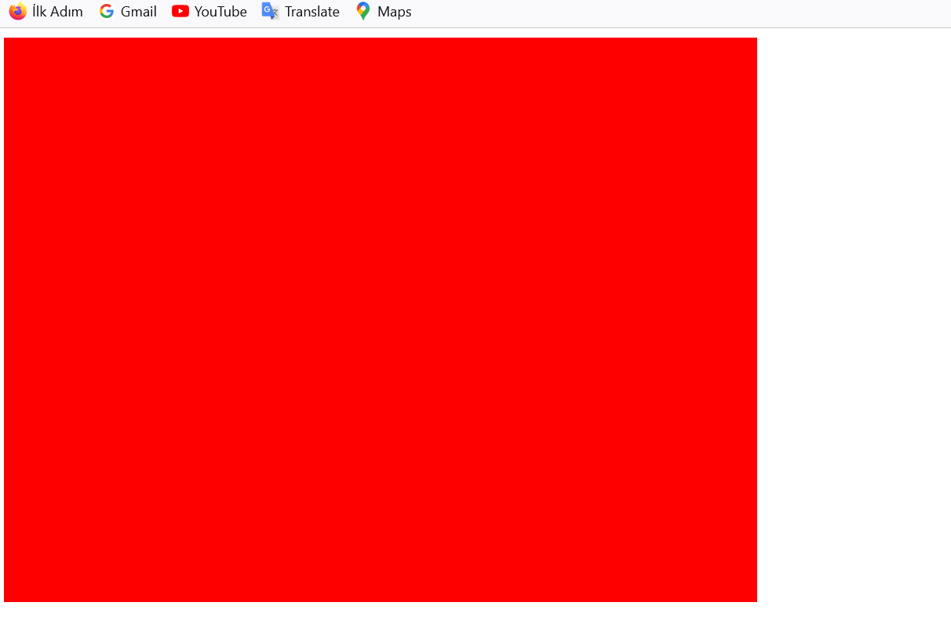

In order to successfully change color from red to blue I should put 0 to red component and raise to 1 to blue component. So my code will become gl_FragColor = vec4(0.0, 0.0, 1.0, 1.0); and color will become:
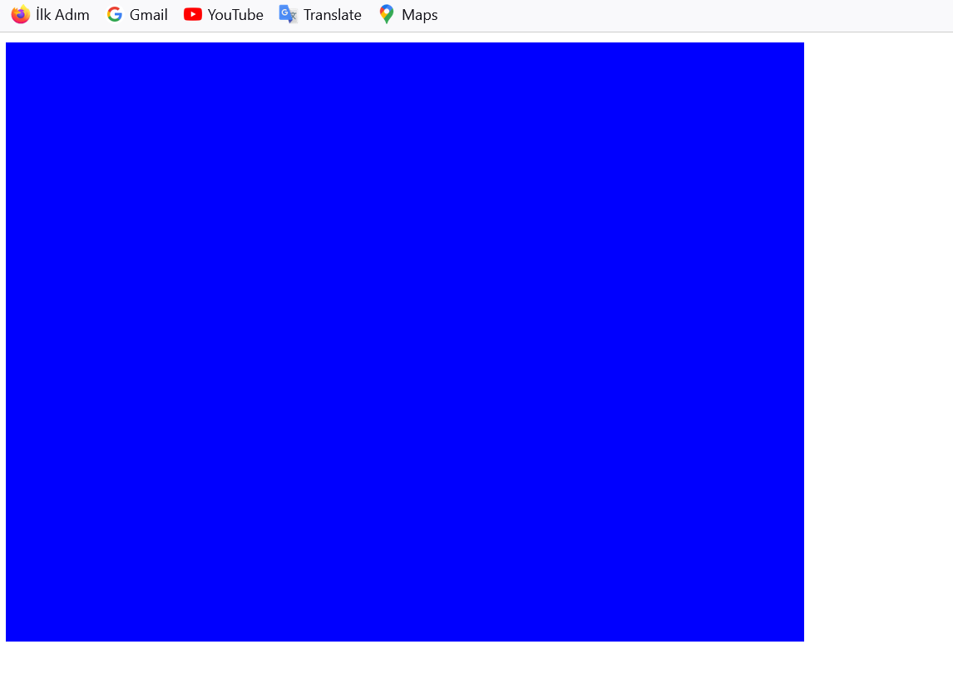
As a result we successfully get blue box. This fragmentShaderSource used by WebGL programme that is in Assignment2.html so that shader already linked to this html file. So we don’t need to update it only updates should made in redbox.js. And when I clear cache and refresh the html file in browser I got blue box successfully. Briefly, after our examinntion we change RGBA values to achieve our mission.

