World Happiness Report
Prediction and Visualization

Özge
Istanbul, Turkey
Bahçeşehir University
July, 2018

Introduction
World Happiness is regularly published every year with the United Nations International Happiness Day. The World Happiness Report 2015 and 2016 rank 156 countries according to their happiness levels and this is important because finding happiness is affected by having a sense of purpose and feeling the value of everything that is done in life is worthwhile.

With this work, I will try to identify which factors are more important in making people's lives happier. And I'll try finding factors that change happy rankings or scores between the reports of 2015 and 2016. At the same time, it should know which countries or regions have the highest overall happiness and each of the six factors contributing to happiness. This gives us the means to analyze all the people in the world and make them feel better. In conclusion, people and countries can focus on the more significant factors to reach a higher happiness level. I also will implement several machine learning algorithms to predict the happiness score and compare the result to discover which algorithm works better for this specific dataset.

Data Understandıng
This dataset gives the happiness rank and happiness score of 156 countries around the world based on seven factors including family, life expectancy, economy, generosity, trust in government, freedom, and dystopia residual. Sum of the value of these seven factors gives us the happiness score and the higher the happiness score, the lower the happiness rank. So, it is proof that the higher value of each of these seven factors means the level of happiness is higher. We can say the meaning of these factors as the extent to which these factors lead to happiness. Dystopia is the opposite of utopia and has the lowest happiness level. Dystopia will be considered as a reference for other countries to show how far they are from being the poorest country regarding happiness level.
The columns following the happiness score consider six factors that make life assessments in each country. These six variables are economic production, social support, life expectancy, freedom, corruption and generosity. Dystopia does not affect an individual's happiness score. There is no effect of using it as a reference only to compare with low averages. We need to understand our variables to understand our data range. Our data sets contain 13 variables and 157 examples. The first variable is the nominal variable "country". It contains 156 countries. Second one is the nominal "Region". This separates the data by region according to the continent. Our third variable is happiness rank. It is numeric and ranks each country's happiness from 1-156 as depends on the world happiness score. The world happiness score variable is numeric and is based on a happiness scale from one to ten. GDP per capita is given as an economic numerical variable. Via this variable we can know ​​how well an economy is doing economically. A family is a numerical description of how much you value a family. Health is a quantitative variable. Freedom and trust is a numerical. This is based on people are really feel free in the country and how much confidence the prisoner has. Generosity is a numerical variant based on how generous people are in the country. Dystopia Residual is the last one that it is an imaginary country where the world has the least happy people. This variable is used to compare with other countries and assess happiness levels.

Variables Used in Data
Happiness Rank: A country's rank on a world scale - determined by how high their happiness score is.
Happiness Score: A score given to a country based on adding up the rankings that a population has given to each category.
Country: The country in question
Region: The region that the country belongs too
Economy: GDP per capita of the country - individuals rank they quality of life based on the amount they earn
Family: quality of family life, nuclear and joint family
Health: ranking healthcare availability and average life expectancy in the country
Freedom: how much an individual is able to conduct them self-based on their free will
Trust: in the government to not be corrupt
Generosity: how much their country is involved in peacekeeping and global aid
Dystopia Residual: Dystopia happiness score (1.85) i.e. the score of a hypothetical country that has a lower rank than the lowest ranking country on the report, plus the residual value of each country.

Data Preprocessıng

Data Cleaning
First, I load our dataset to R. It should be needed determine how much our data missing. When the data is analyzed in detail, it is understood that the data are complete and consistent. This dataset is really very clean. Also some of the variable names are not described clearly enough and I’ll change them as much clearly. Also, I will remove the lower and upper confidence interval of happiness score from my 2016 dataset and also standard error from 2015 dataset. Because I do not need them neither visualization nor prediction.

Data Transformation
Since our data was already ranged out for each year and was clean, I found it easy to comprehend and allowed me to reduce the time I spent preprocessing. I then started to analyze our data.

VISUALIZATION

Correlations
It is showed 2015 and 2016 datasets respectively in the below.
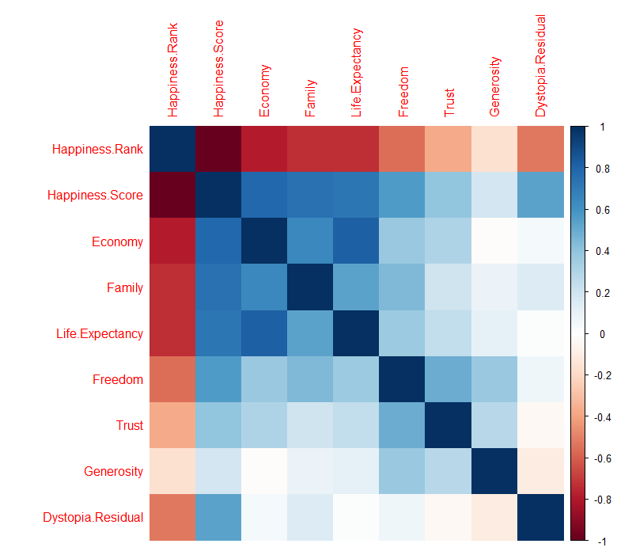

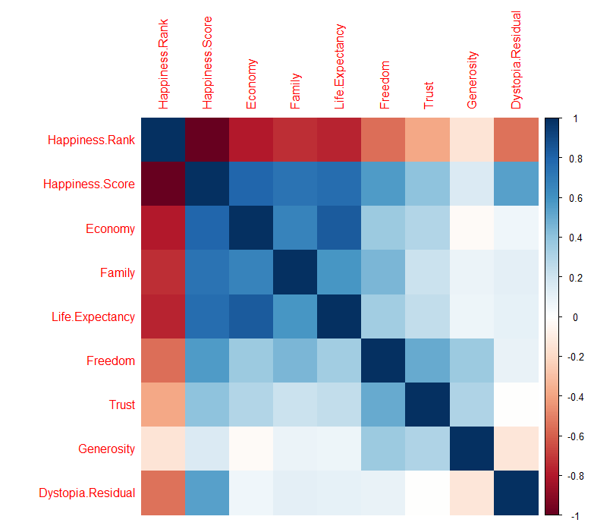
There is an inverse correlation relationship between Happiness Rank and all other numerical variables.
In the other words, the lower the happiness level, the higher the happiness score, and the higher the other seven factors contributing to happiness. I’ll remove the happiness rank variable and see correlation again.
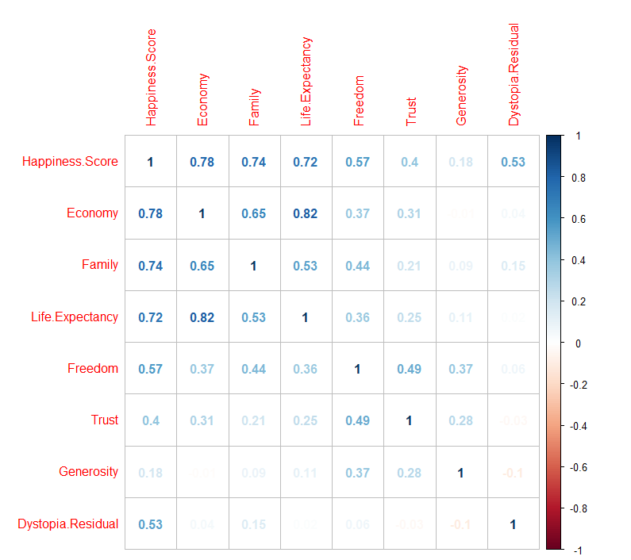
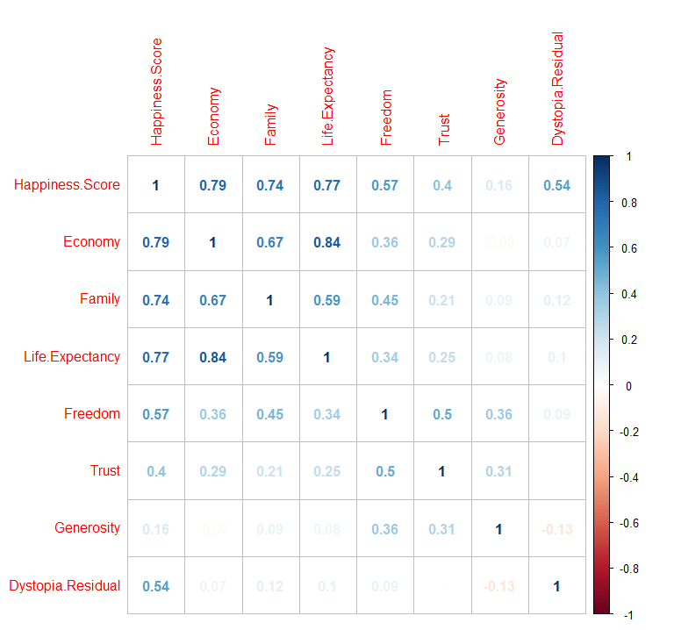
Now that we have a bit of an understanding of the relationship between variables.
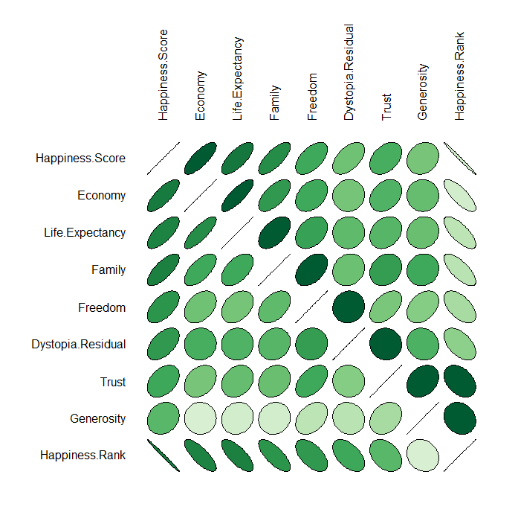
According to the above corrplot, economy, life expectancy, and family play have the highest impact on happiness. Trust and generosity have the lowest impact on the happiness score. Let me explain in details, Happiness is the focal point of one's life. In fact, all the actions and efforts we make are for happiness. Using analytics, we can find out how effective the factors in one's life are. This is where the descriptive analytics comes. Descriptive analytics is important when describing what is happening with our data. According to the correlation visualization, I have found the three factors that have the greatest effect on our attainment of happiness. These variables are economy, health and family. Happiness score is dependent variable. Economy is the most informative variable in this data set when running information gain. It ranks first and there is a positive relationship between happiness score and economy. As one country's economic score and GDP increase, the overall happiness also increases. This makes sense because of the high happiness of a person if his GDP is high. You will be less anxious and suspicious. On the contrary, if your GDP is low, your happiness is likely to be low. You will try to live on and you will have less happiness. As we can see, health is the second one. As health (life expectancy) increases so does the overall happiness score. This is very informative and it can be understood why people are happy in certain countries. Health care plays a major role too. Third most informative variable is family which how much you value a family. This makes logical sense because if you don’t belong to and don’t like your family, the less happy you are likely to be. Trust and generosity have the lowest impact on the happiness score.

Plots
It is used box plot to see the happiness score in different regions, how this score is populated in these regions and also will calculate the mean and median of happiness score for each of these regions.
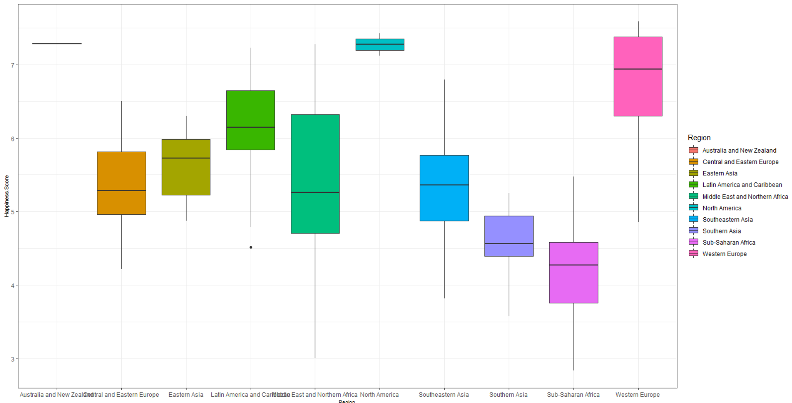
Happiness score comparison on different regions

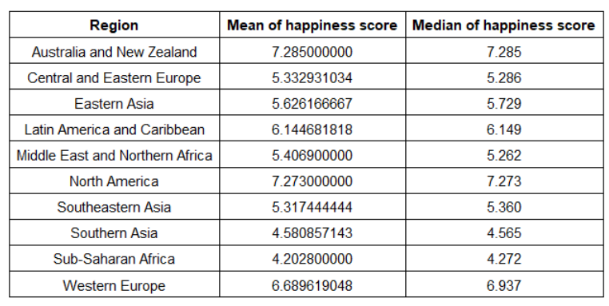

According to the above table and plot, Australia and New Zealand and North America that almost the same score has the highest median happiness score. Western Europe and Latin America and Caribbean are in the second place regarding median happiness score. Sub-Saharan Africa and Southern Asia has the lowest median.

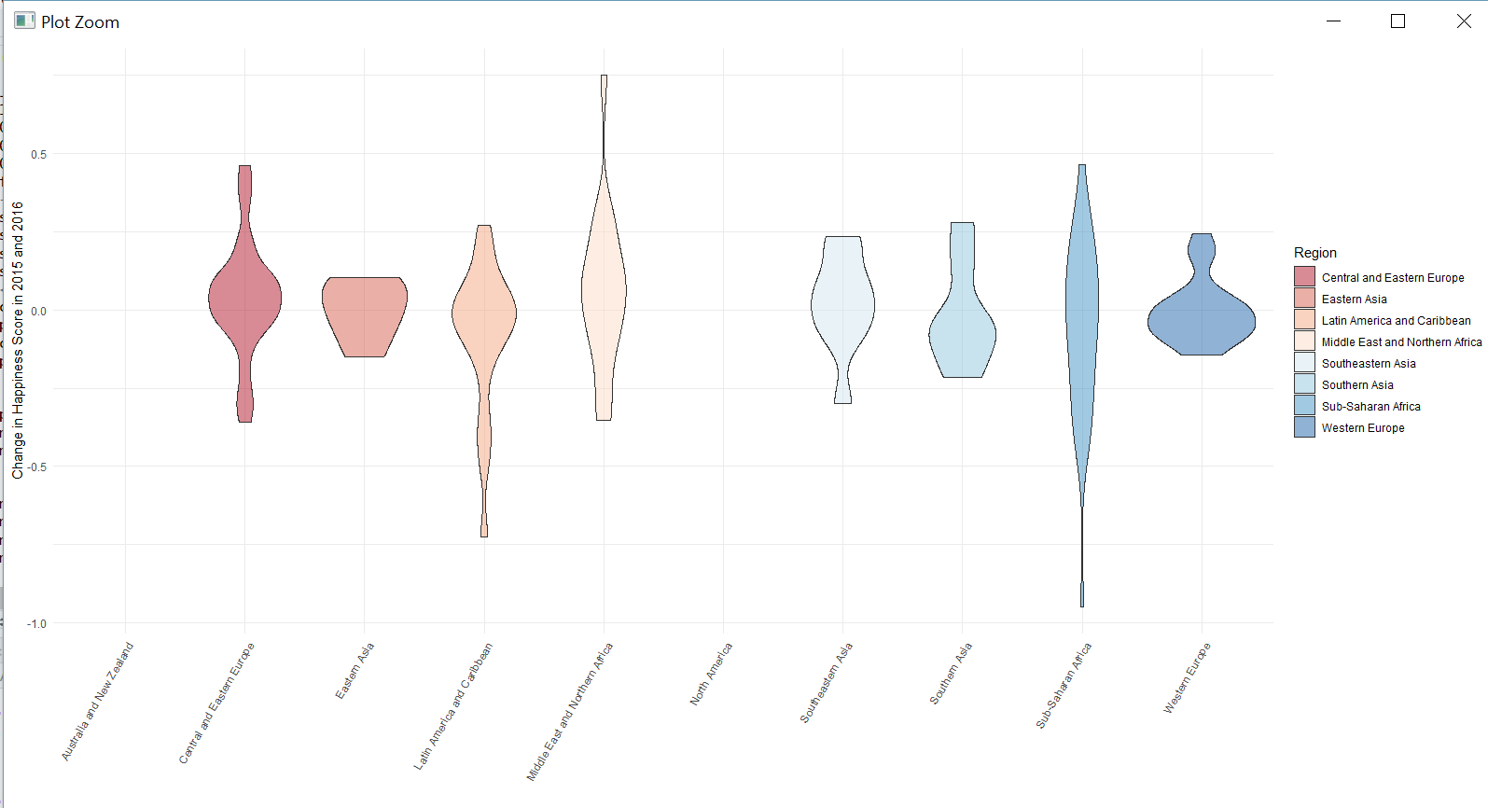
Change in Happiness Score in 2015 and 2016

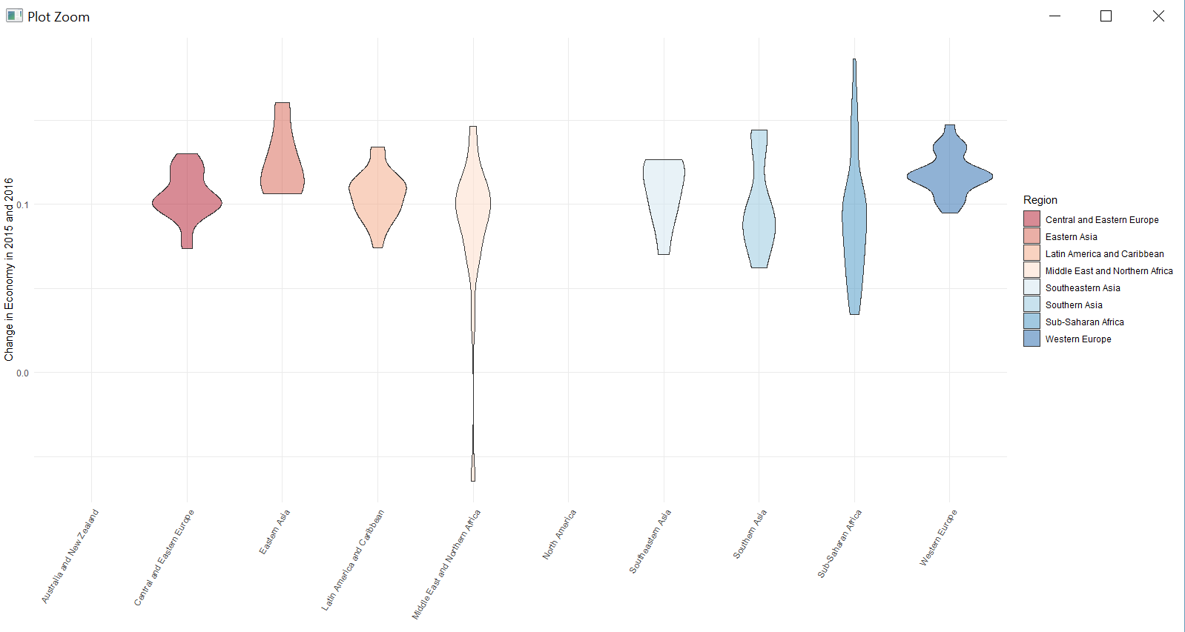
Change in Economy in 2015 and 2016

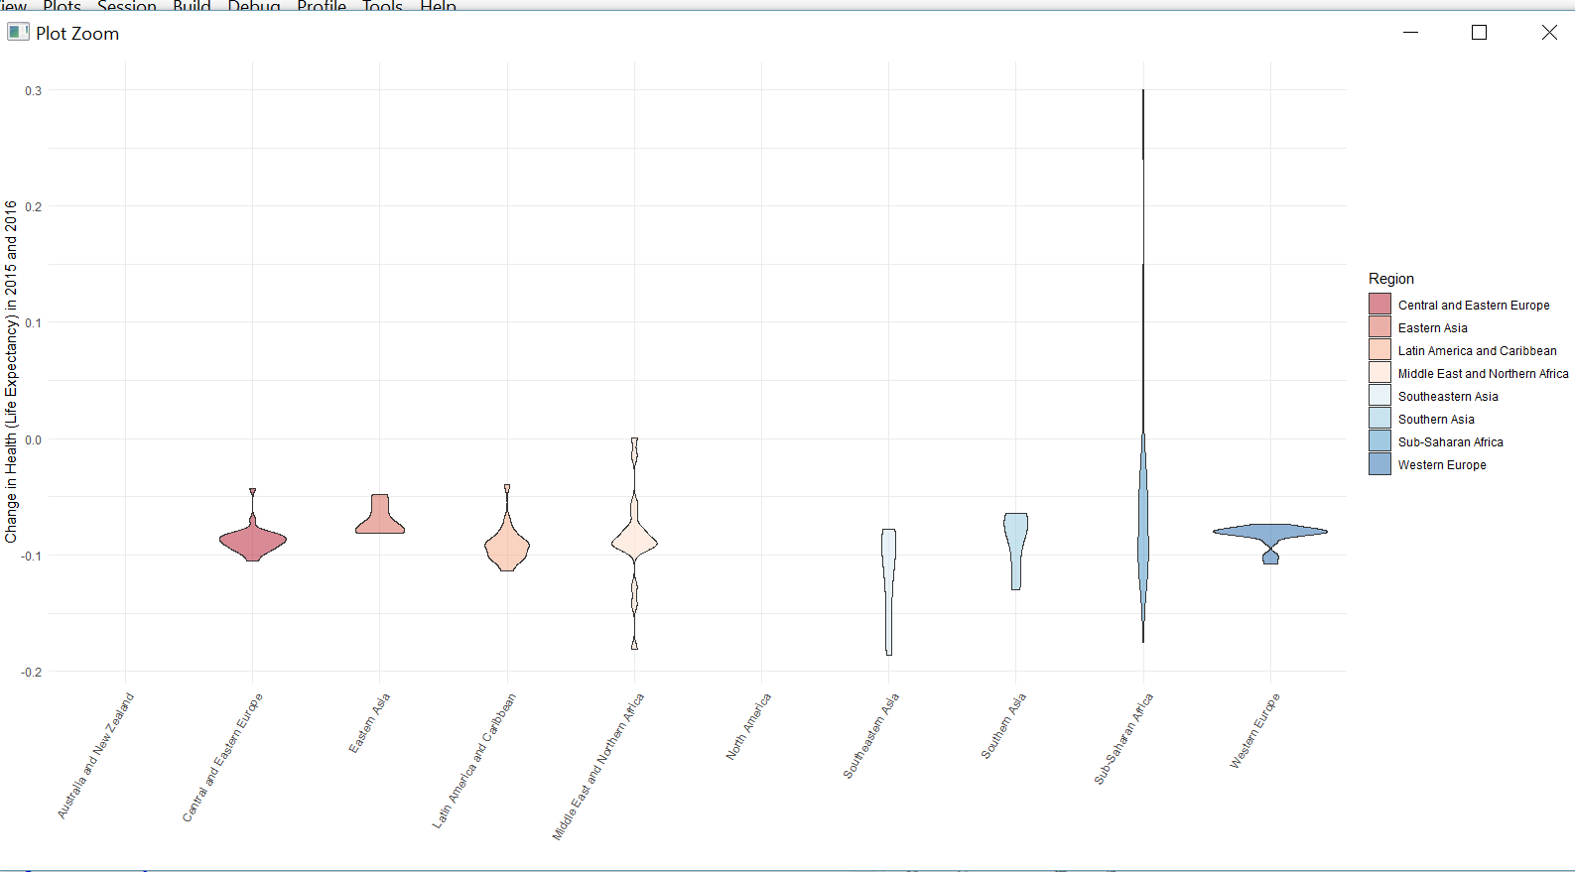
Change in Health in 2015 and 2016

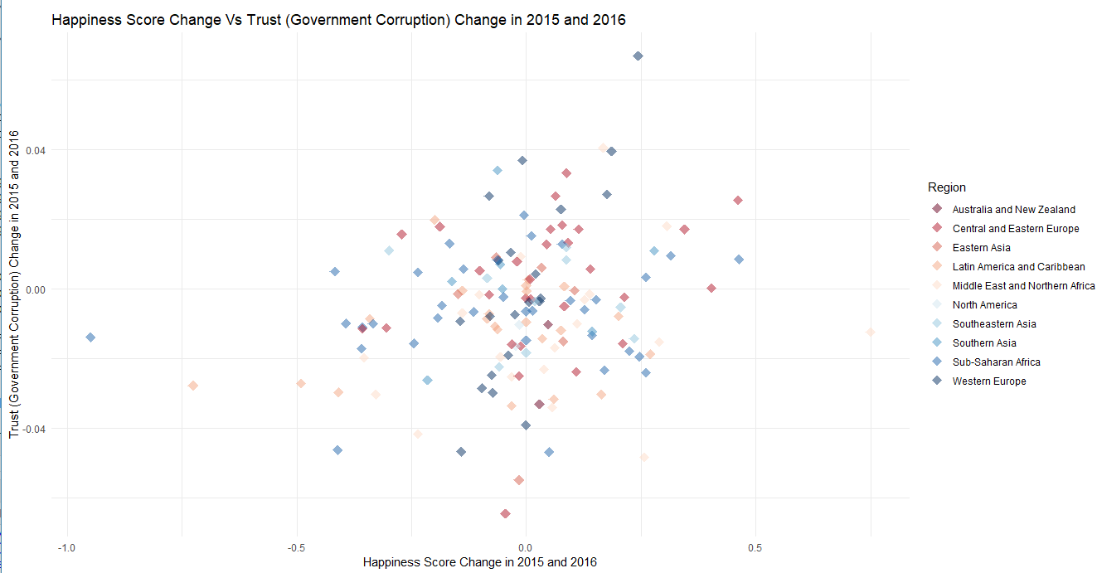
Change in Trust in 2015 and 2016

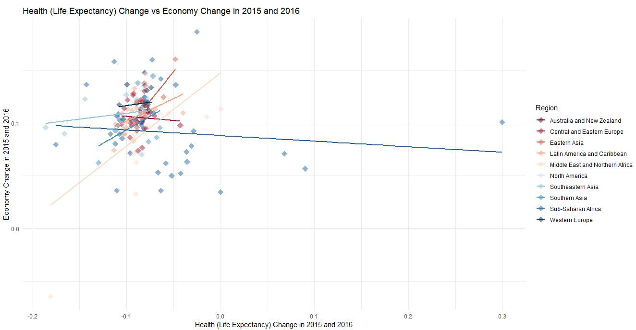
Change in economy in 2015 and 2016
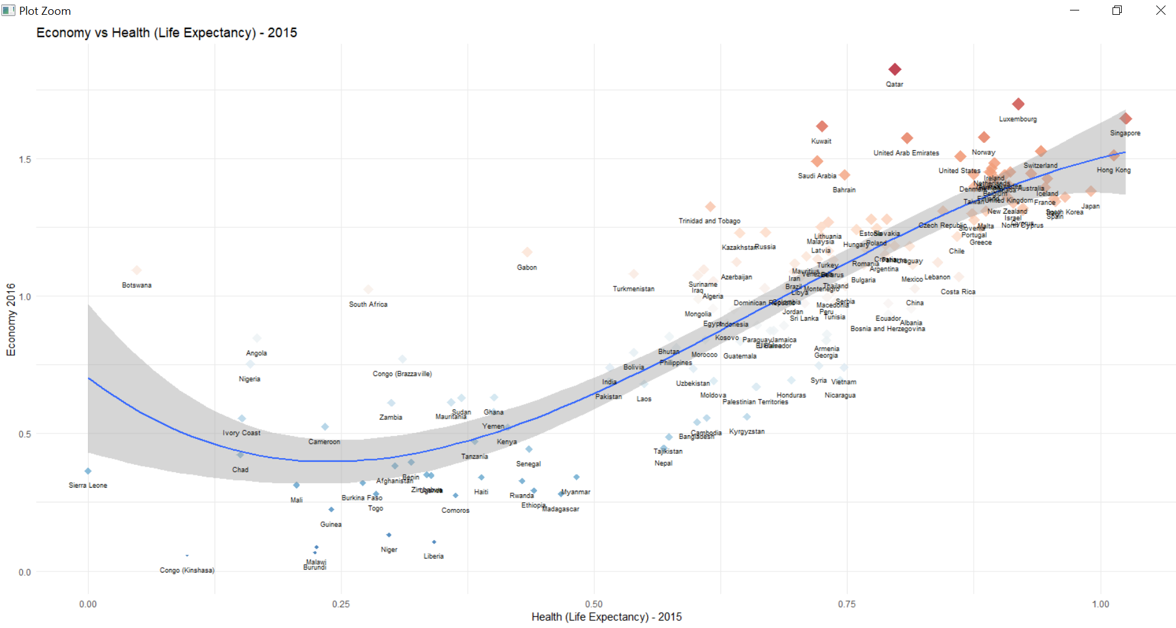

Top and Bottom 15 Happiest Countries
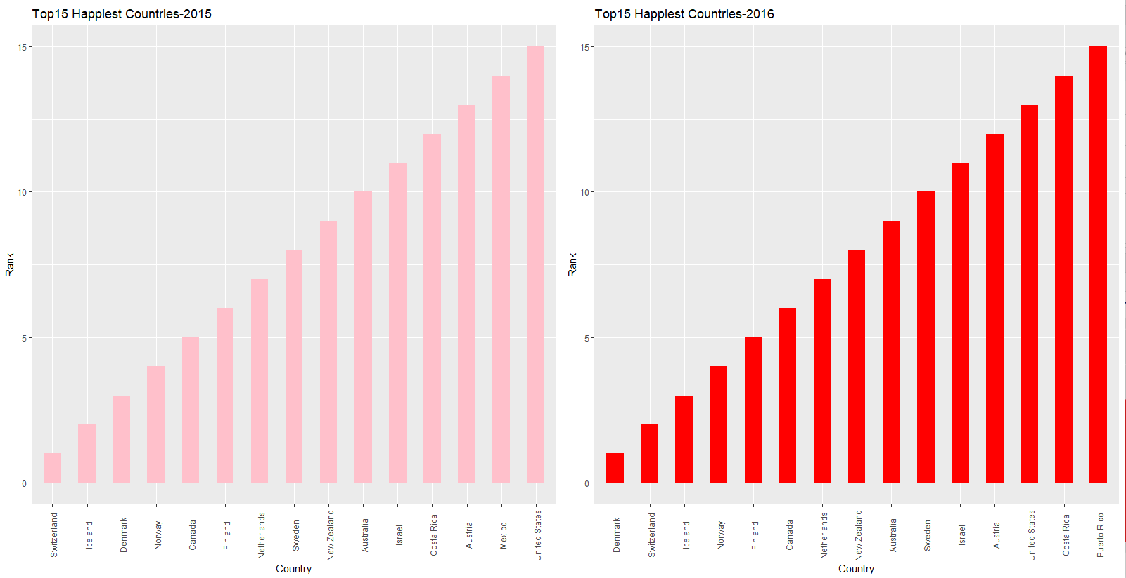

For both 2015 and 2016, Countries are the same, only the score has got changed.

This is the data at a glance, as we can see, the top 4 countries with the highest score from 2015–2016 are Switzerland, Iceland, Denmark, and Norway.
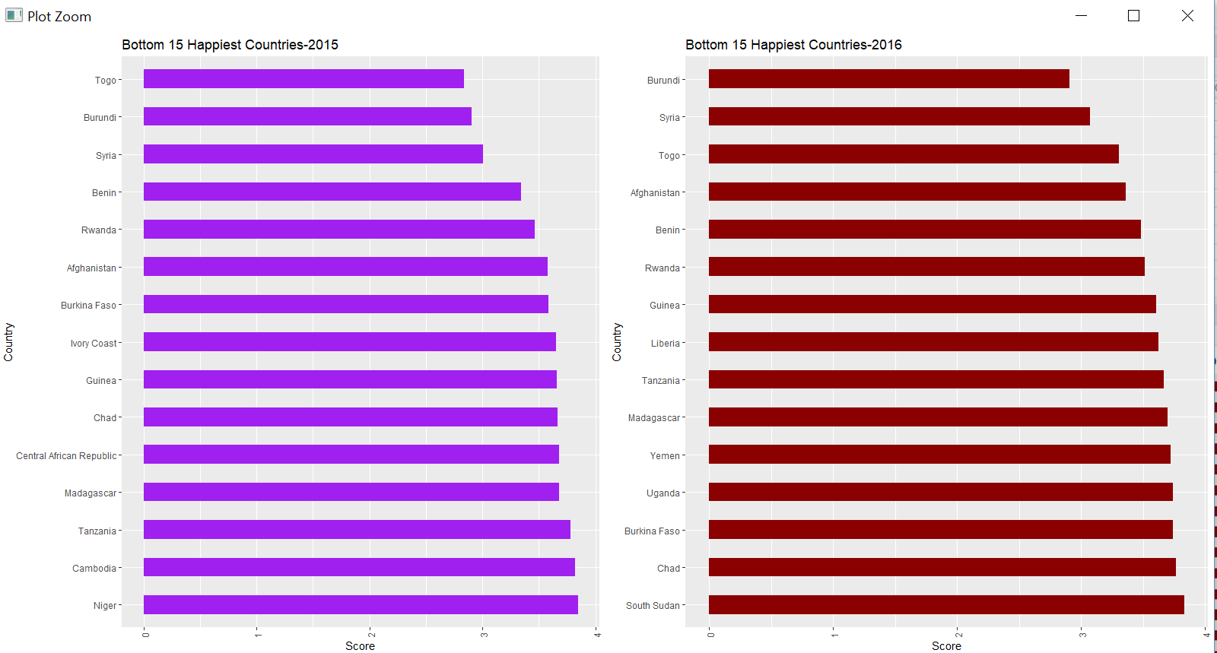
For both 2015 and 2016, Countries are the same, only the score has got changed like the previous one.

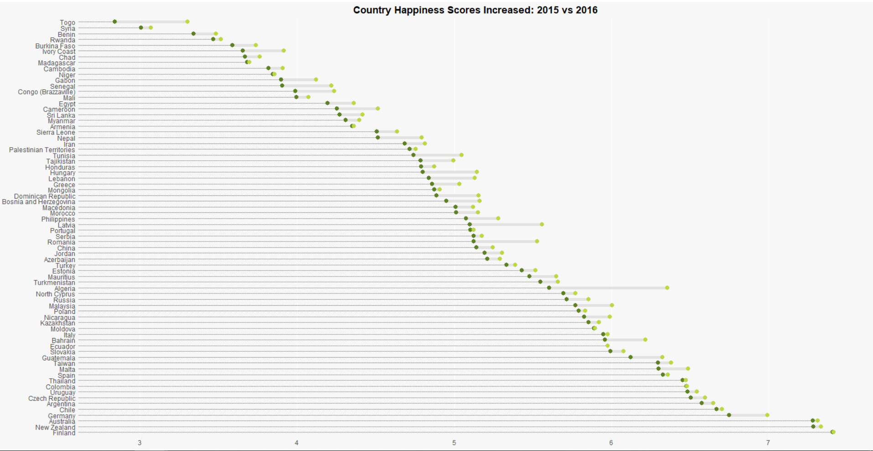

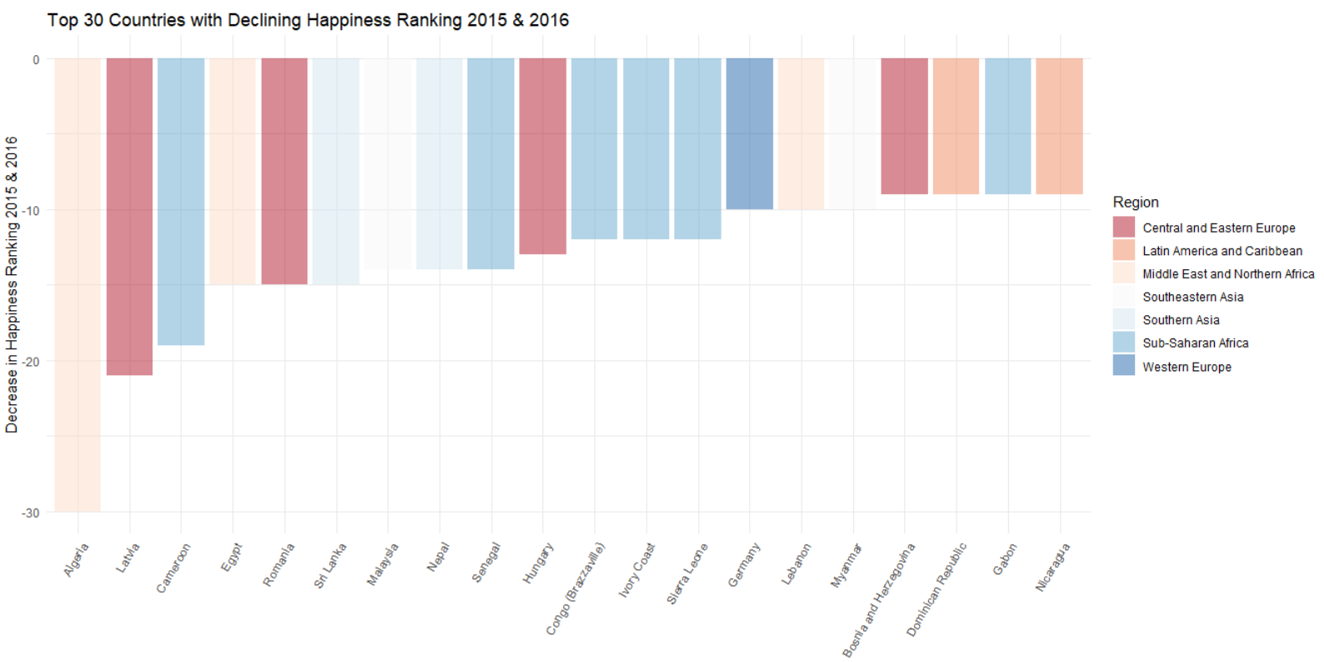
Top 30 Countries with Declining Happiness Ranking

Maps
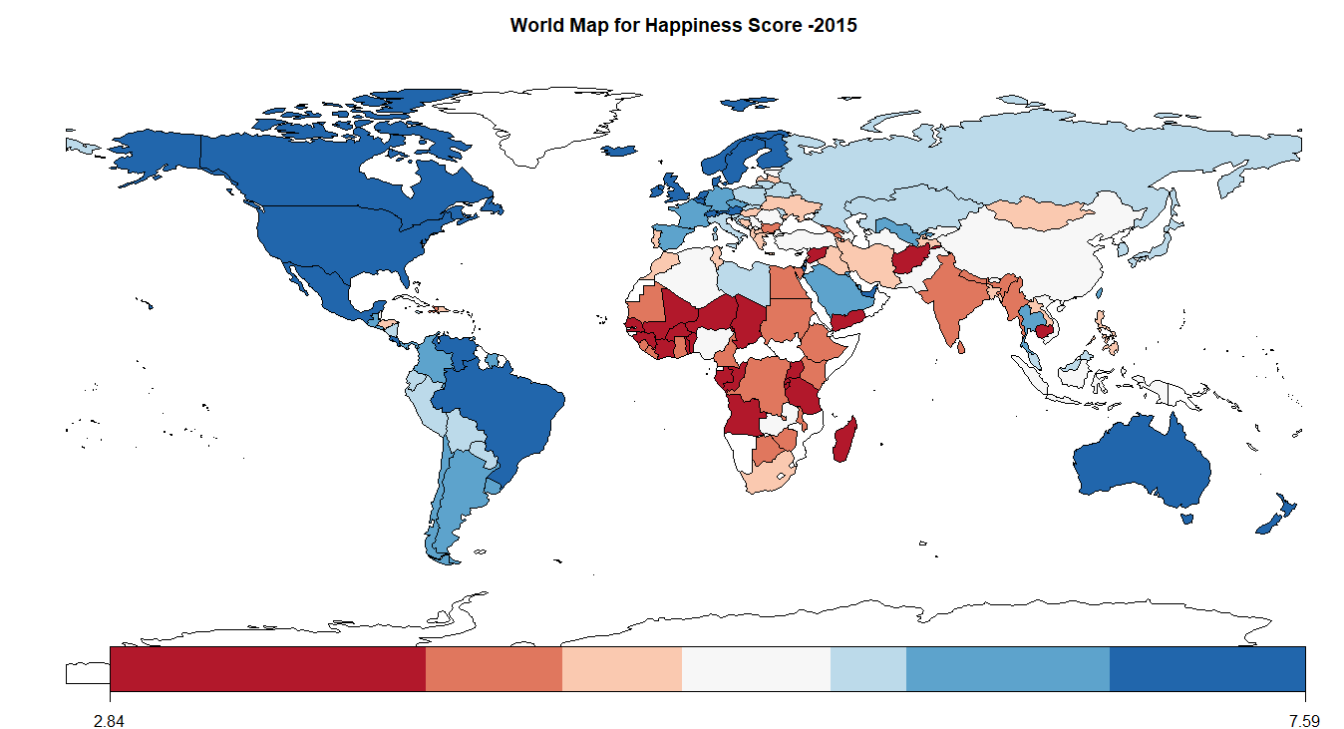

How to read the map: the darker colored countries (red — blue) have the highest rating on the report, while the lighter colored countries have a lower score. We can clearly see that countries in the European, and Americas region have a fairly high ranking than ones in the Asian and African regions.

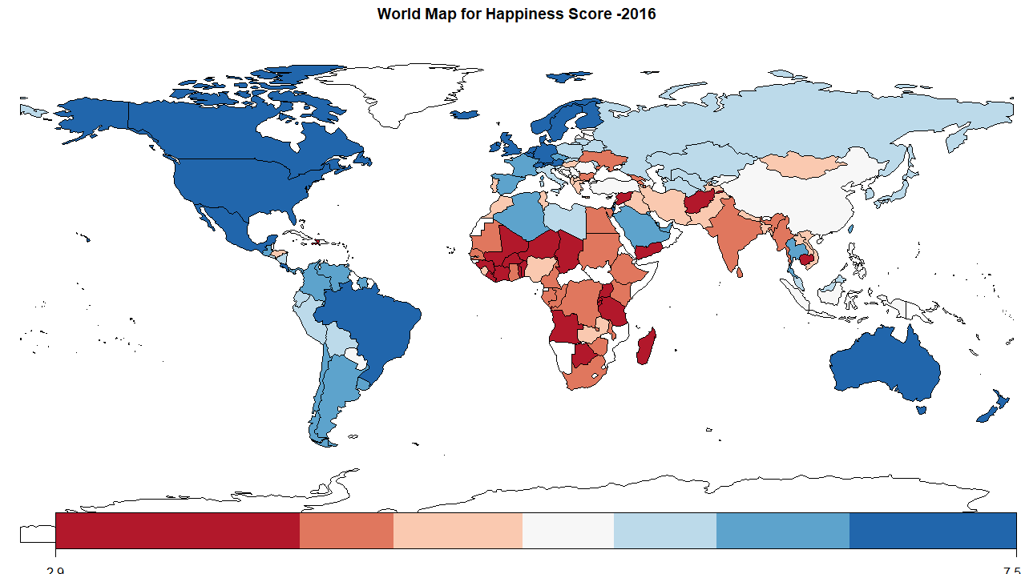

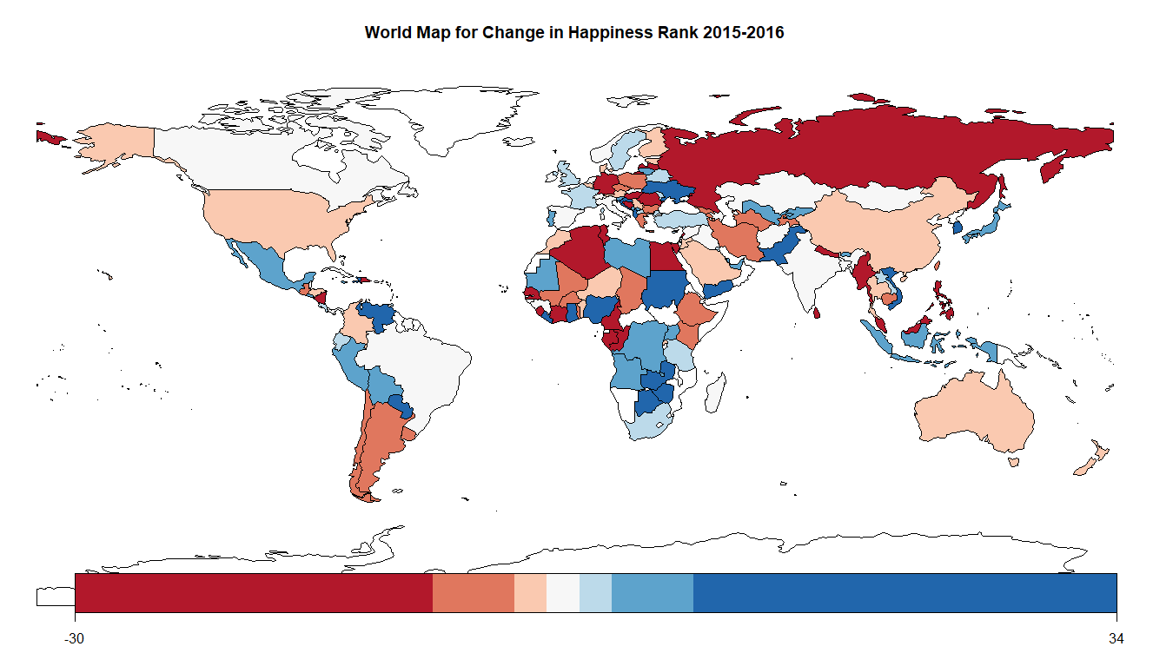

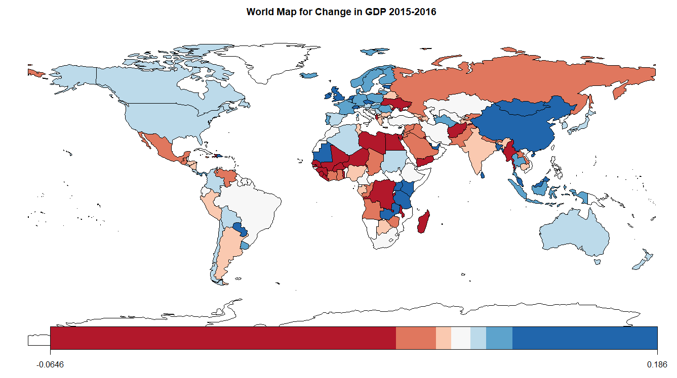

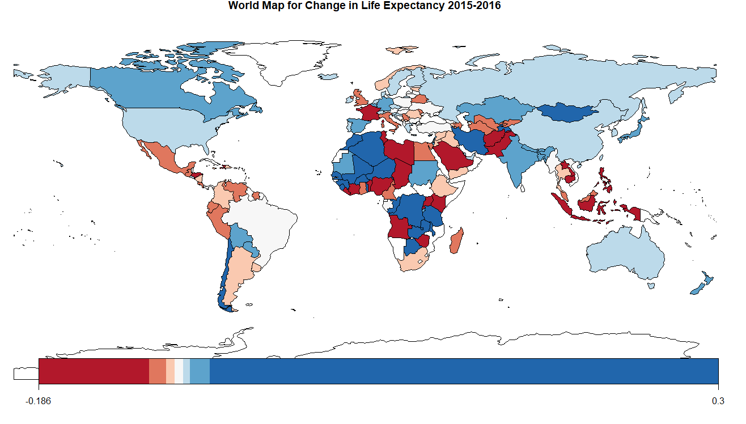

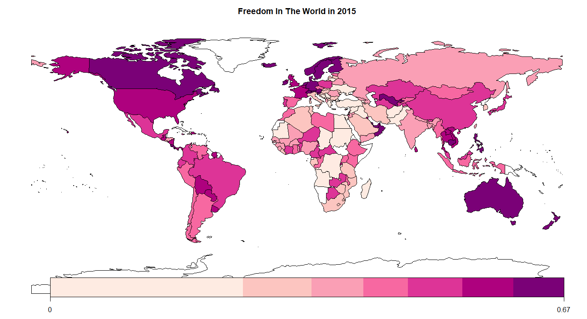

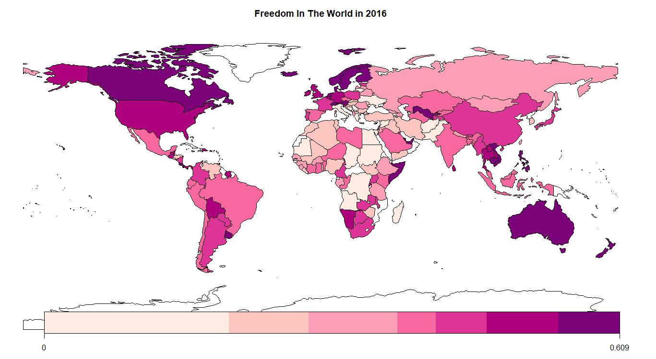

Predıctıon
I will make predictions by using some machine learning algorithms which are multiple linear regression, support vector regression, decision tree regression, random forest, neural net but firstly it is needed to split our data into training and test sets. As their names imply, the training set is used to train and build the model, and then this model is tested on the testing set.
To proceed with finding a predictive model, I first drop rank from our data frame as it does not really tell us anything important in the model itself. Then, I want to get an overall idea of which variables are correlating with each other strongly. Since my focus is happiness score, let’s concentrate on that column. And independent variables; family, economy, life expectancy, trust, freedom, generosity and dysthopia. Let’s say we want to have about 80% of the data in the training set and 20% of the data in the testing set.

Steps are the below for splitting
- First, we set the seed so that the results are reproducible.
- Then, we create a sequence whose length is equal to the number of rows of the dataset. These numbers act as the indices of the dataset. We randomly select 80% of the numbers in the sequence and store it in the variable split.
- Lastly, we copy all the rows which correspond to the indices in split into training_set and all the remaining rows into test_set.

Multiple Lineer Regression

predictionModel = lm(Happiness.Score ~ ., data = trainData)

The above function will try to predict Happiness Score based on the variables Economy, Family, Life.Expentancy, Freedom, Trust, Generosity, Dystopia.Residual. Since we are using all the variables present in the dataset, a shorter way to write the above command is: (this is very helpful when are are a large number of variables.)
Then let’s check the results;
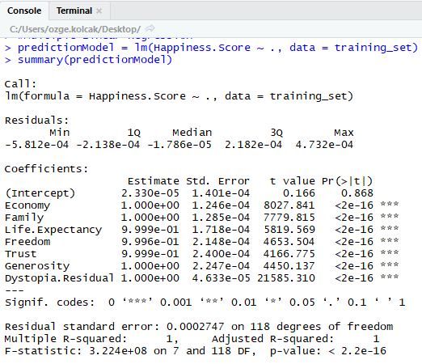
This will help us determine which variables to include in the model. A linear regression can be represented by the equation: y_i = β_1 x_i1 + β_2 x_i2 + β_3 x_i3 + ⋯ + ε where y_i represents the outcome we’re trying to predict (Happiness Score), x_i represent the various attributes (family, economy, life expectancy, trust, freedom, generosity and dysthopia), β represent their coefficients, and ε represents the constant term.
The first column in the summary, namely Estimate gives us these values. The first value corresponds to ε, and the rest of the values correspond to the various βvalues. If the coefficient for a particular attribute is 0 or close to 0, that means it has very little to no effect on the prediction, and hence, can be removed. The standard error column gives an estimation of how much the coefficients may vary from the estimate values. The t value is calculated by dividing the estimate by the standard error column. The last column gives a measure of how likely it is that the coefficient is 0 and is inversely proportional to the t value column. Therefore, an attribute with a high absolute value of t, or a very low absolute value of Pr(>|t|) is desirable.
The best way to understand which variables are important is by looking at the stars next to them. The scheme is described at the bottom of the table. Variables with three stars are most significant. Variables with a period next to them may or may not be significant and are generally not included in prediction models, and variables with nothing next to them are not significant.
In our model, we can see that all our variables are most significant, so we can leave our prediction model as it is. In case you are dealing with a dataset in which there are one or more variables which are non-significant, it is advisable to test the model by removing one variable at a time. Because when two variables are highly correlated with each other, they may be non-significant to the model, but when one of them is removed, the other could become significant. The reason of that is multicollinearity.
The easiest way to check the accuracy of a model is by looking at the R-squared value. The summary provides two R-squared values, namely Multiple R-squared, and Adjusted R-squared. The Multiple R-squared is calculated as follows:
Multiple R-squared = 1 – SSE/SST where:
SSE is the sum of square of residuals. Residual is the difference between the predicted value and the actual value.
SST is the total sum of squares. It is calculated by summing the squares of difference between the actual value and the mean value.

The Adjusted R-squared value is similar to the Multiple R-squared value, but it accounts for the number of variables. This means that the Multiple R-squared will always increase when a new variable is added to the prediction model, but if the variable is a non-significant one, the Adjusted R-squared value will decrease.
An R-squared value of 1 means that it is a perfect prediction model, and an R-squared value of 0 means that it is of no improvement over the baseline model. From the output, we can understand that our R-squared value is 1, which means perfect prediction model. As we discussed, it is clear that there is a linear correlation between dependent and independent variables. Again, I should mention that the sum of the independent variables is equal to the dependent variable which is the happiness score. This is the justification for having an adjusted R squared equals to 1. As a result, I guess Multiple Linear Regression will predict happiness scores with 100 % accuracy.

Testing the prediction model
I will now apply the prediction model to the test data.
Now, let’s look at the first few values of prediction, and compare it to the values of Happiness Score in the test data set.
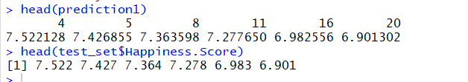
This means that for the value of 7.522, our prediction was 7.522128, for 7.427, it was 7.426855, and so on.
We can calculate the value of R-squared for the prediction model on the test data set as follows:
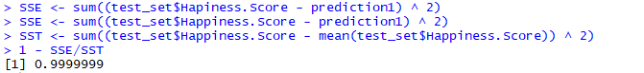

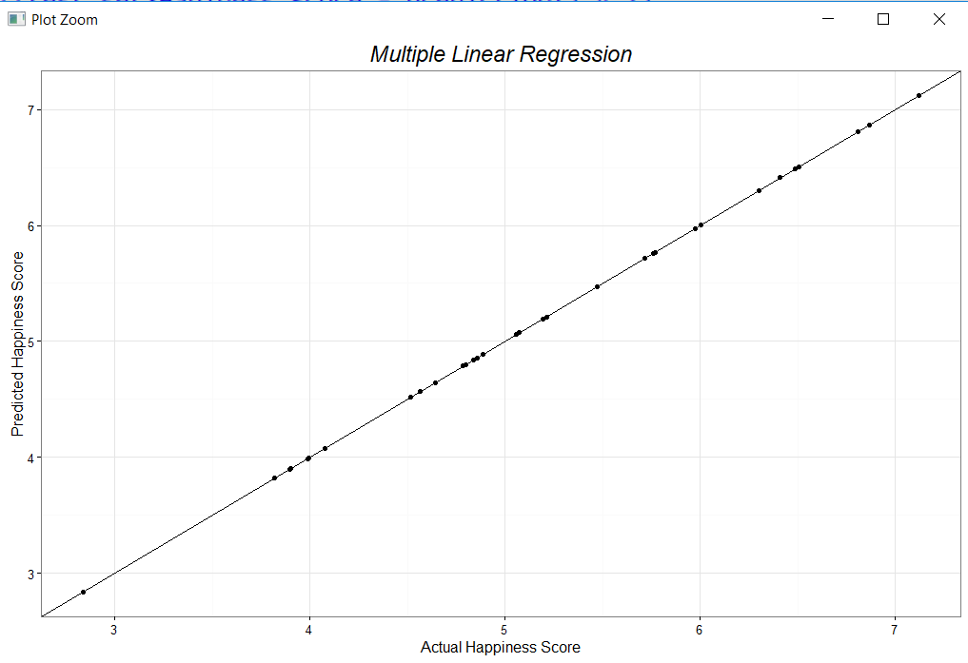

Support Vector Regression
Support Vector Machine can also be used as a regression method, maintaining all the main features that characterize the algorithm (maximal margin). The Support Vector Regression (SVR) uses the same principles as the SVM for classification, with only a few minor differences. First of all, because output is a real number it becomes very difficult to predict the information at hand, which has infinite possibilities.
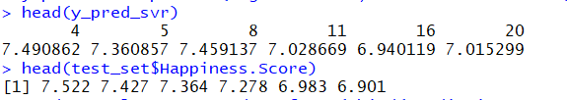
This means that for the value of 7.522, our prediction was 7.490862, for 7.427, it was 7.360857 and so on.
Support Vector Regression predicted happiness scores with pretty high accuracy.
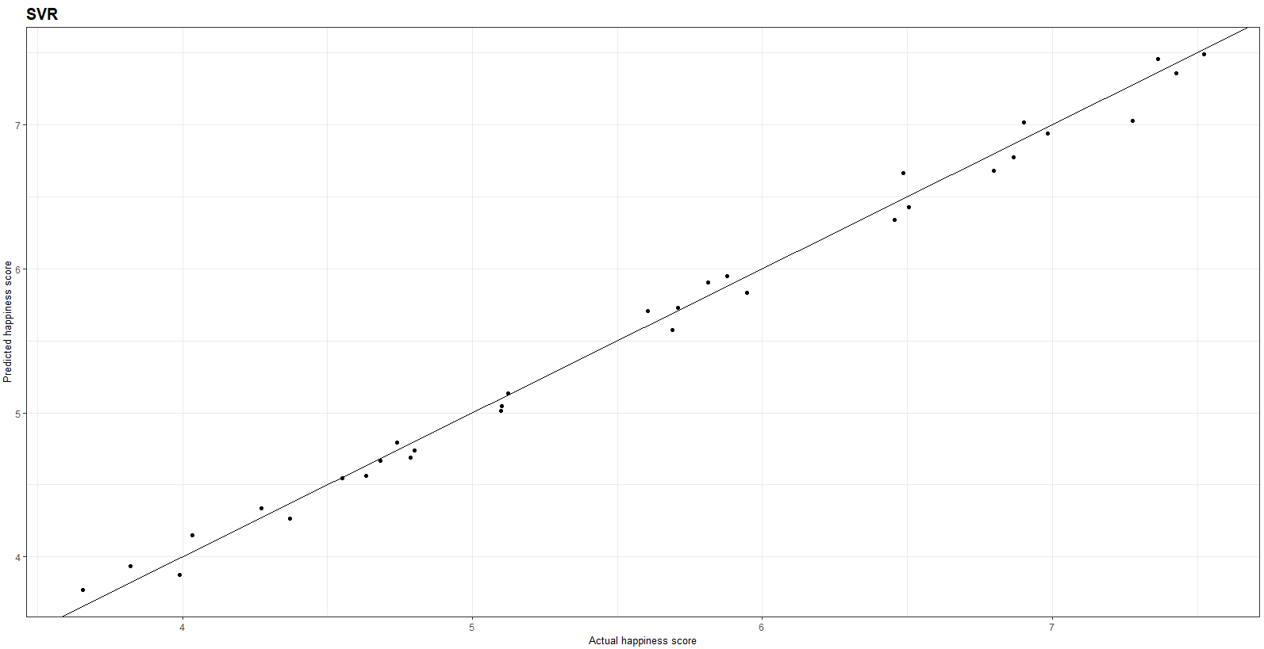

Neural Net
Neural networks are relatively crude electronic networks of neurons based on the neural structure of the brain. They process records one at a time, and learn by comparing their prediction of the record (largely arbitrary) with the known actual record.

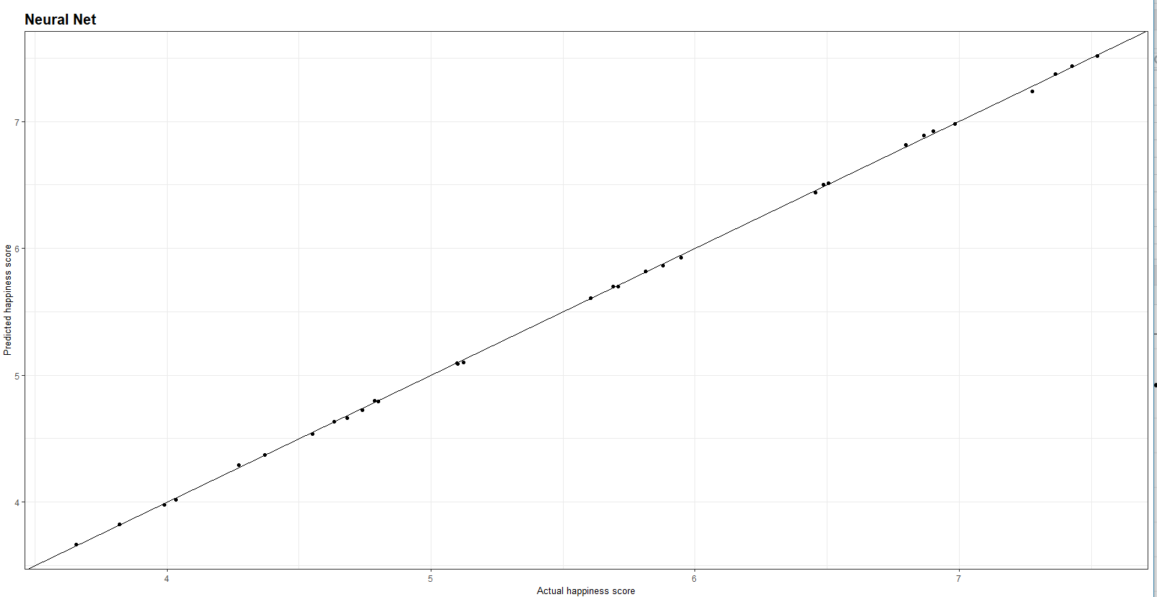
Neural Net predicted almost %100 accuracy.

Decision Tree Regression
Decision tree builds regression or classification models in the form of a tree structure. It breaks down a dataset into smaller and smaller subsets while at the same time an associated decision tree is incrementally developed.
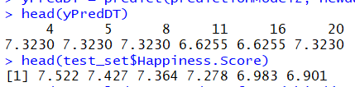
This means that for the value of 7.522, our prediction was 7.3230, for 7.427, it was 7.3230 and so on.
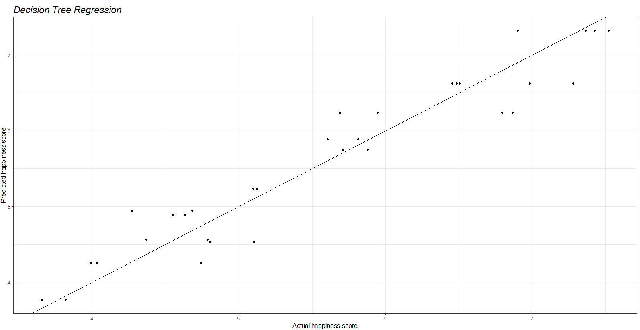

Random Forest Regression
The Random Forest is one of the most effective machine learning models for predictive analytics, making it an industrial workhorse for machine learning.
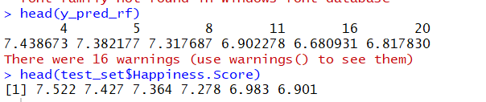
Random Forest Regression predicted happiness scores with pretty high accuracy like SVR.

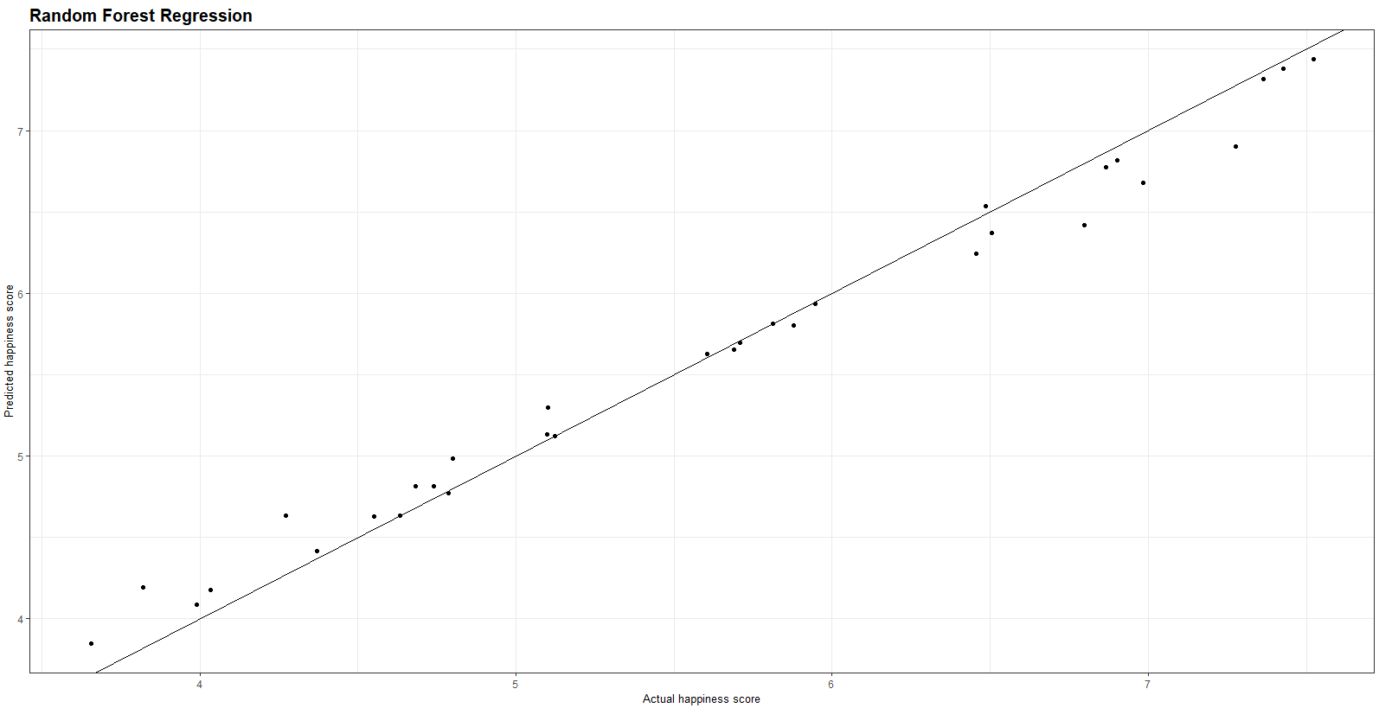

RESULT OF PREDICTIONS
Neural net and multiple lineer regression predicted happiness score almost 100%. Now, I’ll calculate the mean squared error for Multiple Linear Regression and Neural Net model.

Mean Squared Error (Multiple Linear Regression): 0.000000108595806
Mean Squared Error (Neural Net): 0.000488124631469344

Mean squared error for Multiple Linear Regression is smaller than Neural Net.

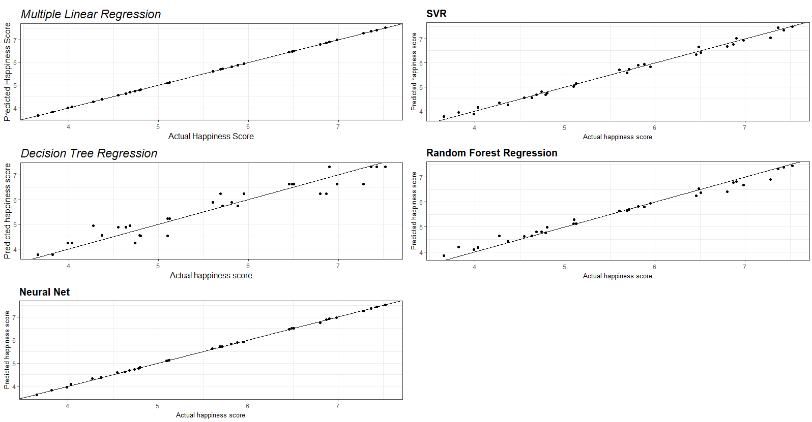
Multiple Linear Regression and neural are the best for this prediction and they predicted approximately the same.
Random Forest and SVR are the second. And the decision tree is the worst one.

Conclusıon
Through this data set, I have discovered many relationships between our happiness and informative variables. I saw that as certain variables such as health, economy and family increased, the overall happiness rankings increased. This was important because it gave us a sense of happiness at the macro level. When manipulating and drawing certain grafts, I realized that there was definitely a linear relationship with these informative variables. The degree of happiness has decreased because of other factors such as health, economy and family. This shows the relationship between happiness. However, as we get closer to the top row and as countries become even more informative, we have noticed that some of the smaller variables are different. As we can see Denmark is the first country in the rank of Happiness Score and Burundi is the last of the rank in 2016. Africa has a concentration of countries with very low Happiness Score, this is caused by the economy, the slavery that still exists in some territories, the lack of government structure. Asian and African countries have no mere presence in the Top Happy Countries list.

