EE568 - Selected Topics on Electrical Machines

Project - 2

Motor Winding Design & Analysis

Özgür Yazıcı

31.03.2020

# Introduction

This study is focused on winding design. In the first part, integral slot winding is designed. In order to reduce harmonic content, 5/6 short pitch winding is used. Then fundamental, third and fifth harmonics are calculated. In the second part, two different fractional slot winding combinations are studied. The first one is 24/20 and the second one is 30/20 combinations. Their winding factors are calculated. In the last part, a 24/20 fractional slot, permanent magnet machine is simulated via FEA tool. Its winding diagram, flux density distribution, cogging torque and induced voltage is calculated.

# Integral Slot Winding Design

In this part, a 20 pole 120 slot machine winding is designed. In order to reduce harmonic distortion, 5/6 short pitched winding is used.

Winding diagram for 5/6 short pitched winding is shown in table 1.

Table 1 winding diagram

|  |  |  |  |  |  |  |  |  |  |  |  |
| --- | --- | --- | --- | --- | --- | --- | --- | --- | --- | --- | --- |
| A1 | A2 | -C1 | -C2 | B1 | B2 | -A3 | -A4 | C3 | C4 | -B3 | -B4 |
| A40 | -C39 | -C40 | B39 | B40 | -A1 | -A2 | C1 | C2 | -B1 | -B2 | A3 |

For the first harmonic:

For the third harmonic:

For the fifth harmonic:

According to the calculations, fundamental winding factor is . Since that value is close to one, it might be usable combination. The third harmonic seems to be large when compared to first harmonic (0.4999). This can be solved by connecting the motor in star configuration. By doing so, third harmonic can be completely eliminated.

# Fractional Slot Winding Design

In this part, we are asked to analyze two different three phase permanent magnet machines with fractional slot windings.

**Firstly, 24 slots and 20 poles.**

That means, each slot has phase difference with respect to the ones that are next to it. Only 12 slots are shown since next 12 will be just the same. Phase angle of induced voltage in each slot is shown in table 2.

Table 2

|  |  |  |  |  |  |  |  |  |  |  |  |  |
| --- | --- | --- | --- | --- | --- | --- | --- | --- | --- | --- | --- | --- |
| Slot | 1 | 2 | 3 | 4 | 5 | 6 | 7 | 8 | 9 | 10 | 11 | 12 |
| angle |  |  |  |  |  |  |  |  |  |  |  |  |

Coil pitch can be chosen by looking at table 2. When chosing coil pitch, main objective is to keep the pitch factor maximum. In order to do so, coil pitch angle should be close to. Since shorter end winding gives better efficiency, coil pitch can be chosen as 1 slot.

After choosing coil pitch, induced voltage phase angles can be calculated. Angle of each coil is shown in table 3. Now series connected coils must be determined. Since they will be connected in series, their phase angle should be as close as possible. Additionally, coils can be connected in counter direction. If this is the case, their phase angle is shifted by .

Table 3

|  |  |  |  |  |  |  |  |  |  |  |  |  |
| --- | --- | --- | --- | --- | --- | --- | --- | --- | --- | --- | --- | --- |
| Coil | 1 | 2 | 3 | 4 | 5 | 6 | 7 | 8 | 9 | 10 | 11 | 12 |
| angle |  |  |  |  |  |  |  |  |  |  |  |  |

First coil is used as starting point with phase angle. If 7th coil is connected in counter direction, it will also be . Now two more coils need to be selected. Next closest angle is in the 8th slot with difference. Lastly 2nd coil can be connected in counter direction. Chosen coils are shown in table 4. Yellow cells are clockwise and green cells are counter clockwise direction.

Table 4

|  |  |  |  |  |  |  |  |  |  |  |  |  |
| --- | --- | --- | --- | --- | --- | --- | --- | --- | --- | --- | --- | --- |
| Coil | 1 | -2 | 3 | 4 | 5 | 6 | -7 | 8 | 9 | 10 | 11 | 12 |
| angle |  |  |  |  |  |  |  |  |  |  |  |  |

Phasor diagram is shown in figure 1 with and vectors.

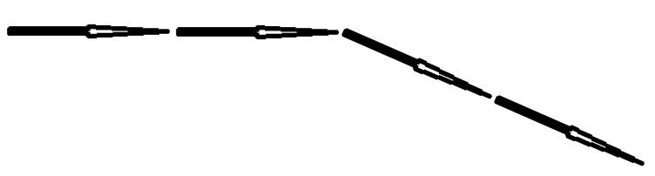

Figure 1 and vectors

For the first harmonic:

**Secondly, 30 slots and 20 poles.**

That means, each slot has 120 phase difference with respect to the ones that are next to it. Only 12 slots are shown. Phase angle of induced voltage in each slot is shown in table 2.

Table 5

|  |  |  |  |  |  |  |  |  |  |  |  |  |
| --- | --- | --- | --- | --- | --- | --- | --- | --- | --- | --- | --- | --- |
| Slot | 1 | 2 | 3 | 4 | 5 | 6 | 7 | 8 | 9 | 10 | 11 | 12 |
| angle |  |  |  |  |  |  |  |  |  |  |  |  |

Coil pitch can be chosen by looking at table 2. When choosing coil pitch, main objective is to keep the pitch factor maximum. In order to do so, coil pitch angle should be close to. Since shorter end winding gives better efficiency, coil pitch can be chosen as 1 slot.

After choosing coil pitch, induced voltage phase angles can be calculated. Angle of each coil is shown in table 6. Now series connected coils must be determined. Since they will be connected in series, their phase angle should be as close as possible. Additionally, coils can be connected in counter direction. If this is the case, their phase angle is shifted by .

Table 6

|  |  |  |  |  |  |  |  |  |  |  |  |  |
| --- | --- | --- | --- | --- | --- | --- | --- | --- | --- | --- | --- | --- |
| Slot | 1 | 2 | 3 | 4 | 5 | 6 | 7 | 8 | 9 | 10 | 11 | 12 |
| angle |  |  |  |  |  |  |  |  |  |  |  |  |

First coil is used as starting point with phase angle. 4th 7th and 10th coils are also at the same phase angle. They can be connected in series. Chosen coils are shown in table 7. Yellow cells are clockwise and green cells are counter clockwise direction.

Table 7

|  |  |  |  |  |  |  |  |  |  |  |  |  |
| --- | --- | --- | --- | --- | --- | --- | --- | --- | --- | --- | --- | --- |
| Slot | 1 | 2 | 3 | 4 | 5 | 6 | 7 | 8 | 9 | 10 | 11 | 12 |
| angle |  |  |  |  |  |  |  |  |  |  |  |  |

Phasor diagram is shown in figure 1 with and vectors.



Figure 2 vectors

For the first harmonic:

# 2D FEA Modeling

In this part, a three phase 20 pole 24 slot permanent magnet machine is simulated by using 2D FEA tool. 2D drawing is shown in figure 3.

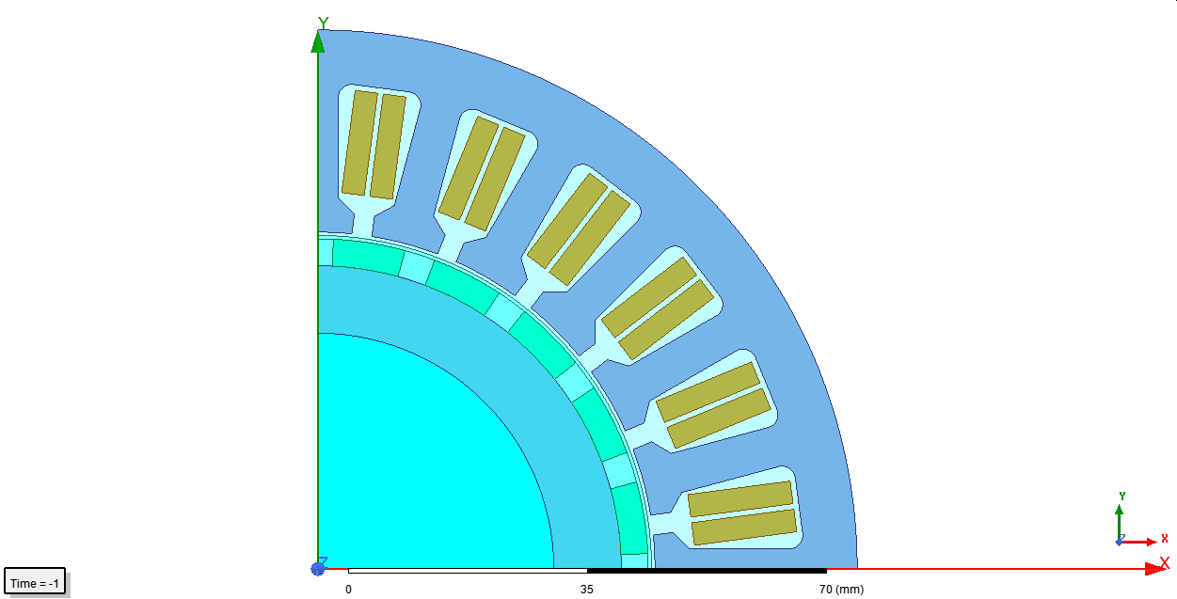

Figure 3

Winding diagram is shown in figure 4.

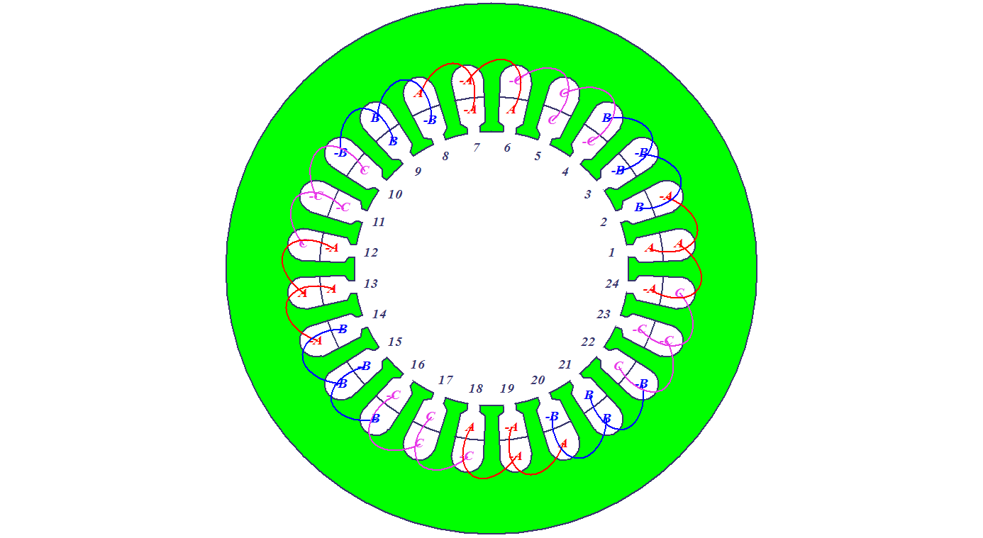

Figure 4 Winding diagram

Flux density distribution is shown in figure 5.

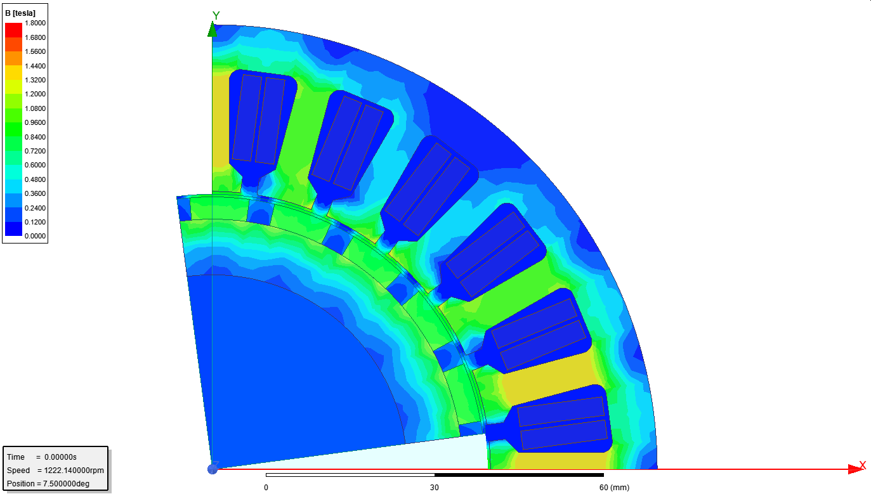

Figure 5 Flux density distribution

Through the air-gap region, a curve is drawn and B with respect to normal of the curve calculated. Result is shown in figure 6. The air gap flux density distribution graph is not smooth and perfect. This is caused by stator tooth. Since stator tooth is ferromagnetic, flux tends to go through them changing its ideal route. This is why flux density distribution through air gap doesn’t seem perfect. This is also the reason why cogging torque appears.

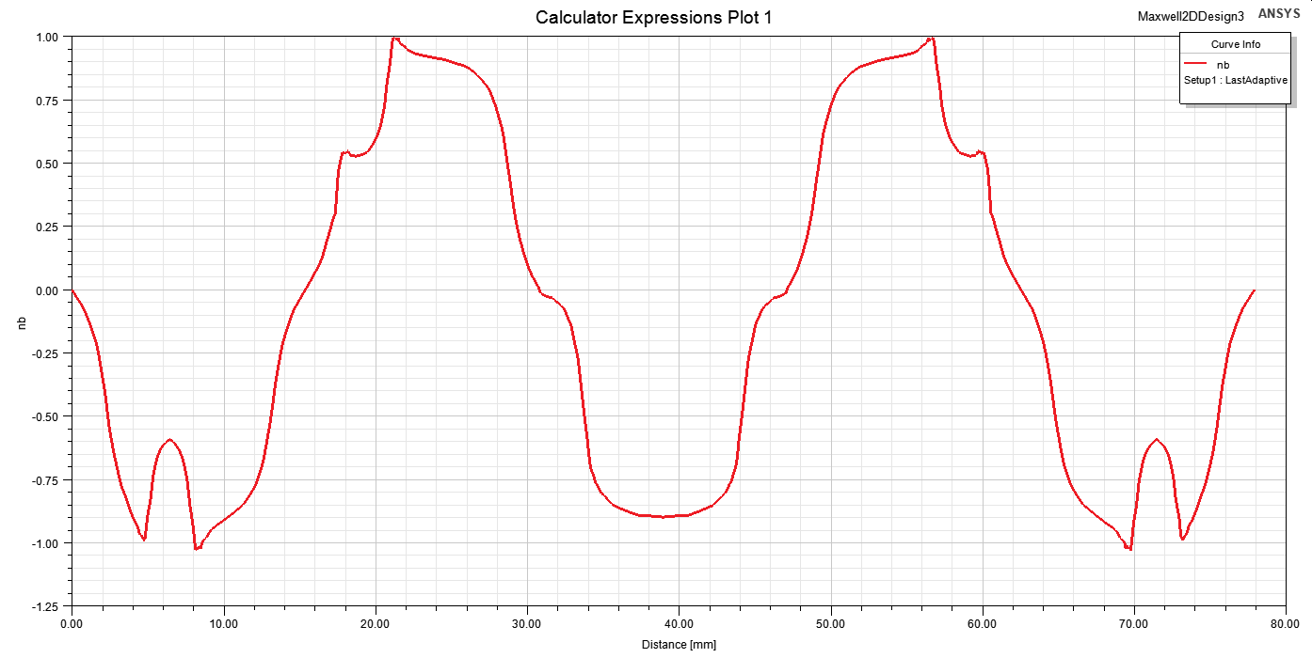

Figure 6 Air-gap flux density

Induced three phase voltages and phaseA-phaseB line to line voltage is shown in figure 7. The orange one is line to line and rest is phase voltages.

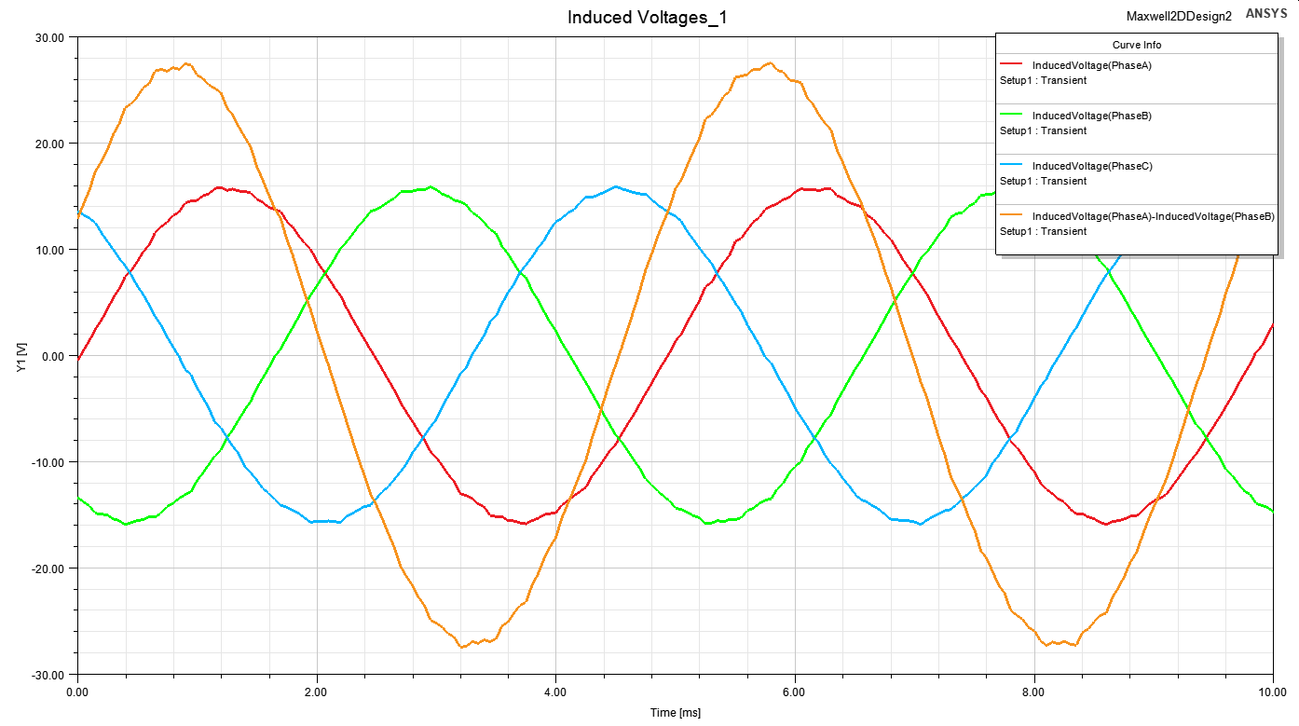

Figure 7 Phase A, B, C and PhaseA-PhaseB voltages

Mechanical torque of the machine is shown in figure 8. This graph is generated when there is no excitation resulting in only cogging torque of the motor. This cogging torque is produced because of interaction between tooth and permanent magnets.

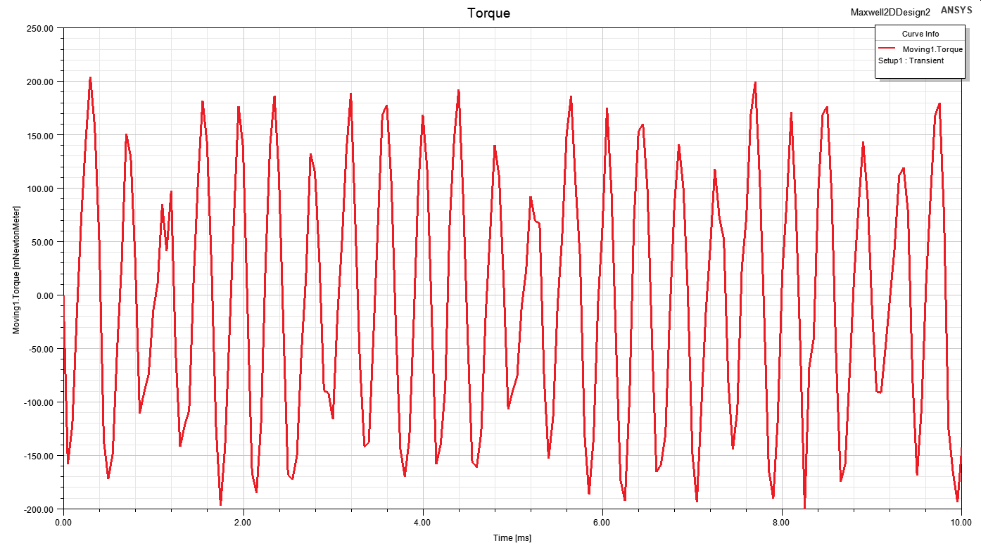

Figure 8 Cogging torque

# Conclusion

This study is focused on winding design. In the first part, integral slot winding is designed. In order to reduce harmonic content, 5/6 short pitch winding is used. Then fundamental, third and fifth harmonics are calculated. In the second part, two different fractional slot winding combinations are studied. The first one is 24/20 and the second one is 30/20 combinations. Their winding factors are calculated. In the last part, a 24/20 fractional slot, permanent magnet machine is simulated via FEA tool. Its winding diagram, flux density distribution, cogging torque and induced voltage is calculated.