EE568 - Selected Topics on Electrical Machines

Project - 3

PM Motor Comparison Analysis

Özgür Yazıcı

03.05.2020

# Introduction

In this project, a machine is modelled starting from magnetic circuit. In the first part, air-gap flux density and magnetic loading is calculated by analytical methods. After that results are compared with FEA solutions. In the second part, machine is designed. Number of turns, electric loading and power output is calculated. In the third part, rotor diameter is optimized by analytical calculations and slot ratio is found. Results are compared with ferrite and neodymium magnets.

# Magnetic Loading

## Magnet operating point

Magnetic equivalent circuit for single pole pair is shown in figure 1.



Figure 1 Magnetic equivalent circuit for single pole pair

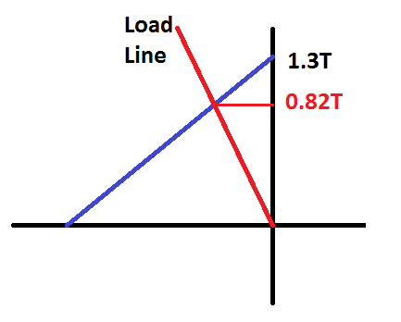

Figure 2 Load line and operating point of magnet

## Magnetic Loading

Magnetic loading means average air gap flux density. It was found in the first part as **0.82T**. This is high for a standard machine. Normally magnetic loading is around 0.6T. This is caused because of assuming the stator solid and taking the gap only 1mm. In reality effective value of air gap length is larger than this value. So magnetic loading should be smaller with a slotted stator.

## Air Gap flux Density Distribution

In this part magnetic circuit is modelled with FEA tool. Model is shown in figure 3. After that, air gap flux density distribution is calculated and plotted in figure 4.

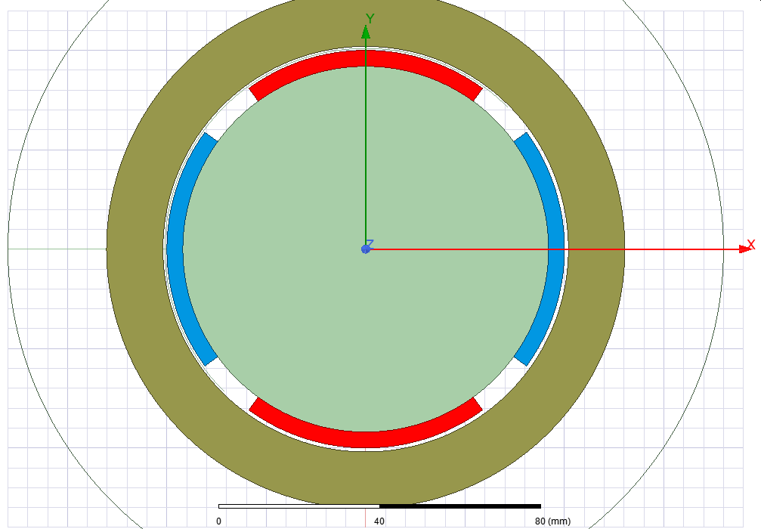

Figure 3 FEA Model

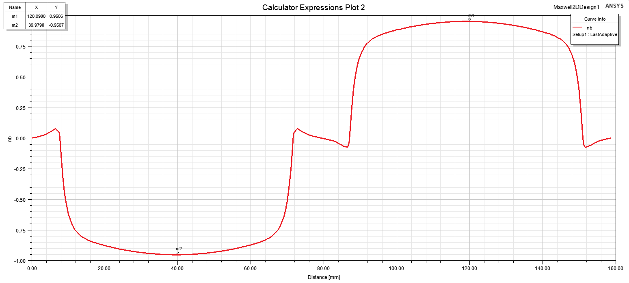

Figure 4 Air gap flux densith distribution

Table 1 Analytical and FEA comparison

|  |  |  |
| --- | --- | --- |
|  | Avg Flux Density | Peak Flux Density |
| Analytical Result | 0.82 T | 1.29 T |
| FEA Result | 0.68 T | 0.95 T |

Analytical flux density results seem to be higher than FEA results. This situation is expected because during analytical calculations, leakage flux is ignored. Bu in FEA model, some flux leak from one magnet to next one and also to itself without reaching to the stator.

# Electrical Loading and Machine Sizing

## Number of slots

When choosing number of slots, both electrical and mechanical disadvantages should be considered. Winding factor should be as high as possible and teeth size should not be too small or large. Because of that 12 slot stator is used for design.

When **12 slots full pitch** is used, winding factor is maximized and slot pitch is 26mm which is usable.

## Suitable Wire

Current is 2.5A and current density is 5A/ so wire cross section needs to be 0.5 . Checking from awg wire catalog**, 20 awg wire can be used with 0.52** area.

## Slot Height, Number of Coils, Back Core Thickness

According to lecture notes, for a 4 pole machine

In our case inner diameter is 100mm so **outer diameter can be 188mm.**

Now back-core thickness should be found. Half of flux per pole goes through back-core and flux density should be around 1.4T.

From the first part;

Back-core flux =

Back-core flux /1.4T/0.1m = **23mm back-core**

Stator starts from 102mm and goes to 188mm

43mm thickness and 23mm back-core

So **teeth length is 20mm**

Lastly, number of turns per slot will be calculated.

Taking teeth with = slot pitch/2

## Electric Loading

According to the lecture notes, electrical loading for a pmsm motor should be between 35-65 kA/m. The calculated value is between this range.

## Tangential Stress

Tangential stress is calculated as:

## Power Output

# Comparison and Optimization

## Rotor diameter optimization

There are some design decisions that needs to be stated.

* 12 slots 4 pole
* Embrace 0.8
* Airgap: 1mm
* Stator yoke: 20mm
* Magnet thickness: 4mm

Since magnet/gap ratio is constant magnetic loading is same. (0.8T)

From now on in order to simplify the equations, constants are started to be removed. At the end derivative will be taken and constants will not be important.

## Ferrite Magnet

When ferrite magnet is used, air gap flux density decreases. When air gap flux density is decreased, magnetic loading is also decreased.

With neodymium magnet, Br was 1.3T. Now it is decreased to 0.4T. Magnetic loading is changed with same ratio (0.4/1.3)

As a result, produced torque will decrease with same ratio (0.3). Also at the same rotation speed, induced voltage is decreased by the same factor. So power output is decreased at the same speed.

# Conclusion

In this project, a machine is modelled starting from magnetic circuit. In the first part, air-gap flux density and magnetic loading is calculated by analytical methods. After that results are compared with FEA solutions. In the second part, machine is designed. Number of turns, electric loading and power output is calculated. In the third part, rotor diameter is optimized by analytical calculations and slot ratio is found. Results are compared with ferrite and neodymium magnets.