Table of Contents

1. Introduction 1

2. Requirements 1

3. Analytical Calculations 1

3.1. Supply and Drive 2

3.2. Motor Current and Wire 3

3.3. Pole-Slot Number, Dimensions 3

3.4. Induced Voltage 4

4. FEA Modelling 4

5. Comparison and Discussion 4

6. Conclusion 4

# Introduction

# Requirements

Motor will be designed for a high torque direct drive application.

Rated Speed: 600 rpm

Rated Torque: 250 Nm

Rated Power: 22 kW

Max outer diameter: 400mm

Supply: Inverter fed from 400 V three phase grid

# Analytical Calculations

Firstly, motor dimensions should be calculated analytically. Analytical calculations provide a starting point for FEA and optimization steps.

## Supply and Drive

Motor driver will be supplied from 400V grid. However, it cant be used directly since variable frequency drive will be used. In order to use a vfd, supply should be rectified at first. There are two options. Firstly, diode rectifier can be used. Six diodes with large bus capacitors would do the job. Secondly, an active rectifier can be utilized.

When diode rectifier is used, initial cost is lower. However, diode rectifiers need a large bus capacitor in order to reduce voltage ripple. Additionally, current ripple high and this effects the other grid connected devices nearby. Moreover, since power factor is not controlled, more current is drawn for the same power. Lastly, when a diode rectifier is used, energy can only flow from grid to the DC side, can’t flow back.

When an active rectifier is used, initial cost is higher since there are additional switching devices and controllers. However active rectifier provides in smaller bus capacitor, bidirectional energy flow, reduced grid current and less harmonic disturbance on the grid.

Because of those reasons active rectifier will be used. The simplest method is to use a three phase rectifier with additional LCL filters on the phase connections. This topology results in boost type pfc. In a boost type pfc, output voltage is larger than the input voltage. Also output voltage can be regulated by controlling the transistors. Topology is represented in figure 1.

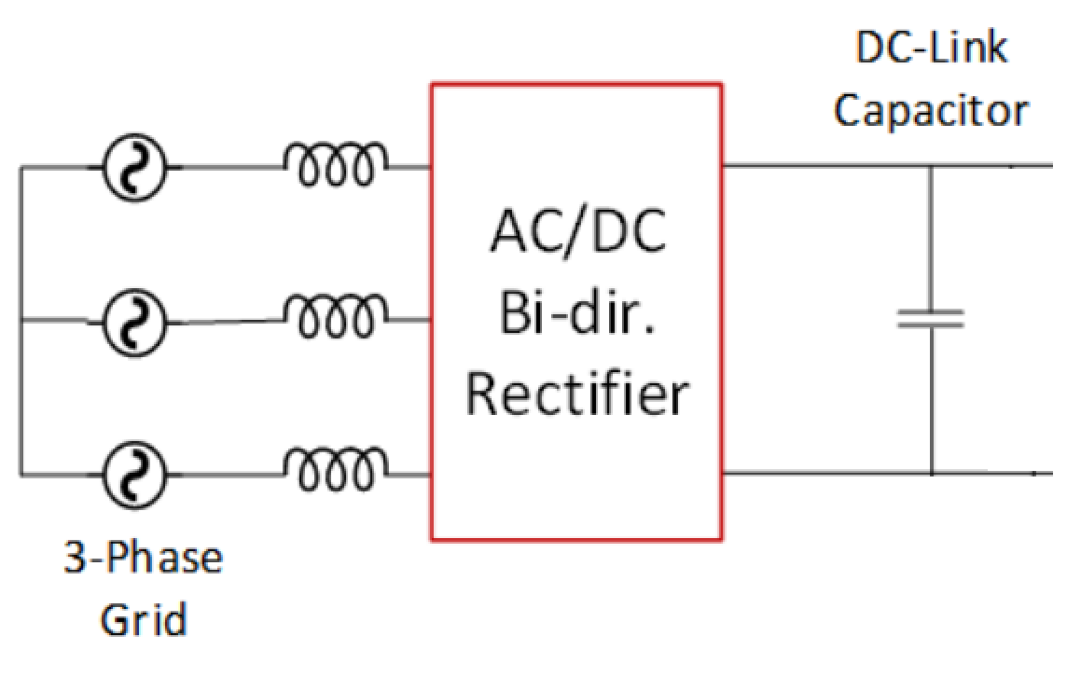

Figure 1 PFC

Now motor voltage can be determined. Input voltage is 400Vrms. Since this voltage is not always constant, limit situations should be considered. Assuming 400V+-15%, max voltage is 460V rms.

Since rectifier is a boost type pfc, minimum regulated output voltage should be 650V for constant DC bus voltage.

SVPWM will be used on the inverter side.

## Motor Current and Wire

Since motor power and voltage is known, phase current can be found.

Taking j = 6 A/mm^2

Using a wire would result in 2.6 mm diameter wire. It is impractical to wind thick cables since bending becomes more and more difficult. Because of that two wires in parallel can be used.

**Chosen wire:** 2x 1.8 mm diameter copper wire in parallel

## Pole-Slot Number, Dimensions

Since outer diameter is limited by 400mm, this can be used as starting point. Taking end winding and mechanical case into account, outer diameter can be 300mm. Design will continue with this assumption. According to [1] analytical optimum value of Do/Di = 0.6-0.7. Using this value, inner diameter should be 200mm.

**Do = 300mm**

**Di = 200mm**

Since this is a low speed torque motor, number of poles should be high. Higher pole number increases the operating frequency and decreases the machine size. However, number of poles can’t be increased infinitely. When pole number is increased, magnets get smaller. Above some point manufacturing becomes impractical. Additionally, leakage between the poles increase. In order to find a suitable number, smallest dimension on the magnet can be used.

If 28 poles used,

So 28 pole rotor is suitable for manufacturing.

Same satiation is valid for number of slots. If there are too many slots, they become smaller and manufacturing will be more difficult. Additionally, slot number effects the winding factor. Lower winding factor results in larger motor size. In this application, cogging torque needs to be considered. Since this motor will be used in a direct drive machine, cogging torque and torque ripple is important. Some pole slot combinations provide lower cogging torque whereas others produce higher.

Taking all these in consideration, 27 slots can be used. 27 slot 28 pole machine has a winding factor of 0.95 which is a good value. Also 27/28 combination has least common multiplier of 756. That means motor will produce 756 cogging steps per turn. This high value results in smaller steps (less cogging torque).

**Pole: 28**

**Slot: 27**

Winding scheme is shown in figure 2.

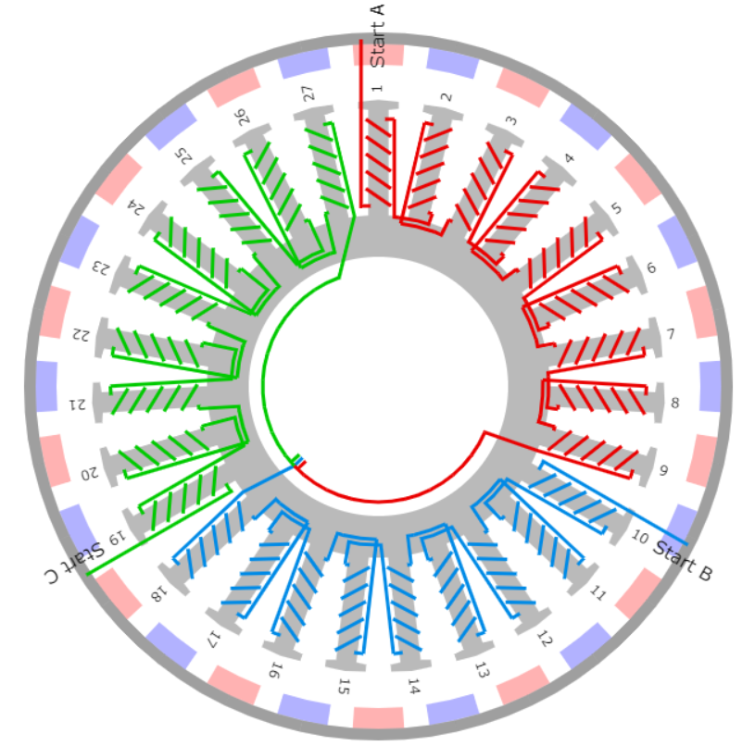

Figure 2 Winding scheme for 27/28 machine

## Induced Voltage and Number of Turns

Number of turns should be calculated.

**N = 15 turns**

# FEA Modelling

Machine is simulated with Ansys Maxwell. Machine model is shown in figure 3. In order to reduce simulation time, half symmetry is used. Model is split by ZX axis.

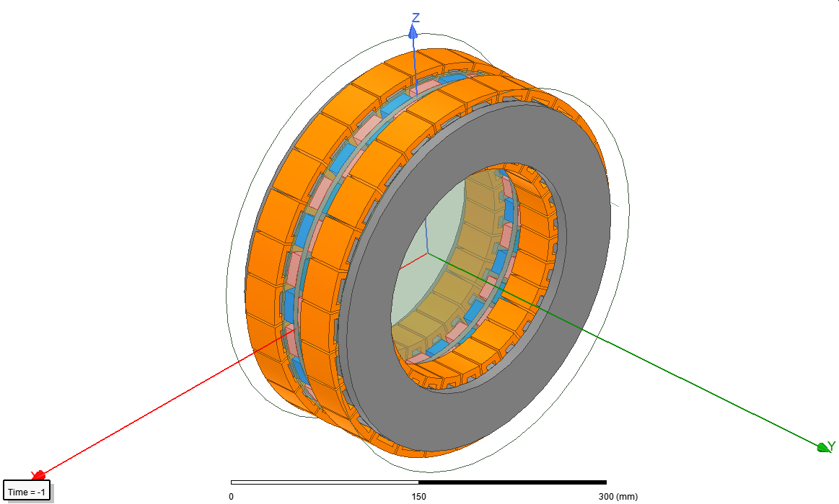

Figure 3 Full machine model

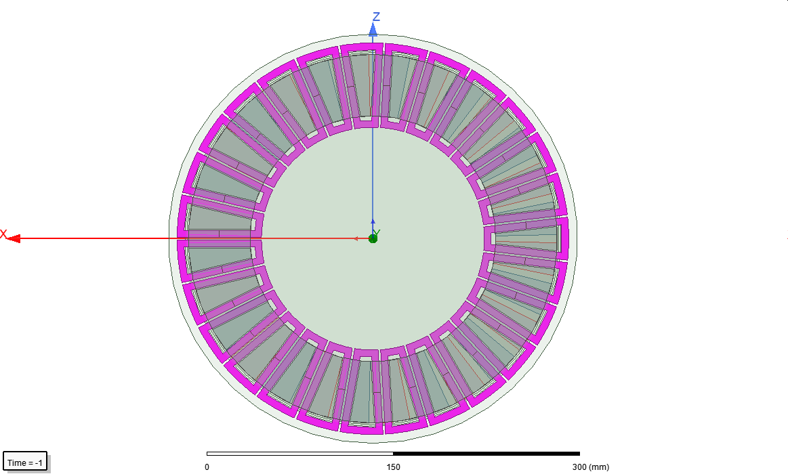

Figure 4 Coils are selected

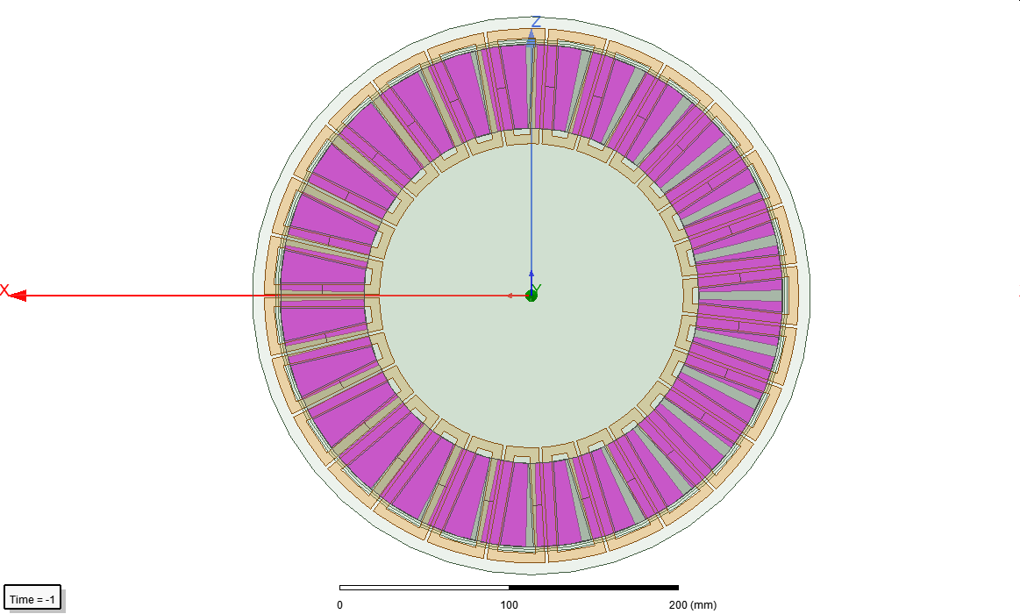

Figure 5 Magnets are selected

# Comparison and Discussion

# Conclusion