## Q2)

In this part, model is simulated by using a 2D FEA software. Firstly, steels are assumed ideal in terms of magnetic properties. In other words, magnetic permeability is constant. In the simulation it is taken as 4000 u0. 2D model is shown in figure1.

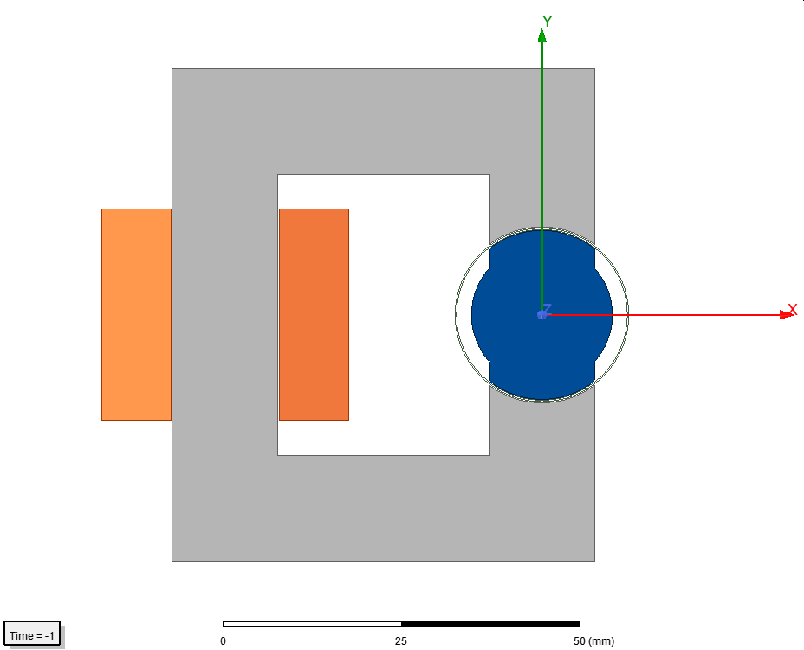

Figure 1 2D model

Copper regions are approximated as solid parts. Number of turns is 250 and current is 3 A.

Flux density vectors are given in figures 2,3 and 4 for angles 0, 45 and 90 degrees.

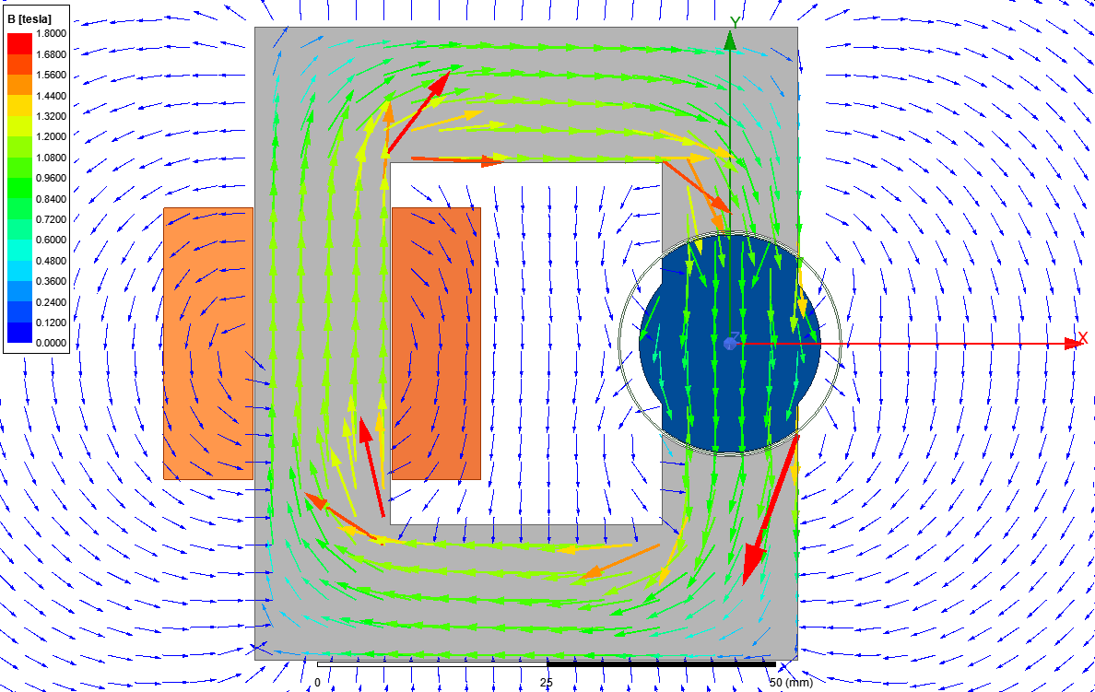

Figure 2

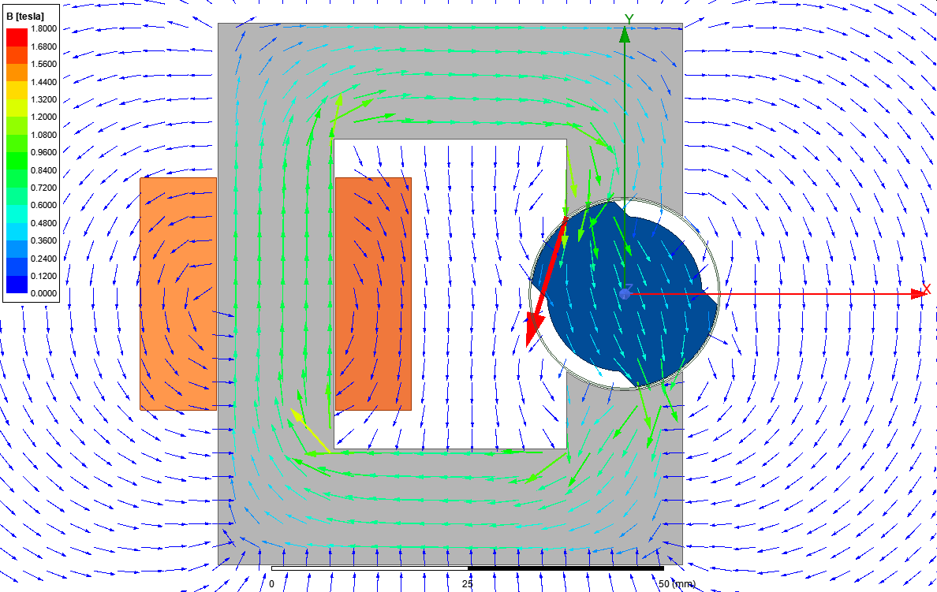

Figure 3

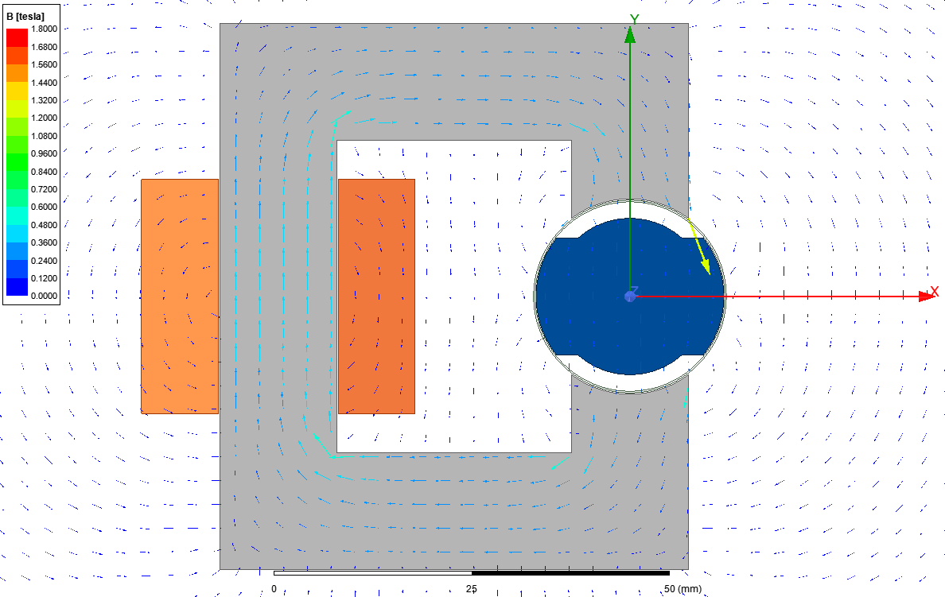

Figure 4

Inductance vs angle table is given in table1.

Table 1



Inductance vs angle graph is given in figure 5.

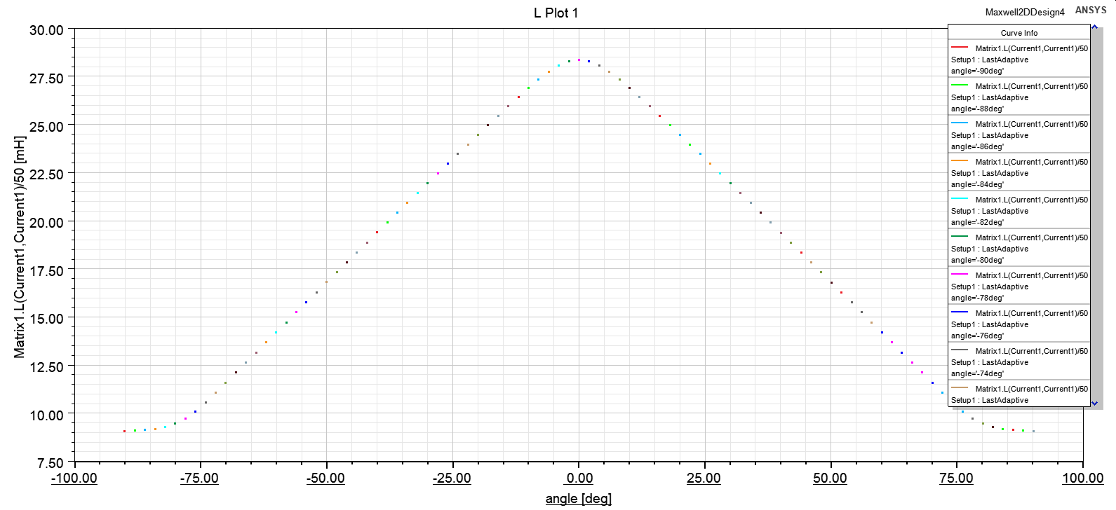

Figure 5

Total energy vs angle is given in table 2.

Table 2 energy vs angle

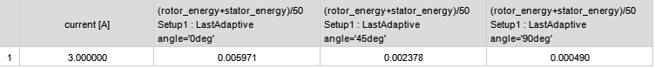

Total coenergy vs angle is given in table 3

Table 3 coenergy vs angle



It can be seen that energy and coenergy is equal to each other. Since linear a material is used, this is expected.

Torque vs angle is given in figure 6

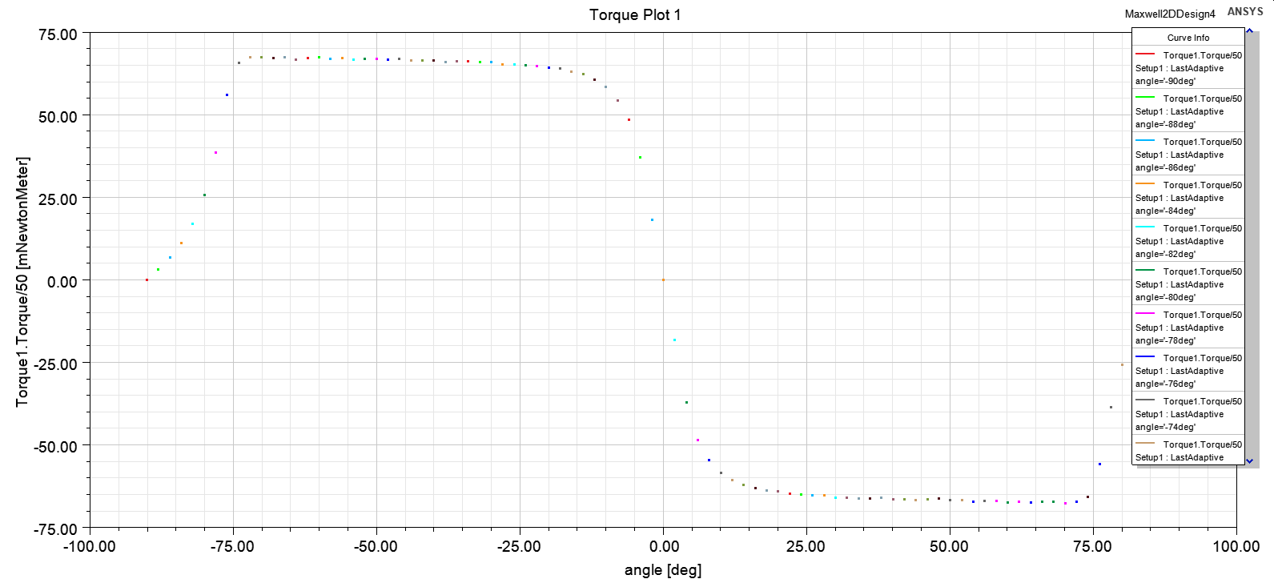

Figure 6

DD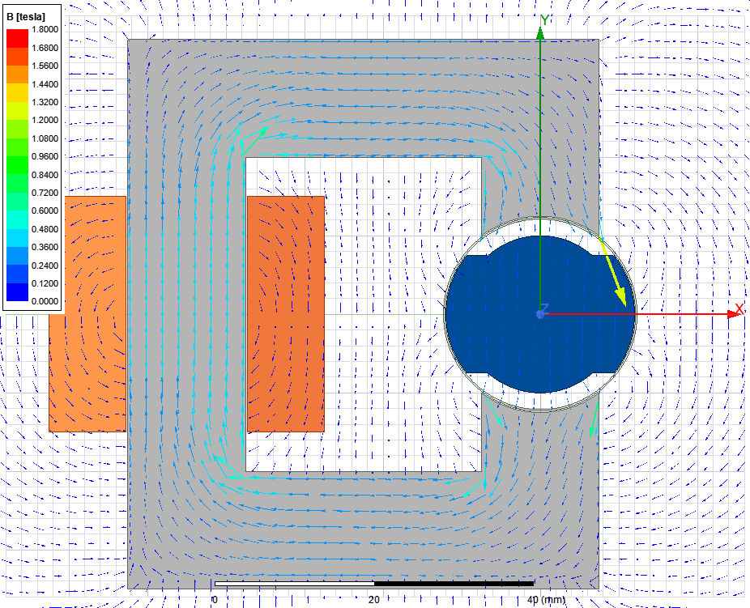

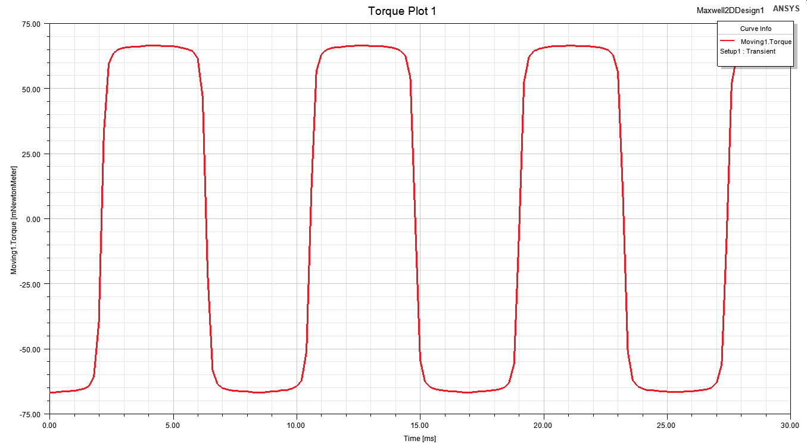

Torque vs angle

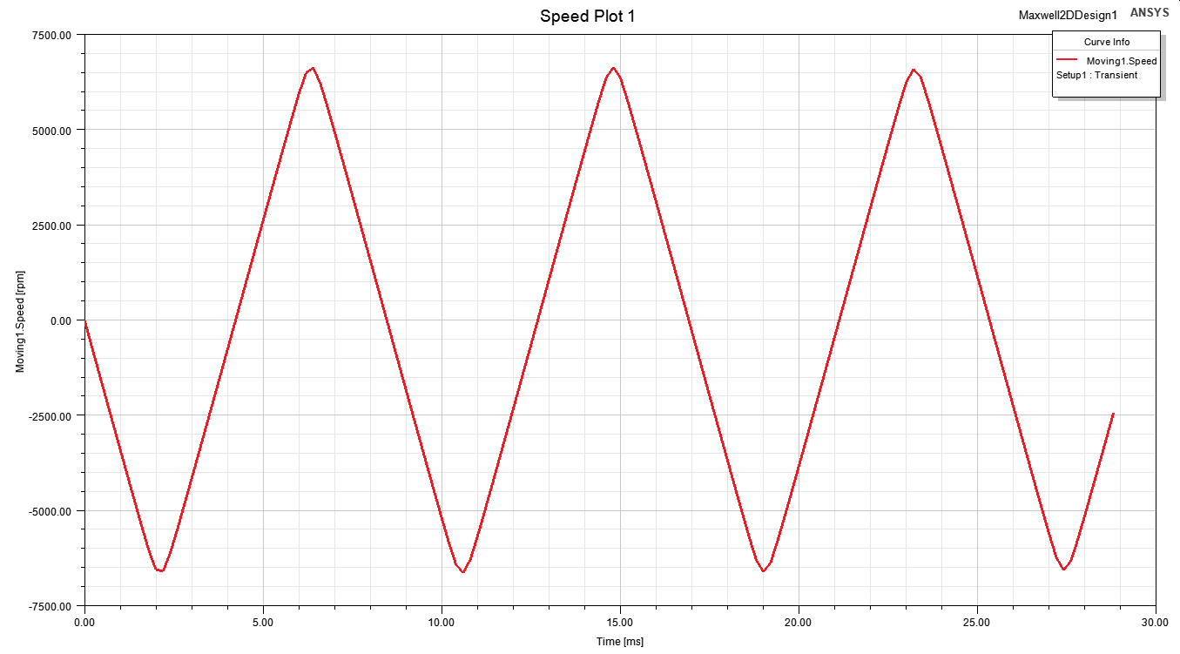

Speed vs angle