BRUSHLESS PERMANENT MAGNET DC MOTOR DESIGN

File: Setup1.res

GENERAL DATA

Rated Output Power (kW): 8

Rated Voltage (V): 520

Number of Poles: 20

Given Rated Speed (rpm): 600

Frictional Loss (W): 0

Windage Loss (W): 0

Rotor Position: Inner

Type of Load: Constant Power

Type of Circuit: Y3

Lead Angle of Trigger in Elec. Degrees: 0

Trigger Pulse Width in Elec. Degrees: 120

One-Transistor Voltage Drop (V): 0

One-Diode Voltage Drop (V): 0

Operating Temperature (C): 75

Maximum Current for CCC (A): 0

Minimum Current for CCC (A): 0

STATOR DATA

Number of Stator Slots: 24

Outer Diameter of Stator (mm): 220

Inner Diameter of Stator (mm): 169

Type of Stator Slot: 4

Stator Slot

hs0 (mm): 1

hs1 (mm): 0.25

hs2 (mm): 18.1672

bs0 (mm): 6

bs1 (mm): 11.2759

bs2 (mm): 16.0594

rs (mm): 0.25

Top Tooth Width (mm): 11.1919

Bottom Tooth Width (mm): 11.1919

Skew Width (Number of Slots) 0

Length of Stator Core (mm): 150

Stacking Factor of Stator Core: 0.95

Type of Steel: steel_1010

Designed Wedge Thickness (mm): 0.177219

Slot Insulation Thickness (mm): 0

Layer Insulation Thickness (mm): 0

End Length Adjustment (mm): 0

Number of Parallel Branches: 1

Number of Conductors per Slot: 38

Type of Coils: 21

Average Coil Pitch: 1

Number of Wires per Conductor: 1

Wire Diameter (mm): 1.9

Wire Wrap Thickness (mm): 0

Slot Area (mm^2): 261.083

Net Slot Area (mm^2): 253.111

Limited Slot Fill Factor (%): 75

Stator Slot Fill Factor (%): 54.1975

Coil Half-Turn Length (mm): 170.031

ROTOR DATA

Minimum Air Gap (mm): 1

Inner Diameter (mm): 142

Length of Rotor (mm): 150

Stacking Factor of Iron Core: 0.95

Type of Steel: steel_1010

Polar Arc Radius (mm): 83.5

Mechanical Pole Embrace: 0.95

Electrical Pole Embrace: 0.891435

Max. Thickness of Magnet (mm): 5.5

Width of Magnet (mm): 24.0999

Type of Magnet: NdFe48H

Type of Rotor: 1

Magnetic Shaft: Yes

PERMANENT MAGNET DATA

Residual Flux Density (Tesla): 1.39

Coercive Force (kA/m): 1011

Maximum Energy Density (kJ/m^3): 351.322

Relative Recoil Permeability: 1.09412

Demagnetized Flux Density (Tesla): 0.0199371

Recoil Residual Flux Density (Tesla): 1.39

Recoil Coercive Force (kA/m): 1011

MATERIAL CONSUMPTION

Armature Copper Density (kg/m^3): 8900

Permanent Magnet Density (kg/m^3): 7400

Armature Core Steel Density (kg/m^3): 7872

Rotor Core Steel Density (kg/m^3): 7872

Armature Copper Weight (kg): 3.913

Permanent Magnet Weight (kg): 2.9426

Armature Core Steel Weight (kg): 10.4498

Rotor Core Steel Weight (kg): 3.67565

Total Net Weight (kg): 20.981

Armature Core Steel Consumption (kg): 33.5107

Rotor Core Steel Consumption (kg): 22.2733

STEADY STATE PARAMETERS

Stator Winding Factor: 0.933013

D-Axis Reactive Inductance Lad (H): 0.000917312

Q-Axis Reactive Inductance Laq (H): 0.000917312

D-Axis Inductance L1+Lad(H): 0.0030593

Q-Axis Inductance L1+Laq(H): 0.0030593

Armature Leakage Inductance L1 (H): 0.00214199

Zero-Sequence Inductance L0 (H): 0.00180553

Armature Phase Resistance R1 (ohm): 0.395607

Armature Phase Resistance at 20C (ohm): 0.325419

D-Axis Time Constant (s): 0.00231874

Q-Axis Time Constant (s): 0.00231874

Ideal Back-EMF Constant KE (Vs/rad): 7.0444

Start Torque Constant KT (Nm/A): 4.71575

Rated Torque Constant KT (Nm/A): 7.59219

NO-LOAD MAGNETIC DATA

Stator-Teeth Flux Density (Tesla): 1.97244

Stator-Yoke Flux Density (Tesla): 2.05676

Rotor-Yoke Flux Density (Tesla): 1.71185

Air-Gap Flux Density (Tesla): 0.949444

Magnet Flux Density (Tesla): 1.00678

Stator-Teeth By-Pass Factor: 0.0205692

Stator-Yoke By-Pass Factor: 0.00353922

Rotor-Yoke By-Pass Factor: 0.000296353

Stator-Teeth Ampere Turns (A.T): 450.432

Stator-Yoke Ampere Turns (A.T): 126.787

Rotor-Yoke Ampere Turns (A.T): 21.212

Air-Gap Ampere Turns (A.T): 935.057

Magnet Ampere Turns (A.T): -1533.01

Armature Reactive Ampere Turns

at Start Operation (A.T): 5460.61

Leakage-Flux Factor: 1

Correction Factor for Magnetic

Circuit Length of Stator Yoke: 0.142811

Correction Factor for Magnetic

Circuit Length of Rotor Yoke: 0.257846

No-Load Speed (rpm): 710.943

Cogging Torque (N.m): 8.02798

FULL-LOAD DATA

Average Input Current (A): 15.8277

Root-Mean-Square Armature Current (A): 13.9125

Armature Thermal Load (A^2/mm^3): 117.266

Specific Electric Loading (A/mm): 23.8981

Armature Current Density (A/mm^2): 4.90691

Frictional and Windage Loss (W): 0

Iron-Core Loss (W): 0.015174

Armature Copper Loss (W): 229.719

Transistor Loss (W): 0

Diode Loss (W): 0

Total Loss (W): 229.734

Output Power (W): 8000.65

Input Power (W): 8230.38

Efficiency (%): 97.2087

Rated Speed (rpm): 635.789

Rated Torque (N.m): 120.166

Locked-Rotor Torque (N.m): 3093.53

Locked-Rotor Current (A): 656

TRANSIENT FEA INPUT DATA

For Armature Winding:

Number of Turns: 152

Parallel Branches: 1

Terminal Resistance (ohm): 0.395607

End Leakage Inductance (H): 1.08709e-005

2D Equivalent Value:

Equivalent Model Depth (mm): 150

Equivalent Stator Stacking Factor: 0.95

Equivalent Rotor Stacking Factor: 0.95

Equivalent Br (Tesla): 1.39

Equivalent Hc (kA/m): 1011

Estimated Rotor Moment of Inertia (kg m^2): 0.0893412

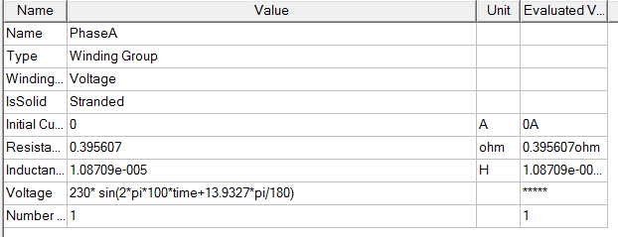

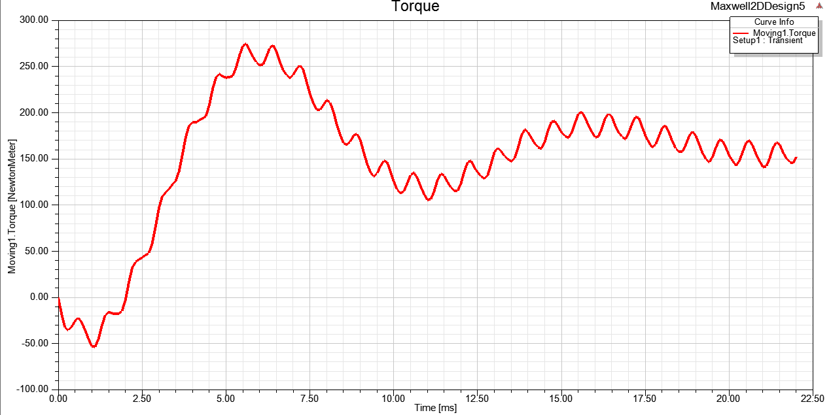

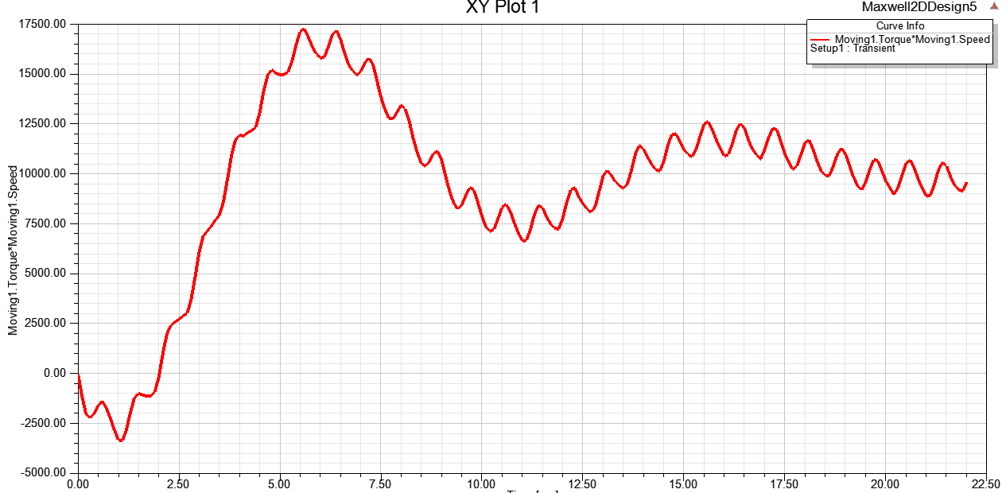

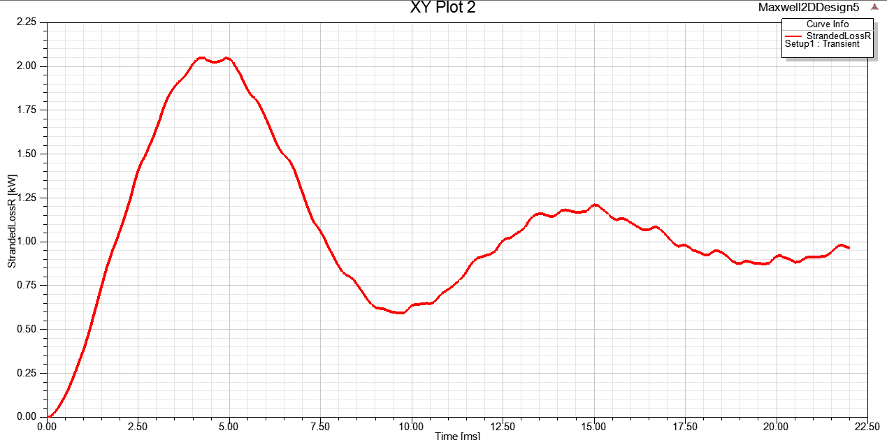

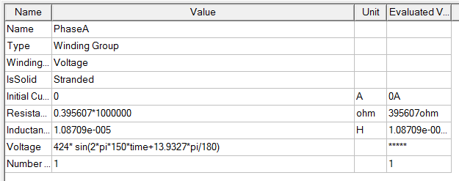

@1000rpm

