**MARMARA UNIVERSITY**

**MECHANICAL ENGINEERING DEPARTMENT**



**ME7009 PROJECT**

**524618020 ÖZGÜRAZAD ÇELİK**

**Lecturer: Dr.Öğr.Üyesi UĞUR TÜMERDEM**

**ISTANBUL, 2022**

Contents

System Linearization 2

System Initialization 4

Full-State Feedback 8

Pole Placement 10

Observer 14

LQR 20

KALMAN Filter 25

Model Linearizer 27

# metin içeren bir resim Açıklama otomatik olarak oluşturulduSystem Linearization

tablo içeren bir resim

Açıklama otomatik olarak oluşturuldu

# System Initialization

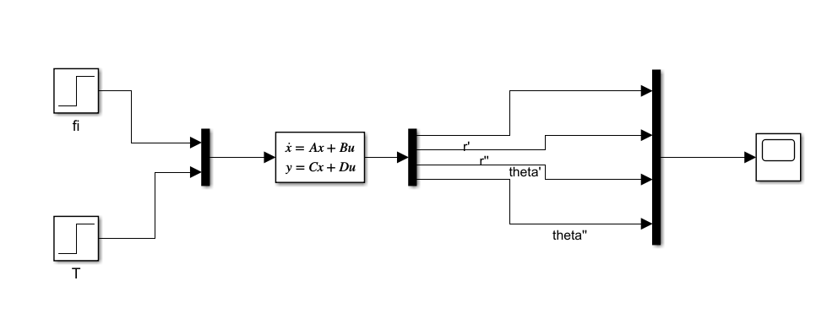

We have to control at the first controllability and observability of the system in order to apply control.

w=0.05

r0=5000

A=[0 1 0 0;

3*w^2 0 0 2*w*r0;

0 0 0 1;

0 (-2*w)/r0 0 0]

B=[0 0;

0 2;

0 0;

0 0]

C=eye(4,4);

C1=[0 0 0 0;

0 0 0 0;

0 0 1 0;

0 0 0 0];

D=zeros(4,2);

sys = ss(A,B,C,D)

[b,a] = ss2tf(A,B,C,D,2)

tf(sys)

% Co = ctrb(A,B)

Co = ctrb(sys)

unco = length(A) - rank(Co)

Ob= obsv(A,C)

% Number of unobservable states

unob = length(A)-rank(Ob)

w = 0.0500

r0 = 5000

A = 4×4

0 1.0000 0 0

0.0075 0 0 500.0000

0 0 0 1.0000

0 -0.0000 0 0

B = 4×2

0 0

0 2

0 0

0 0

sys =

A =

x1 x2 x3 x4

x1 0 1 0 0

x2 0.0075 0 0 500

x3 0 0 0 1

x4 0 -2e-05 0 0

B =

u1 u2

x1 0 0

x2 0 2

x3 0 0

x4 0 0

C =

x1 x2 x3 x4

y1 1 0 0 0

y2 0 1 0 0

y3 0 0 1 0

y4 0 0 0 1

D =

u1 u2

y1 0 0

y2 0 0

y3 0 0

y4 0 0

Continuous-time state-space model.

b = 4×5

0 0 2.0000 0 0

0 2.0000 0 0 0

0 0 0 -0.0000 0

0 0 -0.0000 0 0

a = 1×5

1.0000 0 0.0025 0 0

ans =

From input 1 to output...

1: 0

2: 0

3: 0

4: 0

From input 2 to output...

2 s

1: --------------

s^3 + 0.0025 s

2 s^2

2: --------------

s^3 + 0.0025 s

-4e-05 s

3: ----------------

s^4 + 0.0025 s^2

-4e-05 s

4: --------------

s^3 + 0.0025 s

Continuous-time transfer function.

Co = 4×8

0 0 0 2.0000 0 0 0 -0.0050

0 2.0000 0 0 0 -0.0050 0 0

0 0 0 0 0 -0.0000 0 0

0 0 0 -0.0000 0 0 0 0.0000

unco = 1

Ob = 16×4

1.0000 0 0 0

0 1.0000 0 0

0 0 1.0000 0

0 0 0 1.0000

0 1.0000 0 0

0.0075 0 0 500.0000

0 0 0 1.0000

0 -0.0000 0 0

0.0075 0 0 500.0000

0 -0.0025 0 0

unob = 0

We change the value of T due to uncontrollability.

B=[0 0;

0 2;

0 0;

-0.01 0]

Co = 4×8

0 0 0 2.0000 -5.0000 0 0 -0.0050

0 2.0000 -5.0000 0 0 -0.0050 0.0125 0

0 0 -0.0100 0 0 -0.0000 0.0001 0

-0.0100 0 0 -0.0000 0.0001 0 0 0.0000

unco = 0

Ob = 16×4

1.0000 0 0 0

0 1.0000 0 0

0 0 1.0000 0

0 0 0 1.0000

0 1.0000 0 0

0.0075 0 0 500.0000

0 0 0 1.0000

0 -0.0000 0 0

0.0075 0 0 500.0000

0 -0.0025 0 0

unob = 0

We provide controllability and observability with changing T.

We can find poles of the system find eigenvalues of matrix A.

% P = pole(sys);

Apoles = eig(A)

Apoles = 4×1 complex

0.0000 + 0.0000i

0.0000 + 0.0500i

0.0000 - 0.0500i

0.0000 + 0.0000i

# Full-State Feedback

% State-Feedback Gain Selection

p=[-2+i*2;-2-i*2;-1;-1]

K = place(A,B,p)

P = pole(sys)

plant = (A-B*K)

poles_cl = eig(plant)

p = 4×1 complex

-2.0000 + 2.0000i

-2.0000 - 2.0000i

-1.0000 + 0.0000i

-1.0000 + 0.0000i

K = 2×4

-800.0000 -799.9980 -400.0000 -500.0000

0.0037 0.5000 -0.5000 249.5000

P = 4×1 complex

0.0000 + 0.0000i

0.0000 + 0.0500i

0.0000 - 0.0500i

0.0000 + 0.0000i

plant = 4×4

0 1.0000 0 0

0.0000 -1.0000 1.0000 1.0000

0 0 0 1.0000

-8.0000 -8.0000 -4.0000 -5.0000

poles_cl = 4×1 complex

-2.0000 + 2.0000i

-2.0000 - 2.0000i

-1.0000 + 0.0000i

-1.0000 + 0.0000i

saat, ekran görüntüsü içeren bir resim

Açıklama otomatik olarak oluşturuldu

metin, elektronik eşyalar, vitrin içeren bir resim

Açıklama otomatik olarak oluşturuldu

# Pole Placement

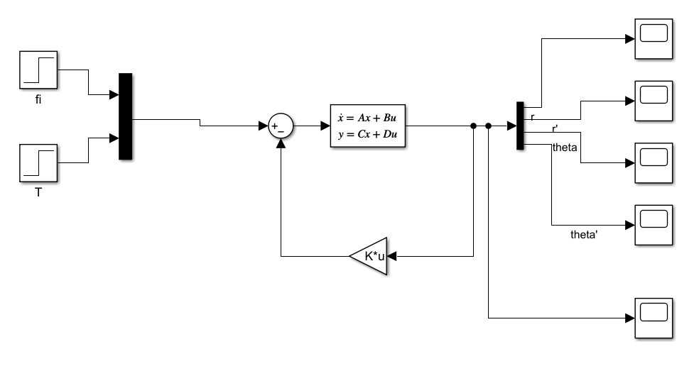

metin içeren bir resim

Açıklama otomatik olarak oluşturuldu

metin, iç mekan, vitrin, elektronik eşyalar içeren bir resim

Açıklama otomatik olarak oluşturuldu

We use 3 times faster roots

des_poles = (min(real(poles_cl))*3)-(1:4);

des_poles

K = place(A,B,des_poles)

step(sys);

des_poles = 1×4

-7.0000 -8.0000 -9.0000 -10.0000

K = 2×4

103 ×

0.7791 0.0918 -6.9333 -1.6740

0.0368 0.0086 -0.0043 0.2495

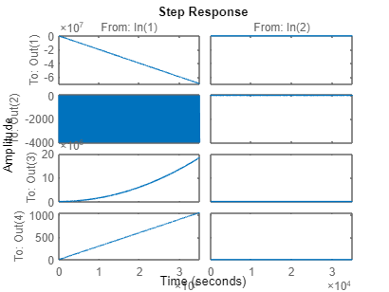

metin, elektronik eşyalar, vitrin içeren bir resim

Açıklama otomatik olarak oluşturuldu

As we can see from plot, our settling time and overshoot percentage is decreased.

sys2=ss(A-B*K,B,C,D);

tf(sys2)

step(sys2)

Kdc=dcgain(sys2);

ans =

From input 1 to output...

-0.01013 s - 0.08653

1: --------------------------------------

s^4 + 34 s^3 + 431 s^2 + 2414 s + 5040

-0.01013 s^2 - 0.08653 s - 2.918e-17

2: --------------------------------------

s^4 + 34 s^3 + 431 s^2 + 2414 s + 5040

-0.01 s^2 - 0.1726 s - 0.7367

3: --------------------------------------

s^4 + 34 s^3 + 431 s^2 + 2414 s + 5040

-0.01 s^3 - 0.1726 s^2 - 0.7367 s

4: --------------------------------------

s^4 + 34 s^3 + 431 s^2 + 2414 s + 5040

From input 2 to output...

2 s^2 + 33.48 s + 138.7

1: --------------------------------------

s^4 + 34 s^3 + 431 s^2 + 2414 s + 5040

2 s^3 + 33.48 s^2 + 138.7 s

2: --------------------------------------

s^4 + 34 s^3 + 431 s^2 + 2414 s + 5040

1.837 s + 15.58

3: --------------------------------------

s^4 + 34 s^3 + 431 s^2 + 2414 s + 5040

1.837 s^2 + 15.58 s + 3.684e-15

4: --------------------------------------

s^4 + 34 s^3 + 431 s^2 + 2414 s + 5040

Continuous-time transfer function.

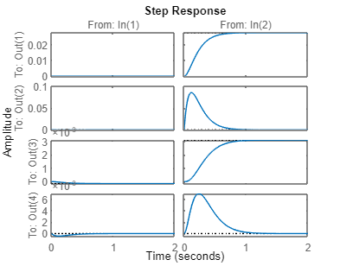

# Observer

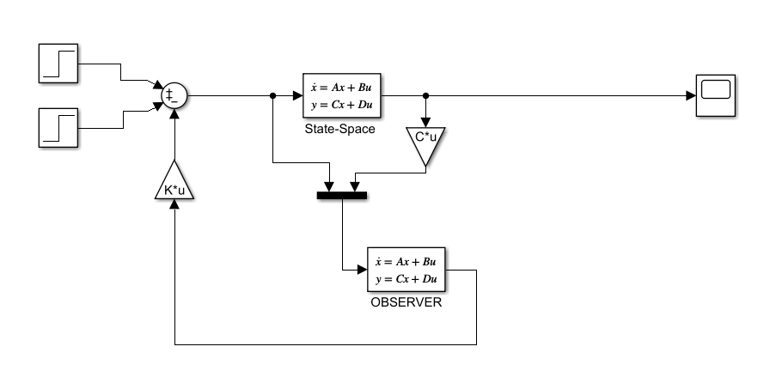

metin içeren bir resim

Açıklama otomatik olarak oluşturuldu

L=place(A.',C.',des_poles)

obsplant=(A-L*C)

poles_obs=eig(obsplant)

des_poles1 = (min(real(poles_obs))*3)-(1:4); %This is better

des_poles1

L = 4×4

7.0000 0.0075 0 0

1.0000 8.0000 0 -0.0000

0 0 9.0000 0

0 500.0000 1.0000 10.0000

obsplant = 4×4

-7.0000 0.9925 0 0

-0.9925 -8.0000 0 500.0000

0 0 -9.0000 1.0000

0 -500.0000 -1.0000 -10.0000

poles_obs = 4×1 complex

102 ×

-0.0900 + 5.0000i

-0.0900 - 5.0000i

-0.0700 + 0.0000i

-0.0900 + 0.0000i

des_poles1 = 1×4

-28.0000 -29.0000 -30.0000 -31.0000

Aobs = [A-L*C]

Bobs = [B L]

Cobs=[0 0 0 0;

0 0 0 0;

0 0 1 0;

0 0 0 0];

Cobs1=[1.1 0 0 0;

0 1 0 0;

0 0 1 0;

0 0 0 1];

Dobs = zeros(4,6);

Aobs = 4×4

-7.0000 0.9925 0 0

-0.9925 -8.0000 0 500.0000

0 0 -9.0000 1.0000

0 -500.0000 -1.0000 -10.0000

Bobs = 4×6

0 0 7.0000 0.0075 0 0

0 2.0000 1.0000 8.0000 0 -0.0000

0 0 0 0 9.0000 0

-0.0100 0 0 500.0000 1.0000 10.0000

metin, elektronik eşyalar, ekran görüntüsü, vitrin içeren bir resim

Açıklama otomatik olarak oluşturuldu

In first attempt we tried slower roots and then we increased its speed. Therefore we observe close performance that we measure before.

metin, elektronik eşyalar, vitrin, ekran görüntüsü içeren bir resim

Açıklama otomatik olarak oluşturuldu

Using observer with faster roots Show us same result with greater magnitude than Full-State Feedback controller.

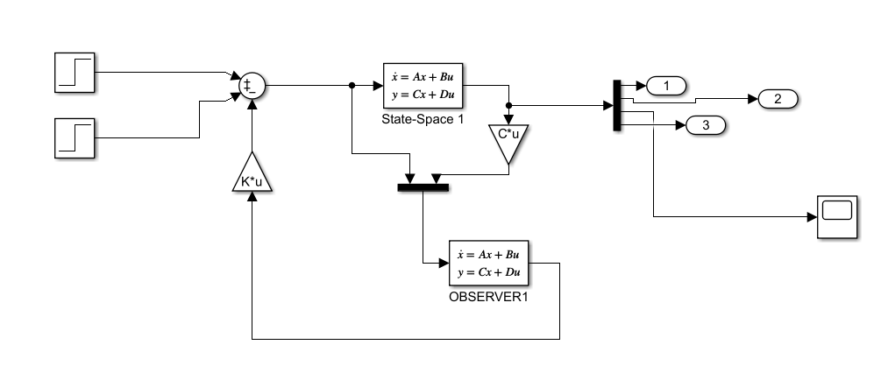

metin içeren bir resim

Açıklama otomatik olarak oluşturuldu

Only the member third columns of third row is equal to 1. So only this point permit transmitting the signal.

Cobs=[0 0 0 0;

0 0 0 0;

0 0 1 0;

0 0 0 0];

metin, elektronik eşyalar, vitrin içeren bir resim

Açıklama otomatik olarak oluşturuldu

This is plot of r measure when the only the angle theta is measured as output

# LQR

%%%LQR 1%%%

Q =[1 0 0 0;

0 1 0 0;

0 0 1 0;

0 0 0 1]

R =eye(2)

N=0;

[Klqr,S,E]=lqr(A,B,Q,R,N)

Nbar= -pinv(C*inv(A-B*Klqr)*B);

G=Nbar;

plant_lqr = (A-B*Klqr)

poles_lqr = eig(plant_lqr)

Q = 4×4

1 0 0 0

0 1 0 0

0 0 1 0

0 0 0 1

R = 2×2

1 0

0 1

Klqr = 2×4

-0.4230 -0.7254 -0.9061 -227.3233

0.9099 1.1750 -0.4230 145.0888

S = 4×4

104 ×

0.0001 0.0000 0.0000 0.0042

0.0000 0.0001 -0.0000 0.0073

0.0000 -0.0000 0.0250 0.0091

0.0042 0.0073 0.0091 2.2732

E = 4×1 complex

-0.0040 + 0.0000i

-0.9789 + 0.0000i

-1.8202 + 1.3397i

-1.8202 - 1.3397i

plant_lqr = 4×4

0 1.0000 0 0

-1.8123 -2.3501 0.8460 209.8224

0 0 0 1.0000

-0.0042 -0.0073 -0.0091 -2.2732

poles_lqr = 4×1 complex

-1.8202 + 1.3397i

-1.8202 - 1.3397i

-0.9789 + 0.0000i

-0.0040 + 0.0000i

In first LQR model we are used Identity matrix for Q.

But we need to observe r values of system. Significance of this of this value more important for us. Because we are trying to control its Radius to mass center.

Therefore we are going to increase fisrt member of Q matrix.

%%%LQR 2%%%

Q2 =[100 0 0 0;

0 1 0 0;

0 0 1 0;

0 0 0 1]

R2 =eye(2)

N2=0;

[Klqr2,S2,E2]=lqr(A,B,Q2,R2,N2)

Nbar2= -pinv(C*inv(A-B*Klqr2)*B);

G=Nbar;

plant_lqr2 = (A-B*Klqr2)

poles_lqr2 = eig(plant_lqr2)

Q2 = 4×4

100 0 0 0

0 1 0 0

0 0 1 0

0 0 0 1

R2 = 2×2

1 0

0 1

Klqr2 = 2×4

-1.4855 -1.0648 -0.9889 -247.6417

9.8928 3.1233 -0.1485 212.9547

S2 = 4×4

104 ×

0.0032 0.0005 0.0001 0.0149

0.0005 0.0002 -0.0000 0.0106

0.0001 -0.0000 0.0250 0.0099

0.0149 0.0106 0.0099 2.4764

E2 = 4×1 complex

-0.0040 + 0.0000i

-2.3972 + 0.0000i

-3.1609 + 3.2965i

-3.1609 - 3.2965i

plant_lqr2 = 4×4

0 1.0000 0 0

-19.7781 -6.2465 0.2971 74.0905

0 0 0 1.0000

-0.0149 -0.0107 -0.0099 -2.4764

poles_lqr2 = 4×1 complex

-3.1609 + 3.2965i

-3.1609 - 3.2965i

-2.3972 + 0.0000i

-0.0040 + 0.0000i

We can see that some poles are getting faster.

%%%LQR 3%%%

Q3 =[1000 0 0 0;

0 1 0 0;

0 0 100 0;

0 0 0 1]

R3 =eye(2)

N3=0;

[Klqr3,S3,E3]=lqr(A,B,Q3,R3,N3)

Nbar3= -pinv(C*inv(A-B*Klqr3)*B);

G=Nbar;

plant_lqr3 = (A-B*Klqr3)

poles_lqr3 = eig(plant_lqr3)

Q3 = 4×4

1000 0 0 0

0 1 0 0

0 0 100 0

0 0 0 1

R3 = 2×2

1 0

0 1

Klqr3 = 2×4

-2.0614 -1.1686 -9.9787 -253.4403

31.5593 5.5847 -0.6519 233.7282

S3 = 4×4

104 ×

0.0179 0.0016 0.0008 0.0206

0.0016 0.0003 -0.0000 0.0117

0.0008 -0.0000 0.2540 0.0998

0.0206 0.0117 0.0998 2.5344

E3 = 4×1 complex

-0.0400 + 0.0000i

-2.4877 + 0.0000i

-5.5880 + 5.6854i

-5.5880 - 5.6854i

plant_lqr3 = 4×4

0 1.0000 0 0

-63.1110 -11.1694 1.3037 32.5436

0 0 0 1.0000

-0.0206 -0.0117 -0.0998 -2.5344

poles_lqr3 = 4×1 complex

-5.5880 + 5.6854i

-5.5880 - 5.6854i

-2.4877 + 0.0000i

-0.0400 + 0.0000i

We can understand that the poles placed upside are decreasing faster.

%%%LQR 4%%%

Q4 =[1000 0 0 0;

0 1 0 0;

0 0 100 0;

0 0 0 1]

R4 =[100 0;

0 10]

N4=0;

[Klqr4,S4,E4]=lqr(A,B,Q4,R4,N4)

Nbar4= -pinv(C*inv(A-B*Klqr4)*B);

G=Nbar;

plant_lqr4 = (A-B*Klqr4)

poles_lqr4 = eig(plant_lqr4)

Q4 = 4×4

1000 0 0 0

0 1 0 0

0 0 100 0

0 0 0 1

R4 = 2×2

100 0

0 10

Klqr4 = 2×4

-0.0799 -0.1219 -0.9997 -80.2874

10.0006 3.1539 -0.0799 243.7770

S4 = 4×4

105 ×

0.0032 0.0005 0.0001 0.0080

0.0005 0.0002 -0.0000 0.0122

0.0001 -0.0000 0.0803 0.1000

0.0080 0.0122 0.1000 8.0287

E4 = 4×1 complex

-0.0127 + 0.0000i

-0.7901 + 0.0000i

-3.1540 + 3.1721i

-3.1540 - 3.1721i

plant_lqr4 = 4×4

0 1.0000 0 0

-19.9936 -6.3078 0.1598 12.4459

0 0 0 1.0000

-0.0008 -0.0012 -0.0100 -0.8029

poles_lqr4 = 4×1 complex

-3.1540 + 3.1721i

-3.1540 - 3.1721i

-0.7901 + 0.0000i

-0.0127 + 0.0000i

When we increase value of R matrix, we observe that speed of poles decreased to previous state

# KALMAN Filter

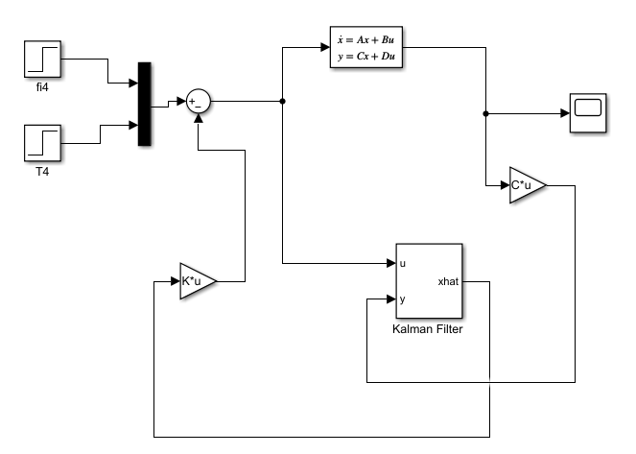

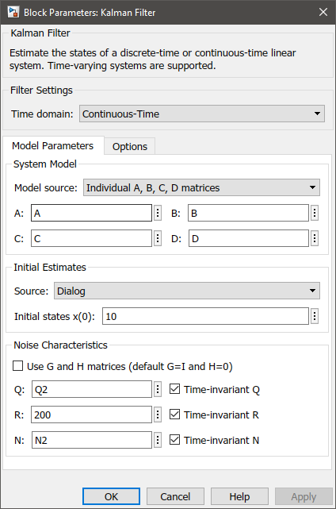

metin, vitrin içeren bir resim

Açıklama otomatik olarak oluşturuldu

In Kalman Filter we used Q2 and N2 that we used before for LQR.

# Model Linearizer

