**MARMARA UNIVERSITY**

**MECHANICAL ENGINEERING**



**ME7007 - ADVANCED DYNAMICS PROJECT**

**524618020 ÖZGÜRAZAD ÇELİK**

**Lecturer: Doç.Dr. İBRAHİM SİNA KUSEYRİ**

**ISTANBUL, 2022**

TABLE OF CONTENTS

I. Deriving the Dynamic Model of the Model 2

A. Obtaining the mass matrix 2

B. Obtaining Coriolis, Centrifugal, Gravity vector and joint torques of joints 8

C. Linear and rotational forces acting on joints [Newton-Euler] 11

D. Calculation of Kinetic and Potential Energies 13

E. Expressing torque in terms of discrete parameters 14

II. Simulation Model of RRP Robot Arm 16

A. M Files and Codes 17

1. initialization.m 17

2. trajectory.m 17

3. dynNS_Force3.m 18

4. plotter.m 21

B. Simulink Files 27

C. Results 29

Figure 1 dynNS.mdl 27

Figure 2 nsdynamic_Cori_Cent.mdl 27

Figure 3 nsdynamic_Energy.mdl 28

Figure 4 nsdynamic_YALFA.mdl 28

Figure 5 nsdynamic_Force1.slx 29

Figure 6 Mass matrix elements 29

Figure 7 Position, Velocity and Acceleration graphs of joints 30

Figure 8 Graphics of Coriolis, Centrifugal and Gravity vectors 30

Figure 9 Kinetic, Potential energy and Hamilton, Lagrangian graphs of joints 31

Figure 10 Linear and angular forces at the 1st joint 31

Figure 11 Linear and angular forces at the 2nd joint 32

Figure 12 Linear and angular forces at the 3rd joint 32

Figure 13 Calculation of Torque with discrete parameters 33

# Deriving the Dynamic Model of the Model

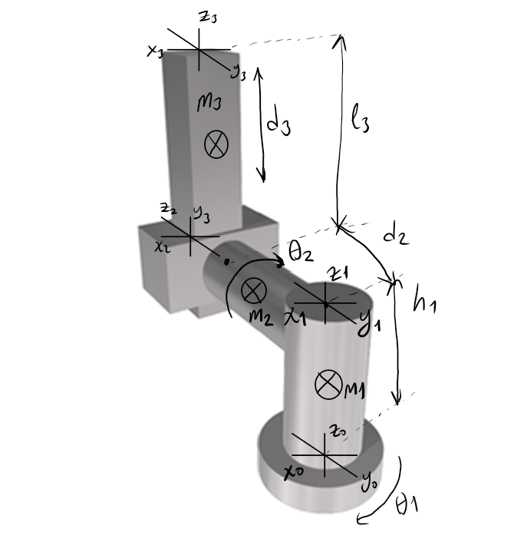

$$=\left[\begin{matrix}cθ_{1} & -sθ_{1} & 0 & 0 \\ sθ_{1} & cθ_{1} & 0 & 0 \\ 0 & 0 & 0 & 0 \\ 0 & 0 & 0 & 1\end{matrix}\right]$$

$$=\left[\begin{matrix}cθ_{2} & -sθ_{2} & 0 & 0 \\ 0 & 0 & 0 & 0 \\ sθ_{2} & cθ_{2} & 0 & 0 \\ 0 & 0 & 0 & 1\end{matrix}\right]$$

$$=\left[\begin{matrix}1 & 0 & 0 & 0 \\ 0 & 0 & 1 & d_{3} \\ 0 & -1 & 0 & 0 \\ 0 & 0 & 0 & 1\end{matrix}\right]$$

## Obtaining the mass matrix

Position vector of the mass center of the first link:



The center of mass coordinates of first link:



= $\left[\begin{matrix}Cθ_{1} & -sθ_{1} & 0 & 0 \\ sθ_{1} & Cθ_{1} & 0 & 0 \\ 0 & 0 & 1 & n_{1} \\ 0 & σ & 0 & 1\end{matrix}\right] \left[\begin{aligned}0 \\ 0 \\ -\frac{h_{1}}{2} \\ 0\end{aligned}\right]$

= 

Inertia Tensor of the first link with respect to main coordinate system:



= $\left[\begin{matrix}cθ_{1} & -sθ_{1} & 0 & 0 \\ sθ_{1} & cθ_{1} & 0 & 0 \\ 0 & 0 & 0 & 0 \\ 0 & 0 & 0 & 1\end{matrix}\right]\left[\begin{matrix}I_{xx_{1}} & 0 & 0 \\ 0 & I_{yy_{1}} & 0 \\ o & 0 & I_{zz_{1}}\end{matrix}\right]\left[\begin{matrix}Cθ & sθ_{1} & 0 \\ -sθ_{1} & Cθ_{1} & 0 \\ 0 & 0 & 1\end{matrix}\right]$

=

The Jacobian matrix of the first joint is the derivative of the vector h1 with respect to and and z1! and ksi1 variables. Since equation1 and the first joint are rotational, ksi=1. Hence, b1=axb.

The Jacobian matrix of the first link is found by using the derivatives of the vector $h_{1}$ with respect to $θ_{1}$, $θ_{2}$ and  and using the variables  and . Since  and the first joint is rotational, . Hence, .

$$=\left[\begin{matrix}\frac{∂}{∂θ_{1}}0 & \frac{∂}{∂θ_{2}}0 & \frac{∂}{∂θ_{3}}0 \\ \frac{∂}{∂θ_{1}}0 & \frac{∂}{∂θ_{2}}0 & \frac{∂}{∂θ_{3}}0 \\ \frac{∂}{∂θ_{1}}\frac{h_{1}}{2} & \frac{∂}{∂θ_{2}}\frac{h_{1}}{2} & \frac{∂}{∂θ_{3}}\frac{h_{1}}{2} \\ 0 & 0 & 0 \\ 0 & 0 & 0 \\ 1 & 0 & 0\end{matrix}\right]$$

$$=\left[\begin{matrix}0 & 0 & 0 \\ 0 & 0 & 0 \\ 0 & 0 & 0 \\ 0 & 0 & 0 \\ 0 & 0 & 0 \\ 1 & 0 & 0\end{matrix}\right]$$

and submatrices obtained from Jacobien matrix:

= $\left[\begin{matrix}0 & 0 & 0 \\ 0 & 0 & 0 \\ 0 & 0 & 0\end{matrix}\right]$, = $\left[\begin{matrix}0 & 0 & 0 \\ 0 & 0 & 0 \\ 1 & 0 & 0\end{matrix}\right]$

Mass Matrix of the first joint:



$\left[\begin{matrix}0 & 0 & 0 \\ 0 & 0 & 0 \\ 0 & 0 & 0\end{matrix}\right]\left[\begin{matrix}0 & 0 & 0 \\ 0 & 0 & 0 \\ 0 & 0 & 0\end{matrix}\right]$ + $\left[\begin{matrix}0 & 0 & 1 \\ 0 & 0 & 0 \\ 0 & 0 & 0\end{matrix}\right]$ $\left[\begin{matrix}0 & 0 & 0 \\ 0 & 0 & 0 \\ 1 & 0 & 0\end{matrix}\right]$



$\left[\begin{matrix}0 & 0 & 0 \\ 0 & 0 & 0 \\ 0 & 0 & \end{matrix}\right]$

Position vector of the mass center of the second link:

$Δh_{2}$ =

Homogeneous Transformation Matrix for the first two axes:

= $\left[\begin{matrix}Cθ_{1}Cθ_{2} & -Cθ_{1}sθ_{2} & sθ_{1} & sθ_{1}d_{2} \\ sθ_{1}Cθ_{2} & -sθ_{1}sθ_{2} & -Cθ_{1} & -Cθ_{1}d_{2} \\ sθ_{2} & Cθ_{2} & 0 & h_{1} \\ 0 & 0 & 0 & 0\end{matrix}\right]$

Inertia Matrix of the second joint with respect to the main coordinate system:



$$=\left[\begin{matrix}Cθ_{1}Cθ_{2} & -Cθ_{1}sθ_{2} & sθ_{1} \\ sθ_{1}Cθ_{2} & -sθ_{1}sθ_{2} & -Cθ_{1} \\ sθ_{2} & Cθ_{2} & 0\end{matrix}\right]\left[\begin{matrix}I_{xx_{2}} & 0 & 0 \\ 0 & I_{yy_{2}} & 0 \\ 0 & 0 & I_{zz_{2}}\end{matrix}\right]\left[\begin{matrix}Cθ_{1}Cθ_{2} & sθ_{1}Cθ_{2} & sθ_{2} \\ -Cθ_{1}sθ_{2} & -sθ_{1}sθ_{2} & Cθ_{2} \\ sθ_{1} & -Cθ_{1} & 0\end{matrix}\right]$$

$$=\left[\begin{matrix}c^{2}θ_{1}d+s^{2}θ_{1}I_{zz_{2}} & sθ_{1}Cθ_{1}\left(d-I_{zz_{2}}\right) & cθ_{1^{C}}θ_{2}sθ_{2}\left(I_{xx_{2}}-I_{yy_{2}}\right) \\ sθ_{1}Cθ_{1}\left(d-I_{zz_{2}}\right) & s^{2}θ_{1}d+C^{2}θ_{1}I_{zz_{2}} & sθ_{1}Cθ_{2}sθ_{2}\left(I_{xx_{2}}-I_{yy_{2}}\right) \\ cθ_{1^{C}}θ_{2}sθ_{2}\left(I_{xx_{2}}-I_{yy_{2}}\right) & sθ_{1}Cθ_{1^{s}}θ_{2}\left(I_{xx_{2}}-I_{yy_{2}}\right) & s^{2}θ_{2}I_{xx_{2}}+C^{2}θ_{2}I_{yy_{2}}\end{matrix}\right]$$

$d=\left(C^{2}θ_{2}I_{xx_{2}}+s^{2}θ_{2}I_{yy_{2}}\right)$

The center of mass coordinates of the second link with respect to the main coordinate system:



$\left[\begin{matrix}\frac{1}{2}d_{2}Sθ_{1} \\ -\frac{1}{2}d_{2}Cθ_{1} \\ h_{1} \\ 1\end{matrix}\right]$

The Jacobian matrix of the second link is found by using the derivatives of the vector $h_{2}$ with respect to $θ_{1}$, $θ_{2}$ and  and using the variables  and .



Second joint is rotational, . Hence, .



$=\left[\begin{matrix}\frac{∂}{∂θ_{1}}\left(\frac{1}{2}d_{2}sθ_{1}\right) & \frac{∂}{∂θ_{2}}\left(\frac{1}{2}d_{2}sθ_{1}\right) & \frac{∂}{∂θ_{3}}\left(\frac{1}{2}d_{2}sθ_{1}\right) \\ \frac{∂}{∂θ_{1}}\left(-\frac{1}{2}d_{2}cθ_{1}\right) & \frac{∂}{∂θ_{2}}\left(-\frac{1}{2}d_{2}cθ_{1}\right) & \frac{∂}{∂θ_{3}}\left(-\frac{1}{2}d_{2}cθ_{1}\right) \\ \frac{∂}{∂θ_{1}}h_{1} & \frac{∂}{∂θ_{2}}h_{1} & \frac{∂}{∂θ_{3}}h_{1} \\ 0 & sθ_{1} & 0 \\ 0 & -cθ_{1} & 0 \\ 1 & 0 & 0\end{matrix}\right]$

= $\left[\begin{matrix}\frac{1}{2}d_{2}cθ_{1} & 0 & 0 \\ \frac{1}{2}d_{2}sθ_{1} & 0 & 0 \\ 0 & 0 & 0 \\ 0 & sθ_{1} & 0 \\ 0 & -cθ_{1} & 0 \\ 1 & 0 & 0\end{matrix}\right]$

= $\left[\begin{matrix}\frac{1}{2}d_{2}cθ_{1} & 0 & 0 \\ \frac{1}{2}d_{2}sθ_{1} & 0 & 0 \\ 0 & 0 & 0\end{matrix}\right]$, = $\left[\begin{matrix}0 & sθ_{1} & 0 \\ 0 & -cθ_{1} & 0 \\ 1 & 0 & 0\end{matrix}\right]$

Mass Matrix of the second joint:





$\left[\begin{matrix}\frac{1}{4}m_{2}d_{2}^{2}+s^{2}θ_{2}I_{xx_{2}}+c^{2}θ_{2}I_{yy_{2}} & 0 & 0 \\ 0 & I_{zz_{2}} & 0 \\ 0 & 0 & 0\end{matrix}\right]$

$Δh_{3}$ =





$\left[\begin{matrix}Cθ_{1}Cθ_{2} & -Sθ_{1} & -Cθ_{1}sθ_{2} & -Cθ_{1}Sθ_{2}d_{3}+Sθ_{1}d_{2} \\ sθ_{1}cθ_{2} & Cθ_{1} & -Sθ_{1}Sθ_{2} & -sθ_{1}sθ_{2}d_{3}-Cθ_{1}d_{2} \\ sθ_{2} & 0 & Cθ_{2} & Cθ_{2}d_{3}+h_{1} \\ 0 & 0 & 0 & 1\end{matrix}\right]$

= $\left[\begin{matrix}C^{2}θ_{1}g+s^{2}θ_{1}I_{yy_{3}} & sθ_{1}Cθ_{1}\left(g-I_{yy_{3}}\right) & cθ_{1}Cθ_{2}sθ_{2}\left(I_{xx_{3}}-I_{zz_{3}}\right) \\ sθ_{1}Cθ_{1}\left(g-I_{yy_{3}}\right) & s^{2}θ_{1}g+C^{2}θ_{1}I_{yy_{3}} & sθ_{1}Cθ_{2}sθ_{2}\left(I_{xx_{3}}-I_{zz_{3}}\right) \\ Cθ_{1}Cθ_{2}sθ_{2}\left(I_{xx_{3}}-I_{zz_{3}}\right) & sθ_{1}Cθ_{2}Sθ_{2}\left(I_{xx_{3}}-I_{zz_{3}}\right) & 9^{2}θ_{2}I_{xx_{3}}+c^{2}θ_{2}I_{zz_{3}}\end{matrix}\right]$

$$g=\left(c^{2}θ_{2}I_{xx_{3}}+s^{2}θ_{2}I_{zz_{3}}\right)$$

= $\left[\begin{matrix}Cθ_{1}sθ_{2}\left(\frac{1}{2}l_{3}-d_{3}\right)+d_{2}sθ_{1} \\ sθ_{1}sθ_{2}\left(\frac{1}{2}l_{3}-d_{3}\right)-d_{2}Cθ_{1} \\ Cθ_{2}\left(-\frac{1}{2}l_{3}-d_{3}\right)+h_{1}\end{matrix}\right]$

 $=\left[\begin{matrix}\frac{∂}{∂θ_{1}} & \frac{∂}{∂θ_{2}} & \frac{∂}{∂θ_{3}} \\ \frac{∂}{∂θ_{1}} & \frac{∂}{∂θ_{2}} & \frac{∂}{∂θ_{3}} \\ \frac{∂}{∂θ_{1}} & \frac{∂}{∂θ_{2}} & \frac{∂}{∂θ_{3}} \\ 0 & sθ_{1} & 0 \\ 0 & -cθ_{1} & 0 \\ 1 & 0 & 0\end{matrix}\right]$ = $\left[\begin{matrix}-sθ_{1}sθ_{2}k+d_{2^{C}}θ_{1} & Cθ_{1}Cθ_{2}k & -Cθ_{1}sθ_{2} \\ cθ_{1}sθ_{2}k+d_{2}sθ_{1} & Sθ_{1}Cθ_{2}k & -sθ_{1}sθ_{2} \\ 0 & sθ_{2}k & 0 \\ 0 & sθ_{1} & 0 \\ 0 & -cθ_{1} & 0 \\ 1 & 0 & 0\end{matrix}\right]$

$h=Cθ_{1}Sθ_{2}\left(\frac{1}{2}l_{3}-d_{3}\right)+d_{2}sθ_{1}$

$k=\left(\frac{1}{2}l_{3}-d_{3}\right)$

$ⅈ=sθ_{1}sθ_{2}\left(\frac{1}{2}l_{3}-d_{3}\right)-d_{2}Cθ_{1}$

$j=Cθ_{2}\left(-\frac{1}{2}l_{3}+d_{3}\right)+h_{1}$

= $\left[\begin{matrix}-sθ_{1}sθ_{2}k+d_{2^{C}}θ_{1} & Cθ_{1}Cθ_{2}k & -Cθ_{1}sθ_{2} \\ cθ_{1}sθ_{2}k+d_{2}sθ_{1} & Sθ_{1}Cθ_{2}k & -sθ_{1}sθ_{2} \\ 0 & sθ_{2}k & 0\end{matrix}\right]$, = $\left[\begin{matrix}0 & sθ_{1} & 0 \\ 0 & -cθ_{1} & 0 \\ 1 & 0 & 0\end{matrix}\right]$

Mass Matrix of the second joint:





$\left[\begin{matrix}l+s^{2}θ_{2}I_{xx_{3}}+C^{2}θ_{2}I_{zz_{3}} & d_{2}m_{3}Cθ_{2}\left(\frac{1}{2}l_{3}-d_{3}\right) & -d_{2}m_{3}sθ_{2} \\ d_{2}m_{3^{C}}θ_{2}\left(\frac{1}{2}l_{3}-d_{3}\right) & m_{3}\left(\frac{1}{4}l_{3}^{2}-l_{3}d_{3}+d_{3}^{2}\right)+I_{yy_{3}} & 0 \\ -m_{3}d_{2}sθ_{2} & 0 & m_{3}\end{matrix}\right]$

$l=m_{3}s^{2}θ_{2}\left(\frac{1}{4}l_{3}^{2}-l_{3}d_{3}+d_{3}^{2}\right)$

$m=d_{2}m_{3^{C}}θ_{2}\left(\frac{1}{2}l_{3}-d_{3}\right)$

$n=m_{3}\left(\frac{1}{4}l_{3}^{2}-l_{3}d_{3}+d_{3}^{2}\right)$

The mass matrix of a three-joint robot is found by adding the mass matrices of the three joints.

$$D\left(q\right)=D\left(θ_{1}\right)+D\left(θ_{2}\right)+D\left(d_{3}\right)$$

$D\left(q\right)$ = $\left[\begin{matrix}D_{11} & d_{2}m_{3}Cθ_{2}\left(\frac{1}{2}l_{3}-d_{3}\right) & -d_{2}m_{3}Sθ_{2} \\ d_{2}m_{3^{C}}θ_{2}\left(\frac{1}{2}l_{3}-d_{3}\right) & D_{22} & 0 \\ -m_{3}d_{2}sθ_{2} & 0 & m_{3}\end{matrix}\right]$

## Obtaining Coriolis, Centrifugal, Gravity vector and joint torques of joints

Velocity coupling matrices of first joint:

* $C_{11}^{1}=\frac{1}{2}\frac{∂}{∂θ_{1}}D_{11}$ =0

$C_{12}^{1}=\frac{1}{2}\frac{∂}{∂θ_{1}}D_{12}=\frac{1}{2}\frac{∂}{∂θ_{1}}\left[d_{2}m_{3}Cθ_{2}\left(\frac{1}{2}l_{3}-d_{3}\right)\right]=0$

$C_{13}^{1}=\frac{1}{2}\frac{∂}{∂θ_{1}}D_{13}=\frac{1}{2}\frac{∂}{∂θ_{1}}\left(-d_{2}m_{3^{S}}θ_{2}\right)=0$

$C_{21}^{1}=\frac{∂}{∂θ_{2}}D_{11}-\frac{1}{2}\frac{∂}{∂θ_{1}}D_{12}=2sθ_{2}C_{2}^{θ}\left[I_{xx_{2}}+I_{xx_{3}}-I_{yy_{2}}-I_{zz_{3}}+m_{3}\left(\frac{1}{4}l_{3}^{2}-l_{3}d_{3}+d_{3}^{2}\right)\right]$

The same operations are performed for all elements and the velocity coupling matrix is obtained.

$c_{1}$ = $\left[\begin{matrix}0 & 0 & 0 \\ C_{21}^{1} & -d_{2}m_{3}Sθ_{2}\left(\frac{1}{2}l_{3}-d_{3}\right) & -d_{2}m_{3}cθ_{2} \\ m_{3}s^{2}θ_{2}\left(-l_{3}+2d_{3}\right) & -d_{2}m_{3^{C}}θ_{2} & 0\end{matrix}\right]$

In the coordinate frame placed at the first joint, the gravity vector is expressed as $\left[\begin{aligned}0 \\ 0 \\ -g\end{aligned}\right]$, since the z-axis is opposite to gravity. Gravitational acceleration of the first joint:

$$Z_{1}=g\left(m_{1}A_{31}^{1}+m_{2}A_{31}^{2}+m_{3}A_{31}^{3}\right)=g\left(m_{1}o+m_{2}0+m_{3}0\right)=0$$

Velocity coupling matrix of second joint:

$c_{2}$ = $\left[\begin{matrix}C_{11}^{2} & \frac{1}{2}d_{2}m_{3}sθ_{2}\left(\frac{1}{2}l_{3}-d_{3}\right) & \frac{1}{2}d_{2}m_{3}Cθ_{2} \\ C_{21}^{2} & 0 & 0 \\ -\frac{1}{2}d_{2}m_{3}cθ_{2} & m_{3}\left(-l_{3}+2d_{3}\right) & 0\end{matrix}\right]$

Gravitational acceleration of the second joint:

$$Z_{2}=g\left(m_{2}A_{32}^{2}+m_{3}A_{32}^{3}\right)=g\left(m_{2}0+m_{3}sθ_{2}\left(\frac{1}{2}l_{3}-d_{3}\right)\right)=gm_{3}Sθ_{2}\left(\frac{1}{2}l_{3}-d_{3}\right)$$

Velocity coupling matrix of third joint:

$c_{3}$ = $\left[\begin{matrix}-\frac{1}{2}m_{3}s^{2}θ_{2}\left(-l_{3}+2d_{3}\right) & \frac{1}{2}d_{2}m_{3^{C}}θ_{2} & \frac{1}{2}d_{2}m_{3}Cθ_{2} \\ -\frac{1}{2}d_{2}m_{3}cθ_{2} & -\frac{1}{2}m_{3}\left(-l_{3}+2d_{3}\right) & 0 \\ 0 & 0 & 0\end{matrix}\right]$

Gravitational acceleration of the third joint:

$$z_{3}=gm_{3}A_{33}^{3}=gm_{3}Cθ_{2}$$

The Coriolis and centrifugal force vector is found by arranging the elements of the velocity coupling matrix of all three joints as follows.

The velocity coupling matrices of the joints are equal to the matrix below:

$$\left[\begin{matrix}{\left({\dot{θ}}_{1}\right)}^{2} & {\dot{θ}}_{1}{\dot{θ}}_{2} & {\dot{θ}}_{1}{\dot{d}}_{3} \\ {\dot{θ}}_{2}{\dot{θ}}_{1} & {\left({\dot{θ}}_{2}\right)}^{2} & {\dot{θ}}_{2}{\dot{d}}_{3} \\ {\dot{d}}_{3}{\dot{θ}}_{1} & {\dot{d}}_{3}{\dot{θ}}_{2} & {\left({\dot{d}}_{3}\right)}^{2}\end{matrix}\right]$$

$\left[\begin{matrix}{\left({\dot{θ}}_{1}\right)}^{2} & {\dot{θ}}_{1}{\dot{θ}}_{2} & {\dot{θ}}_{1}{\dot{d}}_{3} \\ {\dot{θ}}_{2}{\dot{θ}}_{1} & {\left({\dot{θ}}_{2}\right)}^{2} & {\dot{θ}}_{2}{\dot{d}}_{3} \\ {\dot{d}}_{3}{\dot{θ}}_{1} & {\dot{d}}_{3}{\dot{θ}}_{2} & {\left({\dot{d}}_{3}\right)}^{2}\end{matrix}\right]$ = $\left[\begin{matrix}0 & 0 & 0 \\ C_{21}^{1} & -d_{2}m_{3}Sθ_{2}\left(\frac{1}{2}l_{3}-d_{3}\right) & -d_{2}m_{3}cθ_{2} \\ m_{3}s^{2}θ_{2}\left(-l_{3}+2d_{3}\right) & -d_{2}m_{3^{C}}θ_{2} & 0\end{matrix}\right]$

The reciprocal elements in the equation are multiplied and added.

First element of Coriolis and Centrifugal force vector:

$$CM_{1}=C_{12}^{1}{\dot{θ}}_{2}{\dot{θ}}_{1}-d_{2}m_{3}sθ_{2}\left(\frac{1}{2}l_{3}-d_{3}\right){\dot{θ}}_{2}-d_{2}m_{3}Cθ_{2}{\dot{θ}}_{2}{\dot{d}}_{3}+m_{3}s^{2}θ_{2}\left(-l_{3}+2d_{3}\right){\dot{d}}_{3}{\dot{θ}}_{1}-d_{2}m_{3}Cθ_{2}{\dot{d}}_{3}{\dot{θ}}_{2}$$

$$CM_{1}=2sθ_{2^{C}}θ_{2}\left[I_{xx_{2}}+I_{xx_{3}}-I_{yy_{2}}-I_{zz_{3}}+m_{3}\left(\frac{1}{4}l_{3}^{2}-l_{3}d_{3}+d_{3}^{2}\right)\right]{\dot{θ}}_{2}{\dot{θ}}_{1}-d_{2}m_{3}sθ_{2}\left(\frac{1}{2}l_{3}-d_{3}\right){\dot{θ}}_{2}^{2}-2d_{2}m_{3}Cθ_{2}{\dot{θ}}_{2}{\dot{d}}_{3}+m_{3}s^{2}θ_{2}\left(-l_{3}+2d_{3}\right){\dot{d}}_{3}{\dot{θ}}_{1}$$

Second element of Coriolis and Centrifugal force vector:

$\left[\begin{matrix}C_{11}^{2} & \frac{1}{2}d_{2}m_{3}sθ_{2}\left(\frac{1}{2}l_{3}-d_{3}\right) & \frac{1}{2}d_{2}m_{3}Cθ_{2} \\ C_{21}^{2} & 0 & 0 \\ -\frac{1}{2}d_{2}m_{3}cθ_{2} & m_{3}\left(-l_{3}+2d_{3}\right) & 0\end{matrix}\right]$ = $\left[\begin{matrix}{\left({\dot{θ}}_{1}\right)}^{2} & {\dot{θ}}_{1}{\dot{θ}}_{2} & {\dot{θ}}_{1}{\dot{d}}_{3} \\ {\dot{θ}}_{2}{\dot{θ}}_{1} & {\left({\dot{θ}}_{2}\right)}^{2} & {\dot{θ}}_{2}{\dot{d}}_{3} \\ {\dot{d}}_{3}{\dot{θ}}_{1} & {\dot{d}}_{3}{\dot{θ}}_{2} & {\left({\dot{d}}_{3}\right)}^{2}\end{matrix}\right]$

$$CM_{2}=-Sθ_{2}Cθ_{2}\left[I_{xx_{2}}+I_{xx_{3}}-I_{yy_{2}}-I_{zz_{3}}+m_{3}\left(\frac{1}{4}l_{3}^{2}-l_{3}d_{3}+d_{3}^{2}\right)\right]{\dot{θ}}_{1}+\left[m_{3}\left(-l_{3}+2d_{3}\right)\right]{\dot{d}}_{3}{\dot{θ}}_{2}$$

Third element of Coriolis and Centrifugal force vector:

$\left[\begin{matrix}-\frac{1}{2}m_{3}s^{2}θ_{2}\left(-l_{3}+2d_{3}\right) & \frac{1}{2}d_{2}m_{3^{C}}θ_{2} & \frac{1}{2}d_{2}m_{3}Cθ_{2} \\ -\frac{1}{2}d_{2}m_{3}cθ_{2} & -\frac{1}{2}m_{3}\left(-l_{3}+2d_{3}\right) & 0 \\ 0 & 0 & 0\end{matrix}\right]$ = $\left[\begin{matrix}{\left({\dot{θ}}_{1}\right)}^{2} & {\dot{θ}}_{1}{\dot{θ}}_{2} & {\dot{θ}}_{1}{\dot{d}}_{3} \\ {\dot{θ}}_{2}{\dot{θ}}_{1} & {\left({\dot{θ}}_{2}\right)}^{2} & {\dot{θ}}_{2}{\dot{d}}_{3} \\ {\dot{d}}_{3}{\dot{θ}}_{1} & {\dot{d}}_{3}{\dot{θ}}_{2} & {\left({\dot{d}}_{3}\right)}^{2}\end{matrix}\right]$

$$CM_{3}=\left[m_{3}S^{2}θ_{2}\left(\frac{1}{2}l_{3}-d_{3}\right)\right]{\dot{θ}}_{1}^{2}+\left[m_{3}\left(\frac{1}{2}l_{3}-d_{3}\right)\right]{\dot{θ}}_{2}^{2}$$

Substituting the elements we found, we obtain the Coriolis and Centrifugal force vector:

$$C\left(,\dot{}\right)=\left[\begin{matrix}CM_{1} \\ CM_{2} \\ CM_{3}\end{matrix}\right]$$

= $\left[\begin{matrix}D_{11} & d_{2}m_{3}Cθ_{2}\left(\frac{1}{2}l_{3}-d_{3}\right) & -d_{2}m_{3}Sθ_{2} \\ d_{2}m_{3^{C}}θ_{2}\left(\frac{1}{2}l_{3}-d_{3}\right) & D_{22} & 0 \\ -m_{3}d_{2}sθ_{2} & 0 & m_{3}\end{matrix}\right]\left[\begin{matrix}{\ddot{θ}}_{1} \\ {\ddot{θ}}_{2} \\ {\ddot{d}}_{3}\end{matrix}\right]$ + $\left[\begin{matrix}CM_{1} \\ CM_{2} \\ CM_{3}\end{matrix}\right]$ + $\left[\begin{matrix}0 \\ gm_{3}Sθ_{2}\left(\frac{1}{2}l_{3}-d_{3}\right) \\ gm_{3}Cθ_{2}\end{matrix}\right]$

* = $\left[I_{zz_{1}}+\frac{1}{4}M_{2}d_{2}^{2}+S^{2}θ_{2}+{(I}_{xx_{2}}+I_{xx_{3}}+m_{3}\left(\frac{1}{4}l_{3}^{2}-l_{3}d_{3}+d_{3}^{2}\right))+c^{2}θ_{2}\left(I_{yy_{2}}+I_{zz_{3}}\right)+m_{3}d_{2}^{2}\right]{\ddot{θ}}_{1}+\left[d_{2}m_{3}Cθ_{2}\left(\frac{1}{2}l_{3}-d_{3}\right)\right]{\ddot{θ}}_{2}-\left[d_{2}m_{3}sθ_{2}\right]{\ddot{d}}_{3}+2sθ_{2}Cθ_{2}\left[I_{xx_{2}}+I_{xx_{3}}-I_{yy_{2}}-I_{zz_{3}}+m_{3}\left(\frac{1}{4}l_{3}^{2}-l_{3}d_{3}+d_{3}^{2}\right)\right]{\dot{θ}}_{2}{\dot{θ}}_{1}-\left[d_{2}m_{3}Sθ_{2}\left(\frac{1}{2}l_{3}-d_{3}\right)\right]{\ddot{θ}}_{2}^{2}-\left[2d_{2}m_{3}Cθ_{2}\right]{\dot{θ}}_{2}{\dot{d}}_{3}+\left[m_{3}S^{2}θ_{2}\left(-l_{3}+2d_{3}\right)\right]{\dot{d}}_{3}{\dot{θ}}_{1}$
* = $\left[d_{2}m_{3}Cθ_{2}\left(\frac{1}{2}l_{3}-d_{3}\right)\right]{\ddot{θ}}_{1}$ + $\left[I_{zz_{2}}+I_{yy_{3}}+m_{3}\left(\frac{1}{4}l_{3}^{2}-l_{3}d_{3}+d_{3}^{2}\right)\right]{\ddot{θ}}_{2}-sθ_{2}Cθ_{2}\left[I_{xx_{2}}+I_{xx_{3}}-I_{yy_{2}}-I_{zz_{3}}+m_{3}\left(\frac{1}{4}l_{3}^{2}-l_{3}d_{3}+d_{3}^{2}\right)\right]{\left({\dot{θ}}_{1}\right)}^{2}$ + $\left[m_{3}\left(-l_{3}+2d_{3}\right)\right]{\dot{d}}_{3}{\dot{θ}}_{2}$ + $gm_{3}Sθ_{2}\left(\frac{1}{2}l_{3}-d_{3}\right)$
* = $-\left[d_{2}m_{3}sθ_{2}\right]{\ddot{θ}}_{1}+m_{3}{\ddot{d}}_{3}+\left[m_{3}s^{2}θ_{2}\left(\frac{1}{2}l_{3}-d_{3}\right)\right]{\dot{θ}}_{1}+\left[m_{3}\left(\frac{1}{2}l_{3}-d_{3}\right)\right]{\left({\dot{θ}}_{2}\right)}^{2}+gm_{3}cθ_{2}$

## Linear and rotational forces acting on joints [Newton-Euler]

Rotational Forces: = $\left(n_{xi}{,n}_{y_{i}}{,n}_{z_{i}}\right)$

Linear Forces: = $\left(f_{xi}{,f}_{y_{i}}{,f}_{z_{i}}\right)$

If the ()th joint is rotational:

Angular velocity transmitted from one joint to another:



Angular acceleration transmitted from one joint to another:



Linear acceleration of the joint:



Linear acceleration of the center of mass:



The force acting on the center of mass of the object:



Torque acting on the body's center of mass:



If the ()th joint is prismatic:

Angular velocity transmitted from one joint to another:



Angular acceleration transmitted from one joint to another:



Linear acceleration of the joint:



Force-Equilibrium and Moment-Equilibrium expressions:





Equations from the n’th joint to the base coordinate system:





Joint torques:

Revolute Joint:

Prismatic Joint: 

Using the above equation sets, the force and torque expressions of the joints are obtained. Rotational and linear forces acting on the joints are found by solving these expressions using the Newton-Euler method.

Forces acting on first joint:

$\left[\begin{matrix}f_{x1} \\ f_{y_{1}} \\ f_{z_{1}} \\ n_{x1} \\ n_{y_{1}} \\ n_{z_{1}}\end{matrix}\right]$ = $\left[\begin{matrix}Cθ_{2}-Sθ_{2} \\ \\ Sθ_{2}+Cθ_{2}+m_{1}g \\ Cθ_{2}-Sθ_{2}-d_{2}sθ_{2}-d_{2}Cθ_{2} \\ \\ I_{zz_{1}}{\ddot{θ}}_{1}-sθ+Cθ_{2}+d_{2}Cθ_{2}-d_{2}Sθ_{2}\end{matrix}\right]$

The same operations are repeated for the other joints as in the first joint. Thus, all linear and rotational forces acting on the joints are obtained.

## Calculation of Kinetic and Potential Energies





To calculate the kinetic energy of each link:

$$=\frac{1}{2}{\dot{q}}^{T}D\left(q\right)\dot{q}$$

Kinetic energies of links:

* $=\frac{1}{2}{\dot{q}}^{T}D\left(q_{1}\right)\dot{q}$ = $\frac{1}{ 2}I_{zz_{1}}{{\dot{θ}}_{1}}^{2}$
* $=\frac{1}{2}{\dot{q}}^{T}D\left(q_{2}\right)\dot{q}$ = $\frac{1}{2}\left(\frac{1}{4}m_{2}d_{2}^{2}+s^{2}θ_{2}I_{x}x_{2}^{+C^{2}}θ_{2}I_{yy_{2}}\right){\dot{θ}}_{1}^{2}+\frac{1}{2}I_{zz_{2}}{\dot{θ}}_{2}^{2}$
* 

$=\frac{1}{2}{\dot{q}}^{T}D\left(q_{3}\right)\dot{q}\frac{1}{2}\left[s^{2}θ_{2}\left(I_{xx_{3}}+m_{3}\left(\frac{1}{4}l_{3}^{2}-l_{3}d_{3}+d_{J}^{2}\right)\right)+I_{zz_{3}}C^{2}θ_{2}+m_{3}d_{2}^{2}\right]{{\dot{θ}}_{1}}^{2}+\frac{1}{2}\left[{m_{3}\left(\frac{1}{4}l_{3}^{2}-l_{3}d_{3}+d_{J}^{2}\right)+I}_{yy_{3}}\right]{{\dot{θ}}_{2}}^{2}\frac{1}{2}m_{3}{{\dot{d}}_{3}}^{2}+\left[d_{2}m_{3}Cθ_{2}\left(\frac{1}{2}l_{3}-d_{3}\right)\right]{\dot{θ}}_{1}{\dot{θ}}_{2}-\left[d_{2}m_{3}Sθ_{2}\right]{\dot{θ}}_{1}{\dot{d}}_{3}$

To calculate the potential energy of each link:

$$P_{i}=m_{i}gh_{i}\left(z\right)$$

Potential energies of links:

$P_{1}=m_{1}gh_{1}\left(z\right)=\frac{1}{2}m_{1}gh_{1}$

$P_{2}=m_{2}gh_{2}\left(z\right)=m_{2}gh_{1}$

$P_{3}=m_{3}gh_{3}\left(z\right)=m_{3}g\left[Cθ_{2}\left(-\frac{1}{2}l_{3}+d_{3}\right)+h_{1}\right]$

## Expressing torque in terms of discrete parameters

The torque acting on the robot joints can be defined in terms of fixed and variable parameters. Fixed parameters (alpha) are represented by vector, variable parameters are expressed by matrix. The product of these expressions gives the torque.

$$Y\left(q,\dot{q},\ddot{q}\right)α=τ$$

The $Y\left(q,\dot{q},\ddot{q}\right)$ matrix contains the position, velocity and acceleration expressions of the torque vector.

$$\left[\begin{matrix}Y_{11} & Y_{12} & Y_{13} & Y_{14} & Y_{15} & Y_{16} & Y_{17} & 0 & Y_{19} \\ 0 & 0 & Y_{23} & Y_{24} & Y_{25} & Y_{26} & Y_{27} & Y_{28} & 0 \\ 0 & 0 & Y_{33} & Y_{34} & 0 & Y_{36} & 0 & 0 & 0\end{matrix}\right]α=\left[\begin{aligned}τ_{1} \\ τ_{2} \\ τ_{3}\end{aligned}\right]$$

$α_{1}=I_{zz_{1}}+\frac{1}{6}m_{2}d_{2}^{2}+m_{3}d_{2}^{2}$

$α_{2}=I_{xx_{2}}+I_{xx_{3}}+\frac{1}{4}l_{3}^{2}m_{3}$

$α_{3}=m_{3}l_{3}$

$α_{4}=m_{3}$

$α_{5}=\frac{1}{2}d_{2}l_{3}m_{3}$

$α_{6}=d_{2}m_{3}$

$α_{7}=I_{xx_{2}}+I_{xx_{3}}-I_{yy_{2}}-I_{zz_{3}}+\frac{1}{4}l_{3}^{2}m_{3}$

$α_{8}=I_{zz_{2}}+I_{yy_{3}}+\frac{1}{4}l_{3}^{2}m_{3}$

$α_{9}=I_{yy_{2}}+I_{zz_{3}}$

$Y_{11}={\ddot{θ}}_{1}$

$Y_{12}=S^{2}θ_{2}{\ddot{θ}}_{1}$

$Y_{13}=-d_{3}S^{2}θ_{2}{\ddot{θ}}_{1}-2d_{3}sθ_{2}Cθ_{2}{\dot{θ}}_{1}{\dot{θ}}_{2}-s^{2}θ_{2}{\dot{θ}}_{1}{\dot{θ}}_{3}$

$Y_{14}=d_{3}^{2}s^{2}θ_{2}{\ddot{θ}}_{1}+2d_{3}^{2}s^{2}θ_{2}cθ_{2}{\dot{θ}}_{1}{\dot{θ}}_{2}+2d_{3}s^{2}θ_{2}{\dot{θ}}_{1}{\dot{θ}}_{3}$

$Y_{15}=Cθ_{2}{\ddot{θ}}_{2^{-S}}θ_{2}{{\dot{θ}}_{2}}^{2}$

$Y_{16}=-d_{3}Cθ_{2}{\ddot{θ}}_{2}-sθ_{2}{\ddot{θ}}_{3}+d_{3}sθ_{2}{{\dot{θ}}_{2}}^{2}-2Cθ_{2}{\dot{θ}}_{2}{\dot{θ}}_{3}$

$Y_{17}=2sθ_{2}Cθ_{2}{\dot{θ}}_{1}{\dot{θ}}_{2}$

$Y_{19}=c^{2}θ_{2}{\ddot{θ}}_{1}$

$Y_{23}=-d_{3}{\ddot{θ}}_{2}+d_{3}sθ_{2}Cθ_{2}{{\dot{θ}}_{1}}^{2}-{\dot{θ}}_{2}{\dot{θ}}_{3}+\frac{1}{2}gsθ_{2}$

$Y_{24}=d_{3}^{2}{\ddot{θ}}_{2}+d_{3}^{2}sθ_{2}Cθ_{2}{{\dot{θ}}_{1}}^{2}-2d_{3}{\dot{θ}}_{2}{\dot{θ}}_{3}-d_{3}gsθ_{2}$

$Y_{25}=cθ_{2}{\ddot{θ}}_{1}$

$Y_{26}=-d_{3}cθ_{2}{\ddot{θ}}_{1}$

$Y_{27}=-sθ_{2}Cθ_{2}{\dot{θ}}_{1}^{2}$

$Y_{28}={\ddot{θ}}_{2}$

$Y_{33}=\frac{1}{2}s^{2}θ_{2}{{\dot{θ}}_{1}}^{2}+\frac{1}{2}{\dot{θ}}_{2}^{2}$

$Y_{34}={\ddot{d}}_{3}-d_{3}s^{2}θ_{2}{{\dot{θ}}_{1}}^{2}-d_{3}{{\dot{θ}}_{2}}^{2}-d_{3}{\dot{θ}}_{2}^{2}-gcθ_{2}$

$Y_{36}=-sθ_{2}{\ddot{θ}}_{1}$

# Simulation Model of RRP Robot Arm



Definition of state: Starting from the zero position of the joints, within 10 seconds, the first joint, the second joint and the third joint move 20 units, respectively. While this movement is taking place:

1. Find each element of the mass matrix.
2. Find Coriolis/Centrifugal force, Gravity vector and Joint torques.
3. Draw graphs showing the time variation of linear and rotational forces at each joint.
4. Find the kinetic-potential energy of each joint, Lagrange and Hamilton graphs.
5. Using the Y matrix and the vector, plot the torque at each joint versus time. Compare with the results obtained in part b earlier.

$$h_{1}=30,{ d}_{2}=10,{ d}_{3}=20,{ m}_{1}=15,{ m}_{2}=6,{ m}_{3}=3$$

$I_{xx_{1}}=I_{yy_{1}}=\frac{m_{1}\left(3r_{1}^{2}+4h_{1}^{2}\right)}{12}=\frac{15\left({3.3}^{2}+{4.30}^{2}\right)}{12}=4533.8$

$I_{zz_{1}}=\frac{m_{1}r_{1}^{2}}{2}=67.5$

$I_{xx_{2}}=I_{yy_{2}}=\frac{m_{2}\left(3r_{2}^{2}+4ⅆ_{2}^{2}\right)}{12}=206$

$I_{zz_{2}}=\frac{m_{2}r_{2}^{2}}{2}=12$

The third joint is prismatic:

$I_{xx_{3}}=\frac{m_{3}\left(b^{2}{+ⅆ}_{3}^{2}\right)}{12}=400.02$

$I_{yy_{3}}=\frac{m_{3}\left(a^{2}+ⅆ_{3}^{2}\right)}{12}=400.25$

$I_{zz_{3}}=\frac{m_{3}\left(a^{2}+b^{2}\right)}{12}=0.265$

## M Files and Codes

### initialization.m

global h1 d2 l3 m1 m2 m3 Ixx2 Ixx3 Iyy2 Iyy3 Izz1 Izz2 Izz3 g q1i q1f q2i q2f q3i q3f tf

h1=30; d2=10; l3=20; m1=15; m2=6; m3=3;

Ixx1= 4533.8; Iyy1=4543.8; Izz1=67.5;

Ixx2= 206; Iyy2=206; Izz2=12;

Ixx3= 400.02; Iyy3=400.25; Izz3=0.265;

g=9.81;

q1i=0; %first joint initial angle

q1f=360; %first joint final angle

q2i=0; %second joint initial angle

q2f=180; %second joint final angle

q3i=0; %third joint initial angle

q3f=20; %third joint final angle

tf=10; %final time

### trajectory.m

function traj=trajectory(t);

global q1i q1f q2i q2f q3i q3f tf

%first joint%

a10=q1i;

a11=0;

a12=(3/tf^2)*(q1f-q1i)

a13=(-2/tf^3)*(q1f-q1i)

position1=a10+a11*t+a12*t^2+a13*t^3;

velocity1=a11+2*a12*t+3*a13*t^2;

acceleration1=2*a12+6*a13*t;

%second joint%

a20=q2i;

a21=0;

a22=(3/tf^2)*(q2f-q2i);

a23=(-2/tf^3)*(q2f-q2i)

position2=a20+a21*t+a22*t^2+a23*t^3;

velocity2=a21+2*a22*t+3*a23*t^2;

acceleration2=2*a22+6*a23*t;

%third joint%

a30=q3i;

a31=0;

a32=(3/tf^2)*(q3f-q3i);

a33=(-2/tf^3)*(q3f-q3i)

position3=a30+a31*t+a32*t^2+a33*t^3;

velocity3=a21+2*a32*t+3*a33*t^2;

acceleration3=2*a32+6*a33*t;

traj=[position1; velocity1;acceleration1;position2;velocity2;acceleration2;position3;velocity3;acceleration3];

### dynNS_Force3.m

function robot_param=dynNS_Force3(u)

global h1 d2 l3 m1 m2 m3 Ixx2 Ixx3 Iyy2 Iyy3 Izz1 Izz2 Izz3 g;

q1=u(1); %position of first joint

q2=u(4); %position of 2nd joint

q3=u(7); %positionof 3rd joint

dq1=u(2); %velocity of first joint

dq2=u(5); %velocity of 2nd joint

dq3=u(8); %velocity of 3rd joint

ddq1=u(3); %acceleration of first joint

ddq2=u(6); %acceleration of 2nd joint

ddq3=u(9); %acceleration of 3rd joint

s1=sin(q1*pi/180);

s2=sin(q2*pi/180);

s3=sin(q3*pi/180);

c1=cos(q1*pi/180);

c2=cos(q2*pi/180);

c3=cos(q3*pi/180);

%%% Mass Matrix

M11=Izz1+00.25*l3^2-l3*q3+q3^2))+c2^2*(Iyy2+Izz3)+m3*d2^2;

M12=d2*m3*c2*(0.5*l3-q3);

M13=-d2*m3*s2;

M21=d2*m3*c2*(0.5*l3-q3);

M22=Izz2+Iyy3+m3*(0.25*l3^2-l3*q3+q3^2);

M23=0;

M31=-d2*m3*s2;

M32=0;

M33=m3;

M=[M11 M12 M13; M21 M22 M23; M31 M32 M33];

robot_param=[M];

%%% Coriolis and Centrifugal Forces

C1= 2*[s2*c2*(Ixx2+Ixx3-Iyy2-Izz3+m3*(0.25*l3^2-l3*q3+q3^2))]*dq1*dq2-...

[d2*m3*s2*(0.5*l3-q3)]*dq2^2-2*[d2*m3*c2]*dq2*dq3+[m3*s2^2*(-l3+2*q3)]*dq1*dq3;

C2=-s2*c2*(Ixx2+Ixx3-Iyy2-Izz3+m3*(0.25-l3^2-l3*q3+q3^2))*dq1^2+m3*(-l3+2*q3)*dq2*dq3;

C3=m3*s2*(0.5*l3-q3)*dq1^2+m3*(0.5*l3-q3)*dq2^2;

C=[C1;C2;C3];

%%% Gravity Vector

G1=0;

G2=m3*g*s2*(0.5*l3-q3);

G3=m3*g*c2;

G=[G1;G2;G3];

%%% Joint Torques

ddq=[ddq1;ddq2;ddq3];

torque= M*ddq+C+G;

robot_param=[C G torque];

%%% Kinetic Energy

K1= 0.5*Izz1*dq1^2

K2=0.5*(0.25*m2*d2^2+s2^2*Ixx2+c2^2+Iyy2)*dq1^2+0.5*Izz2*dq2^2;

K3=0.5*[s2^2*(Ixx3+m3*(0.25*l3^2-l3*q3+q3^2))+c2^2*Izz3+m3*d2^2]*dq1^2+0.5*[m3*(0.25*l3^2-l3*q3+q3^2)+Iyy3]*dq2^2+...

(0.5*m3*dq3^2)+[d2*m3*c2*(0.5*l3-q3)]*dq1*dq2-[d2*m3*s2]*dq1*dq3;

KinEn=[K1;K2;K3];

%%% Potential Energy

P1=m1*g*(h1/2);

P2=m2*g*h1;

P3=m3*g*[c2*(-0.5*l3+q3)+h1];

PotEn=[P1;P2;P3];

robot_param=[KinEn;PotEn];

%%% Y Matrix and Alpha vector

alfa1=Izz1+0.25*m2*d2^2+m3*d2^2;

alfa2=Ixx2+Ixx3+0.25*m3*l3^2;

alfa3=m3*l3;

alfa4=m3;

alfa5=0.5*d2*l3*m3;

alfa6=d2*m3;

alfa7=Ixx2+Ixx3-Iyy2-Izz3+0.25*l3^2*m3;

alfa8=Izz2+Iyy3+0.25*l3^2*m3;

alfa9=Iyy2+Izz3;

y11=ddq1;

y12=s2^2*ddq1;

y13=-q3*s2^2*ddq1-2*q3*s2*c2*dq1*dq2-s2^2*dq1*dq3;

y14=q3^2*s2^2*ddq1+2*q3^2*s2*c2*dq1*dq2+2*q3*s2^2*dq1*dq3;

y15=c2*ddq2-s2*dq2^2;

y16=-q3*c2*ddq2-s2*ddq3+q3*s2*dq2^2-2*c2*dq2*dq3;

y17=2*s2*c2*dq1*dq2;

y19=c2^2*ddq1;

y23=-q3*ddq2+q3*s2*c2*dq1^2-dq2*dq3+0.5*g*s2;

y24=q3^2*ddq2-q3^2*s2*c2*dq1^2+2*q3*dq2*dq3-q3*g*s2;

y25=c2*ddq1;

y26=-q3*c2*ddq1;

y27=-s2*c2*dq1^2;

y28=ddq2;

y33=0.5*s2^2*dq1^2+0.5*dq2^2;

y34=ddq3-q3*s2^2*dq1^2-q3*dq2^2+g*c2;

y36=-s2*ddq1;

ALFA=[alfa1 alfa2 alfa3 alfa4 alfa5 alfa6 alfa7 alfa8 alfa9];

Y=[y11 y12 y13 y14 y15 y16 y17 0 y19;0 0 y23 y24 y25 y26 y27 y28 0;0 0 y33 y34 0 y36 0 0 0];

joint_torque=Y*ALFA';

robot_param=[joint_torque];

% %%% Linear and Angular Forces on First Joint 96

%

% fx1=c2*[0.5*d2*m2*c2*ddq1+g*m2*s2-0.5*l3*m3*s2*c2*dq1^2+0.5*l3*m3*ddq2+m3*(-q3*ddq2+q3*s2*c2*dq1^2+d2*c2*ddq1+g*s2-2*dq2*dq3)]-...

% s2*[-0.5*d2*m2*s2*ddq1+g*m2*c2+0.5*l3*m3*(s2^2*dq1^2+dq2^2)+m3*(-q3*(s2^2*dq1+dq2^2)-d2*s2*ddq1+g*c2+ddq3)];

% fy1=-(-0.5*d2*m2*dq1^2)+0.5*l3*m3*(s2*ddq1+2*c2*dq1*dq2)+m3*(-q3*s2*ddq1-2*q3*c2*dq1*dq2+d2*dq1^2-2*s2*dq1*dq2);

% fz1=s2*[0.5*d2*m2*c2*ddq1+g*m2*s2-0.5*l3*m3*s2*c2*dq1^2+0.5*l3*m3*ddq2+m3*ddq2+m3*(-q3*ddq2+q3*s2*c2*dq1^2+d2*c2*ddq1+g*s2-2*dq2*dq3)]+...

% c2*[-0.5*d2*m2*s2*ddq1+g*m2*c2+0.5*l3*m3*(s2^2*dq1^2+dq2^2)+m3*(-q3*(s2^2*dq1^2+dq2^2)-d2*s2*ddq1+g*c2+ddq3)]+m1*g;

%

%

% nx1=c2*[Ixx2*s2*ddq1+(Ixx2-Iyy2+Izz2)*c2*dq1*dq2]-s2*[Iyy2*c2*ddq1+(Ixx2-Iyy2-Izz2)*s2*dq1*dq2]-...

% d2*s2*[0.5*d2*m2*c2*ddq1+g*m2*s2-0.5*l3*m3*s2*c2*dq1^2+0.5*l3*m3*ddq2+m3*(-q3*ddq2+q3*s2*c2*dq1^2+d2*c2*ddq1+g*s2-2*dq2*dq3)]-...

% d2*c2*[-0.5*d2*m2*s2*ddq1+g*m2*c2+0.5*l3*m3*(s2^2*dq1+dq2^2)+m3*(-q3*(s2^2*dq1^2+dq2^2)-d2*s2*ddq1+g*c2+ddq3)];

% ny1=-Izz2*ddq2-(Iyy2-Ixx2)*s2*c2*dq1^2;

% nz1=[Izz1+0.25*m2*d2^2+s2^2*(Ixx2+Ixx3+m3*(0.25*l3^2-l3*q3+q3^2))+c2^2*(Iyy2+Izz3)+m3*d2^2]*ddq1+...

% [d2*m3*c2*(0.5*l3-q3)]*ddq2-[d2*m3*s2]*ddq3+2*[s2*c2*(Ixx2+Ixx3-Iyy2-Izz3+m3*(0.25*l3^2-l3*q3+q3^2))]*...

% dq1*dq2-[d2*m3*s2*(0.5*l3-q3)]*dq2^2-2*[d2*m3*c2]*dq2*dq3+[m3*s2^2*(-l3+2*q3)]*dq1*dq3;

%

% F1=[fx1;fy1;fz1];

% N1=[nx1;ny1;nz1];

%

% robot_param=[F1 N1];

%

%

% %%% Linear and Angular Forces on Second Joint

%

%

% fx2=c2*[0.5*d2*m2*c2*ddq1+g*m2*s2-0.5*l3*m3*s2*c2*dq1^2+0.5*l3*m3*ddq2+m3*(-q3*ddq2+q3*s2*c2*dq1^2+d2*c2*ddq1+g*s2-2*dq2*dq3)];

% fy2=-0.5*d2*m2*s2*ddq1+g*m2*c2+0.5*l3*m3*(s2^2*dq1^2+dq2^2)+m3*(-q3*(s2^2*dq1^2+dq2^2)-d2*s2*ddq1+g*c2+ddq3);

% fz2=-0.5*d2*m2*dq1^2-[0.5*l3*m3*(s2*ddq1+2*c2*dq1*dq2)+m3*(-q3*s2*ddq1-2*q3*c2*dq1*dq2+d2*dq1^2-2*s2*dq1*dq3)];

%

%

% nx2=Ixx2*s2*ddq1+(Ixx2-Iyy2+Izz2)*c2*dq1*dq2+[Ixx3*s2*ddq1+(Ixx3+Iyy3-Izz3)*c2*dq1*dq2]+0.5*d2*(-0.5*d2*m2*s2*ddq1+g*m2*c2)+(0.5*l3-q3)*...

% [0.5*l3*m3*(s2*ddq1+2*c2*dq1*dq2)+m3*(-q3*s2*ddq1*2*q3*c2*dq1*dq2+d2-dq1^2-2*s2*dq1*dq3)];

% ny2=Iyy2*c2*ddq1+(Ixx2-Iyy2-Izz2)*s2*dq1*dq2+Izz3*c2*ddq1+(Ixx3-Iyy3-Izz3)*s2*dq1*dq2-0.5*d2*(0.5*d2*m2*c2*ddq1+g*m2*s2);

% nz2=[-d2*m3*c2*(0.5*l3+q3)]*ddq1+[Izz2+Iyy3+m3*(0.25*l3^2+l3*q3+q3^2)]*ddq2-s2*c2*(Ixx2+Ixx3-Iyy2-Izz3+m3*(0.25*l3^2-l3*q3+q3^2))*...

% dq1^2+m3(-l3+2*q3)*dq2*dq3-m3*(l3+2*q3)*dq2*dq3+m3*g*s2*(0.5*l3-q3);

%

% F2=[fx2;fy2;fz2];

% N2=[nx2;ny2;nz2];

%

% robot_param=[F2 N2];

%

%%% Linear and Angular Forces on Third Joint

fx3=-0.5*l3*m3*s2*c2*dq1^2+0.5*l3*m3*ddq2+m3*(-q3*ddq2+q3*s2*c2*dq1^2+d2*c2*ddq1+g*s2-2*dq2*dq3);

fy3=0.5*l3*m3*(s2*ddq1+2*c2*dq1*dq2)+m3*(-q3*s2*ddq1-2*q3*c2*dq1*dq2+d2*dq1^2-2*s2*dq1*dq3);

fz3=[-d2*m3*s2]*ddq1+m3*ddq3+m3*s2^2*(0.5*l3-q3)*dq1^2+m3*(0.5*l3-q3)*dq2^2+m3*g*c2;

nx3=Ixx3*s2*ddq1+(Ixx3+Iyy3-Izz3)*c2*dq1*dq2+0.5*l3*[0.5*l3*m3*(s2*ddq1+2*c2*dq1*dq2)+m3*(-q3*s2*ddq1-2*q3*c2*dq1*dq2+d2*dq1^2-2*s2*dq1*dq3)];

ny3=-Iyy3*ddq2+(Ixx3-Izz3)*s2*c2*ddq1^2-0.5*l3*[-0.5*l3*m3*s2*c2*dq1^2+0.5*l3*m3*ddq2+m3*(-q3*ddq2+q3*s2*c2*dq1^2+d2*c2*ddq1+g*s2-2*dq2*dq3)];

nz3=Izz3*c2*ddq1+(Ixx3-Iyy3-Izz3)*s2*dq1*dq2;

F3=[fx3;fy3;fz3];

N3=[nx3;ny3;nz3];

robot_param=[F3 N3];

### plotter.m

load q1.mat; load dq1.mat; load ddq1.mat;

load q2.mat; load dq2.mat; load ddq2.mat;

load q3.mat; load dq3.mat; load ddq3.mat;

load M11.mat; load M12.mat; load M13.mat;

load M21.mat; load M22.mat; load M23.mat;

load M31.mat; load M32.mat; load M33.mat;

figure(1);

subplot(3,3,1);

plot(M11(1,:));

ylabel('M11');

subplot(3,3,2);

plot(M12(1,:));

ylabel('M12')

subplot(3,3,3);

plot(M13(1,:));

ylabel('M13')

subplot(3,3,4);

plot(M21(1,:));

ylabel('M21')

subplot(3,3,5);

plot(M22(1,:));

ylabel('M22')

subplot(3,3,6);

plot(M23(1,:));

ylabel('M23')

subplot(3,3,7);

plot(M31(1,:));

ylabel('M31')

subplot(3,3,8);

plot(M32(1,:));

ylabel('M32')

subplot(3,3,9);

plot(M33(1,:));

ylabel('M33')

hold on

figure(2);

subplot(3,3,1);

plot(q1(1,:));

title('q1');

ylabel('Position')

subplot(3,3,2);

plot(dq1(1,:));

title('dq1')

ylabel('Velocity')

subplot(3,3,3);

plot(ddq1(1,:));

title('ddq1')

ylabel('Acceleration')

subplot(3,3,4);

plot(q2(1,:));

title('q2')

ylabel('Position')

subplot(3,3,5);

plot(dq2(1,:));

title('dq2')

ylabel('Velocity')

subplot(3,3,6);

plot(ddq2(1,:));

title('ddq2')

ylabel('Acceleration')

subplot(3,3,7);

plot(q3(1,:));

title('q3')

ylabel('Position')

subplot(3,3,8);

plot(dq3(1,:));

title('dq3')

ylabel('Velocity')

subplot(3,3,9);

plot(ddq3(1,:));

title('ddq3')

ylabel('Acceleration')

%%%

load C1.mat; load C2.mat; load C3.mat;

load G1.mat; load G2.mat; load G3.mat;

load CGTorque1.mat; load CGTorque2.mat; load CGTorque3.mat;

figure(3);

subplot(3,3,1);

plot(C1(1,:));

ylabel('C1');

subplot(3,3,2);

plot(C2(1,:));

ylabel('C2')

subplot(3,3,3);

plot(C3(1,:));

ylabel('C3')

subplot(3,3,4);

plot(G1(1,:));

ylabel('G1')

subplot(3,3,5);

plot(G2(1,:));

ylabel('G2')

subplot(3,3,6);

plot(G3(1,:));

ylabel('G3')

subplot(3,3,7);

plot(CGTorque1(1,:));

ylabel('CGTorque1')

subplot(3,3,8);

plot(CGTorque2(1,:));

ylabel('CGTorque2')

subplot(3,3,9);

plot(CGTorque3(1,:));

ylabel('CGTorque3')

hold on

%%%

load K1.mat; load K2.mat; load K3.mat;

load P1.mat; load P2.mat; load P3.mat;

load Lagrange.mat; load Hamilton.mat;

figure(4);

subplot(3,3,1);

plot(K1(1,:));

title('K1');

subplot(3,3,2);

plot(K2(1,:));

title('K2');

subplot(3,3,3);

plot(K3(1,:));

title('K3');

subplot(3,3,4);

plot(P1(1,:));

title('P1');

subplot(3,3,5);

plot(P2(1,:));

title('P2');

subplot(3,3,6);

plot(P3(1,:));

title('P3');

subplot(3,3,7);

plot(Lagrange(1,:));

title('Lagrange');

subplot(3,3,8);

plot(Hamilton(1,:));

title('Hamilton');

hold on

%%%

load fx1.mat; load fy1.mat; load fz1.mat;

load nx1.mat; load ny1.mat; load nz1.mat;

figure(5);

subplot(2,3,1);

plot(fx1(1,:));

title('fx1');

subplot(2,3,2);

plot(fy1(1,:));

title('fy1');

subplot(2,3,3);

plot(fz1(1,:));

title('fz1');

subplot(2,3,4);

plot(nx1(1,:));

title('nx1');

subplot(2,3,5);

plot(ny1(1,:));

title('ny1');

subplot(2,3,6);

plot(nz1(1,:));

title('nz1');

hold on

load fx2.mat; load fy2.mat; load fz2.mat;

load nx2.mat; load ny2.mat; load nz2.mat;

figure(6);

subplot(2,3,1);

plot(fx2(1,:));

title('fx2');

subplot(2,3,2);

plot(fy2(1,:));

title('fy2');

subplot(2,3,3);

plot(fz2(1,:));

title('fz2');

subplot(2,3,4);

plot(nx2(1,:));

title('nx2');

subplot(2,3,5);

plot(ny2(1,:));

title('ny2');

subplot(2,3,6);

plot(nz2(1,:));

title('nz2');

hold on

load fx3.mat; load fy3.mat; load fz3.mat;

load nx3.mat; load ny3.mat; load nz3.mat;

figure(7);

subplot(2,3,1);

plot(fx3(1,:));

title('fx3');

subplot(2,3,2);

plot(fy3(1,:));

title('fy3');

subplot(2,3,3);

plot(fz3(1,:));

title('fz3');

subplot(2,3,4);

plot(nx3(1,:));

title('nx3');

subplot(2,3,5);

plot(ny3(1,:));

title('ny3');

subplot(2,3,6);

plot(nz3(1,:));

title('nz3');

hold on

load Torque1.mat; load Torque2.mat; load Torque3.mat;

figure(8);

subplot(3,1,1);

plot(Torque1(1,:));

title('Torque1');

subplot(3,1,2);

plot(Torque2(1,:));

title('Torque2');

subplot(3,1,3);

plot(Torque3(1,:));

title('Torque3');

## Simulink Files

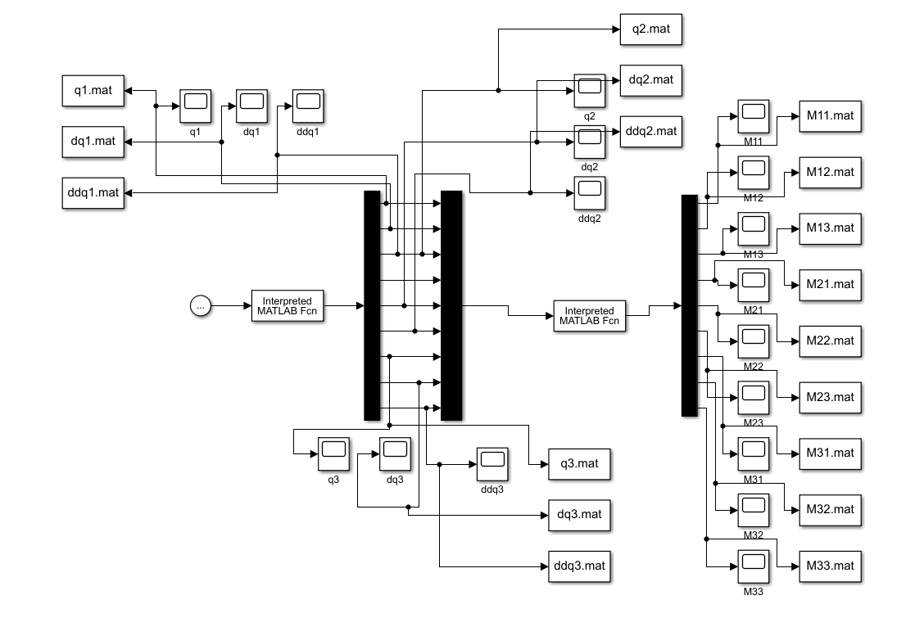

Figure 1 dynNS.mdl

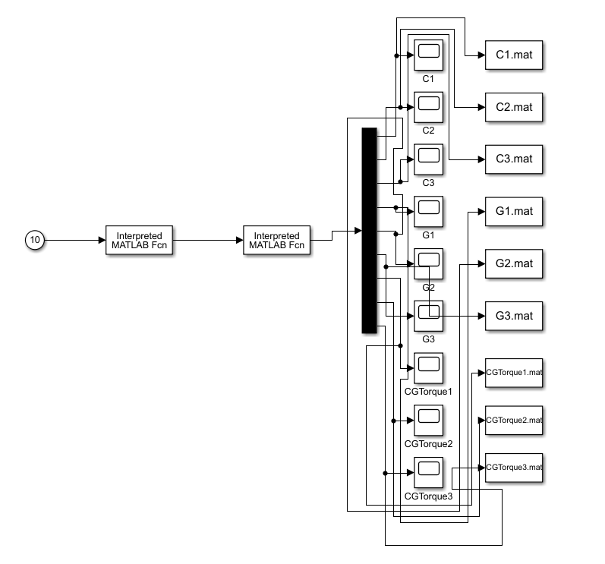

Figure 2 nsdynamic_Cori_Cent.mdl

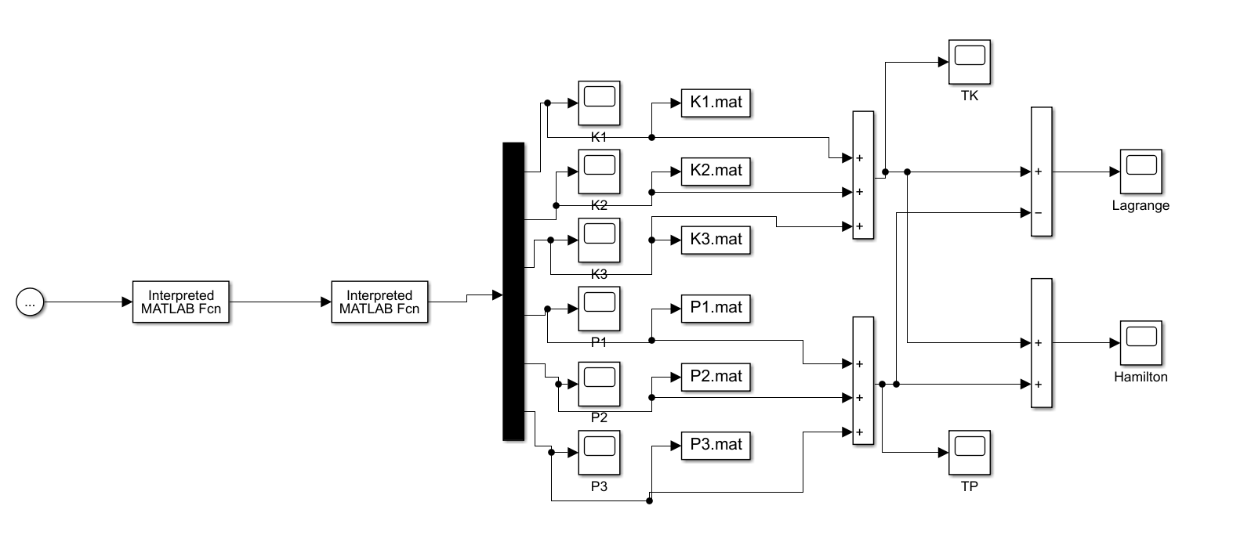

Figure 3 nsdynamic_Energy.mdl

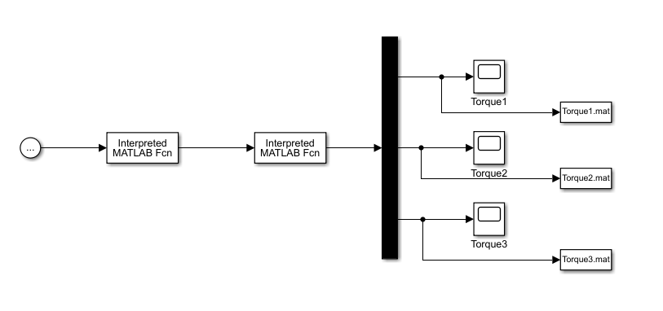

Figure 4 nsdynamic_YALFA.mdl

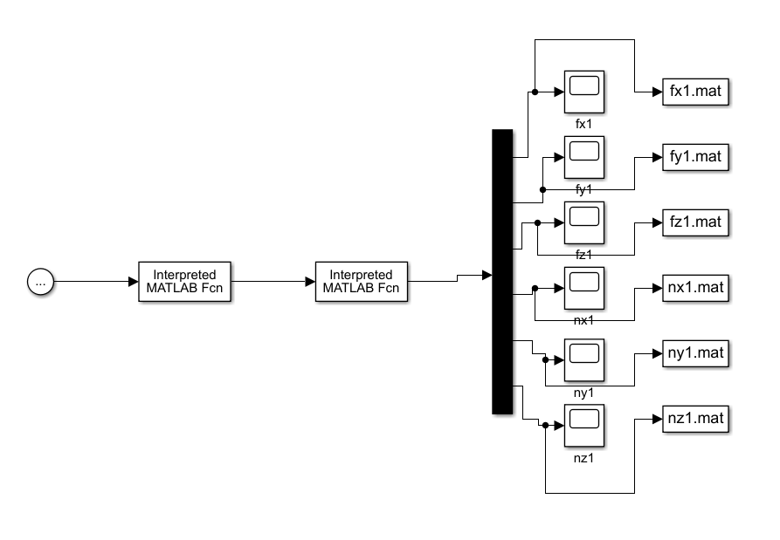

Figure 5 nsdynamic_Force1.slx

## Results



Figure 6 Mass matrix elements



Figure 7 Position, Velocity and Acceleration graphs of joints



Figure 8 Graphics of Coriolis, Centrifugal and Gravity vectors



Figure 9 Kinetic, Potential energy and Hamilton, Lagrangian graphs of joints



Figure 10 Linear and angular forces at the 1st joint



Figure 11 Linear and angular forces at the 2nd joint



Figure 12 Linear and angular forces at the 3rd joint



Figure 13 Calculation of Torque with discrete parameters