

# EHB326E – INTRODUCTION TO EMBEDDED SYSTEMS

# Final Project

In this project, we were asked to Design a system which includes a BlockRAM and two PicoBlazes. A 6 x 6 matrix is stored in BRAM(0000h – 0024h). Even rows of the transpose of the matrix are computed and then stored to BRAM by PicoBlaze_1, odd rows are computed and stored to the same BRAM by PicoBlaze_2. For our object we used two different FIDEx codes. One for even and other one is for odd rows of the matrix. Transpose process is completed in the FIDEx code part.

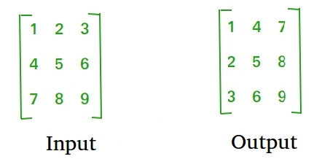

Fig 1. Matrix Transpose[1]

Fig 1 shows the matrix transpose operation. It switches the rows and columns of the matrix.

**Algorithm Description:**

Initial code’s that are written in FIDEx are as follows

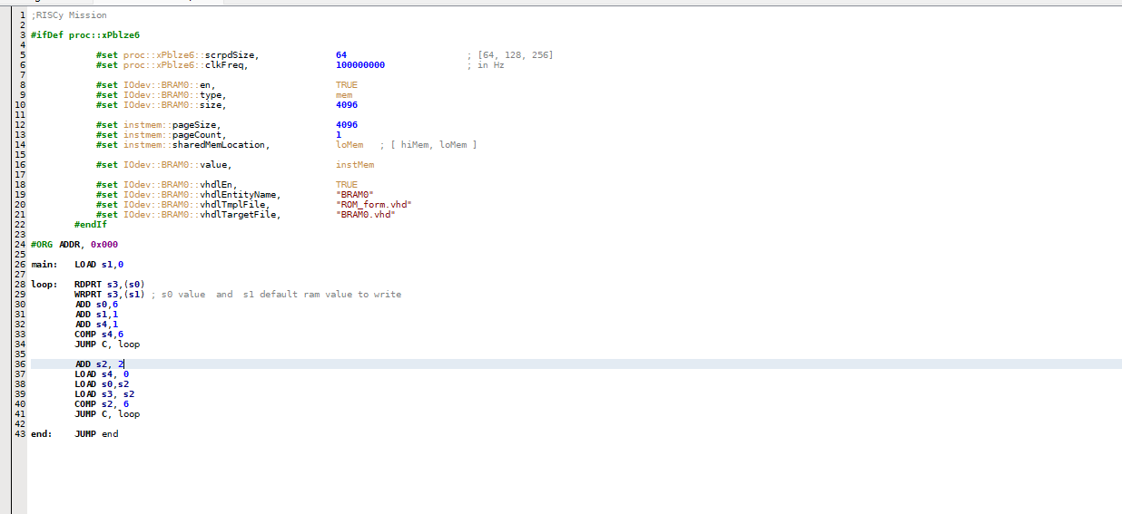

Figure. 2 FIDEx code for odd part of the rows for matrix

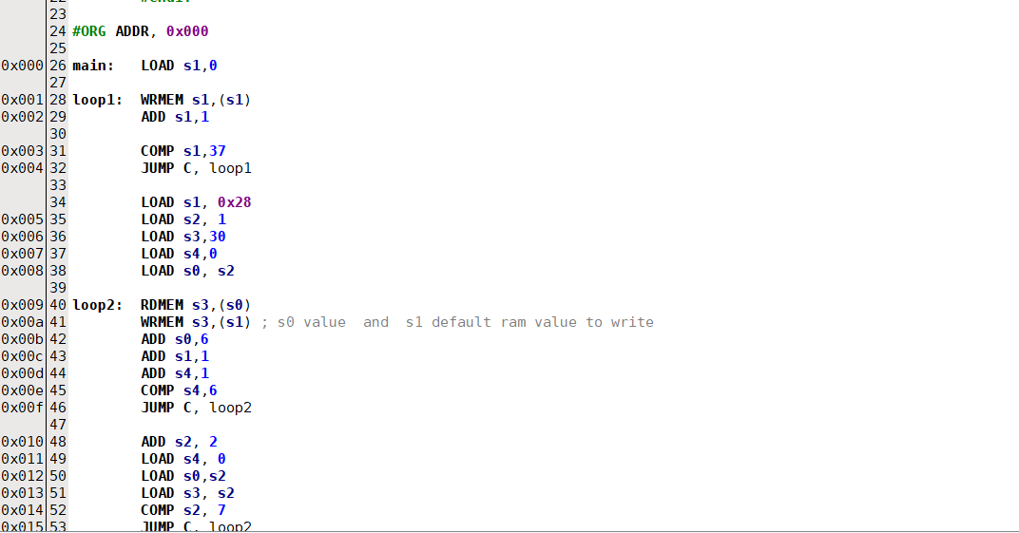

Fig. 3 FIDEx code for the even part of the rows for matrix.

These codes work in this order and algorithm.

S0 and S1 holds the values to read from and write to ram respectively. In the loop what we do is writing the value of s0 to S3 adress and increasing the address values for writing and reading the ram. After that we check the boundary for the loop and this cycle continous. Manipulating with the index numbers, we travel up and down in the column which enables us navigating in the addresss’ of the ram. Main idea behind the these two codes are explained.

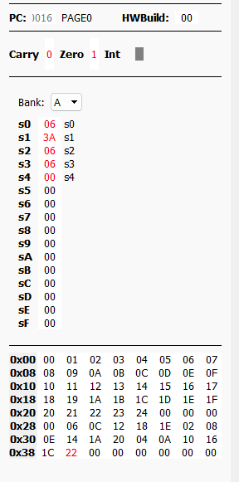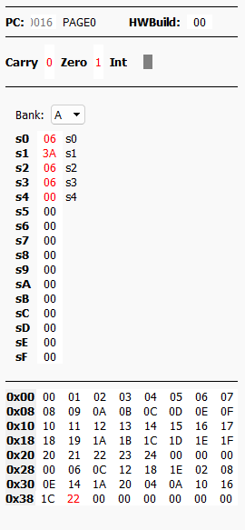

Fig 4. Scratchpad values of the even and odd part of the matrix.

After the FIDEx part is compete we work on the Vivado part for the simulation. Sources and testbench are given below.

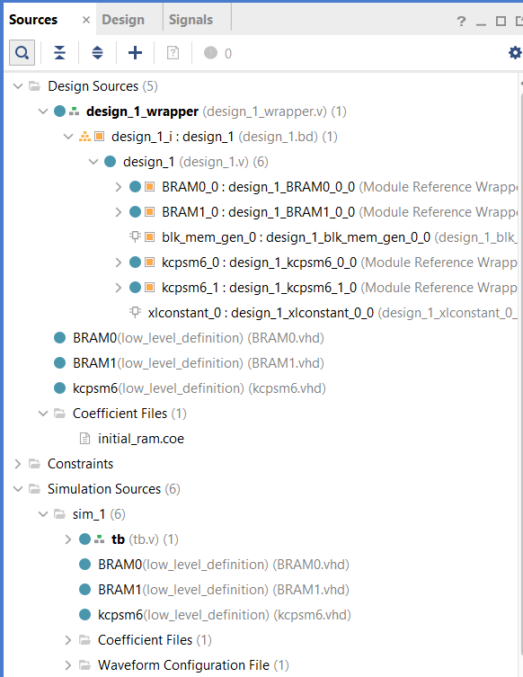

Fig 5. Sources files for simulation. Design sources are formed according to the İTÜ GSTSL Picoblaze and Vivado design manuel.

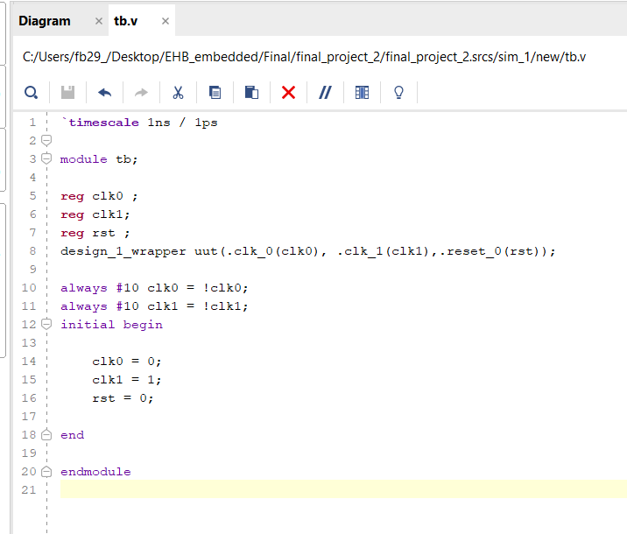

Fig 6. Testbench code written by us according to the needs of the simulation.

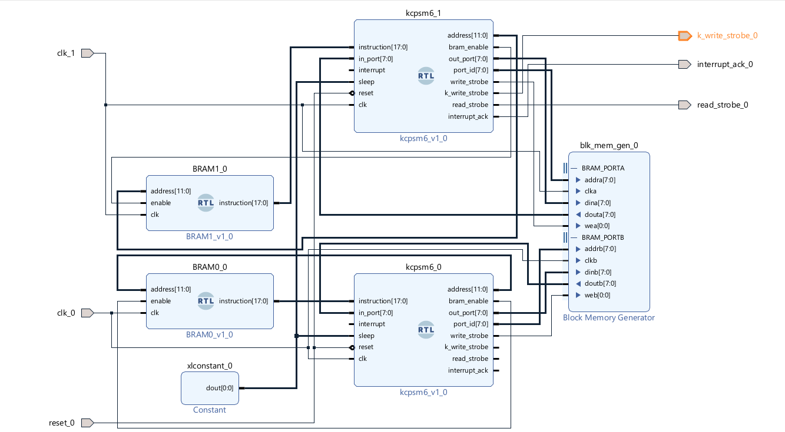

Fig 7. Block Diagram of our design.

In the Fig 7. It can be seen that two picoblaze connects with a single blockRAM. BRAM modules act as a registers for picoblaze since picoblaze doesn’t have a memory.

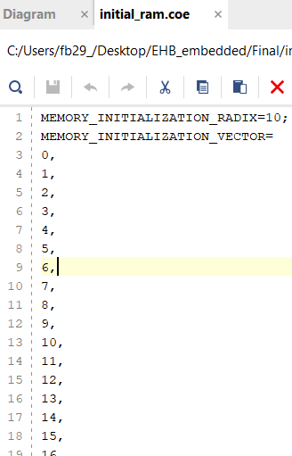

Fig 8. Coefficients in our 6x6 matrix.

It was chosen this way because there were no restriction.

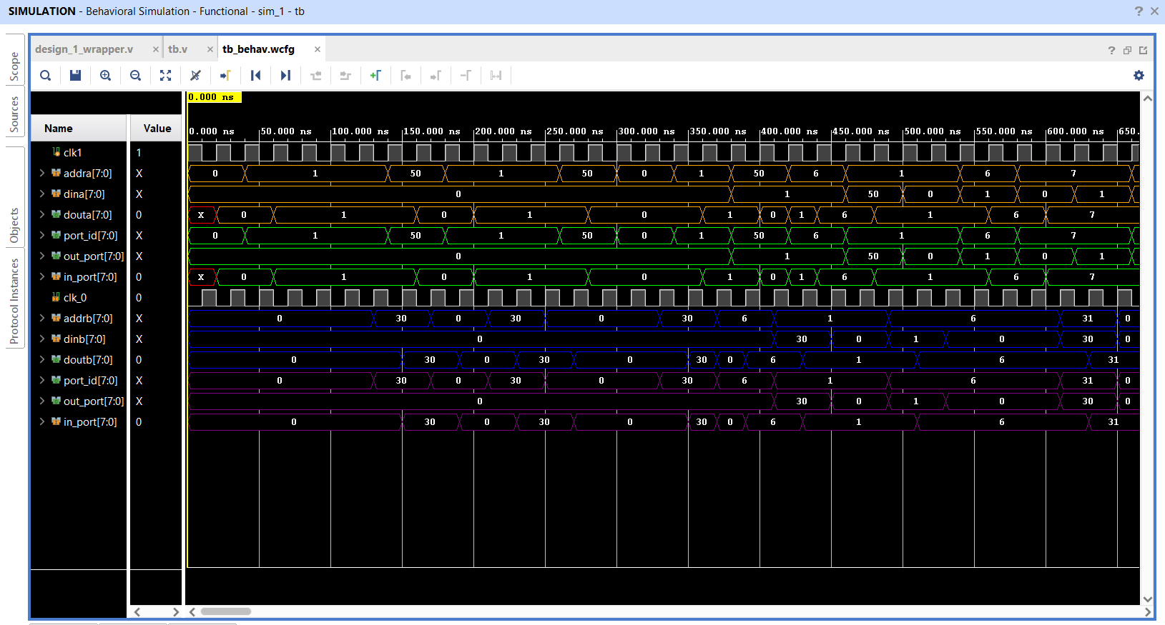

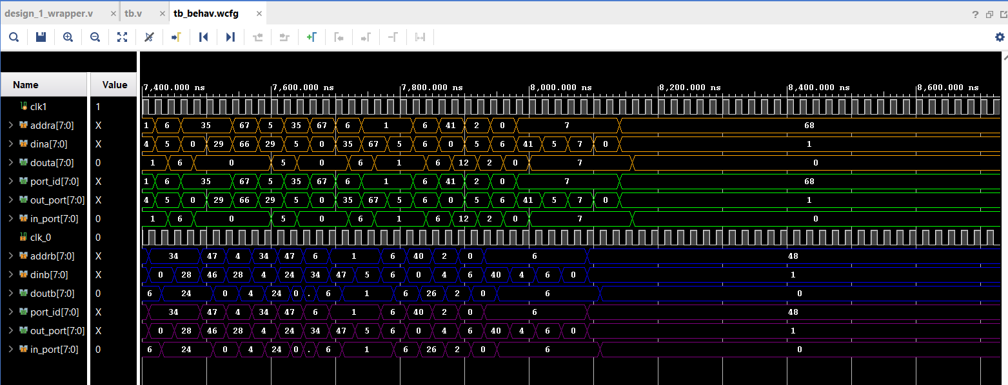

Fig 9. Simulation results of the block diagram.

In the Fig 9. It can be seen that, two picoblazes share memory location in the ram. It writes the transpose of the matrix to the ram’s memory.