8D report INC-2026-006 - Repeated gearbox oil over-temperature on WTG-07
Revision of 2026-07-10: D1 to D7 complete, D8 open until the bearing replacement.
Field | Value
Report number | INC-2026-006
Turbine | WTG-07 (serial LT32-19-0421, gearbox FGT-3200-18-07752)
Opened | 2026-05-30 after the first A2102 trip
8D lead | Yusuf Arkwell, Reliability Engineer

D1 - Team
Yusuf Arkwell (lead), Dario Penwarden (O&M Supervisor), Callum Rydings (Lead Wind Technician), Élise Ternaux (Wind Technician), Katrin Ostermeier (Fabrikam Getriebetechnik GmbH, remote support) and Imogen Thackwray (Trey Research Laboratories, oil analysis).

D2 - Problem description
Between 2026-04-09 and 2026-06-21 WTG-07 logged 27 A2101 warnings (gearbox oil sump temperature high, 75 °C) and two A2102 trips (82 °C): on 2026-05-30 at 14:12 (82.6 °C) and on 2026-06-19 at 15:47 (83.4 °C). No other turbine logged an A2101 warning in the same period.
The HSS bearing vibration (generator side) rose from 2.1 mm/s RMS on 2026-01-05 to 5.2 mm/s RMS on 2026-06-15, above the alarm level of 4.5 mm/s.
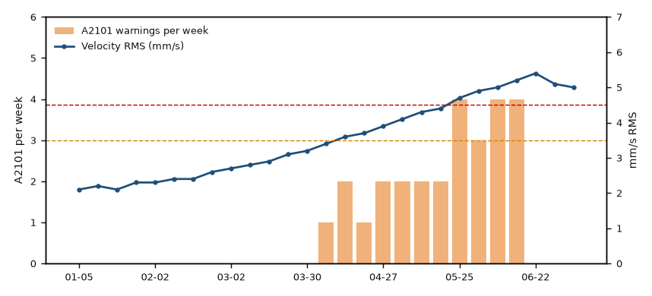
Figure 1 - WTG-07: weekly A2101 warnings and HSS bearing vibration (2026)

D3 - Containment
From 2026-06-01 WTG-07 was limited to 2.6 MW by the park controller and the oil temperature was checked every day. The limit was removed on 2026-06-25 after the corrective actions of D6.

D4 - Root cause analysis (5 Whys)
Why 1 - Why did the oil overheat? The oil cooler did not reject enough heat at high load.
Why 2 - Why? The cooler fan ran at reduced speed and the radiator fins were about 40 % blocked by insects and pollen.
Why 3 - Why did the fan run slowly? The bearing of the fan motor LWS-P-30418 had failed; the motor current was 35 % above nominal.
Why 4 - Why was it not detected earlier? The fan motor current is not monitored by the SCADA system and the radiator was cleaned only when found dirty.
Why 5 - Why? The maintenance plan followed the manual, which gives no interval for radiator cleaning ('as required').
Root cause: missing preventive maintenance of the oil cooler (radiator cleaning and fan check) allowed a fan motor bearing failure and radiator fouling to reduce the cooling capacity.
Contributing factor: wear of the HSS bearing on the generator side, confirmed by oil analysis TR-OA-2026-0614 (iron 64 ppm, PQ index 112) and by the vibration trend, increased the friction losses in the gearbox.

D5 and D6 - Corrective actions
Action | Work order | Owner | Date | Status
Replace oil cooler fan motor LWS-P-30418 | WO-26-0398 | Callum Rydings | 2026-06-24 | done
Clean oil cooler radiator | WO-26-0399 | Élise Ternaux | 2026-06-24 | done
Remove the 2.6 MW limit after verification | - | Dario Penwarden | 2026-06-25 | done
Replace HSS bearing, generator side (FGT-P-22328) | WO-26-0412 | Callum Rydings | on delivery of the bearing | waiting for parts

D7 - Prevent recurrence
- Task MP-GBX-07 'Oil cooler radiator cleaning and fan current check' added to the maintenance plan for all turbines, every 6 months (issue 2 of 2026-07-01).
- Minimum stock of fan motor LWS-P-30418 raised from 1 to 2 (2026-07-01).
- Request to Litware Wind Systems to add the fan motor current to the SCADA signals (ticket LWS-TS-51877, open).
Verification: no A2101 warning on WTG-07 since 2026-06-24 (SCADA log). The vibration stays above the alarm level until the bearing is replaced.

D8 - Closure
Open. The 8D will be closed after WO-26-0412 and an oil sample 500 operating hours after the bearing replacement.

