Decoupling coercive field from relaxation time in wurtzite Al–Sc–Ga–N: a designed time-constant spectrum for in-materio computing, and the limits of what it computes
[Author]¹, [Author]²
¹ [Affiliation] ² [Affiliation]
This is a modelling study. No film was grown and no device was measured. The material model is phenomenological; two of its four calibration anchors are stated design targets rather than measurements.

Abstract
In-materio reservoirs draw their computational richness from a broad distribution of relaxation times, which in disordered nanomaterial networks arises from stochastic self-assembly and is therefore irreproducible. Crystalline alternatives restore reproducibility but deliver one time constant at a time. We show that designing the distribution instead of inheriting it carries a sharper requirement than it appears: the elements of an array must also switch at the same field, or they cannot share a drive line. Wurtzite quaternary Al(1−x−y)Ga(x)Sc(y)N supplies the two composition axes this needs, Sc setting the coercive field and the Al:Ga ratio setting the bandgap and hence the leakage that governs depolarization. On an iso-coercive-field trajectory the alloy spans 7.43 decades of relaxation time at exactly constant switching threshold; inside a ±5% coercive-field tolerance the ternary parents reach only 0.196 and 0.072 decades. Simulating a composition-spread pad array as a delay-based reservoir, the designed spectrum raises nonlinear memory capacity over one time constant per pad by 11.7% at two readout channels, narrowing at four and reversing at eight — a scarce-channel advantage. A matched software reservoir still reaches three to four times the capacity. Two controls proved decisive: a plain delay line beats the device on NARMA-10, so delayed parity is used instead; and driven open-loop the pad is a Hammerstein system whose nonlinear memory is perfect at zero delay and gone by the fourth, until a delayed-feedback loop is closed. With perfect fabrication the designed spread transfers a trained readout between devices at zero cost where a random spread of identical statistics incurs a penalty of 0.088; the advantage survives to ±1 at% deposition tolerance. Two requirements emerged that we did not anticipate: the readout must resolve about 90 dB, and the wide spectrum earns its width through temperature robustness rather than peak capacity.
Keywords: wurtzite ferroelectrics, AlScN, ScGaN, physical reservoir computing, in-materio computing, composition spread, combinatorial synthesis

Introduction
Physical reservoir computing exploits the dynamics a material already has. An input drives a physical system, the system's own relaxation supplies fading memory and its own nonlinearity supplies the expansion, and only a linear readout is trained [1]. The appeal is that the expensive part of a recurrent network — the recurrent dynamics — costs nothing to run, because the physics runs it.
What makes a material good at this is not a single relaxation time but a broad distribution of them. A reservoir with one time constant is a single low-pass filter; a reservoir carrying many, spread over decades, can hold the recent past and the distant past at once, and a linear readout can then select the timescale each task needs. This is why disordered nanomaterial networks work so well [6-8]. In Ag/Ag₂S nanoparticle assemblies the spread of junction sizes produces a spread of ionic diffusion rates, and it is precisely that heterogeneity that supplies the computational richness [6, 7].
The same mechanism is also the field's central obstacle. The distribution arises from stochastic self-assembly, so no two networks are alike. Device-to -device reproducibility is out of reach, a readout trained on one sample is worthless on the next, and manufacturing is therefore not on the table. The usual response has been to move to crystalline materials and tune the relaxation time extrinsically — with bias, illumination, or ferroelectric polarization state. That restores reproducibility but gives up the thing that made the disordered networks work: those knobs deliver one time constant at a time, not a simultaneous spectrum.
We ask whether a spectrum can be designed rather than inherited. The requirement is sharper than it first appears. It is not enough to find a material whose relaxation time varies with composition; almost any alloy does that. The elements of an array must also switch at the same field, or they cannot share a drive line, and an array whose elements each need their own drive voltage is not a reservoir but a collection of separately addressed devices. The real requirement is therefore a material in which the relaxation time can be moved over decades while the coercive field stays put.
Wurtzite quaternary Al(1−x−y)Ga(x)Sc(y)N offers exactly the two independent axes this needs. Scandium content sets the coercive field [9, 11], because switching nucleates in Sc-bearing unit cells; the Al:Ga ratio sets the bandgap, and through it the leakage that drives depolarization, and so the relaxation time. A combinatorial co-sputtered wafer with a lateral composition gradient can therefore carry a designed distribution of time constants at a single coercive field; combinatorial gradient deposition is already established for AlScN [16] and, in the quaternary AlScBN, across 850 samples of a single phase space [17]. Ferroelectricity has been demonstrated in sputtered ScGaN [10, 11] and, as a quaternary, in MBE-grown Sc-Al-Ga-N [13]; what has not been examined is what the second composition axis is worth as a design variable. Neither ternary can: with one composition axis, moving the relaxation time necessarily drags the coercive field with it.
This paper makes that argument quantitative and then tests it honestly. We first map the composition design space and show what the decoupling is worth, measured the way a device engineer would measure it — decades of relaxation time available inside a given coercive-field tolerance. We then simulate the resulting pad array as a delay-based reservoir and ask what it computes.
The second half of the paper is as much about controls as about results, because the controls turned out to change the conclusions. Three of them deserve stating up front.
First, NARMA-10, the field's most-used benchmark, cannot carry this argument. Its target is dominated by a linear function of the input history, so a plain delay line — ridge regression on the raw inputs, no device at all — beats the device on it. Selecting an operating point by NARMA error also drives the input modulation toward zero, switching the device's nonlinearity off. We report NARMA-10 beside that control rather than omitting the task, and use delayed parity as the primary metric instead: no linear filter of the input can exceed chance on it at any delay, unlike NARMA-10 [5], so a score above chance is direct evidence that the device is computing rather than storing.
Second, driven open-loop the pad is not a reservoir at all. It is a Hammerstein system — an instantaneous nonlinearity followed by a bank of linear filters — and although it solves zero-delay parity perfectly, what it retains at longer delays is weak and gone by the fourth. We show why this follows from the structure of the switching equation, and that a delayed-feedback loop, which is one charge amplifier summed into the drive, is what makes the dynamics recurrent [2]. The usable loop gain spans about three quarters of a decade.
Third, the readout is severely ill-conditioned: the array produces far more state columns than independent dynamical directions. Choosing the regularization for single-device accuracy alone yields weights that are exact on the device they were fitted to and meaningless on any other, so cross-device transfer must be studied as a function of regularization or the metric reports conditioning rather than reproducibility.
None of these three is specific to nitride ferroelectrics, and we suspect the first two apply to a good deal of the physical-reservoir literature.
What we claim, in the end, is bounded and we state the bounds plainly. The materials result stands on its own: the quaternary buys orders of magnitude more usable time-constant range at fixed coercive field than any ternary, and that is a design rule for anyone building an array of nitride ferroelectric elements. The computational result is real but modest: the designed spectrum measurably raises nonlinear memory over one time constant per pad at matched readout channels, and the deterministic spread matches a random one in performance while beating it in device-to-device reproducibility, which was the point. We do not claim to approach a tuned software reservoir; a matched echo state network [3] reaches three to four times the nonlinear memory capacity, and the case for the device is energy and area at the sensor, not accuracy parity. Finally, everything here is simulated, from a phenomenological model whose calibration anchors we state individually, and the experiment that would test it is described in the discussion together with the measurement precision it would require.

Methods
All results in this work are simulated. No film was grown and no device was measured. The material model is phenomenological and calibrated to published coercive-field measurements; the two retention anchors are stated design targets rather than measurements, and are identified as such below. Unless a temperature sweep is stated explicitly, every reported result is at an ambient of 300 K. The complete simulation package, including every script that produced a figure, is available at [repository].

1. Composition–property model
We model wurtzite Al(1−x−y)Ga(x)Sc(y)N through four maps of the cation fractions x (Ga) and y (Sc), with the Al fraction 1 − x − y constrained to stay above 0.02.
Bandgap. The main results use the linear virtual-crystal approximation,
Eg(x, y) = (1 − x − y)·E_AlN + x·E_GaN + y·E_ScN,
with E_AlN = 6.2 eV, E_GaN = 3.43 eV and an effective E_ScN = 2.0 eV. Bowing is neglected here and its effect is reported as a sensitivity analysis using pairwise bowing parameters (b_AlGa, b_AlSc, b_GaSc) = (0.9, 4.2, 3.0) eV. The AlGa value sits within the range reported for wurtzite AlGaN in the standard compilation [21] and in dedicated measurements on the alloy [32]; the two Sc-pair values are estimates, since no comparable compilation exists for them. The neglect is not free. AlGaN bowing alone is of order 0.9 eV, so absolute compositions carry errors of a few hundred meV of gap; the Sc-containing pairs are more strongly nonlinear still, which is why the two Sc bowing parameters used in the sensitivity run are larger than the AlGa value and are estimates rather than recommended constants. What survives the approximation is the design rule — a monotone iso-Ec trajectory spanning more than seven decades of relaxation time — and not the particular composition that realises a given time constant. Composition values quoted anywhere in this work should be read in that light.
Coercive field. Switching in Sc-containing wurtzites nucleates in Sc-bearing unit cells, so Ec is taken to be governed by the Sc fraction with a weak Ga softening term,
Ec(x, y) = [E0 + S·(y − y0)]·(1 − g·x), g = 0.12.
E0 and S are fixed by two literature anchors: Ec = 4.7 MV cm⁻¹ for sputtered Al(0.73)Sc(0.27)N [9] and Ec = 1.5 MV cm⁻¹ for sputtered Sc(0.40)Ga(0.60)N [11, 12], the lowest coercive field reported for any wurtzite ferroelectric. This gives E0 = 4.70 MV cm⁻¹ and S = −23.7 MV cm⁻¹ per unit Sc fraction. Unlike the retention anchors below, both are measured values and are cited as such.
Because Ec depends on both cation fractions, the locus Ec(x, y) = Ec* can be inverted analytically for y(x); we call this the iso-Ec trajectory and every device in this work lies on one.
Retention time constant. Depolarization is leakage-mediated, and the leakage barrier is taken proportional to the alloy bandgap in the manner of a Poole–Frenkel process, which is the dominant leakage mechanism identified in Al0.7Sc0.3N itself, attributed there to positively charged nitrogen vacancies [29], and in Al-rich AlGaN [23],
τ_ret(x, y, T) = τ0 · exp{[φ0 + Γ·Eg(x, y)] / kT}.
The prefactor τ0 is pinned at 10⁻¹³ s, an inverse phonon attempt time, so that the temperature dependence is physically parameterised rather than an artefact of an unconstrained fit. Γ = 0.258 (dimensionless) and φ0 = −0.196 eV then follow from two anchors: τ_ret = 10³ s at (x, y) = (0.10, 0.35) and 10⁻³ s at (0.60, 0.35). These two anchors are design targets rather than measurements: they encode the established qualitative ordering that wide-gap AlScN is effectively non-volatile on laboratory timescales while Ga-rich nitride ferroelectrics are leakage-limited and volatile. The Al-rich anchor is conservative against what has been measured - Al0.7Sc0.3N shows negligible polarization loss over 1000 s even at 400 °C [24], and AlScN memory devices have held their state for 10⁵ s [30], so 10³ s at 300 K understates the true retention of that end of the range. The anchor fixes where the spectrum sits in absolute time; a longer true retention shifts the whole spectrum together, which is compensated by moving the composition window rather than by changing the design rule. The offset φ0 is phenomenological and carries no microscopic claim; only the combination is calibrated, and only at 300 K. Everything the paper concludes depends on the τ span being large and monotone in the Al:Ga ratio, not on either endpoint value being exact.
The effective barrier φ0 + Γ·Eg is not a single number across the design window: it falls from ≈1.02 eV at the Al-rich end of the iso-Ec trajectory to ≈0.59 eV at the Ga-rich end, and is ≈0.95 eV at the Al-rich retention anchor. The temperature sensitivity therefore varies with it, from one decade of τ per 19 K at the slow end of the spectrum to one decade per 33 K at the fast end, and one decade per 25 K at mid-window. A warming film does not slide its spectrum rigidly — the spectrum also compresses, the fast end moving about 1.7 times fewer decades per kelvin than the slow end.
Remanent polarization and permittivity are ad hoc linear maps (Pr ≈ 115 − 25x − 60(y − 0.25) µC cm⁻², ε_r by linear virtual-crystal interpolation between 9.0, 9.5 and 20). Unlike Ec and τ_ret, neither is tied to a calibration anchor. The permittivity map in particular gives ε_r = 10.9–11.8 over Sc = 0.17–0.25 and so undershoots by roughly a factor of two the 17–21 measured for Sc(x)Al(1−x)N in that range [22], precisely because the linear form omits the strong bowing of the measured ScAlN dielectric constant [31]. Neither map appears in a segment's equation of motion, but neither is inert either: Pr scales the measured charge, and because the delayed-feedback loop returns that charge to the drive, the loop gain quoted here is really the product of the electronic gain and Pr. A systematic error in Pr would rescale the loop gain rather than change any conclusion, since the gain is selected by search. ε_r is used only for a bounding screening estimate that no reported result depends on.

2. Device model
Geometry. Combinatorial co-sputtering produces a lateral composition gradient [16, 17, 26]. This is a different device from a film graded along the growth axis, which has been pursued separately to manage defects and breakdown in ultrathin AlScN [25]; the distinction matters here because it is what makes the uniform-field treatment below exact rather than approximate. One metal–ferroelectric–metal pad on such a wafer therefore covers a strip of compositions side by side, not stacked along the growth axis. We model the pad as N parallel segments sharing one electrode pair. Three consequences follow, and the choice is made for the first of them:
1. every segment sees exactly the same field E = V/d, so the uniform-field assumption is exact rather than approximate; 2. inter-segment electrostatic coupling is neglected and the segments are treated as independent, up to in-plane fringing at their mutual boundaries. On a combinatorial wafer the composition varies over millimetres while the film is ~100 nm thick, so that boundary region is ~10⁻⁴ of the pad area and the neglect is defensible for this geometry; 3. the measured charge is the area-weighted sum of segment polarizations, and that sum is symmetric in the segments.
Neither the uniform field of (1) nor the independence of (2) would be defensible for a growth-axis graded stack, where polarization mismatch at internal interfaces and conductivity-driven field redistribution are first-order effects. The lateral geometry is what buys both, and we adopt it for that reason rather than presenting a uniform field as a generic approximation.
A direct and important consequence of the symmetry in (3), stated here rather than left implicit: the model depends only on the multiset of segment properties, so it is exactly invariant to segment ordering and to gradient direction. "Graded" in this work means "designed distribution of time constants", nothing more. We verified the invariance numerically (outputs agree to 3 × 10⁻¹⁴ under random permutation of the segments over 3000 field steps). Readers should not infer from the word that gradient direction or spatial ordering is a design variable here: in this model they provably are not, and no result in this paper depends on either.
Dynamics. Each segment carries a normalized polarization p ∈ [−1, 1]. Under a field E two processes compete: Merz-law [14] field-activated switching toward sign(E) at rate r_sw = exp(−W·Ec/|E|)/τ_sw0, and leakage-mediated depolarization toward zero at rate r_rt = 1/τ_ret, so that
dp/dt = [sign(E) − p]·r_sw − p·r_rt.
Within a constant-field slot this is linear in p and we use the exact solution, which is unconditionally stable and step-size exact:
p_eq = sign(E)·r_sw/(r_sw + r_rt), p ← p_eq + (p − p_eq)·exp[−(r_sw + r_rt)·Δt].
Three modelling choices are encoded here and must be read as choices. (i) The depolarization channel stays active while the field is applied, so the sustained-field steady state is |p_eq| < 1 and leaky segments pole incompletely — this is the mechanism by which the time-constant spectrum enters the response, and it is a modelling choice rather than a derived result. (ii) Switching within a segment is a single exponential, the n = 1 limit of the Kolmogorov–Avrami–Ishibashi model [20], so all switching-time dispersion comes from the composition spread and none from within a segment. This is not the measured limit for the regime we operate in. Al0.72Sc0.28N switches by nucleation-limited switching [19] at low field and crosses over to KAI-like uniform switching only at high field [28], and our drive is sub-coercive — the low-field side of that crossover. The dispersion the nucleation-limited picture would add is not exploited by our design, so the treatment stays conservative with respect to our claim; but it is the wrong limit for the operating regime, and a quantitative match to experiment would need the nucleation-limited distribution rather than a single exponential. (iii) With τ_sw0 = 1 ns and a switching time of 1 ms at
|E| = Ec, W = ln(10⁶) = 13.8. This defines Ec as a kHz-loop coercive field, consistent with the loop-measured anchors; Merz-law coercive fields are frequency dependent [14], so every Ec in this work carries that convention. The same convention fixes the activation field at W·Ec ≈ 37 MV cm⁻¹ at our working point, about three times shallower than the ≈126 MV cm⁻¹ measured for Al0.72Sc0.28N [28]. A steeper field dependence than ours would move the usable drive bias closer to Ec and raise the switching energy. It would not change the structure of the competition between switching and leakage on which the design rests, because the drive bias is re-selected by search for every design rather than fixed a priori.

3. Reservoir architecture
Pad array. P pads on the same wafer share one drive line — identical field and identical mask — and are read out on P independent charge channels. Since every design lies on one iso-Ec trajectory, all pads switch at the same field and sharing a drive line is legitimate. This is precisely what the quaternary buys: in a ternary alloy, moving composition to change τ also moves Ec, and a shared drive line becomes impossible.
Four designs are compared at matched channel count P and matched feature count P·M: graded (pad p spans the p-th sub-window of the wafer's composition range, so each channel carries a continuum of time constants), homogeneous (pad p sits at a single composition, the P compositions tiling that arm's own selected window: one time constant per channel; because the window is itself a searched variable, the two arms do not necessarily cover identical spans), uniform (all pads at one composition), and stochastic (pad p spans an i.i.d. random composition draw over the same window: matched spectrum statistics, no reproducibility). The uniform arm's single composition is not an arbitrary pick: its time-constant window was selected by the same coordinate search, on the same disjoint seeds, as the spread designs, so the four-design comparison of Figure 3 is best-versus-best. Two further comparisons are not, and are flagged where they appear: the interleaved comb of Results Section 3 and the readout-noise sweep of Section 5 both evaluate an arm at the composition spread's operating point rather than at one searched for them.
Time multiplexing. Each input sample u(k) is expanded by a fixed mask into M virtual-node slots of duration θ, following the delay-based scheme of Appeltant et al. [2], with M = 50 throughout. Polarity alternates regularly, keeping the pad charge-balanced, while the mask offsets each slot's operating point along the Merz exponential:
E(k, j) = Ec_ref · s_j · [b·(1 + σ_m·m_j) + G·ũ(k)], s_j = (−1)^j,
with m_j drawn once from U(−1, 1) and held fixed as hardware. Every virtual node therefore sits at a different distance from threshold and responds to the input with a different gain and curvature — the physical analogue of per-neuron biases. A mask that only flips polarity leaves every node with the same transfer function and is reported as the naive reference.
Delayed feedback. ũ(k) = u(k) + F·q(k − 1), where q is the array-summed charge of the previous frame. This is one charge amplifier and one summing node. The loop is not optional. Open-loop the pad is a Hammerstein system — an instantaneous nonlinearity followed by a bank of linear filters — and has almost no nonlinear memory: it solves zero-delay parity perfectly, and what little it retains beyond that decays within about three delays. The reason is structural: the slot update has the form p ← p·f(E) + g(E), so products of inputs at different times do appear in the state, but each such product is multiplied by the intervening f(E) values and is therefore entangled with the intervening inputs rather than cleanly readable by a linear readout, whereas the additive g(E) terms survive intact. The deficit is not a property of one design — no choice of composition spread repairs it. Field-free dwell slots do not repair it either (tested; Section 2 of the Results). Closing the loop does. All reported results below use the closed-loop configuration; open-loop numbers appear only as the control that establishes why the loop is necessary.
Readout. The observable is the per-slot switched charge ΔP, which is what a charge amplifier on an MFM pad delivers. Training is ridge regression with an unpenalised intercept on z-scored states, the standardisation and the regularisation both fitted on the training window only, with λ selected on a held-out tail of that window. Because that selection optimises single-device accuracy, it lands near the unregularised end: the median selected λ runs from 10⁻⁶ to 10⁻² depending on design and channel count. Every capacity reported below is therefore a lightly regularised, single-device number, and the cross-device transfer results of Section 4 of the Results are the ones that show what a transferable λ costs.

4. Benchmarks, and why these
NARMA-10 is reported but is not the primary metric. Its target has a large linear component, so minimising its error rewards storage over computation. Measured on the same footing, a plain 30-tap delay line — ridge regression on the raw input history, no device at all — reaches NRMSE ≈0.39 where the pad reaches ≈0.56, and selecting an operating point by NARMA error drives the input modulation toward zero, switching the device nonlinearity off. Every NARMA number here is quoted beside that control.
The primary metric is nonlinear memory capacity from delayed parity, the nonlinear counterpart of the linear memory capacity of Jaeger [4]. The target is the parity of two consecutive inputs ending d steps in the past,
y(k) = s(k − d)·s(k − d − 1), s = 2u − 1, u ∈ {0, 1},
and the capacity is Σ_d max(2·acc_d − 1, 0)². No linear filter of the input can score above chance on this at any delay, delay line included: we measure 0.004 for the same 30-tap delay line, against 7.00 for an oracle carrying the products of the first seven delays. That oracle bounds only those seven terms and is not a ceiling for the thirteen-delay capacities reported below. A capacity above zero is therefore direct evidence that the device is computing rather than storing.
Linear memory capacity [4], measured against a surrogate-input noise floor because the sum of squared correlations is positively biased, is reported alongside.
Baselines. A leaky echo state network [3] with a bias input, tuned over spectral radius, leak rate, input scale and bias scale and averaged over several weight realizations, at matched readout dimension; and the delay line above. The echo state network's hyperparameters were tuned on the same selection seeds and against the same objective as the device operating points, so the baseline is selected out of sample too and is not a strawman.

5. Selection and statistics
Operating points — drive bias, input modulation, mask spread, slot duration, the designed time-constant window, and the feedback loop gain — were chosen for each design separately by coordinate search maximising nonlinear memory capacity on SELECTION seeds. The designed time-constant window is itself one of the searched variables, for every arm including the uniform baseline. Every reported design comparison uses EVALUATION seeds, which are disjoint. The single-device characterisation sweeps of Figure 2 — the drive-regime scan, the loop-gain scan and the linear-memory profile — are averaged over three evaluation seeds at the selected operating point. One number is an exception and we state it rather than let a reader assume otherwise: the regularization trade-off of Figure 4a is computed on a selection seed, because it is a diagnostic of the readout rather than a claim about one design beating another.
Every selected optimum was checked against its grid boundaries and the grids widened until the optimum was interior. Two contacts remain and we report them rather than suppress them: the homogeneous arm's window-centre multiplier sits at the edge of the searched centre range, and the uniform arm's spectral span sits at the narrow edge of the span grid, pinned at 0.25 decades. The second is a boundary of that arm's own definition — a "uniform" array is one whose span tends to zero — rather than evidence of an unexplored optimum, but it does mean the uniform baseline is the narrowest the grid allows.
Reported comparisons use 10 mask realizations crossed with 10 input realizations, with identical (mask, input) pairs across designs, so design differences are paired and are tested with a Wilcoxon signed-rank test. The deposition-tolerance sweep of Figure 4b uses 20 nominally identical devices per arm at each noise level. The significance tests quoted beside it are a separate, smaller run: 10 devices per arm, paired across 10 input realizations, tested with the same Wilcoxon signed-rank test. No other test is used anywhere in this work.
A note on the readout. The state matrix contains far fewer independent directions than columns. A four-pad array with fifty virtual nodes each produces 200 state columns, but the participation ratio of the z-scored state correlation matrix is 1.05–1.12, only 60 of the 201 columns of the training design matrix are numerically independent, and its Gram matrix has a condition number of order 10³³. Selecting λ for single-device accuracy alone therefore returns an essentially unregularised solution: legitimate on one device, since it is validated and tested out of sample, but composed of large mutually cancelling weights that are exact only there. Cross-device transfer is consequently reported as a function of λ. We also report the effective degrees of freedom the ridge readout actually spends — 11.1 of 50 columns at P = 1, 14.5 of 100 at P = 2, 16.2 of 200 at P = 4 and 18.2 of 400 at P = 8, against 139.2 of 200 for a tuned echo state network at P = 4 — so that P·M columns is never read as P·M usable features. One further consequence has to be carried forward by the reader: because the readout leans on very-low-variance directions, every capacity we report presumes a readout able to resolve them, which is why the measurement-noise sweep of Results Section 5 is reported and why its answer is the binding experimental requirement.

Results
All values are simulated. Every number here is generated into results/SUMMARY.md by the analysis scripts and transcribed from there. Unless a temperature sweep is stated, all values are at an ambient of 300 K.

1. Coercive field and relaxation time come apart in the quaternary
Figures 1a and 1b show the two property maps over the cation plane. The coercive-field contours run almost horizontally: Ec follows the Sc fraction and is nearly indifferent to the Al:Ga ratio. The time-constant contours run diagonally, following the bandgap. The two families are not parallel, and that non-parallelism is the whole content of the decoupling claim — the iso-Ec trajectory drawn on Figure 1b crosses seven decades of relaxation time without leaving its own coercive-field contour.
At Ec = 2.7 MV cm⁻¹ the accessible Ga range spans 7.43 decades of relaxation time while the coercive field varies by less than 10⁻¹⁴ MV cm⁻¹, exactly constant because the trajectory is an analytic inverse (Figure 1c).
The comparison that matters for a device is not the range available in principle but the range available at one switching threshold, since an array whose elements switch at different fields cannot share a drive line. On that basis (Figure 1d, Table 1), moving the relaxation time along AlScN costs 1.30 MV cm⁻¹ of coercive field per decade, and along ScGaN 3.44. Holding Ec to ±5%, AlScN delivers 0.196 decades and ScGaN 0.072, against the quaternary's 7.43 at zero tolerance — a factor of 38 at ±5%, and unbounded as the tolerance closes.
Table 1. Decades of relaxation time reachable inside a coercive-field tolerance band.
tolerance on Ec | AlScN | ScGaN | quaternary
±1% | 0.030 | 0.010 | 7.43
±2% | 0.075 | 0.026 | 7.43
±5% | 0.196 | 0.072 | 7.43
±10% | 0.406 | 0.154 | 7.43

Including pairwise bandgap bowing shifts the compositions that realise a given time constant but leaves the trajectory monotone and the span at 7.56 decades, so the design rule does not rest on the bandgap approximation — though, as Methods Section 1 sets out, the composition values themselves do.

2. The device computes, but only with the loop closed
Two controls decide whether any benchmark number that follows means anything.
A delay line is the benchmark to beat, and on NARMA-10 it wins. Ridge regression on the raw input history, with no device at all, reaches NRMSE 0.3875 with 30 taps; the pad array reaches 0.56 at its NARMA-selected drive and 0.84 at the drive selected for the primary metric. NARMA-10's target is dominated by a linear function of the input history and a delay line has perfect linear memory, so the task rewards storage. Worse, selecting an operating point by NARMA error pushes the input modulation toward zero and switches the device nonlinearity off. NARMA-10 is therefore reported only beside this control (Figure 3d).
On delayed parity the same delay line is exactly at chance: capacity 0.004, accuracy 0.501, against 7.00 for an oracle carrying the required products. The pad array reaches capacity 2.3–3.2 and solves zero-delay parity perfectly, so it computes something no linear filter of the input can.
Open-loop, however, the pad has little nonlinear memory, and what it has is shallow. Figure 2e sweeps the feedback loop gain. With the loop open the capacity is 1.33 on that sweep, but the number needs reading carefully: the zero-delay parity term, which requires no memory at all, contributes 1.00 of it. Resolved by delay on the 25-realization paired protocol used for the dwell-slot control below — where the same open-loop configuration scores 1.30 — parity accuracy is 1.000 at delay zero, 0.710 at delay one, 0.622 at delay two, 0.551 at delay three and 0.505 at delay four, contributing 1.000, 0.201, 0.071, 0.012 and 0.002 to the capacity. Only about 0.29 of it reflects memory of any depth. That residual is what the Hammerstein structure predicts: products of inputs at different times are present in the state but entangled with the intervening inputs, so a linear readout recovers only a rapidly decaying fraction of them. Closing the loop raises the capacity to 3.10 at a gain of 0.003 and parity is solved out to delay two. The usable window is 0.001 to 0.006, a factor of six or about three quarters of a decade; its lower edge is censored by the sweep grid, on which 0.001 is the smallest non-zero gain tested, so the window may extend further down. Above it the loop saturates the pad and memory collapses fast: capacity is already 1.27 at a gain of 0.010, 0.17 at 0.020 and 0.01 at 0.030. Interleaving field-free dwell slots, tested on the reasoning that it would separate strong input coupling from fast decay, leaves the open-loop capacity genuinely unchanged — 1.30 ± 0.12 with no dwell slot and 1.30 with one, two or four, over the same 25 paired realizations. The limitation is structural, not a matter of duty cycle.
Figure 2a–d shows the signatures an experiment would check first. The retention half-life is almost the same for a spread pad and a single-composition pad (0.203 s against 0.210 s), so a single-number retention measurement does not see the spectrum at all; the decay shape does. Figure 2d locates the selected drive at bias 0.65, where the switching rate sits in the middle of the relaxation-rate spectrum and 59% of segments forget by leakage rather than field overwrite — the crossover, not either extreme. Linear memory capacity there is 4.07 for the spread pad, 2.98 for one time constant per pad and 2.00 for a single time constant, significant against a surrogate-input threshold out to delays 4, 4 and 3 respectively. The nonlinear-memory scan is flat across this region — 3.11, 3.10 and 3.10 at biases 0.60, 0.65 and 0.70 — so the selected drive sits on a plateau rather than a sharp optimum.

3. The designed spectrum pays when readout channels are scarce
Figure 3 compares the four designs at matched channel count and matched feature count, each at its own selected operating point, over 100 paired realizations.
Table 2. Nonlinear memory capacity, mean ± s.d.
design | P = 1 | P = 2 | P = 4 | P = 8
composition spread | 2.29 ± 0.28 | 2.90 ± 0.22 | 3.10 ± 0.38 | 2.92 ± 0.61
one τ per pad | 2.20 ± 0.32 | 2.59 ± 0.37 | 3.03 ± 0.19 | 2.97 ± 0.63
random spread | 2.21 ± 0.13 | 2.56 ± 0.22 | 2.95 ± 0.24 | 3.16 ± 0.27
single τ | 2.07 ± 0.38 | 2.24 ± 0.27 | 2.33 ± 0.26 | 1.93 ± 0.39
tuned ESN | 6.34 ± 0.26 | 8.72 ± 0.19 | 10.80 ± 0.23 | 12.52 ± 0.19
delay line | 0.00 ± 0.01 | — | — | —

Paired against one time constant per pad on identical mask and input realizations, the spread gains +4.1% at P = 1 (p = 9.5 × 10⁻³) and +11.7% at P = 2 (p = 9.6 × 10⁻¹⁸). By four channels the advantage has narrowed to +2.4%, and by eight it has reversed to −1.6%. Against a single time constant for the whole array it instead grows monotonically, from +11.0% at P = 1 to +51.2% at P = 8.
The useful form of this is a channel-efficiency statement: a continuum of time constants inside each pad substitutes for extra readout channels, and stops paying once there are enough channels to tile the spectrum discretely. Since each channel is a charge amplifier and a converter, the scarce-channel regime is the one a physical implementation occupies. The claim is explicitly a scarce-channel claim and must not be carried to large arrays.
We also tested an interleaved design in which every pad carries a comb spanning the full window rather than a contiguous sub-window. At one channel the two are statistically indistinguishable, as they must be, since a single pad spans the whole window either way (−0.2%, p = 0.09). From two channels up the comb is clearly worse: −7.4% at P = 2, −9.7% at P = 4 and −11.5% at P = 8, all with p < 10⁻¹⁶. Channel decorrelation evidently matters more than per-channel spectral coverage: partitioning specialises each channel, interleaving makes the channels resemble one another. The comb was evaluated at the partitioned design's selected operating point rather than at one searched for it, so the deficit is an upper bound on how well a comb could do; we report the negative result because even so it establishes that the partitioned design is not an arbitrary choice among equivalent tilings of the same τ window.
Figure 3b shows where each design runs out. Every device variant solves parity at zero delay and falls to chance by delay five or six. The tuned echo state network does not fall to chance anywhere in the swept range: it is still at 0.873 accuracy at delay twelve, the largest delay measured, so its depth is right-censored by our sweep rather than resolved. Its capacity there is 12.5 against the device's 2.9 at the same eight channels, and 3.1 at the device's best channel count of four. We state that plainly: this device does not approach a software reservoir on this metric — the ratio runs from 2.8× at one channel to 4.3× at eight — and the case for it is energy and area at the sensor.

4. Deterministic disorder reproduces; random disorder does not
The two spreads perform alike — that they do is the point of the comparison. With perfect fabrication their NARMA-10 errors are 0.804 and 0.806 — both well above the 0.3875 delay-line control of Section 2, beside which Section 2 requires every NARMA number to be read — and their time constant statistics are matched by construction. They differ in reproducibility.
At zero deposition noise the designed array shows exactly zero device-to-device variation, a state correlation of 1.0000 between nominally identical devices, and a readout transfer penalty of 0.000 — a readout trained on one device runs on another with no loss. The random array, with the same statistics and the same performance, still incurs a penalty, because its spectrum is redrawn per device: 0.082 over the twenty-device sweep and 0.088 over the ten-device paired run that carries the significance tests below.
As deposition noise rises the two converge (Figure 4b). The designed array remains significantly more transferable at σ = 0.005 (penalty 0.053 against 0.126, a factor 2.39, p = 0.002) and at σ = 0.010 (0.114 against 0.181, factor 1.58, p = 0.006), and the difference vanishes at σ = 0.020 (factor 1.01, p = 0.77). The designed spread therefore stops being measurably more transferable at σ\* = 0.02 in cation fraction, which is 2 at%; the last scatter at which it still pays is σ = 0.01, so the fabrication budget is to hold composition to about ±1 at% or better, and beyond 2 at% a designed spectrum buys nothing a random one does not. For scale, the run-to-run reproducibility of a co-sputtered composition spread has been measured at 0.1 at.% mean absolute deviation and 0.7 at.% maximum [27], which is the quantity sigma represents and sits well inside the budget; the systematic variation of Sc cation fraction across a 200 mm AlScN wafer is larger, 28.4% at the centre against 30.6% at the edge [26], but that is a gradient with position rather than scatter between nominally identical pads.
Reporting this required a detour we consider a result in its own right. The array produces far more state columns than independent dynamical directions — the participation ratio of the standardised state correlation matrix is 1.05 to 1.12 for 200 columns, only 60 of the 201 columns of the training design matrix are numerically independent, and the Gram matrix condition number is of order 10³³. Choosing the readout regularization for single-device accuracy alone returns an essentially unregularised solution whose large cancelling weights are exact only where they were fitted: it scores 0.730 on its own device and 1321 on another. On a selection seed and at σ = 0.01, where the two arms can be told apart at all, regularising at λ = 10² costs 0.090 in single-device error and brings the designed array's transfer penalty to 0.080 (Figure 4a); the 0.000 above is the same arm at zero deposition noise. Cross-device transfer has to be reported against regularization, or the metric describes conditioning rather than reproducibility.

5. Readout precision is the binding experimental requirement
The same ill-conditioning appears a second time, and this is the most consequential number in the paper for anyone attempting the experiment. Because the trained readout leans on low-variance directions, it needs large dynamic range. Figure 4c sweeps readout signal-to-noise ratio at zero deposition noise and zero switching jitter:
readout SNR | capacity advantage of the spread over one τ per pad
noiseless | +0.161
100 dB | +0.212
90 dB | +0.132
80 dB | +0.036
70 dB and below | ≈ 0

The composition-spread advantage stops being resolvable below about 90 dB, and the spread design needs 100 dB to reach 95% of its noiseless capacity. Ninety decibels on a per-slot switched-charge measurement is roughly fifteen effective bits — demanding but not exotic for a slow-integrating charge amplifier. It is a specification on the charge amplifier rather than a property of the film, it is nonetheless the single most binding requirement the design imposes, and it should be budgeted before a device is fabricated rather than after. Cycle-to-cycle coercive-field jitter compounds it, and no amount of readout precision buys the loss back: 1% jitter alone drops the spread array's capacity from 3.05 to 0.99 at every readout SNR from noiseless down to 50 dB (Figure 4d). It also reverses the comparison, and we state that plainly. Under 1% jitter one time constant per pad scores 1.27 against the spread's 0.99, and under 3% jitter 0.54 against 0.42 — a designed spectrum is the worse design once switching jitter dominates, because the jitter destroys precisely the deterministic structure the design contributes. The composition-spread claim is therefore bounded twice over: it is a scarce-channel claim, and it is a low-jitter claim.

6. The spectrum earns its width through temperature, not through capacity
The robustness sweeps (Figure 5) separate two questions that are easy to conflate.
How many decades does the task need? At fixed temperature, remarkably few. Capacity rises from 2.57 with a single time constant to 3.12 with one decade of spread and is then flat out to five (3.12, 3.11, 3.10, 3.09). Linear memory keeps improving to about three decades (1.06 → 3.38). A discrete ladder reaches the continuum's value at roughly eight distinct time constants.
Why then design seven decades? Because the whole spectrum moves with ambient temperature — one decade per 25 K at mid-window, and, since the barrier falls along the trajectory, one decade per 19 K at the slow end against one per 33 K at the fast end, so the spectrum compresses as it moves rather than sliding rigidly. A wide spectrum always retains some segments at the useful timescale wherever it goes. Over 275–325 K the single-time-constant array loses 36.6% of its capacity while the spread arrays lose 2.4% and 0.5%. The width buys temperature robustness, not peak capacity, and that is the honest statement of what the material is for.
Bandgap bowing changes the capacity by 0.1% for the composition spread and 0.1% for one time constant per pad, and by 0.3% for the single-time-constant array; the random-spread arm was not run under bowing. Results are converged in the number of composition segments resolved per pad (3.075 at four segments to 3.060 at sixty-four) and in the number of virtual nodes.

7. The ternary control, and the substitution it can and cannot make
Figure 6 joins the materials argument to the device argument. A ternary-like array is built along a single composition axis, driven from the same shared line, and given its own best drive.
It cannot build the designed window: asked for five decades of relaxation time it reaches 1.09 before leaving the physical composition range, and pays 3.65 MV cm⁻¹ of coercive-field spread for even that.
What happens next is more interesting than a simple failure. Because the Merz rate is exponential in Ec/E, that coercive-field spread becomes 3.7 decades of switching-rate spread under one shared drive — uncontrolled dynamical diversity standing in for the designed kind. At its own best drive the ternary array reaches capacity 2.62 against the quaternary's 3.05, or 86% of it. Coercive-field disorder does substitute for designed time-constant disorder.
But only at one temperature. Over 275–325 K the ternary array loses 22.9% of its capacity against the quaternary's 2.2%, because temperature robustness requires a wide spread of relaxation times and the ternary has barely one decade of them. The substitution is real and it is fragile, and separating those two statements is what the quaternary is for.

Discussion

What the device is, as a computational object
The pad array is not a general-purpose reservoir and it is worth naming what it is instead. Driven open-loop it is a Hammerstein system: a static nonlinearity applied to the instantaneous drive, followed by a bank of linear filters whose time constants are the designed composition spread. Such a system has linear memory of whatever depth its slowest filter provides, and it has an instantaneous nonlinearity, but it has almost no nonlinear memory — it cannot cleanly form products of inputs separated in time. Our measurements bear this out: open-loop the pad solves zero-delay parity perfectly, retains a weak and fast-decaying ability at delays one to three (accuracy 0.71, 0.62, 0.55), and is at chance from delay four onward. Of its open-loop capacity of 1.33, the zero-delay term — which requires no memory at all — accounts for 1.00.
The reason is visible in the update equation. Each slot maps the state as p ← p·f(E) + g(E). Products of inputs at different times do appear in the resulting state, but every such product is multiplied by the intervening f(E) factors and is therefore entangled with the intervening inputs, whereas the additive g(E) terms survive cleanly and accumulate. A linear readout recovers only the small unentangled residue, which is why the open-loop parity signal decays within three delays. Linear memory is long; nonlinear memory is not. The deficit belongs to the architecture rather than to any one design: no choice of composition spread repairs it. Interleaving field-free dwell slots, which we tried on the reasoning that it would decouple strong input coupling from fast decay, does not change it either — the entanglement is structural, not a matter of duty cycle.
Closing a delayed-feedback loop does change it, because the state then re- enters the drive and the nonlinearity acts on stored information rather than only on the present input. This is the ingredient the original delay-based scheme [2] has and a bare masked drive lacks, and in a nitride pad it costs one charge amplifier and one summing node. It is, in our view, the single most consequential design statement in this paper: a composition spread supplies the timescales, but only a feedback loop turns them into computation.

Which tasks this family fits
Read as a Hammerstein-plus-feedback system with long linear memory, shallow nonlinear memory, and a designed spectrum, the natural targets are tasks whose structure matches: a nonlinearity acting on the recent past combined with a long linear history. Nonlinear channel equalisation is the canonical example. Sensor linearisation and drift compensation are others, and both are plausible at the point of measurement, which is where a device like this belongs. Tasks requiring products across long delays — the ones an echo state network handles comfortably — are not a good fit and we would not propose them.

What the experiment would have to deliver
Three numbers, in decreasing order of how much they constrain the experiment.
Readout precision. Because the state matrix carries far fewer independent directions than columns, the trained readout leans on small signals. The composition-spread advantage stops being resolvable below about 90 dB of readout signal-to-noise ratio, and reaching 95% of the noiseless capacity needs 100 dB — roughly fifteen effective bits on a per-slot switched-charge measurement. That is a specification for the charge amplifier, not a property of the film, and it should be checked before a device is fabricated rather than after. It also conditions everything else we report: the capacities in Table 2 presume a readout able to resolve those directions.
Loop gain. The usable feedback window spans about three quarters of a decade — 0.001 to 0.006, and the lower edge is set by our sweep grid rather than by the physics, so it may be wider. Below it the system is feed-forward and has almost no nonlinear memory; above it the loop saturates the pad and both linear and nonlinear memory collapse, with capacity already down to 1.27 at a gain of 0.010 and to zero by 0.030. An experiment therefore needs a trimmable loop gain, and the trim range matters more than its absolute accuracy. Like the readout requirement, this is a constraint on the amplifier and not on the film.
Deposition tolerance. The reproducibility argument is a variance statement, and it has a threshold: above a certain composition scatter the designed and random spectra become statistically indistinguishable, at which point the designed array has no reproducibility advantage left to offer. That scatter is σ = 0.02 in cation fraction, i.e. 2 at%, and the last value at which the designed spread still pays is 1 at%; two published measurements bear on it - though they measure different things and should not be conflated. Our sigma is independent random scatter between nominally identical pads, so its direct analogue is run-to-run reproducibility: Gregoire et al. co-sputtered the same composition-spread library on two separate days and mapped both by x-ray fluorescence, finding a mean absolute deviation of 0.1 at.% and a maximum of 0.7 at.% [27] - well inside our budget, although for an oxide rather than a nitride. The other quantity is systematic drift with position: Carmona-Cejas et al. measured the Sc cation fraction across a 200 mm AlScN wafer by Rutherford backscattering as 28.4% at the centre and 30.6% at the edge [26], a full range of 0.022 in cation fraction. That is a gradient rather than scatter, so it bounds how far a pad's mean composition moves with wafer position rather than how much identical pads differ; comparable radial variation is reported elsewhere [15], and wafer-scale integration of a fixed AlScN composition has been demonstrated across 200 mm [18]. Read correctly, the run-to-run requirement is met with margin and the positional requirement is the one to design around.

Relation to the ternary literature
The lowest coercive field yet reported for a wurtzite ferroelectric was achieved in sputtered ScGaN [11, 12], and the AlScN family [9] is where most of the device work sits. The quaternary itself has been grown by molecular beam epitaxy [13], though not as a composition spread. Our result does not compete with either; it explains what neither can do. Both are single-composition-axis systems, so both trade coercive field against relaxation time at a fixed exchange rate, which we quantify. The quaternary is not a better ferroelectric than either parent — it is the smallest system in which the two properties come apart.

Honest limits
We have not shown that this device is efficient, only that it is designable. We quote no energy figure at all, and no reader should infer one from the case we make for energy and area at the sensor: an estimate counting ferroelectric switching work alone would exclude the drive amplifier, the sense amplifier and the converter, which in comparable analog systems typically dominate. We have not shown that it beats software: a tuned echo state network at matched readout dimension reaches three to four times the nonlinear memory capacity, the ratio widening with channel count from 2.8× at one channel to 4.3× at eight, and its depth exceeds the largest delay we measured.
Nor have we grown anything, and three features of the model deserve to be weighed before the numbers are. The material model is phenomenological, and two of its four calibration anchors — the retention pair — are design targets rather than measurements; what the conclusions rest on is that the relaxation-time span is wide and monotone in the Al:Ga ratio, not that either endpoint is right. The composition values that realise a given time constant shift when bandgap bowing is included, even though the design rule itself survives, so those values should be read as illustrative rather than as fabrication targets. And the switching kinetics are treated in the single-exponential limit, which is the wrong limit for the sub-coercive regime we operate in: Al0.72Sc0.28N is nucleation-limited at these fields [19, 28]. That choice is conservative with respect to our claim, because the extra dispersion nucleation-limited switching would supply is dispersion our design does not exploit, but a quantitative comparison with a real film would need it. In the same vein, our Merz convention defines the coercive field at a kHz loop rate and yields an activation field about three times shallower than the measured one; a steeper dependence would push the usable drive closer to Ec and raise the switching energy without altering the switching-versus-leakage competition the design rests on.
Finally, the operating point is 300 K. Because the effective barrier varies along the trajectory, the spectrum does not merely slide with temperature but compresses, and the temperature sweep we report is what discharges that limitation rather than an incidental robustness check.
What we believe does transfer beyond this material system is the framing. A time-constant spectrum is only useful if the elements carrying it can be driven together, so the figure of merit for a designed reservoir material is not the range of relaxation times it offers but the range it offers at fixed switching threshold. By that measure the quaternary nitride is, as far as we know, without a competitor among the wurtzite ferroelectrics.

Conclusion
A wurtzite quaternary nitride can carry a designed distribution of relaxation times at a single coercive field, and that combination — not either property alone — is what an array of physical reservoir elements needs. Quantified as decades of relaxation time reachable inside a coercive-field tolerance, the figure of merit we propose for this class of material, Al–Sc–Ga–N delivers 7.43 decades at zero tolerance against 0.196 and 0.072 decades for its ternary parents at ±5%. That result stands on the composition–property model alone and is independent of everything we then do with it.
Simulating the resulting composition-spread pad array as a delay-based reservoir places three bounds on what such a device can be expected to do, and we regard the bounds as the more useful half of the paper.
The advantage of a designed spectrum is a scarce-channel advantage. It is 11.7% in nonlinear memory capacity over one time constant per pad at two readout channels, and it has reversed by eight. Since each channel is a charge amplifier and a converter, the regime where the spectrum pays is the regime a physical implementation occupies — but the claim must not be carried to large arrays.
The device is not a reservoir until a loop is closed around it. Driven open-loop it is a Hammerstein system: an instantaneous nonlinearity followed by a bank of linear filters, whose nonlinear memory is shallow enough to be gone by the fourth delay and whose open-loop capacity is dominated by the zero-delay term. A delayed-feedback loop raises the capacity from 1.33 to 3.10, within a usable gain window about three quarters of a decade wide. Any experimental attempt needs a trimmable loop gain, and the trim range matters more than its absolute accuracy.
The binding requirement is readout precision, not materials quality. Because the array produces far more state columns than independent dynamical directions, the trained readout leans on small signals: below roughly 90 dB of readout signal-to-noise ratio the composition-spread advantage is not resolvable at all. Together with a deposition tolerance of ±1 at% - against a measured run-to-run reproducibility of 0.1 to 0.7 at.% for co-sputtered composition spreads [27] - and the loop gain window, this is the specification an experiment would have to meet, and it should be budgeted before fabrication rather than discovered after.
Finally, the width of the spectrum earns its keep somewhere other than where we expected. At fixed temperature one decade suffices; five add nothing. What the extra decades buy is immunity to the fact that the whole spectrum moves with ambient temperature — one decade per 25 K at mid-window, and compressing as it moves, from one decade per 19 K at the slow end to one per 33 K at the fast — so that over 275–325 K a single-time-constant array loses 36.6% of its capacity where the spread array loses 2.4%. A ternary alloy can partly substitute coercive-field disorder for designed time-constant disorder and reach 86% of the quaternary's capacity at one temperature, but it loses 22.9% across the same range. The quaternary is not a better ferroelectric than either parent; it is the smallest system in which the two properties come apart, and that is the claim we make for it.
We do not claim parity with software. A tuned echo state network at matched readout dimension reaches three to four times the nonlinear memory capacity, and the case for a device of this kind rests on energy and area at the point of measurement. Nothing here has been grown or measured, and the experiment that would test it is specified above.

Acknowledgements
[To be completed.]

Data availability statement
All data in this work are simulated. The complete simulation package - the material and device models, every experiment script, and the scripts that produced each figure - is available at [repository], together with the consolidated numerical results from which every value quoted in the text was transcribed. No experimental data were generated or analysed.

Conflict of interest
The authors declare no conflict of interest.

References
[1] Tanaka G, Yamane T, Héroux J B, Nakane R, Kanazawa N, Takeda S, Numata H, Nakano D and Hirose A 2019 Recent advances in physical reservoir computing: a review Neural Netw. 115 100–23 (doi:10.1016/j.neunet.2019.03.005)
[2] Appeltant L, Soriano M C, Van der Sande G, Danckaert J, Massar S, Dambre J, Schrauwen B, Mirasso C R and Fischer I 2011 Information processing using a single dynamical node as complex system Nat. Commun. 2 468 (doi:10.1038/ncomms1476)
[3] Jaeger H 2001 The "echo state" approach to analysing and training recurrent neural networks GMD Report 148 (Sankt Augustin: GMD German National Research Institute for Computer Science)
[4] Jaeger H 2002 Short term memory in echo state networks GMD Report 152 (Sankt Augustin: GMD German National Research Institute for Computer Science)
[5] Atiya A F and Parlos A G 2000 New results on recurrent network training: unifying the algorithms and accelerating convergence IEEE Trans. Neural Netw. 11 697–709 (doi:10.1109/72.846741)
[6] Srikimkaew O, Banerjee D, Azhari S, Usami Y and Tanaka H 2024 High performance of an in-material reservoir computing device achieved by complex dynamics in a nanoparticle random network memristor ACS Appl. Electron. Mater. 6 688–95 (doi:10.1021/acsaelm.3c01046)
[7] Hadiyawarman, Usami Y, Kotooka T, Azhari S, Eguchi M and Tanaka H 2021 Performance of Ag–Ag2S core–shell nanoparticle-based random network reservoir computing device Jpn. J. Appl. Phys. 60 SCCF02 (doi:10.35848/1347-4065/abe206)
[8] Kotooka T, Lilak S, Stieg A Z, Gimzewski J K, Sugiyama N, Tanaka Y, Kawabata T, Karacali A, Tamukoh H, Usami Y and Tanaka H 2024 Thermally stable Ag2Se nanowire network as an effective in-materio physical reservoir computing device Adv. Electron. Mater. 10 2400443 (doi:10.1002/aelm.202400443)
[9] Fichtner S, Wolff N, Lofink F, Kienle L and Wagner B 2019 AlScN: a III-V semiconductor based ferroelectric J. Appl. Phys. 125 114103 (doi:10.1063/1.5084945)
[10] Uehara M, Mizutani R, Yasuoka S, Shiraishi T, Shimizu T, Yamada H, Akiyama M and Funakubo H 2021 Demonstration of ferroelectricity in ScGaN thin film using sputtering method Appl. Phys. Lett. 119 172901 (doi:10.1063/5.0068059)
[11] Uehara M, Mizutani R, Yasuoka S, Shimizu T, Yamada H, Akiyama M and Funakubo H 2022 Lower ferroelectric coercive field of ScGaN with equivalent remanent polarization as ScAlN Appl. Phys. Express 15 081003 (doi:10.35848/1882-0786/ac8048)
[12] Uehara M, Hirata K, Nakamura Y, Anggraini S A, Okamoto K, Yamada H, Funakubo H and Akiyama M 2024 Excellent piezoelectric and ferroelectric properties of ScxGa1−xN alloy with high Sc concentration APL Mater. 12 121102 (doi:10.1063/5.0236507)
[13] Yang S, Wang D, Tanim M M H, Wang D and Mi Z 2024 Molecular beam epitaxy and characterization of ferroelectric quaternary alloy Sc0.2Al0.45Ga0.35N Appl. Phys. Lett. 124 193501 (doi:10.1063/5.0200057)
[14] Merz W J 1954 Domain formation and domain wall motions in ferroelectric BaTiO3 single crystals Phys. Rev. 95 690–8 (doi:10.1103/PhysRev.95.690)
[15] Barth S, Schreiber T, Cornelius S, Zywitzki O, Modes T and Bartzsch H 2022 High rate deposition of piezoelectric AlScN films by reactive magnetron sputtering from AlSc alloy targets on large area Micromachines 13 1561 (doi:10.3390/mi13101561)
[16] Patidar J, Thorwarth K, Schmitz-Kempen T, Kessels R and Siol S 2024 Deposition of highly crystalline AlScN thin films using synchronized high-power impulse magnetron sputtering: from combinatorial screening to piezoelectric devices Phys. Rev. Mater. 8 095001 (doi:10.1103/PhysRevMaterials.8.095001)
[17] Messi F, Rodkey N, Kober-Czerny M and Siol S 2026 Boron co-alloying in AlScN wurtzite ferroelectrics: insights from an 850-sample combinatorial study arXiv:2606.11954 (preprint)
[18] Nayak S, Nallagatla V R, Bisht R S, Solonenko D, Henzen D, Ali W R, Lazzari C M, Frost R J W, Serafini A, Codegoni D, Balsamo A, Scaldaferri R, Allahyari E, Ghosh A, Kratzer M, Picco A, Costantini S, Rusconi A, Moridi M, Campanella H, Deluca M and De Pastina A 2026 Wafer-scale integration of piezo- and ferroelectric Al0.64Sc0.36N thin films by reactive sputtering J. Phys. D: Appl. Phys. 59 315102 (doi:10.1088/1361-6463/ae8c49)
[19] Tagantsev A K, Stolichnov I, Setter N, Cross J S and Tsukada M 2002 Non-Kolmogorov-Avrami switching kinetics in ferroelectric thin films Phys. Rev. B 66 214109 (doi:10.1103/PhysRevB.66.214109)
[20] Ishibashi Y and Takagi Y 1971 Note on ferroelectric domain switching J. Phys. Soc. Jpn. 31 506–10 (doi:10.1143/JPSJ.31.506)
[21] Vurgaftman I and Meyer J R 2003 Band parameters for nitrogen-containing semiconductors J. Appl. Phys. 94 3675–96 (doi:10.1063/1.1600519)
[22] Casamento J, Lee H, Maeda T, Gund V, Nomoto K, van Deurzen L, Turner W, Fay P, Mu S, Van de Walle C G, Lal A, Xing H G and Jena D 2022 Epitaxial ScxAl1−xN on GaN exhibits attractive high-K dielectric properties Appl. Phys. Lett. 120 152901 (doi:10.1063/5.0075636)
[23] Reddy P, Khachariya D, Mecouch W, Breckenridge M H, Bagheri P, Guan Y, Kim J H, Pavlidis S, Kirste R, Mita S, Kohn E, Collazo R and Sitar Z 2021 Study on avalanche breakdown and Poole–Frenkel emission in Al-rich AlGaN grown on single crystal AlN Appl. Phys. Lett. 119 182104 (doi:10.1063/5.0062831)
[24] Drury D, Yazawa K, Zakutayev A, Hanrahan B and Brennecka G 2022 High-temperature ferroelectric behavior of Al0.7Sc0.3N Micromachines 13 887 (doi:10.3390/mi13060887)
[25] Hu Z, Zhang H, Rai R K, Cao Y, Tong X, Yousefian P, Cho H, Choi B, Chen C-C, He Y, Bao K, Leblanc C, Stach E A, Olsson R and Jariwala D 2026 Compositional gradient engineering for enhanced ferroelectricity in ultrathin AlScN arXiv:2606.12568 (preprint)
[26] Carmona-Cejas J M, Mirea T, Nieto J, Olivares J, Felmetsger V and Clement M 2023 Homogeneity and thermal stability of sputtered Al0.7Sc0.3N thin films Materials 16 2169 (doi:10.3390/ma16062169)
[27] Gregoire J M, Dale D, Kazimirov A, DiSalvo F J and van Dover R B 2010 Cosputtered composition-spread reproducibility established by high-throughput x-ray fluorescence J. Vac. Sci. Technol. A 28 1279–80 (doi:10.1116/1.3478668)
[28] Lu H, Schönweger G, Petraru A, Kohlstedt H, Fichtner S and Gruverman A 2024 Domain dynamics and resistive switching in ferroelectric Al1−xScxN thin film capacitors Adv. Funct. Mater. 34 2315169 (doi:10.1002/adfm.202315169)
[29] Chen L, Wang Q, Liu C, Li M, Song W, Wang W, Loke D K and Zhu Y 2024 Leakage mechanism and cycling behavior of ferroelectric Al0.7Sc0.3N Materials 17 397 (doi:10.3390/ma17020397)
[30] Liu X, Wang D, Kim K-H, Katti K, Zheng J, Musavigharavi P, Miao J, Stach E A, Olsson R H III and Jariwala D 2021 Post-CMOS compatible aluminum scandium nitride/2D channel ferroelectric field-effect-transistor memory Nano Lett. 21 3753–61 (doi:10.1021/acs.nanolett.0c05051)
[31] Ambacher O, Christian B, Feil N, Urban D F, Elsässer C, Prescher M and Kirste L 2021 Wurtzite ScAlN, InAlN, and GaAlN crystals, a comparison of structural, elastic, dielectric, and piezoelectric properties J. Appl. Phys. 130 045102 (doi:10.1063/5.0048647)
[32] Yun F, Reshchikov M A, He L, King T, Morkoç H, Novak S W and Wei L 2002 Energy band bowing parameter in AlxGa1−xN alloys J. Appl. Phys. 92 4837–9 (doi:10.1063/1.1508420)

Figures
Figure 1. Composition design space and the decoupling it enables. (a) Coercive field over the cation plane. (b) Relaxation time over the same plane, with the iso-coercive-field trajectory overlaid. (c) Relaxation time along iso-coercive-field trajectories. (d) Decades of relaxation time reachable inside a coercive-field tolerance band, quaternary against both ternary parents.
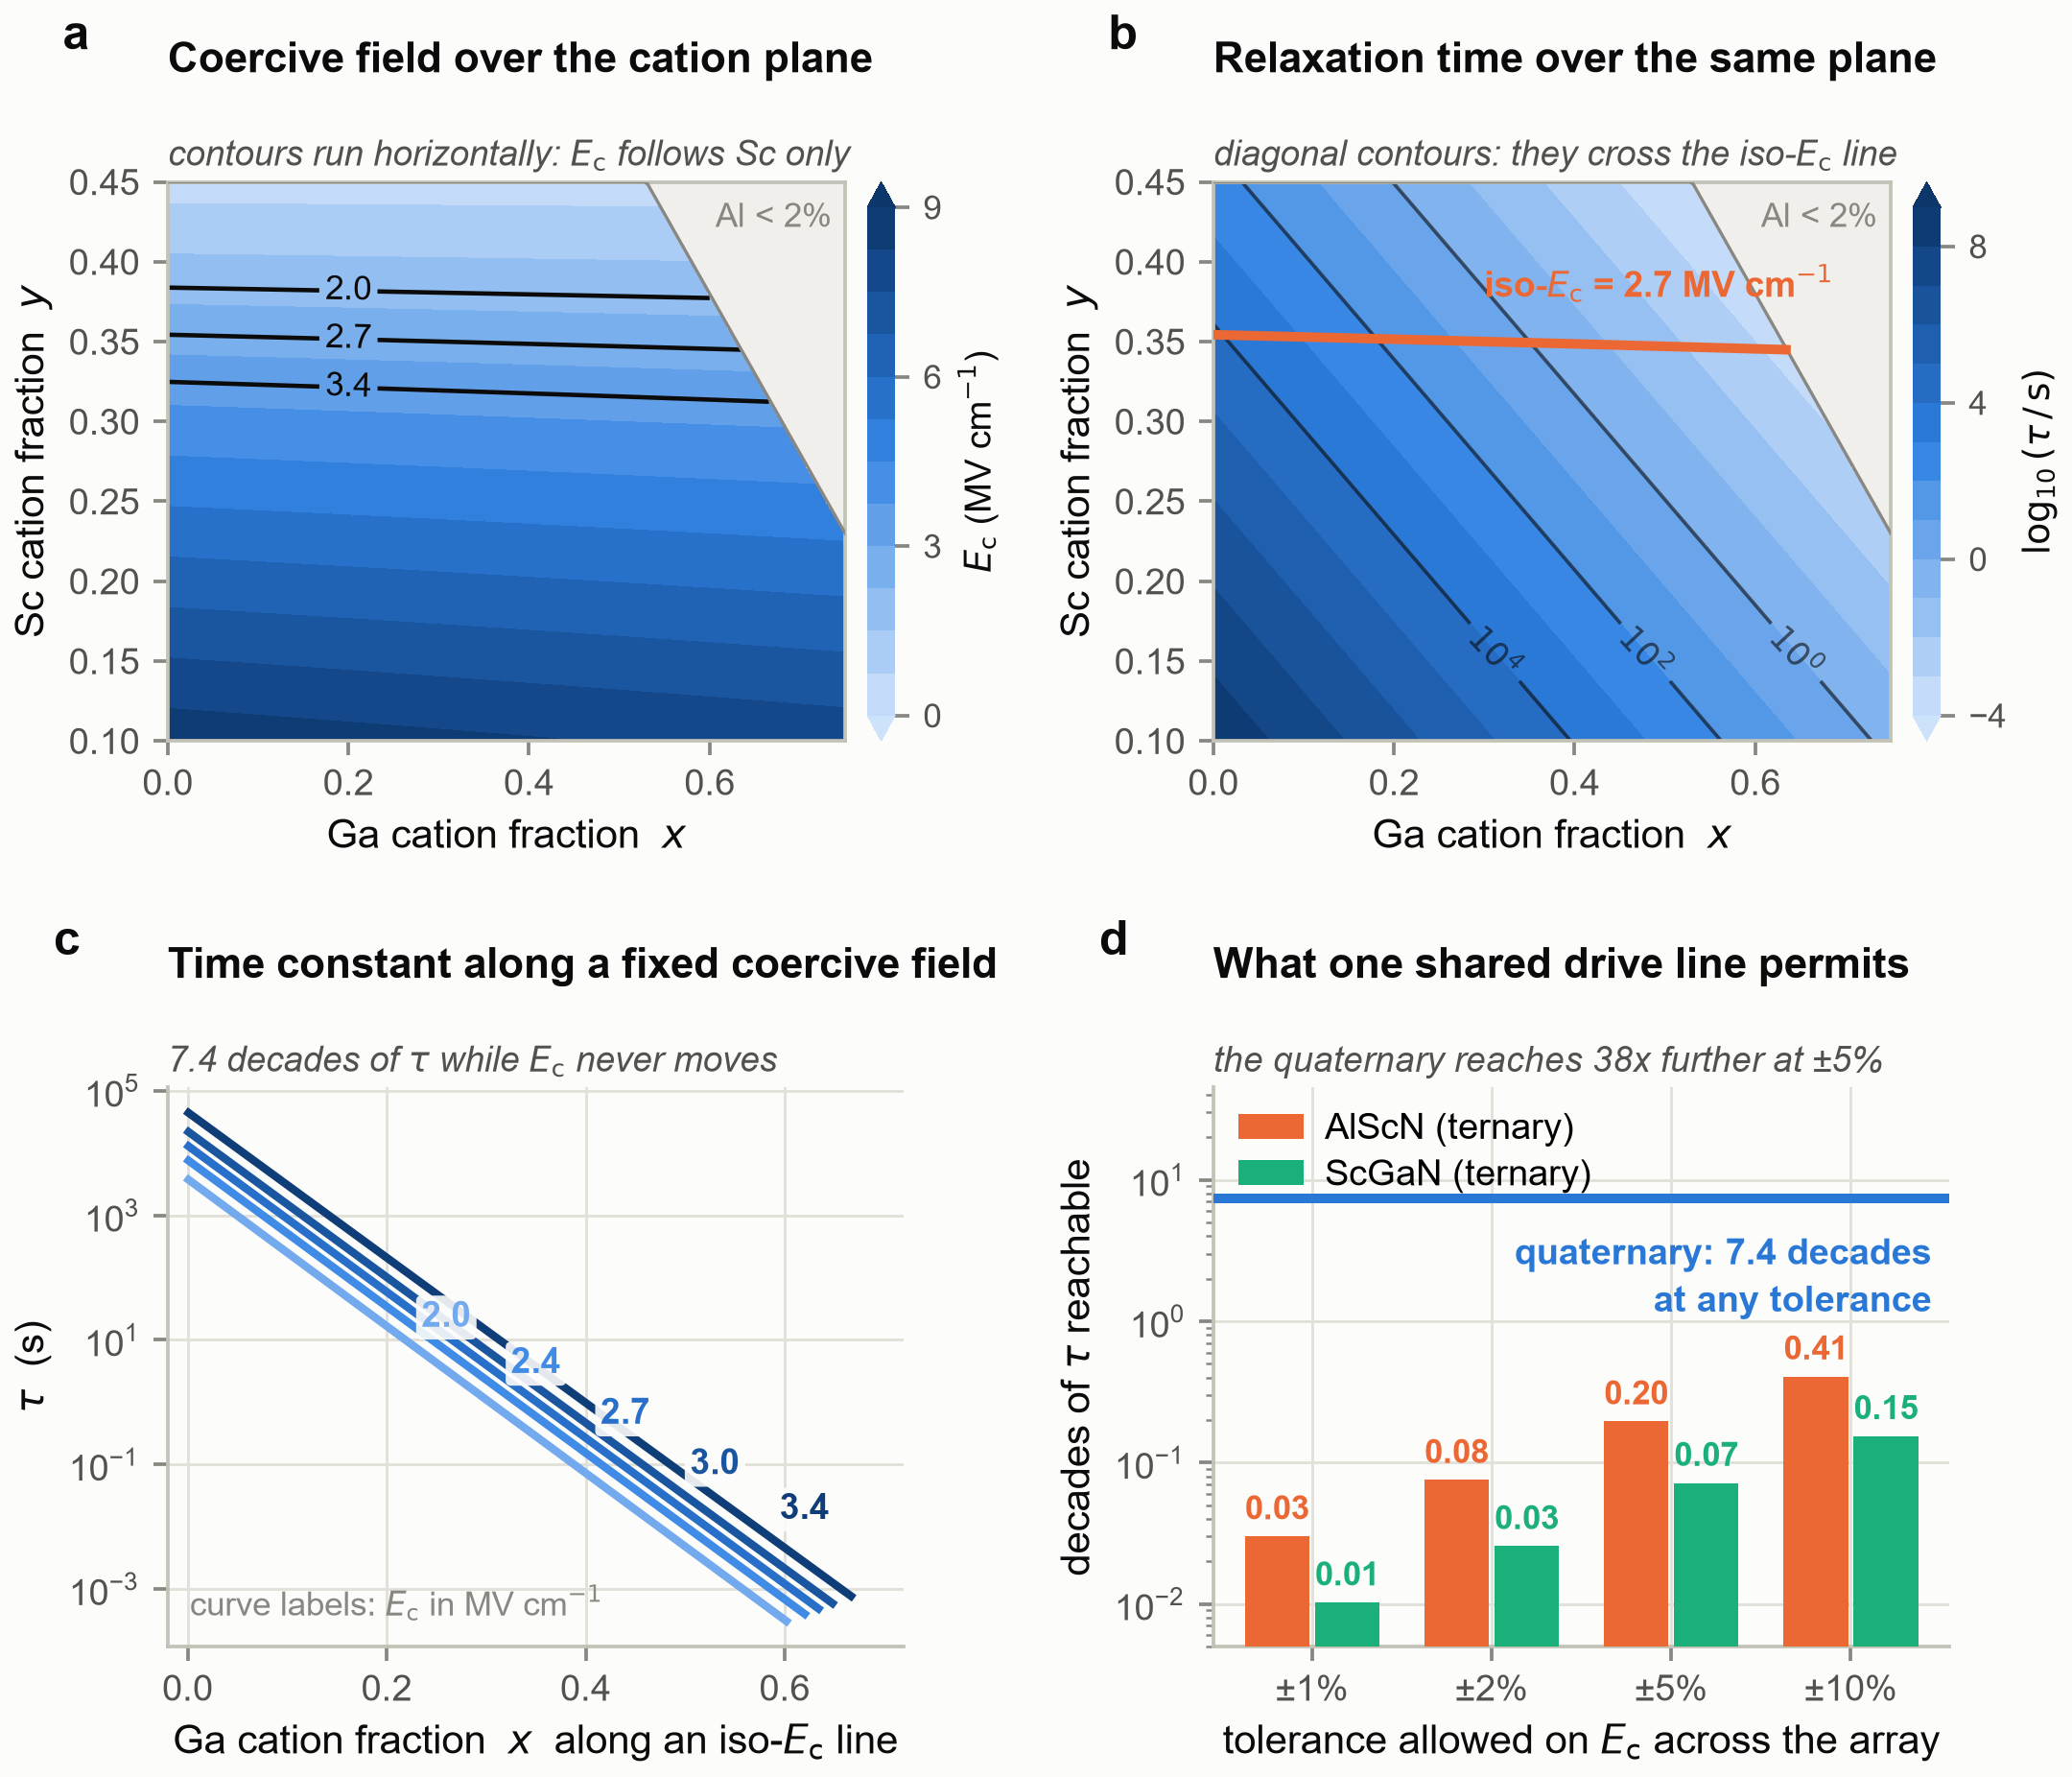
Figure 2. Device signatures, drive regime and feedback loop. (a) P-E loops. (b) Retention after poling. (c) The designed time-constant spectra. (d) Switching rate against drive bias, with the span of relaxation rates shaded. (e) Nonlinear memory capacity against feedback loop gain; the open-loop value is dotted. (f) Linear memory capacity against delay.
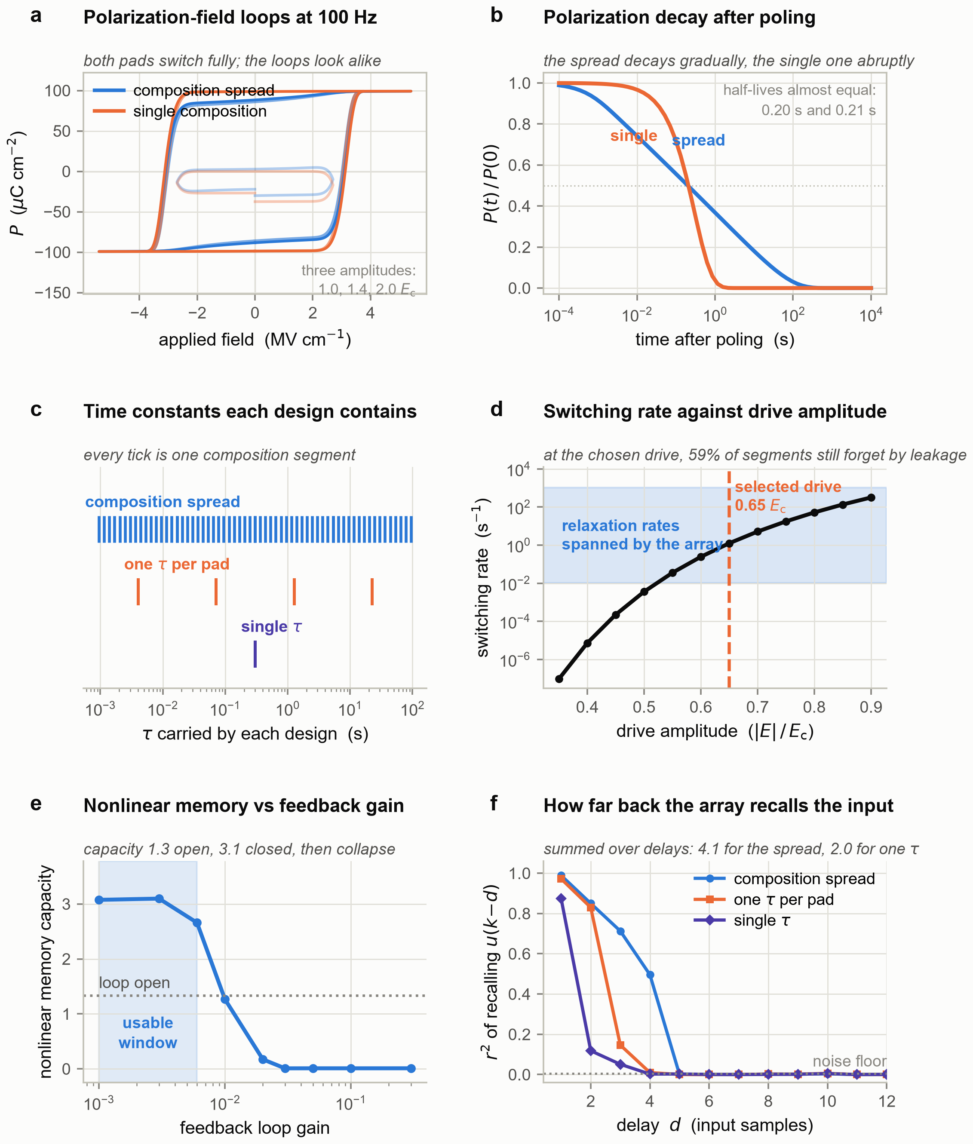
Figure 3. Capability against readout channel count. (a) Nonlinear memory capacity on a logarithmic axis, so the software reference and the zero-scoring delay-line control are both visible. (b) Delayed-parity accuracy against delay at eight channels. (c) Paired difference between the composition spread and each competitor. (d) NARMA-10 error beside its delay-line control.
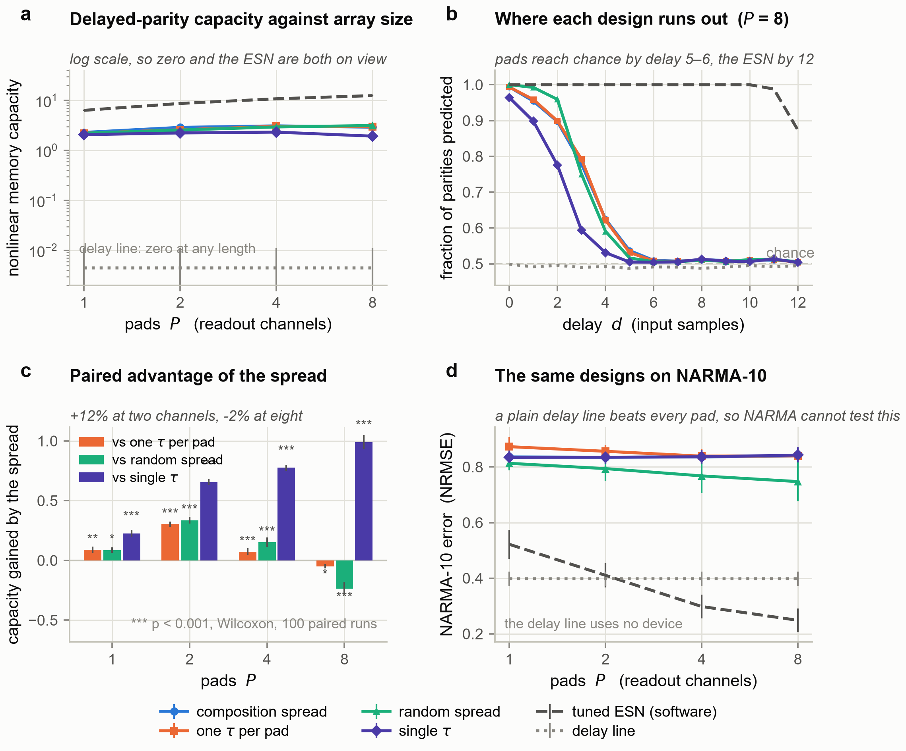
Figure 4. Reproducibility and the two prices the readout charges. (a) Accuracy against transferability as a function of ridge regularization. (b) Readout transfer penalty against deposition tolerance, with the fabrication budget marked. (c) Design advantage against readout signal-to-noise ratio. (d) Capacity against readout precision for several levels of switching jitter.
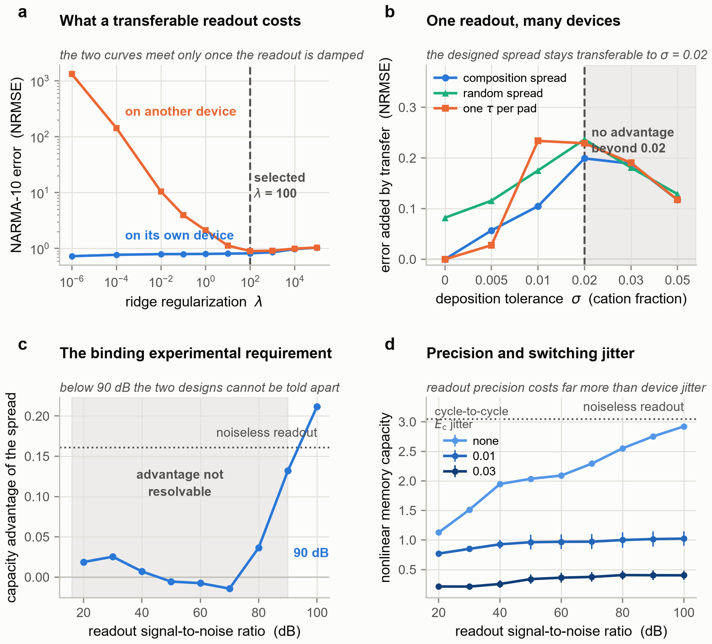
Figure 5. Robustness of the design rule, and the numerical checks. (a) Capacity against ambient temperature. (b) Capacity against the designed spectral span. (c) Discrete time-constant ladders against the continuum. (d) Convergence in composition segments resolved per pad. (e) Convergence in virtual nodes per pad. (f) Sensitivity to bandgap bowing in the alloy model.
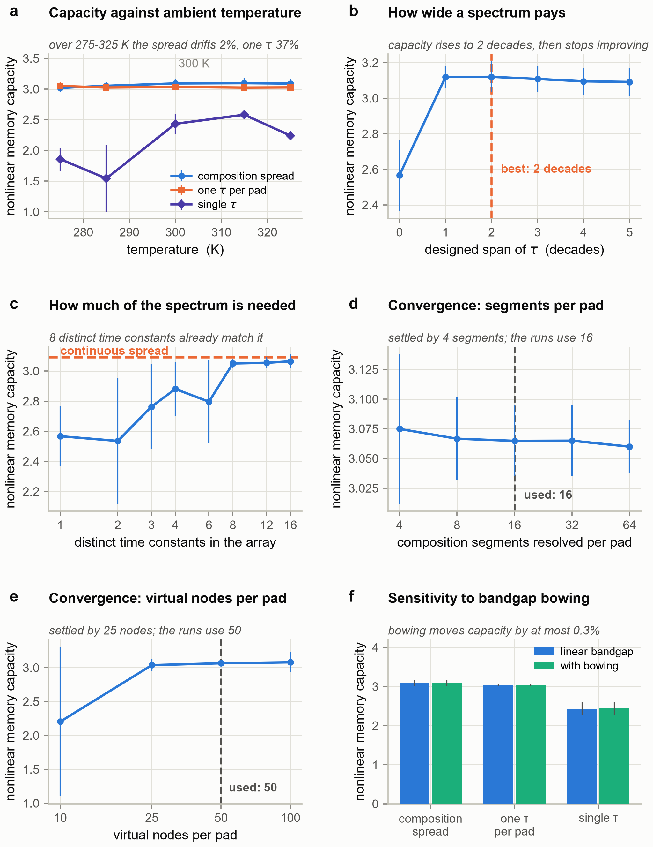
Figure 6. The ternary control. (a) Decades of relaxation time each alloy can build against the window requested. (b) Capability against drive, each design at its own optimum. (c) Temperature, where the substitution fails.
